Exhibit No.:
Issues: ETC Designation

Witness: Adam McKinnie
Sponsoring Party: MO PSC Staff
Type of Exhibit: Rebuttal Testimony
Case No.: TO-2004-0527
Date Testimony Prepared: September 15, 2004

MISSOURI PUBLIC SERVICE COMMISSION

UTILITY OPERATIONS DIVISION

REBUTTAL TESTIMONY

OF

ADAM MCKINNIE

WWC LICENSE, LLC D/B/A CELLULAR ONE

CASE NO. TO-2004-0527

Jefferson City, Missouri
September 2004
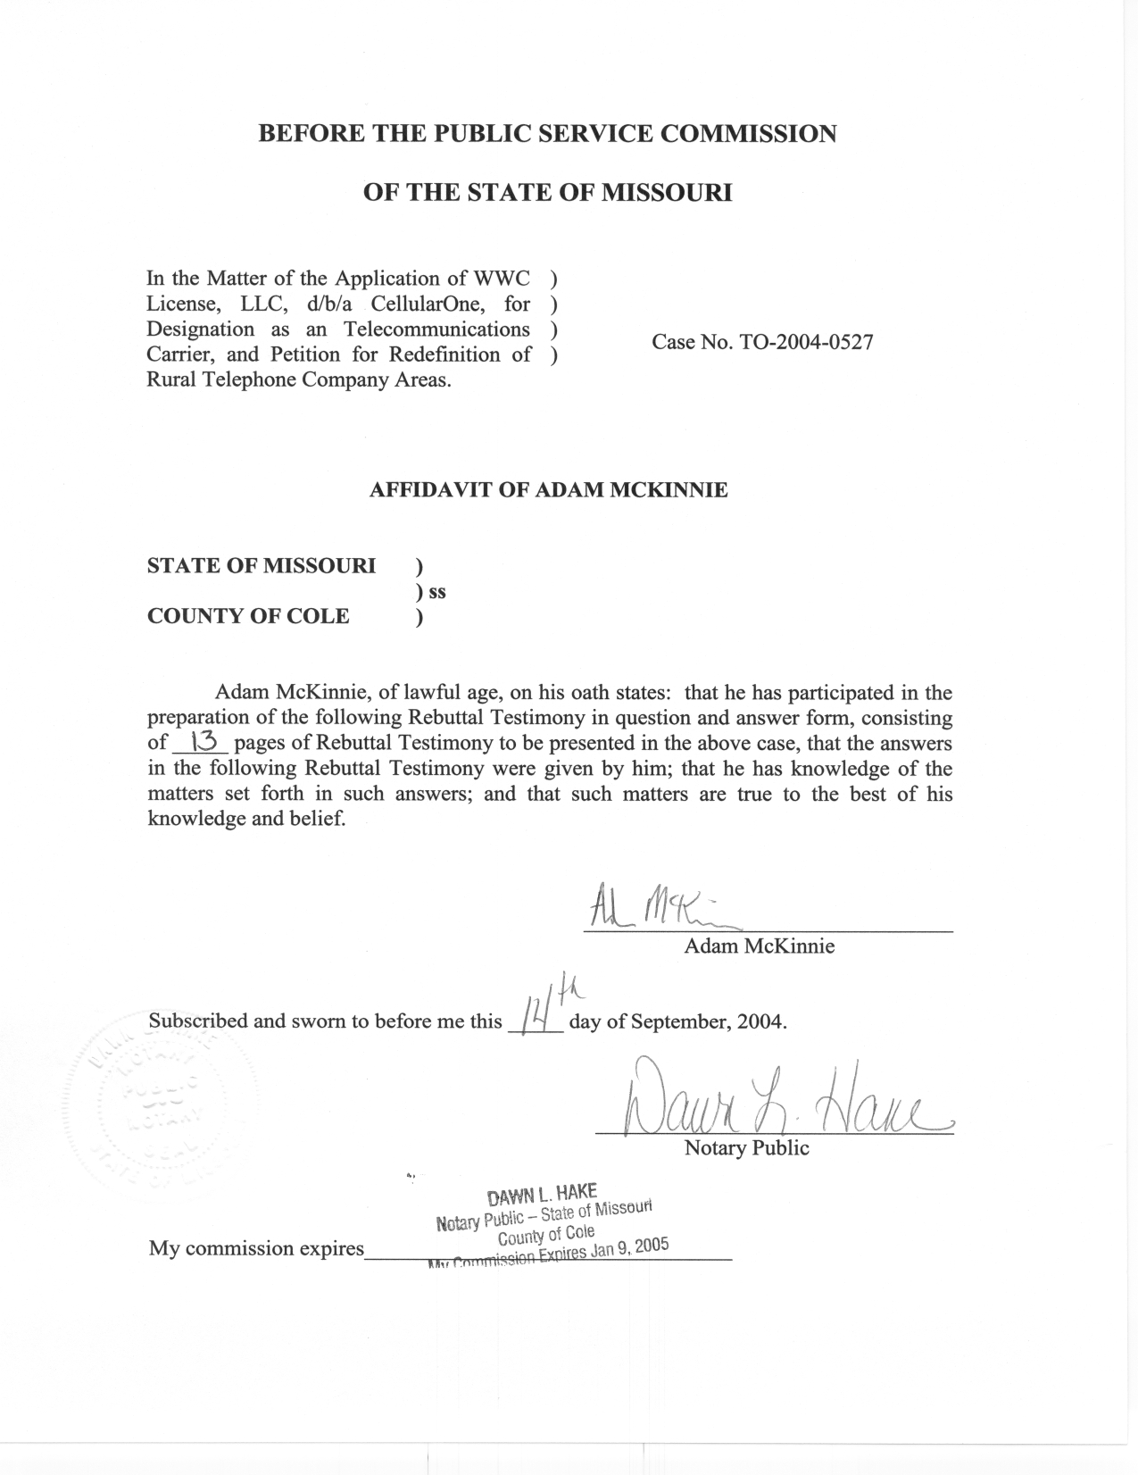

TABLE OF CONTENTS

Previous Wireless ETC Decisions 2
Verification Requirements 3
Public Interest Standard 4
Other Issues 12
Summary 13

REBUTTAL TESTIMONY

OF

ADAM MCKINNIE

WWC LICENSE, LLC D/B/A CELLULAR ONE

CASE NO. TO-2004-0527

Q. Please state your name and business address.
A. My name is Adam McKinnie. My business address is 200 Madison Street, Jefferson City, MO 65102-0360.
Q. By whom are you employed?
A. I am employed by the Missouri Public Service Commission (MoPSC or Commission) as a regulatory economist for the Telecommunications Department Staff (Staff) of the Commission.
Q. What is your educational background?
A. I hold a Bachelor of Art’s degree in English and Economics that I received from Northeast Missouri State University (now called Truman State University) in May 1997. I also hold a Master of Science degree in Economics (with electives in Labor, Tax, and Industrial Organization) that I received from the University of Illinois in May 2000.
Q. What are your current responsibilities at the Commission?
A. I review, analyze, and prepare recommendations on contentious tariff filings for both competitive and non-competitive companies, interconnection agreements, certificate applications and merger agreements. I also conduct research and work on special projects related to telecommunications and economics. For the past two years, I have worked on the federal Universal Service Fund (USF) annual certification process for telecommunications carriers.
Q. Have you testified in front of the Commission before?

A. Yes I have. I filed testimony in Case No. IO-2003-0281 (the Sprint Missouri, Inc. effective competition Case) and Case No. TO-2003-0531 (Missouri RSA No. 7 Limited Partnership d/b/a Mid-Missouri Cellular (MMC) application for ETC status, the previous ETC request by a wireless carrier).
Q. What is the purpose of your testimony?
A. The purpose of my testimony is to respond to the Direct Testimony of WWC License LLC (Western Wireless) witnesses Blundell and Wood, as well as Western Wireless’ application for Eligible Telecommunications Carrier (ETC) status. My testimony will explain why Staff is not in favor of granting ETC status to Western Wireless.

Previous Wireless ETC Decisions

Q. Has the commission decided whether or not any other cellular providers should be granted ETC status?
A. In Case No. TO-2003-0531, MMC filed for ETC status. In that case, the Commission, in its Report and Order effective August 15, 2004, chose not to grant MMC ETC status in any region of Missouri, rural or non-rural.
Q. What, if any, differences exist between the application of Western Wireless and the denied application of MMC?
A. There are a few differences between the two carriers and their applications:
  - Western Wireless is not affiliated with an incumbent local exchange carrier within the state of Missouri, as is MMC.
  - Western Wireless has already received grants of ETC status in other states and regions (as listed on page 5, lines 6-10 of Western Wireless witness Blundell’s Direct Testimony).
  - The Virginia Cellular order (In the Matter of Federal-State Board on Universal Service, Virginia Cellular, LLC Petition for Designation as an Eligible Telecommunications Carrier in the Commonwealth of Virginia, CC Docket No. 96-45, Memorandum Report and Order, FCC 03-338) and the Highland order (In the Matter of Federal-State Joint Board on Universal Service, Highland Cellular, Inc., Petition for Designation as an Eligible Telecommunications Carrier in the commonwealth of Virginia, CC Docket No. 96-45, FCC 03-338) have been issued by the FCC, giving state commissions more guidance in how to interpret the public interest standard.

Verification Requirements

Q. According to Section 214(e)(1) of the Telecommunications Act (Act), a carrier may be designated as an ETC (eligible telecommunications carrier) and receive universal service support as long as the carrier, throughout its service areas, offers services supported by federal support and advertises the availability of those services using media of general distribution. Has Western Wireless provided verification of these requirements?
A. Yes. Similar to other ETC applications, Western Wireless verifies in its application that it provides all of the services required by the Act and advertises the same throughout its service area. Staff concurs with Western Wireless witness Blundell that Western Wireless meets these eligibility requirements.

Public Interest Standard

Q. On page 7 of his Direct Testimony, Mr. Blundell states that “to be designated as a competitive ETC in an area served by a rural telephone company, Section 214(e)(2) requires that the Commission make a separate public interest finding.” In Staff’s opinion, has Western Wireless provided sufficient evidence for the Commission to rely upon in making a public interest finding?
A. No, it has not.
Q. Has the FCC or this Commission established any standards to be considered to support a public interest finding?
A. Yes. In the Virginia Cellular order, the FCC outlined the following information as things that could be considered or provided to support a public interest finding:
We conclude that the value of increased competition, by itself, is not sufficient to satisfy the public interest test in rural areas. Instead, in determining whether designation of a competitive ETC in a rural telephone company’s service area is in the public interest, we weigh the benefits of increased competitive choice, the impact of the designation on the universal service fund, the unique advantages and disadvantages of the competitor’s service offering, any commitments made regarding quality of telephone service, and the competitive ETC’s ability to satisfy its obligation to serve the designated service areas within a reasonable time frame. (Virginia Cellular Order, paragraph 4) (emphasis added)

Further, in the Mid-Missouri Cellular case Report and Order; on page 20, this Commission noted that it utilized the framework of the Virginia Cellular order:
On the eve of the hearing in this proceeding, the FCC issued an order setting forth additional guidance to be used in conjunction with a public interest finding for competitive ETC designations in areas served by rural telephone companies. In addition, the FCC has issued an order in the Highland case that helps define the public interest standard. Thus, the current case may be distinguished from the Commission’s previous Green Hills Order because the FCC has given this additional guidance and specifically “acknowledge[d] the need for a more stringent public interest analysis for ETC designations in rural telephone company service areas.” (footnotes omitted)

Q. What information has Western Wireless provided as to how they would spend any universal service funding they would receive upon potential grant of ETC status?
A. In his Direct Testimony, on page 4, beginning on line 19, Western Wireless witness Blundell wrote:
Obtaining federal universal support funding will allow Western Wireless to compete equitably with the incumbent telephone company in those areas, which are currently eligible for, and are actually receiving, federal universal service support. It will also allow Western Wireless to make additional investments in the network infrastructure in the Designated Areas. (emphasis added)

Q. What was the Commission’s position on similar evidence as to future plans in the MMC ETC case?
A. In describing MMC’s evidence, the Commission wrote in its Report and Order, beginning on page 10:
MMC provided no specific written plans to the Commission regarding the use of the universal service funds. MMC has failed to provide written documentation of any specific system build-out plans and improvements other than the technology upgrade and has not provided any timetable for implementation of the upgrade.

Q. Has Western Wireless provided the Commission or Staff with its “specific written plans”?
A. No, it has not. Realizing that Western Wireless’ Direct Testimony did not provide specific plans, Staff submitted a series of Data Requests to seek further information. The following is from a Data Request submitted to Western Wireless:
Q. Please describe the enhancement and expansion of network infrastructure if Western Wireless receives access to universal service subsidies.

A. Western Wireless is committed to utilizing all universal service support it receives in the State of Missouri for the provision, maintenance, and upgrading of facilities and services for which the support is intended as required by federal law. Western Wireless has not finalized its plans for any future enhancement or expansion of network infrastructure in Missouri and is unlikely to do so without the assurance that it will receive universal service support to assist with such capital expenditures. As the FCC has acknowledged, such hypothetical planning would be an inappropriate use of Company resources. Nevertheless, Western Wireless is currently evaluating the construction of two new cell sites within Missouri RSA 9 subject to its designation as an ETC. See Confidential Exhibit 1-21. (italics added)

Q. Did the Commission indicate in its MMC ETC Report and Order that it was looking for more specific plans?
A. Yes, it did. On page 24 of its Report and Order in the MMC ETC case, the Commission wrote:
One distinction between this case and the Virginia Cellular and Highland cases is that in those cases the companies each presented some specific build-out plans for adding additional towers and being able to service areas where currently no landline service exists and to improve dead spots…Also, MMC has only generally said that it would increase its network capabilities. It has not presented any specific plans for how to upgrade its network, except for the technology upgrade. Without specific plans for upgrades before it, the Commission cannot determine that MMC will offer any advantages over its current service offering.

Q. When asked in another Data Request, “How will the service plans offered by Western Wireless to customers in the proposed ETC areas in Missouri change if Western Wireless is granted ETC status”, how did Western Wireless witness Blundell respond?
A. According to a Data Request Response:
Western Wireless has not finalized pricing or other terms with respect to rate plans that it may offer in the future. If designated as an ETC, Western Wireless intends to offer unlimited local usage as part of at least one of its service offerings that is not available from the Company in the requested ETC service areas today. Other terms and conditions of Western Wireless’ future service offerings will be driven by customer demand and will be responsive to competition within these areas.

Q. Is Western Wireless willing to commit to lower rate plans upon potential receipt of ETC status?
A. No, it is not. In response to a Staff Data Request asking if Western Wireless would be willing to commit to lower rates if ETC status was granted, Western Wireless witness Blundell wrote:
Western Wireless objects to this request as calling for information that is neither admissible nor reasonably calculated to lead to the discovery of information relevant to the matters presented in this proceeding. There is no requirement under federal or state law that an ETC applicant commit to providing lower prices for existing services, higher quality services or new telecommunications technologies. Rather, in designating Western Wireless as a competitive ETC in Wyoming, the FCC recognized that these consumer benefits will naturally result from increased competition for the provision of universal service. Specifically, the FCC acknowledged that competitive entry by wireless carriers will incent all carriers to provide better service to rural and high cost customers.
Western Wireless also asserts that any ad hoc requirement imposed by the Commission to set the Company’s rates for the provision of universal service offerings would result in impermissible rate regulation under federal law. Western Wireless is not aware of an instance where the Commission required such commitments of other ETCs and believes application of such a requirement in this case would be discriminatory.

Q. Western Wireless, in its application on page 13, discusses the Cellular Telecommunications and Internet Association’s (CTIA’s) Consumer code for Wireless Service. What is the enforcement mechanism for this code?
A. According to a response to a Staff Data Request, Western Wireless witness Blundell writes:
Western Wireless’ compliance with the provisions of the CTIA Consumer Code is enforced by its subscribers every day. Western Wireless is answerable to consumers, and if consumers find that Western Wireless’ service quality is not up to the standards established in the CTIA Consumer Code, they do not subscribe to Western Wireless’ services.

Q. How much oversight will the Commission have over a wireless carrier who is granted ETC status?
A. Virtually none. When a CLEC is granted ETC status, the Commission has limited jurisdiction over the rates charged by that telecommunications carrier to ensure that the rates are just, reasonable and non-discriminatory. The Commission will have no such authority over the rates charged by Western Wireless regardless of its ETC status. In effect, granting this status will give Western Wireless a “blank check” over the future of its telecommunications service. As long as Western Wireless is able to certify to the Commission that it is using the funds in accordance to Section 254(e) of the Act, Western Wireless will continue to be eligible to receive high cost funds.
Q. Was the Commission concerned about these matters in the MMC ETC Case?
A. Yes, it was. The Commission stated in its Report and Order for the MMC ETC case on page 26:
The Commission will have no jurisdiction over rates or service plans of MMC, and MMC has not agreed to provide plans with lower rates if it is allowed to become an ETC except for the Lifeline service required under the law.

Q. Is it possible to determine any public interest benefits from Western Wireless testimony or Data Requests sent by Staff to Western Wireless to gain further information that can be directly tied to designation as an ETC?
A. No, it is not. It is impossible for Staff to make any recommendations on public interest determinations from assertions about such generalities about the future. Further, it is not clear what Western Wireless will offer and / or deploy after its potential ETC designation that is not already available today. In response to a Staff Data Request, Western Wireless witness Blundell wrote:
More importantly, Western Wireless can offer Missouri consumers numerous specific benefits (many of which will not be available from the incumbent local exchange provider) as an ETC, including the following:

Increased consumer choice, which will allow consumers to choose their service provider on the basis of the most advantageous pricing, services, service quality, customer service, and service availability;

Q. What was the Commission’s position with regard to public interest benefits in its MMC ETC Report and Order?
A. With regard to the public interest finding, the Commission wrote the following in its MMC Report and Order on page 15:
MMC suggests in its Application that granting ETC status to MMC “will enhance consumer welfare by bringing service choices, innovation, quality differentiation and rate competition to the local market.” MMC fails to explain in sufficient detail how these public interest benefits will occur. The only mention of a forward-looking plan is MMC’s assertion that it will use universal service fund support to finance construction, maintenance and upgrading of facilities, which would allow MMC to serve remote locations. However, MMC provided no supporting documentation to substantiate that such remote locations exist, or that these locations are substantial enough to make the ETC grant in the public interest.

Q. Beginning on page 6, Western Wireless witness Wood discusses the benefits of competitive entry and ETC designation. Is the competitive entry described in this section contingent upon Western Wireless receiving ETC designation?
A. No, it is not. Competitive entry into the telecommunications service market has already been obtained by Western Wireless. For instance, current service offerings are already presumably driven by customer demand and competitive responsiveness.
Q. On page 15, beginning on line 24, of his Direct Testimony, Western Wireless witness Blundell writes:
The KLM Telephone company study area listed in Exhibit JHB-1 is a rural telephone company study area, and the areas listed on Exhibit JHB-2 are entire wire centers within rural telephone company study areas.

What is one of the relevant principles of the Universal Service Fund with regard to rural areas?
A. One of the principles of the Universal Service Fund, according to 47 U.S.C. § 254(b), is that:
Consumers in all regions of the Nation, including low-income consumers and those in rural, insular, and high cost areas, should have access to telecommunications and information services, including interexchange services and advanced telecommunications and information services, that are reasonably comparable to those services provided in urban areas and that are available at rates that are reasonably comparable to rates charged for similar services in urban areas.

Q. Are Western Wireless’ services, which are offered in rural areas, currently comparable to those cellular services offered in urban areas?
A. Yes, they are. This is stated clearly in a Data Request Response as follows:
Q. With regard to Western Wireless’ response to Original Data Request 19, are Western Wireless’ services currently comparable to services available from CMRS providers in urban areas?

A. Western Wireless provides services that are favorably comparable with those offered by CMRS providers in urban areas.

Q. Are Western Wireless’ rates comparable to those of urban carriers?
A. Yes, they are. This is stated clearly in a Data Request Response as follows:
Q. With regard to Western Wireless’ response to Original Data Request 19, are Western Wireless’ rates currently comparable to rates from CMRS providers in urban areas?

A. Yes.

Q. Beginning on page 17, lines 25 of his Direct Testimony, Western Wireless witness Blundell states:
Western Wireless’ ETC designation will bring beneficial competition to rural and high-cost areas. Indeed, the hallmark of a competitive marketplace, and perhaps the most beneficial impact for consumers, is the maximization of consumer choice.

Since Western Wireless currently provides service throughout the proposed ETC area that is comparable to those provided in urban areas at rates comparable to urban areas, how would the designation of Western Wireless as an ETC bring about “beneficial competition”?
A. It could not. It appears that Western Wireless’ current business plan has already provided beneficial competition to the rural areas cited in Western Wireless’ proposed ETC study area. Western Wireless has not shown that granting its ETC application will produce any additional benefits that could satisfy the public interest standard needed to receive rural ETC designation.

Other Issues

Q. On pages 13-17 of the Direct Testimony of Wood and on pages 32-37 of the Direct Testimony of Blundell, Western Wireless discusses its request for redefinition under 47 U.S.C.A. 214(e)5. Does Staff have any concerns regarding the redefinition of the requested areas?
A. While Staff does not have any concerns with the request for redefinition, the issue is moot since, in Staff’s opinion, Western Wireless has not met its burden of proof on the public interest standard.
Q. On page 17, lines 11 through 19, of his Direct Testimony, Mr. Blundell states that this Commission addressed the public interest standard in the designation of competitive local exchange carriers. Are these references applicable in this case?
A. No. As the Commission noted in its Mid-Missouri Cellular order, since the designation of various competitive local exchange carriers in Missouri, the FCC issued its Virginia Cellular order providing further guidance to states when addressing the public interest standard. As previously stated, this guidance was applied in the Commission’s decision in Mid-Missouri Cellular’s ETC request, thus making that decision more closely parallel to the public interest standard in this request.

Summary

Q. Please summarize your testimony.
A. Staff does not support Western Wireless’ application for a grant of ETC status. As the commission noted in its conclusion to the Report and Order in the MMC ETC case beginning on page 26:
The Commission determines that the grant of ETC status to MMC is not in the public interest because MMC has not provided competent and substantial evidence to show that the public will benefit from designating MMC an eligible telecommunications carrier for universal service fund purposes.

MMC has not agreed to abide by the same quality of service standards as landline companies and will not be required to do so by law. The Commission will have no jurisdiction over rates or service plans of MMC, and MMC has not agreed to provide plans with lower rates if it is allowed to become an ETC except for the Lifeline service required under the law. MMC has told the Commission that the funds will be used for an upgrade of its system, but it has not presented the Commission with any construction or financial plans or any timelines for these upgrades.

Additionally, MMC has not shown that the customers in the rural service areas will see any increased competition or benefits from the grant of ETC status to MMC. MMC has made no showing that it intends to expand its coverage area or fix dead spots. Although cellular service does offer mobility that the landline carriers cannot provide, that service is already available throughout MMC’s service area to those customers who have a need for that service.

Much like MMC, Western Wireless has not provided “competent and substantial evidence” to show that the public will benefit from a grant of ETC status.
- Does this conclude your RebuttalTestimony?
A. Yes it does.

