St Peters 7/2612004
Mr/Ms I First Name I Last Name Street Address C ity State Zip Code imate Set-up Date
Ms. Bonnie Hanger 310 N. Jefferson Farmington MO 63640-Dec 20O1
Mr David Doucette 5918 Twin Fawn Ridge Hillsboro MO 63050 Apr 2002
Mr. Nathan Burris 17801 Jehovah Place Marthasville MO 63351 Dec 2001 __I
Mr. Jamie Ellis 814 Portau -Prince Moscow Mills MO 63362 Mar 2001
Ms. Helen Riley 80 Runnymeade Estates O'Fallon MO 63366 Sep 2003
Mr. Gary McMeans 23 Mustang Dr. O'Fallon MO 63366 Jul 2003
Mr. Dennis Dorrell 400 Glengate Estates Dr. O'Fallon MO 63366 Dec 2001
Ms. Sara Etchason 57 Kingway Trailer Pacific MO 63069 Jul 2001
Ms. Dana Schneedle 1405 Casey St. Potosi MO 63664 Sep 2000
Mr. Floyd Kitchen 1408 Lorenzo Ct -St. Charles MO 63301 Apr 2003 Charles MO 63301 Oct 2002
Ms. Phyllis Pruette 1469 N. Rue
Mr. William Loida 1008 New Street Sullivan _MO 630811 Aug 2001
Mr. Norman Jett 1608 E.. Springfield Sullivan MO 63080 May2001
Mr. Mike Ward 2885 Aborlot Wright City ;:MO 63390 May 2001
Page 1

Eureka 7/26/2004

Mr/Ms I First Name I Last Name Street Address City State Zip Code Approximate Set-up Date
Mrs. Laura Pieper 322 Country Aire Pacific MO 63069 Nov 2002
Mr. James Kay 1428 Megan Heights Pevely MO 63070 Sept2002
Mr. Tony Sabatino 4701 Eagle Ridge Rd. Robertsville MO 63072 Feb 2000
Mr. Ron Combs 6053 Hwy HH Robertsville MO 63072 Aug 2000
Mrs. Sherri Squires 5510 Highway N Robertsville MO 63072 Aug 2001
Mr. John Russell #-4 Finney Lake Rd Robertsville MO 63072 Dec 20 01
Mr. Charles Cox 1639 Chinnock Robertsville -MO 63072 June 2002
Mrs. Eva Webster .5309 Finney PI Robertsville MO 63072 July 2002
Mr Robert Wright 6903 Hwy HH Robertsville MO 63072 April 2003
Mr. Rick McClelland Oak Grove Church Road Robertsville MO 63072 Dec 2000
Mr. Joseph Jones Lot 22 Fawn Ct. St Clair MO 63077 March 2000
Mr. David Hatfield 1633 N. Service Rd St- Clair MO -63077 Nov 2000
Mr. Richard Hess-- 731 Cove Creek Rd St. Clair MO '63077 April 2001
Ms Karen Valconi 32 Buckstand St. Clair MO 63077 Aug 2001
Mrs. Deborah Duke 245 Hibbard St St. Clair MO 63077 Dec 2001
Mr. Earl Prost 6851 Mockingbird Ln. St. Clair MO 63077 May 2002
Mr. David Jenkins #5A Paradise Trailer Ct St. Clair MO 63077 Oct 2002
Mr. Ban Heller 2448 N. Bend Loop Union MO 63084 April 2000
Mr. Scotty Garrett 24 Bourbeuse MHP Union MO 63084 April 2001
Mrs. Vivian Beal 520 N. Church Union MO 63084 June 2001
Mr. Ronald Simily 580 River Hawk Trails Union MO 63084 June 2002
Mrs. Stephanie Martin 805 West Park Union MO 63084 Nov 2002
Mr. Roy Kramme 5023 Beck Addition Union MO 63084 Dec 2003
Ms. Lisa Davis 2730 Fantasy Ln. villa Ridge MO 63089 Feb 2000
Mrs. Daniel Milberg 560 American Inn Rd. Villa Ridge MO 63089 July 2000
Mr. Orlo Walters #13 Pacific Summit Villa Ridge MO 63089 July 2000
Mrs. Kathy Brauch 560 American Inn Rd Villa Ridge MO 63089 Aug 2000
Mrs. Barbara Goodson 883 Dunwood Ct. Villa Ridge MO 63089 Aug 2000
Mr. Jim Farrar r 66 Pacific Summit Villa Ridge MO 63089 Oct 2000
Mr. Henry Wurtz 327 Villa Village Villa Ridge MO 63089 Oct 2001
Mr. John Knichel 67 Pacific Villa Ridge MO 63089 April 2002
Mr. Jeffrey Vitt 2 Rosette Villa Ridge MO 63089 June 2003
,Mrs. Rosetta Reeves Lot 26 Villa Village Villa Ridge MO 63089 Dec 2003

Page 2

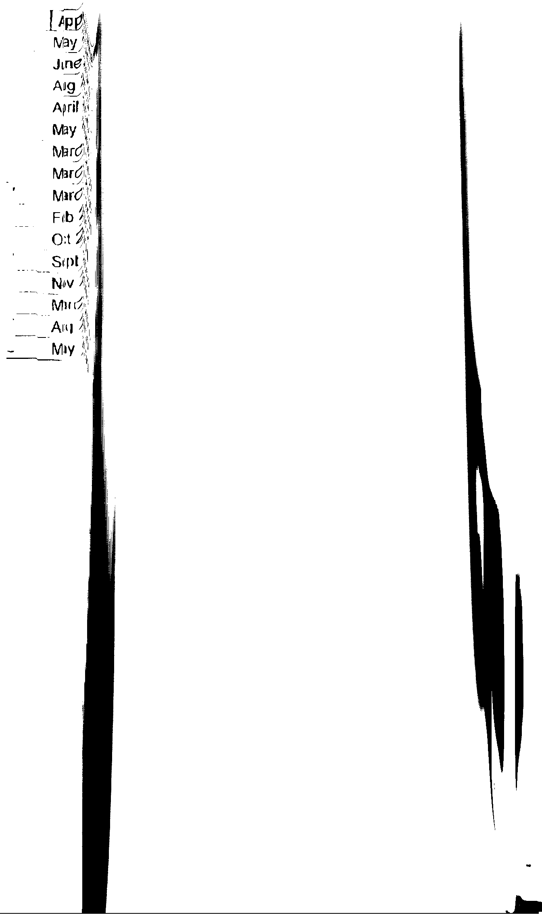
Eureka

Mr/Ms First Name Last Name Street Address I City State Zip Code
Mrs. Patricia Clevenhagen 923 Norwood MHP Washington MO 63090
Mrs. Lela Myers 16 Norwood Ct. Washington MO 63090
Mr. Richard Langhorst 3254 Danz Road Rosebud MO 63091
Mr. Maurice Hess 83 Hidden Oak Or- O'Fallon MO 63366
Mr. Byron Grimsley 8004 Oakmont Ct. O'Fallon MO 63366
Mr. Charles Prosser 26 Riadosa St- Peters MO 63376
Mr. James Nickelson Rt I Box 1352 Belgrade MO 63622
Mr. Franklin King #6 Crosstrails -Bloomsdale MO 63627
Mr. Dennis Adkins 9182 Sunset Dr Bloomsdale MO 63627
Mr. Dallas Thompson Rt- 1 Box 2018 Potosi MO 63664
Mrs. Clara Biere 1398 Hwy Y Bland MO 65014
Mr. David Freeman 2879 Hwy 19 Owensville :MO 65066
Mrs. Belinda Nantz 201 Winter Ln. Bourbon MO 65441
Mr. Charles Halfaker 100 S. Hobby Hut Leas MO 65535
Mr. James Pickett 23 Bowers Road Steelville MO 65565
Page 3

South

Mr/Ms Name I Last Name I Street Address City State Zip Code Approximate Set
Mr. Lloyd Harper 102 Rex-Aire Arnold MO 63010 Aug 2002
Ms. Judith Kittrell #45 Rex-Aire Arnold MO 63010 Jan 2000
Ms. Mabel Mueller 21 Sandiscott Arnold MO 63010 Aug 2003
Mr. Orville Weppner 21 Sandiscott Arnold MO 63010: Dec 2001
Mr. Melvin Ward 183 Starling Community Arnold MO 630110 Feb 2004
Ms. Katherine Warner 23 Sandiscott Or. Arnold MO 63010 Jun 2003
Mr. Gabe Steams Rt. I Box 1674 Cadet MO 63630 Jan 2000
Mr. Gene Williams 3400 Papin Road DeSoto MO 63020 Oct 2002
Mr. Dennis Forgotston 92 Starling Community Desoto MO 63020 Oct 2003
Mr. Tim LaComb 1773 Pendleton Farmington MO 63640 Jul 2003
Mr. 'William Edburg 1126 Hollercamp Farmington MO 63640 Jan 2000
Mr. Robert Wells 738 N. Low View Fenton MO 63026 Oct 2 002
Ms. Betty Hardin 822 Appaloosa Fenton MO 63026 Jun 2003
Ms. Linda Lucy 1010 Coriander Fenton MO 63026 Nov 2001
Mr. Timothy Shell 467 Montauk Rd. Lot 50-Festus MO 63028:Dec 2002
Mr. Walter Thompson 123 Lilac Festus MO 63028 Dec 2001
Mr. Adrian Dick 560 Oakland Hill Drive Festus MO 63028 Jan 2002
Mr. Lonnie Crocker 2264 Highway J Fredricktown MO 63645 Nov 2001
Mr. Christopher Hargrove 8414 Ridge Dr. Hillsboro MO 63050 Jun 2003
Mr. Troy Trimborn 7140 Pleasant View Dr- Hillsboro MO 63050 Sep 2003
Ms. -Barbara Thomas 1105 Lisa Or- Imperial MO 63052 Apr 2003
Mr. Whitney Weldele 6017 Cedar Edge Imperial MO 63052 Aug 2003
Ms. Sandra Brown 1531 San Juan Moscow Mills MO 63362 Jan 2002
Ms. Judith Paris 603 Vivian Court Park Hills MO 63601 Nov 2002
Mr. Jason Harden 1560 Glenoma Pevely NO 6307O May 2002
Ms. Delila Cupp 1412 Megan Heights Pevely MO 63020 May 2002
Mr. Floyd Medley Rt. I Box 1781 Potosi MO 63664 Jun 2002
Mr. James Sampson 22480 Coffelt Road St. Mary MO 63673 Apr 2003
Mr. Tim O'Haver 8168 Sprott Ste. Genevieve MO 63670 Nov 2001
Mr. Gordon Pierce 4474 Highway K Sullivan MO 63086--JuI 2002
Mr. David Ham 2832 Allen Lane Villa Ridge MO 63089 Aug 2001

Page I

712612004
Eureka

Mr/Ms I First Name I Last Name Street Address City State Zip Approximate Set-up Date
Mr. Arnold Reeves 3286 Hwy EE Beaufort MO 63013 Sept 2001
Mr. Ricky Anderson 1173 Meremac St Catawissa MO 63015 March 2000
Mrs. Jessica Leonhardt 212 Juliet Ct. Cedar Hill MO 63016 July 2000
Ms. Keri Ocheltree 14 Oakview Drive #48 Cedar Hill MO 63016 May 2001
Mr. Timothy McNulb 6 Roxanne Dr. Cedar Hill MO 63016 Dec2003
Mrs. Dellaphene Meyer 8777 State Rd 30 Dittmer MO 63023 Nov 2002
Mrs. Kim Johnston 7902 State Rd Y. Dittmer MO 63023 April 2003
Mr. John Dachs 764 N. Lowview Fenton MO 63026 May.2000
Mrs. Phyllis Jones 1247 Golden Oak Dr. Fenton MO 63026 Sept2000
Mr. Gary Frossard 1558 Fenpark Fenton MO 63026 Oct2000
Mrs. Tammy Pierce 312 Nutmeg Fenton NO 63026 May 2002
Mrs. Wendy Stephens 1458 Robindale Fenton MO 63026 Oct 2002 --- - --
Mrs. Marianne Loveless 1224 Robindale Dr. Fenton MO 63026 April 2003
Mrs. Carrol Carron 22 Manderly Court Festus MO 63028 Aug 2001
Mrs. Iris Chamberlain 4828 E. Golden Circle High Ridge MO 63049 May 2000
Mrs. Shirley Moentmann 5033 Gem High Ridge MO 63049 Aug 2001

Mr. William Burrous 9725 Cedar Drive Hillsboro MO 63050 Sep12000
Mr. Delbert Wideman 5701 Hwy Y Hillsboro MO 63050 July 2003

Mr. Robert Machester 109 Juliet Dr. Cedar Hill M0 63051 April 2000

Mr. Joe McMahan 4850 Bettina House Springs MO 63051 May 2001
Mr. Samuel Lacey 4430 Shawn House Springs MO 63051 Dec 2001

Mr. Richard Leuthauser 475 North Ridge Labadie MO 63055 March 2001
Mr. Billy Chavers 9 Herm'it Hollow Labadie MO 63055 June 2001

Ms. Shirley Foreman 3803 Petersford Rd. Leslie MO 63056 Feb 2000
Mrs. Lola Dempsey #8 Segelhorst Leslie MO 63056 Sept2000
Mr. Gary Sutterfleld 3265 Huff Rd Lonedell MO 63060 Nov 2000
Mr. Cory Thurman 8339 Little Indian Ck Rd Lonedell MO 63060 Sep12003
Mrs. Sandra Worden 62 Pacific Summit Es. Pacific MO 63069 July 2000
Mr. Jeff Brown 4046 Tower View Dr. Pacific MO 63069 Aug 2000
Mr. Kevin Wright 40 Avery MHP Pacific MO 63069 Feb 2001

Mr. Jack Blake 349 Avery MHP Pacific MO 63069 April 2001
Mr. Joseph Taylor 2622 Hwy N Pacific MO 63069 June 2001
Mrs. Kathy Maddox 57 Avery Pacific MO 63069 May 2002
Page 1

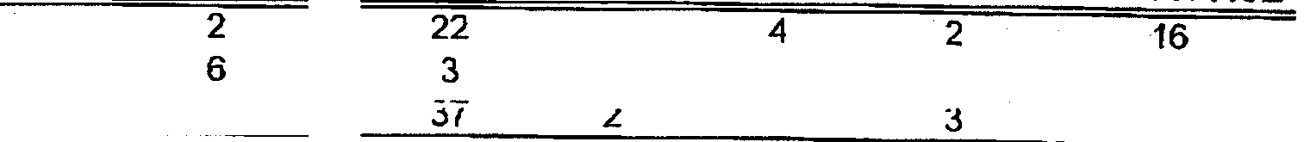
SOUTH
ST.PETERS
r-11mr-Ka
EUREKA KA
LOCATION
PIER SET
TOTAL
31 29
14 8
81
PIER SET PIER SET
SW MW
OTHERS HOUSE BASEMENT
TOTAL REPO'S USED ILLINOIS CRAWLSPACE
-is
35
TOTALS
126 85 41
3
32
62 2 - 4 5 51 -

