BEFORE THE PUBLIC SERVICE COMMISSION

OF THE STATE OF MISSOURI

In the Matter of the Request of Southwestern Bell )
Telephone, L.P., d/b/a SBC Missouri, for ) Case No. TO-2006-0102
Competitive Classification Pursuant to Section ) TariffFileNo.YI-2006-0145
392.245.6, RSMo (2005) – 60-day Petition. )

PUBLIC COUNSEL’S POST HEARING BRIEF

EVIDENCE DOES NOT SUPPORT THAT THE GRANT OF A COMPETITIVE STATUS IS IN THE PUBLIC INTEREST.

SBC continues to dominate the local exchange in the requested exchanges

Residential market

Public Counsel asks the Commission to reject all competitive classifications for SBC in this case. Specifically, the residential marketplace in the requested exchanges continue to be dominated by SBC. Under price cap regulation, SBC has not shown any “price discipline” for its regulated services that was the consequence of local competition. Ex. 7 Meisenheimer Rebuttal, p. 9) Every year, SBC has taken the opportunity to increase nonbasic service rates by up to 8% and has only made reductions in local basic service rates in response to its duty to implement reductions due to CPI-TS; SBC has not waived its opportunity to increase local basic rates when the CPI-TS allowed upward adjustment. (Ex. 7 Meisenheimer Rebuttal, p. 9)
The percentages of residential lines served (SBC Late Filed Ex 9HC) show a drastic difference between the “market share” that SBC has and the market share that CLECs IN THE AGGREGATE serve. Remember, when SBC starts with 100% of the market in 1996 and competition is introduced to provide choice of providers, it should not be an unexpected result or surprise that after almost 10 years of competition, SBC’s market share would be less than the monopoly 100%. The key factor is that the market share by competitors is so minimal even after almost a decade of competition. Apparently, CLECs have made only nominal entry into the residential market and no CLEC has come to the forefront to challenge the market dominance of SBC.
The number of residential lines in SBC exchanges served IN THE AGGREGATE by CLECS pales in comparison to the total number of residential lines and SBC total dominance of the residential segment of the market in each exchange. This statistic is even more telling than the percentage differences; small exchanges with a small number of lines could register an apparent significant percentage of the marketplace but still only be just a handful of customers served by CLECs ----once again IN THE AGGREGATE—as compared to the total lines serviced by SBC in the exchange.
The question is “how does this market place protect the ratepayers as required by Section 392.185 (6), RSMo?” With SBC still acting with virtual monopoly power in these residential exchanges, the “invisible hand of competition” will not only be unseen, but a no show. Removal of price cap limits for local basic service and other nonbasic services opens the door for abuse of these customers who have no real choice; ten years of competition have demonstrated that CLECs are not considered a true substitute for SBC service or is not a realistic option for the local residential customers in those exchanges. The CLECs lack of major inroads into these exchanges is significant evidence that competition has not reached a level that merits competitive classification, notwithstanding the presence services that could potentially compete with SBC’s local basic service. It is contrary to the public interest to allow SBC a free hand, unchecked by real and meaningful competition and unchecked by regulators. (Ex. 7 Meisenheimer Rebuttal, p. 15-16)
SBC wants the PSC to close its eyes to any evidence other than the mere presence of entities that provide voice service within its exchanges. That turns the Commission into tally clerks and bean counters (Tr. ), rather than the regulatory body delegated considerable power, expertise, and discretion to weigh all relevant factors and make decisions that serve the goals and purposes of Section 392.185, RSMo and do not result in circumstance that are contrary to the public interest. SB 327 did not remove the PSC’s basic duty to consider all relevant factors and be founded on competent and substantial evidence when making a regulatory decision; not to do so is arbitrary and an abuse of discretion. From an economic and public policy perspective, it is reasonable and appropriate for the PSC to investigate and evaluate the quality and quantity of competition before making a decision that could have detrimental effects on ratepayers and the market place. (Ex. 7 Meisenheimer Rebuttal, p. 9-11)

Business Service

Lack of Competent and Substantial Evidence for Wireless competitors

A. SBC’s wireless carriers evidence not reliable or accurate
Public Counsel expert witness Meisenheimer testified to the results of her personally conducted investigation into the accuracy and reliability of the data source used by SBC’s Unruh to present evidence of wireless competition for both residential and business services. Her findings were that Letstalk.com used by SBC was neither accurate nor reliable. (Ex. 7 Meisenheimer Rebuttal, p. 12-13; Sch. BAM-1 and BAM-2) She cautioned the PSC not to rely upon the wireless carriers as the basis for competitive classification because SBC paints too rosy of a picture of wireless availability and does not address issues regarding deficiencies in availability and quality of coverage in the exchanges especially in exchanges where there are a limited number of facilities-based alternatives or where landline alternatives rely heavily on the incumbent’s network. (Tr. 270-1; Ex. 7 Meisenheimer Rebuttal, p. 12-13) She also pointed out wireless carriers’ use of long term contracts with termination penalties, credit checks as a condition of service, and bundled packages whereby the customer is forced to purchase more services to obtain the best price which then exceeds the incumbent’s price for basic local service. (Ex. 7 Meisenheimer Rebuttal, p. 13) Staff’s recommendation for the 15 business exchanges did not include an analysis of whether or not wireless carriers at issue provided basic local service included the specific eight elements as defined by Section 386.020(4), RSMo or whether it was just local exchange service (Sec. 386.020 (31) (Tr. 277-278; 181-2).
SBC’s evidence as to wireless carriers has not been demonstrated to be accurate or reliable and no witness has testified as to the source’s reliability or accuracy, therefore, the evidence is not competent as a study or compilation of data under Section 536.070 (13), RSMo and is hearsay and cannot be the basis of the Commission’s decision.

B. Staff’s recommendation lacks evidentiary weight, reliability, and legal significance

The Staff’s recommendation on the 15 business exchanges and the two residential exchanges using the 30 criteria as the basis of its recommendation also lacks sufficient evidentiary weight and reliability as well as legal significance. The Staff did not perform the evaluation necessary for wireless to qualify as an eligible competitor under the criteria its used, that is, is the wireless carrier providing local basic service the exchange. (Tr. 277-278; 181-2). Staff’s recommendation lacks evidentiary support without such investigation and without the results; provision of local basic service cannot be presumed, it is an element of proof. (Section 386.020 (4); Section 392.245.6, RSMo as amended) A recommendation that purports to use certain criteria as the basis for its recommendation but in fact did not use evidence of that criteria is not competent and substantial evidence of facts necessary to base a competitive classification.
As a result, the evidence in the record fails to demonstrate that the named wireless providers are providing the necessary service and given Ms. Meisenheimer’s notation of wireless problems, it would be contrary to the public interest to approve the 15 business exchanges recommended by Staff and any of the residential exchanges.

Exhibit 8: SBC’s “script” for its witnesses at the public hearings
Public Counsel does not object to the inclusion of this exhibit into the record. This type of overreaching should be part of the record in a case where the issue of whether or not SBC should be removed from regulatory oversight and free to price telecommunications services as it sees fit in its own discretion. It goes to the very issue of whether its is in the public interest to give SBC a free hand and rely on other companies to act as the check on SBC’s activities in the market place. Public Counsel sets out the “messages” SBC wanted its witnesses to convey to the PSC so that this script (and no euphemism such as “talking points” is realistic) can be clearly shown. (Tr. 116-122; 59-63; 57-59)

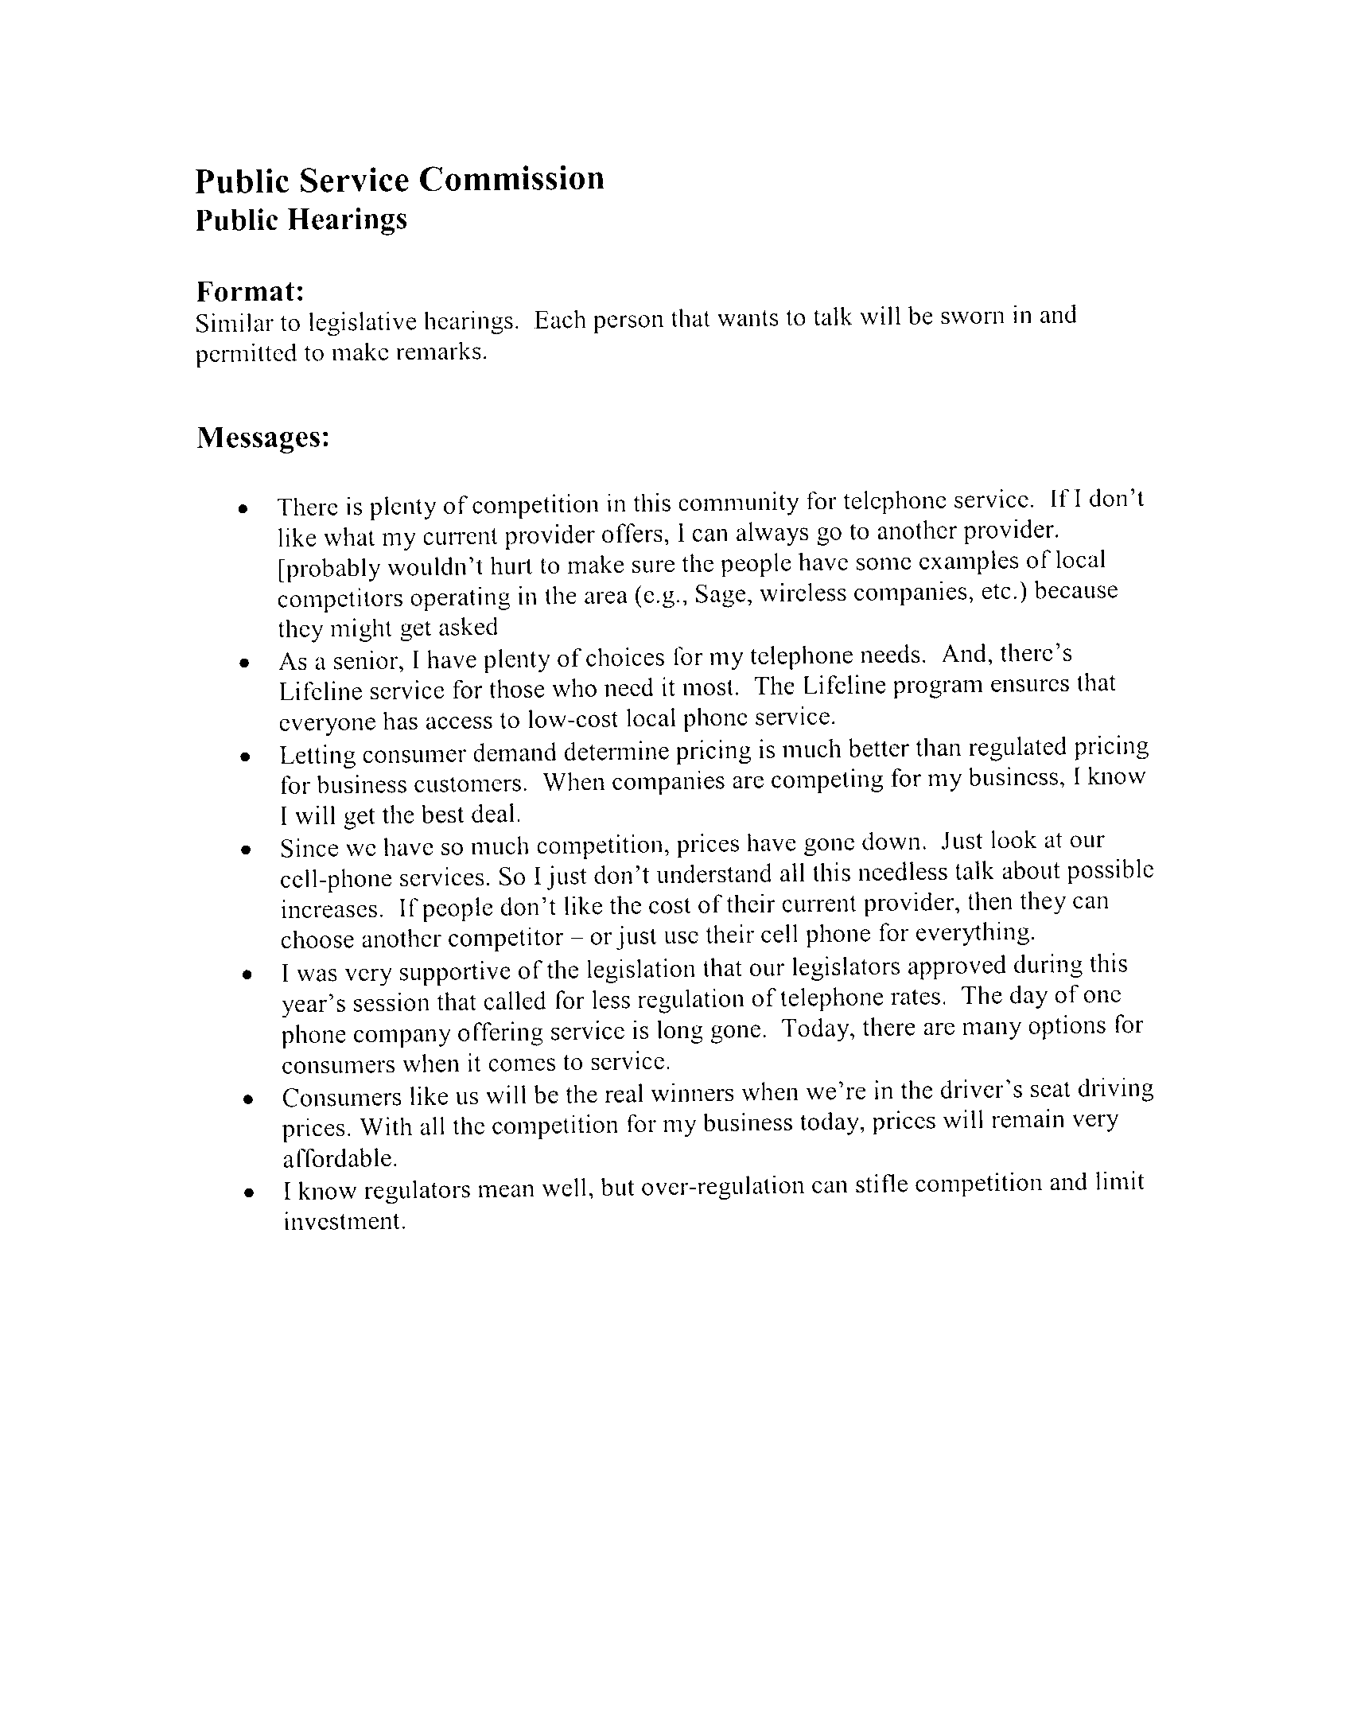
SBC’s interest to advance the interests of its shareholders is not the same as the public interest. (Tr.69-70). SBC’s manipulation of the public hearing process was an attempt to paint its interest as identical to the public interest.
In the evidentiary hearing and in briefs and opening statements, SBC argued that it had no obligation to present any evidence that reclassification would be in the public interest or that it would not be contrary to the public interest. (Tr. 70-71; 131-2) This position stands in marked contrast to SBC’s “messages” where it is apparent that SBC intended through friendly community leaders to inject evidence of public need and positive public interest effects into the PSC’s public hearing record. SBC stands silent on the public interest issue in the evidentiary hearing, but scripts the testimony for witnesses.
Public Counsel does not question the truth or sincerity of the witnesses that testified at the public hearings. It is apparent that SBC has a long history of community involvement and participation and brand recognition which cannot be hoped to be matched by competitors even over 10 years. (After all, Southwestern Bell has been THE telephone company for most adults’ memory.)
Public Counsel’s concern is SBC’s abuse of the hearing system in the manner in which the Company’s point of view was set up as the public’s point of view. SBC’s tactics regarding the public hearings has introduced a new and relevant factor for the PSC to consider in determining whether SBC should be removed from price cap regulation. The PSC should give it due consideration and weight in making its public interest analysis.
Public Interest Standard under the 60-day petition
SBC wants to turn the 60 day proceeding into a counting exercise: it there are two local voice providers using any type of technology referenced in the statute, then that meets the statutory requirement and the PSC cannot investigate any further and is duty bound to approve the competitive classification. That is a strained, if not, wishful, reading of the statute. (Tr. 128-132)
But Staff and Public Counsel read the statute in a reasonable light and with the intend of the General Assembly firmly in mind: the public interest requirement in the 60 day proceeding is in addition to the identification of the qualifying competing entities. (Tr. 175-180) The public interest is a limitation on the unbridled and unreviewed use of competitors. The PSC is in the place to exercise its discretion and expertise to ensure that the public interest standard (See, Section 392.185, RSMo) is advanced and preserved.
The public interest has been entrusted to the PSC. . Lightfoot v. City of Springfield, 361 Mo. 659, 236 S.W.2d 348 (1951); May Dep't Stores Co. v. Union Electric Light & Power Co., 341 Mo. 299, 107 S.W.2d 41, 48 (1937)
The General Assembly gave the PSC legal authority to fulfill its duty to protect the public and ensure that the public interest is advanced. All the statutes relating to the PSC’s powers and duties must be read in harmony with each other. "The construction of a statute should accord with reason and common sense and should not require unreasonable things. . . The reason of the law should prevail over its letter, and general terms should be so limited in their application as not to lead to injustice, oppression or an absurd consequence, the presumption being that the legislature intended no such anomalous results." State ex rel. McPherson v. St. Louis & S. F. R. Co., 79 S.W. 714, 716 (Mo App. 1904)
In State ex rel., Sprint Missouri, Inc., v. Public Service Commission, 165 S.W.3d 160 (Mo. banc 2005), interpreting Section 392.245, RSMo 2000, the Court recognized the interrelationship of Section 392.185, RSMo and the price cap statute: “In this way, price cap regulation can help the PSC meet its statutory duty of ensuring that ratepayers pay only reasonable charges for telecommunications services, while allowing companies to make a reasonable profit, by permitting "flexible regulation of competitive telecommunications companies . . . and to allow full and fair competition to function as a substitute for regulation when consistent with the protection of ratepayers and otherwise consistent with the public interest." Sec. 392.185 (emphasis added). To interpret the statute otherwise would contravene its purpose. . . .” (at 165-166)
Notwithstanding SBC’s failure to submit evidence of the public interest, Staff made a showing that it recommended denial based on reclassification being contrary to the public interest. (Tr. 175-181; 279) Public Counsel also submitted evidence that identified a number of facts which would demonstrate that reclassification would not be in the public interest. (Tr. 244-248; Ex 7; Tr. 194-232)
Respectfully submitted,
OFFICE OF THE PUBLIC COUNSEL

/s/ Michael F. Dandino

BY: _____________________________
Michael F. Dandino (Bar No. 24590)
Deputy Public Counsel
200 Madison Street, Box 2230
Jefferson City, MO 65102
Telephone: (573) 751-5559
Facsimile: (573) 751-5562
E-mail: mike.dandino@ded.mo.gov
CERTIFICATE OF SERVICE

I hereby certify that a true and correct copy of the foregoing was mailed, emailed or hand delivered this 19th day of October, 2005 to the following:

General Counsel Leo Bub
Missouri Public Service Commission SBC Missouri
P. O. Box 360 One SBC Center, Room 3520
Jefferson City, MO 65102 St. Louis, MO 63101

/s/ Michael F. Dandino

__________________________________

