Diana M. Vuylsteke
Voice: 259-2543
dmvuylsteke@bryancave.com
March 17, 2004
Mr. Dale Hardy Roberts
Secretary/Chief Regulatory Law Judge
Missouri Public Service Commission
Governor Office Building
200 Madison Street
Jefferson City, Missouri 65101
Re: Case No. EO-2004-0108

Dear Mr. Roberts:
Attached for filing is the Position Statement of the Missouri Industrial Energy Consumers.

Thank you for your assistance in bringing this filing to the attention of the Commission, and please call me if you have any questions.

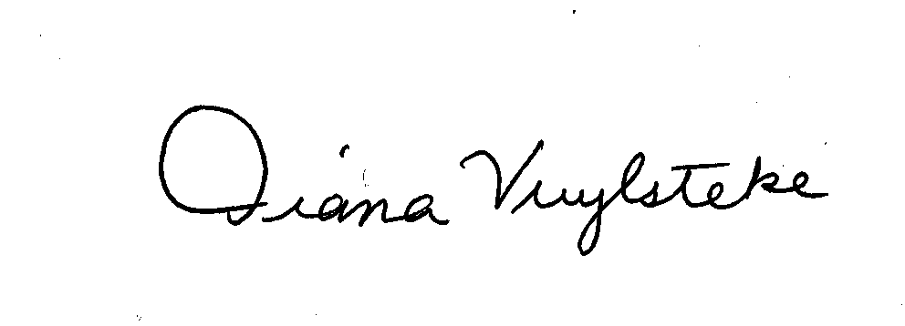
Very truly yours,
Diana M. Vuylsteke
DMV:rms
Attachment
cc: All Parties

