Diana M. Vuylsteke
Voice: 259-2543
dmvuylsteke@bryancave.com
May 25, 2004

Mr. Dale Hardy Roberts
Secretary/Chief Regulatory Law Judge
Missouri Public Service Commission
Governor Office Building
200 Madison Street
Jefferson City, Missouri 65101
Re: Case No. EE-2004-0267 and Case No. EE-2004-0268

Dear Mr. Roberts:
Attached for filing please find the Request of River’s Edge for Extension of Filing Date.
Thank you for your assistance in bringing this filing to the attention of the Commission, and please call me if you have any questions.

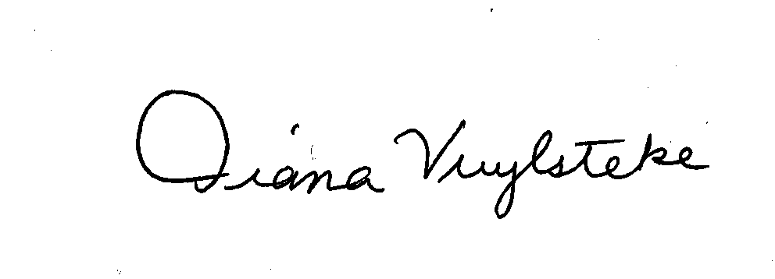
Very truly yours,
Diana M. Vuylsteke
DMV:rms

cc: Bruce Bates by email (brucebates@psc.mo.gov.)

