Diana M. Vuylsteke
Voice: 259-2543
dmvuylsteke@bryancave.com
June 7, 2004

Mr. Dale Hardy Roberts
Secretary/Chief Regulatory Law Judge
Missouri Public Service Commission
Governor Office Building
200 Madison Street
Jefferson City, Missouri 65101
Re: Case No. EW-2004-0596

Dear Mr. Roberts:
Attached for filing please find Application of the Missouri Industrial Energy Consumers to Intervene Out of Time.
Thank you for your assistance in bringing this filing to the attention of the Commission, and please call me if you have any questions.

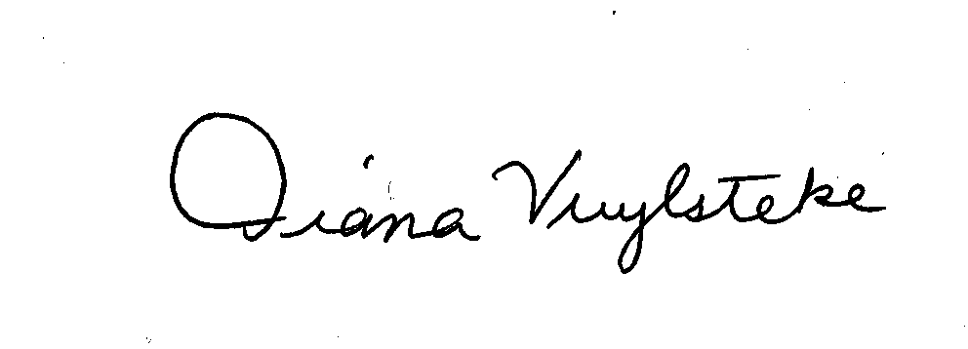
Very truly yours,
Diana M. Vuylsteke
DMV:rms
Attachment
cc: All parties

