Exhibit No.:

Issues: General Conditions and

Eight Percent Increase in

Non-Basic Services

Witness: Christopher C. Thomas
Sponsoring Party: MO PSC Staff
Type of Exhibit: Rebuttal Testimony
Case No.: IT-2004-0015
Date Testimony Prepared: September 26, 2003

MISSOURI PUBLIC SERVICE COMMISSION

Utility Operations DIVISION

Rebuttal TESTIMONY

OF

CHRISTOPHER C. THOMAS

SOUTHWESTERN BELL TELEPHONE COMPANY
D/B/A SBC MISSOURI

CASE NO. IT-2004-0015

Jefferson City, Missouri

September, 2003

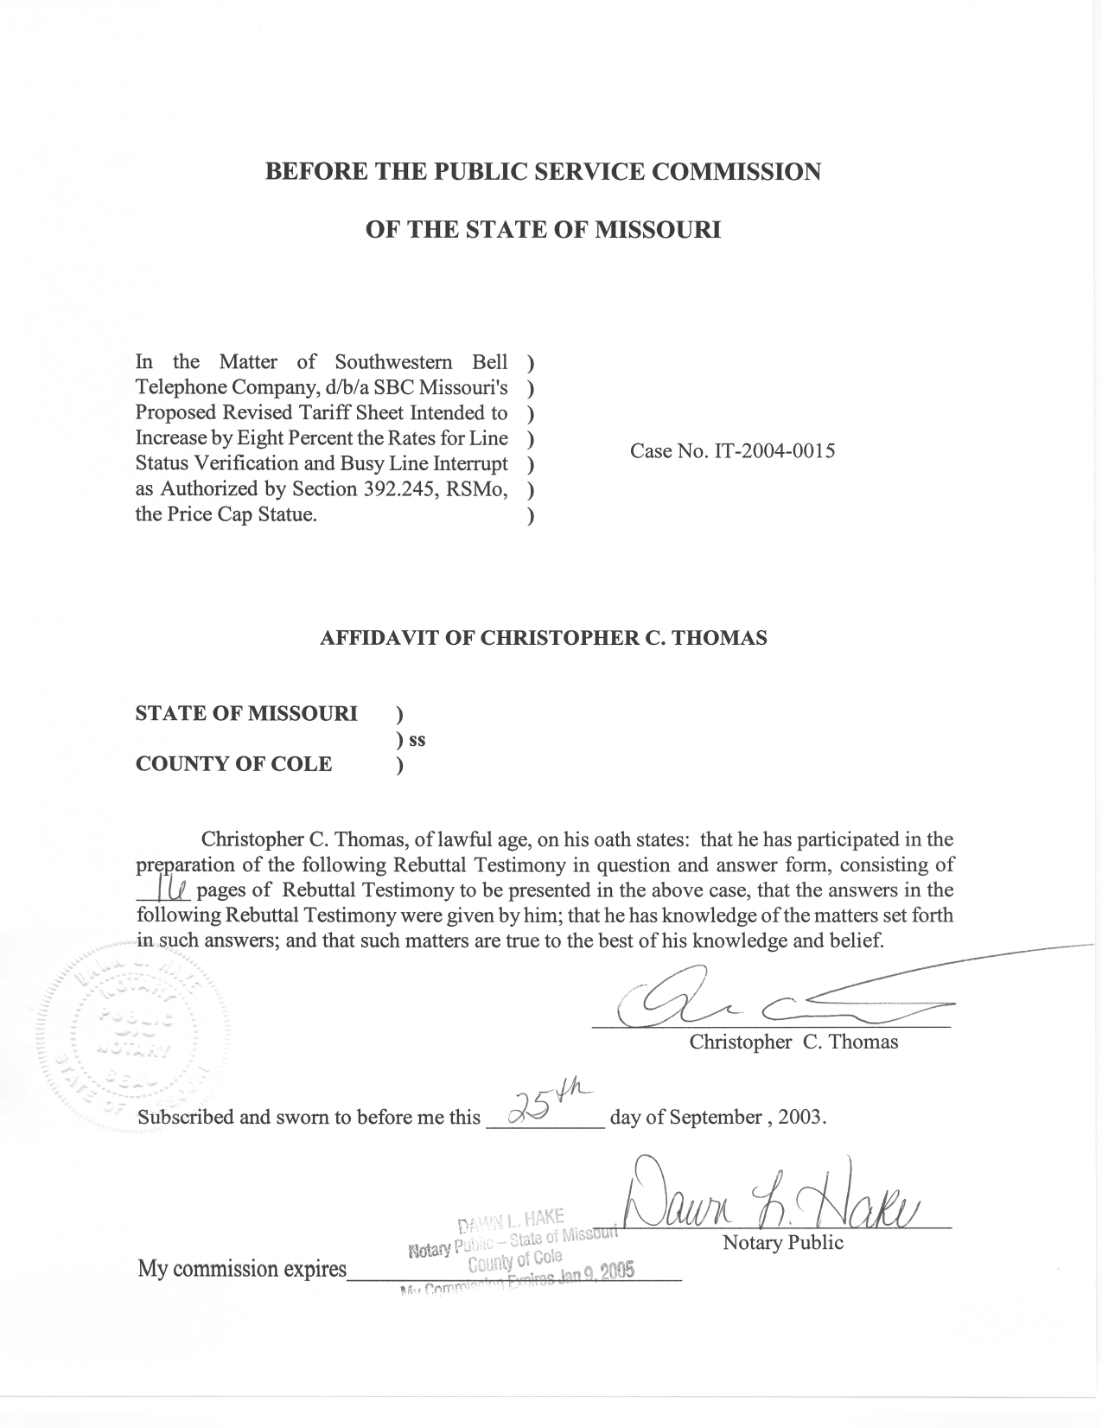
TABLE OF CONTENTS

Purpose 2
General Economic Conditions 4
Legacy Rate Setting and Price Cap Impacts 11
Price Cap Adjustments in Other States 14
Summary of the presented information 14
Recommendation 15

REBUTTAL TESTIMONY
OF
CHRISTOPHER C. THOMAS
CASE NO. IT-2004-0015

Q. Please state your name, employer, and business address.
A. My name is Christopher C. Thomas and I am employed in the Telecommunications Department of the Missouri Public Service Commission (Commission). My business address is 200 Madison Street, Jefferson City, Missouri, 65102.
Q. Please describe your work experience.
A. I am employed as a regulatory economist in the Telecommunications Department Staff (Staff) of the Commission. The duties of my position include reviewing, analyzing, and writing recommendations for controversial or contested tariff filings and other cases. I also provide expert testimony on costing theory and economic policy issues. I have previously filed testimony before the Commission in Case Nos.
TO-98-329, TT-2000-527/513, TT-2001-298, TO-2001-439, TO-2001-455,
TA-2001-475, TO-2002-222, and TT-2002-472.
Q. Please describe your educational background.
A. I received my Bachelor’s Degree in Business Administration with a concentration in Finance from Truman State University in 1998, and subsequently received my Master’s Degree in Economics and Finance from Southern Illinois University-Edwardsville in May of 2000.

Purpose
Q. What is the purpose of your testimony?
A. The purpose of my testimony is to assist the Commission in addressing the concerns that it identified in its Order Suspending Tariff and Setting Prehearing Conference (Order Suspending Tariff). The Commission highlighted concerns with an 8% increase in the prices of non-basic services. This testimony will attempt to provide information that will enable the Commission to address these concerns. Staff Witness Bill Peters is filing Rebuttal Testimony to address the reasonableness of SBC Missouri’s (SBC’s) proposed rates for Line Status Verification (LSV) and Busy Line Interrupt (BLI) and to provide an overview of Staff’s understanding of these specific services.
Q. What is your understanding of the Commission’s concerns in this docket?
A. In its Order Suspending Tariff, the Commission stated the following:
The Commission notes that the condition of the national economy over the course of the past two years may not support an eight percent increase in rates for nonbasic telecommunications services. It is not at all clear that the legislature intended to permit annual rate increases of eight percent regardless of general economic conditions. The Price Cap Statute is complex and it has not yet been the subject of a reported decision by any Missouri appellate court. Section 392.245.11 expressly requires that rate changes for nonbasic services be "consistent" with Section 392.200. The latter statute, in turn, requires that charges for telecommunications services rendered be "just and reasonable and not more than allowed by law or by order or decision of the commission." The question is whether an eight percent increase in the rates for nonbasic telecommunications services at this time is just and reasonable.

The Commission is mindful that the legislature has provided an express statement of public policy to guide the Commission and the courts in implementing the provisions of Chapter 392, which includes the Price Cap Statute:
Section 392.185: The provisions of this chapter shall be construed to:
(1) Promote universally available and widely affordable telecommunications services;
(2) Maintain and advance the efficiency and availability of telecommunications services;
(3) Promote diversity in the supply of telecommunications services and products throughout the state of Missouri;
(4) Ensure that customers pay only reasonable charges for telecommunications service;
(5) Permit flexible regulation of competitive telecommunications companies and competitive telecommunications services;
(6) Allow full and fair competition to function as a substitute for regulation when consistent with the protection of ratepayers and otherwise consistent with the public interest;
(7) Promote parity of urban and rural telecommunications services;
(8) Promote economic, educational, health care and cultural enhancements; and
(9) Protect consumer privacy.
Rate increases of eight percent under the current economic conditions would appear to violate Section 392.185(4) because affected customers might pay unreasonable charges for telecommunications services. Likewise, services subject to inappropriate rate increases cannot be said to be "widely affordable." Section 392.185. In particular, Section 392.185(6) conditions competition between carriers as a substitute for regulation upon "the protection of ratepayers" and "the public interest." This condition is equally applicable to the Price Cap Statute.

I am not an attorney, and therefore am not addressing any of the legal implications of the price cap statute or of the setting of rates. However, it is my understanding that the Commission is concerned about the reasonableness of an 8% increase in nonbasic services, in general.
Q. How can the Commission determine if an 8% increase in nonbasic services is reasonable?
A. From a public policy perspective, there are many factors that must be considered when investigating the reasonableness of any proposed price increases. The Commission specifically asked whether an 8% increase is reasonable at this time, under current economic conditions. Although general economic conditions are certainly one factor that must be considered, Staff believes that the nature of the price cap statute and the rate structures of services offered by SBC could also be important factors, depending upon the scope of the Commission’s authority. In examining the reasonableness of a particular price increase it is important to evaluate the reasonableness standard from the perspective of the producer, SBC, and that of consumers in order to effectively balance the needs of every affected party. In addressing this issue I will provide information concerning: general economic conditions over the past two years (as well as for longer periods of time) by examining changes in the prices that consumers pay and cost changes experienced by firms, the impact of price cap regulation on SBC’s ability to raise its rates, and a brief overview of price cap regulation in other states.

General Economic Conditions
Q. When investigating the reasonableness of price increases, what do you consider to be the most relevant economic indicators?
A. In my opinion the Commission needs to understand changing economic conditions faced by both consumers and producers. There are many different indicators that could be considered. However the most accessible and recognizable are several of the indices published by the Bureau of Labor Statistics (BLS) (www.bls.gov) and the Bureau of Economic Analysis (BEA) (www.bea.doc.gov). These indices will enable the Commission to examine both changes experienced in consumer prices and the changing cost structure of firms in the marketplace.
Q. How can the Commission examine price changes experienced by consumers?
A. The Missouri price cap statute, Section 392.245.4 (1) RSMo 2000, references two measures of price change, the Consumer Price Index (CPI), specifically the CPI Telephone Services (CPI-TS), and the Gross Domestic Product Price Index (GDP-PI). The CPI is perhaps the most well-known and comprehensive indicator of consumer price changes in the overall economy, as well as in specific sectors and industries. The CPI is essentially a measure of the average change over time in price paid by urban consumers for a market basket of consumer goods and services. The market basket is compiled by examining the spending habits of a sample of urban consumers. The CPI measures economy wide price changes, while the CPI-TS and the CPI Local Service Charges (CPI-LS) specifically address price changes for telephone services, in general, and local service respectively. The GDP-PI is another measure of price changes and is published by the BEA. The GDP-PI is essentially a price index based on the market value of goods and services produced by labor and property in the United States. The following table indicates the annual rates of change for the CPI, CPI-TS, CPI-LS, and the GDP-PI over both a two year time period and for the longer period indicated. Supporting data is found in Schedule 1.

Series | Last 2 years (average) | Average Yearly Change | Data (approximate)
CPI | 1.73% | 2.74% | 10 years
CPI - TS | -0.72% | -0.34% | 6 years
CPI - LS | 4.17% | 2.73% | 10 years
GDP-PI | 1.76% | 1.77% | 10 years

Q. How can the Commission examine the reasonableness of a particular price increase from the perspective of industry firms’ changing cost structures?
A. Firms can increase prices for many different reasons; however, for the Commission’s purposes Staff believes that increases in cost are the most relevant. In general, firms could raise prices just to reduce consumer welfare, or the amount consumers are willing to pay above the current price, and to increase profit margins. However in the presence of competition this sort of behavior is not rational and the most likely price increases will directly result from increasing costs. Economic theory dictates that competitive forces will drive rates close to cost. Since the Commission has been directed, pursuant to 392.185, to allow competition to substitute for regulation Staff believes that it is reasonable to examine increasing prices in the context of a firm’s changing cost structure.
Q. What should the Commission consider when examining cost changes a firm experiences?
A. There are several factors to consider when examining cost changes that a firm may experience. The Producer Price Index (PPI) measures changes in the price that producers receive from whomever first purchases their products, and are a good proxy for wholesale price changes in the overall economy and in specific markets. The PPI measure these changes on an economy-wide basis, while the PPI – Telephone Communications, except radiotelephone (PPI-Telephone); PPI - Local Service, except private lines (PPI-LS); PPI – Private Lines (PPI-PL); and PPI Other Telephone Services (PPI-Other Telephone) measure changes for specific groups of services. The following table indicates the annual rates of change for the PPI-Telephone, PPI-LS, PPI-PL, and PPI-Other over both a two year time period and for the longer period indicated. Supporting data is found in Schedule two.
Series | Last 2 years (average) | Average Annual Change | Data (approximate)
PPI - Telephone | -2.98% | -1.68% | 8 years
PPI - LS | 0.65% | 0.50% | 8 years
PPI - PL | 0.43% | 0.15% | 8 years
PPI - Other Telephone | 0.24% | 0.23% | 8 years

Q. Are there other measures of changing cost structures that could be examined?
A. Yes, in addition to the PPI we can also examine individual inputs, specifically labor and capital, that firms use. We can examine changing labor rates using BLS statistics and cost of capital, or the return a firm requires in order to ensure access to capital, using a proxy for SBC’s capital cost.
- How can we examine changing labor costs?
A. One method for examining changing labor costs is to examine BLS data from the Employment Cost Index (ECI). The ECI measures quarterly changes in employment costs, including wages and salaries and the employer cost for employee benefits. The most relevant granular data available is from the communications industry as a whole, including wireless, and is indexed much like the CPI and PPI. While these changes are important, increasing employment costs don’t tell the entire story. Staff believes that any analysis of the impact of employment costs on a firm should also consider productivity changes.
- What is productivity, and how can we measure it?
A. Productivity is the rate at which goods and services are produced, generally described in output per hour. As technology advances, and management finds more efficient ways to utilize their existing human capital, firms are able to increase the amount of output per hour of labor input. As a result, firms are more productive with the same amount of employee hours. The BLS measures output per hour of labor for different sectors of the US economy. The relevant sector for our analysis is the non-farm business analysis done by the BLS. It is vital to note that this index covers a wide range of activities that occur in the general economy, as non-farm businesses perform a variety functions. Staff would also note that the FCC has previously examined a telecommunications specific productivity growth, the X-factor, and has concluded that it outpaces the growth measured in the non-farm business sector (Sixth Report and Order IN CC Docket Nos. 96-262 and 94-1, FCC 00-193, See: Footnote 286). The following table summarizes the changes in labor costs, productivity gains, and the net effect of rising costs and productivity gains on a firm’s bottom line over both a two year time period and for the longer period indicated. Supporting data is found in Schedule 3.
Series | Last 2 years (average) | Average Annual Change | Data (approximate)
Employee Compensation (ECI) | 3.97% | 4.82% | 10 years
Productivity
BLS NonFarm Businesses (NFB) | 4.20% | 2.68% | 10 years
Compensation Net Productivity
ECI - NFB | -0.23% | 2.14%
The net effect of simultaneously rising labor costs and productivity growth has actually decreased employment costs during the past two years. This is an effect the Commission has examined before. In both Case No. TO-97-40, In the Matter of AT&T Communications of the Southwest, Inc.’s Petition for Arbitration Pursuant to Section 252(b) of the Telecommunications Act of 1996 to Establish an Interconnection Agreement with Southwestern Bell Telephone Company (Attachment C to Report and Order, pages 117-119) and Case No. TO-2001-438, In the Matter of the Determination of Prices, Terms, and Conditions of Certain Unbundled Network Elements (Report and Order, Issue Number 64) the Commission determined that the net effect of employment cost inflation and productivity growth would essentially cancel each other out and did not allow SBC to include explicit inflation factors to account for rising employment costs.
Q. You mentioned cost of capital. What is a firm’s cost of capital, and how can we examine changes in it?
A. Cost of capital is simply the return that a firm must receive on its invested capital in order to satisfy investors. Firms must utilize capital in such a way that capital markets will continue to find the firm attractive. Essentially, a firm’s cost of capital is calculated in such a way as to account for the investor’s alternative uses of the capital the firm requires to maintain and grow its business. If a firm is unable to generate a sufficient return then investors could better utilize their capital in other alternative uses.
There are many different ways to calculate a firm’s cost of capital. In order to keep this proceeding as simple as possible, Staff has determined that it is reasonable to examine changes in the cost of capital that SBC has proposed in prior cases. The primary assumption is that SBC was in the best position to determine the return that its investors expect to receive at the time the Commission issued its decisions in those cases. Staff is not taking a position on the cost of capital previously proposed by SBC; it is just using SBC’s proposals for ease of discussion. Although SBC might be in the best position to know the return that investors demand from its entire business, there are many public policy goals that must be considered when setting a firm’s cost of capital in both rate of return and arbitration proceedings under the federal Telecommunications Act. Staff is only analyzing the changes in what SBC has proposed in order to approximate how capital costs have changed over time from the company’s perspective.
The following table summarizes the costs of capital that SBC has proposed in prior Commission cases, and the yearly rate of change over the relevant time period.

 | Cost of Capital | Date of Commission Order
SBC Proposed in Case No. TO-97-40 | 10.69% | 20-Aug-97
SBC Proposed in TO-2001-438 | 12.19% | 16-Aug-02
Average annual change over the 5 year period
2.81%

Q. Can you draw any conclusions about the reasonableness of an 8% price increase from the data that you have examined in relation to changing economic conditions?
A. It is difficult to draw any firm conclusions with respect to the 8% increase for specific services by examining the data I have provided without first understanding the Commission’s authority to address the rates of price cap companies. The Commission has asked the parties to address if it has authority to investigate rates. The Commission must also determine its ability to examine rates, i.e. whether it can examine each rate individually or if it must examine the impact of each price increase on SBC’s profitability. If the Commission believes that is has the authority to examine SBC’s rates for each service individually, then it appears as though an 8% increase exceeds every measure of changing prices and or costs that I have examined. Staff would be hard pressed to support an 8% increase in the prices of non-basic services under such conditions. However, if the Commission finds that it must investigate the impact that an 8% increase has on SBC’s overall profitability then the Commission must examine the impact that legacy rate setting, and price cap regulation have had on SBC’s bottom line.

Legacy Rate Setting and Price Cap Impacts
Q. What do you mean by legacy rate setting?
A. Mr. Unruh describes on pages 4 and 5 of his Direct Testimony how rates were set prior to the application of the price cap statute. Essentially, Staff concurs with Mr. Unruh’s assessment of how SBC’s rates were set prior to the effective date of SBC’s price cap status pursuant to the methodology established in Case No. 18,309. Rates for basic local service were set residually, meaning that after pricing all other company services, basic local service rates were set to recover the remainder of SBC’s revenue requirement. Staff has not seen a cost study produced to determine the cost of all of the services that the company provides. However, the application of the principles established in Case No. 18,309 have the effect of removing the relationship between rates and their cost. In addition, this methodology has resulted in services that are priced well above their cost. In the Report and Order in Case No. 18,309 the Commission stated:
(5) “Excess monopoly profits” is a term used by the Office of Public Counsel in its cross-examination of Dr. Alessic. By that term the Office of public Counsel means the difference between the price set where marginal cost equals marginal revenue and the price located on the demand curve above the intersection of the marginal revenue curve and the marginal cost curve. The Commission is certain that some services presently provided by the Company are priced at such levels at the present time. The extent of that pricing is not known. However, using the Company’s proposal will at least quantify the existence of such a situation and the Commission will be in a position to react if it so desires. The Commission finds no inherent evil in pricing certain services in this manner, if it is socially and economically desirable to do so and the composite of the resulting rates is fair, reasonable and not unduly discriminatory.

Essentially, the Commission allowed some services to be priced well above their cost, while others were potentially priced below cost in order to maintain universal service.
Q. Is residual pricing something the Commission could consider when examining the reasonableness of a proposed rate increase?
A. Yes, it is. Theoretically, as a market becomes more competitive, rates should be driven closer to cost. The effect of an 8% increase in non-basic service rates can potentially drive rates, already priced above their cost, further above cost. While the policy determined in Case No. 18,309 was reasonable under a regulated monopoly environment, in some cases it could be an obstacle to effectively substituting competition for regulation. Theoretically, if basic local service is priced below its cost and supported through all of the other services the company offers, then it is difficult for competitors, both for the same service and for substitutable services, to match the below-cost rates. In addition, the lack of a relationship between rates and the underlying cost of providing a specific service makes it much more difficult to determine if a proposed price increase is reasonable given current changes in economic conditions. Some services may not cover their cost and the company would have to rely on the sum total of all of its revenues to cover its costs.
Q. Are there any other aspects of the price cap statute that are relevant to this discussion?
A. Staff believes that since there is potentially no relationship between rates and the cost of providing each particular service the Commission might find it necessary to consider the impact that each increase has on the company’s bottom line. The price cap statute has several provisions that could be important in this respect. These provisions were described in the Direct Testimony of SBC witness Craig Unruh. I agree with Mr. Unruh that SBC was found to be subject to price cap regulation by the Commission on September 16, 1997 in Case No. TO-97-397. Mr. Unruh is also correct in his assertion that SBC Missouri’s initial maximum allowable rates were those in effect on December 31, 1996. It is also my understanding that for exchange access and basic local service, the maximum allowable prices were frozen until January 1, 2000, while non-basic services were frozen until January 1, 1999. Essentially, price cap regulation required that SBC’s exchange access and basic local rates be frozen for a period of three years, while the rates for non-basic services were frozen for a period of two years. If the Commission determines that it must concern itself with SBC’s overall profitability, then the fact that SBC’s rates have been frozen makes it difficult to accurately analyze SBC’s profitability in any sort of historical context, and necessitates an examination on a prospective basis only.

Price Cap Adjustments in Other States
Q. Has Staff gathered information considering price cap adjustments for non-basic type services in other states?
A. Yes. Attached, as Schedule 4 to my testimony is a summary of regulatory adjustment allowed gathered from the State Telephone Regulation Report as updated through May and June 2003. An examination of this schedule demonstrates wide variance in different states’ price cap statutes. A few examples:
- Nebraska - rates are not reviewed; the PSC can roll back excessive residential local rate increases in exchanges without competition upon petition by effected ratepayers.
- Arkansas - basic exchange service and switched access are capped and are allowed to increase by 75% of the GDP-PI while the rates for all other services are deregulated.
- Nevada – Basic services are capped where rate cuts are allowed, but not increases. Other services can be priced at any point above the price floor.
- Ohio - Basic service rates are capped; Rates for certain vertical services and specialty business services are frozen until 2004, will be deregulated. All other retail rates deregulated.

Summary of the presented information
- Please summarize the information you have presented.
A. If the Commission determines that it has the authority to examine each rate individually then:
  - An 8% increase is greater than several commonly accepted indicators of changing prices and costs and Staff would find it difficult to justify such increases.
If the Commission determines that it must examine SBC’s profitability as a whole when examining individual rate increases then it should be aware that:
  - Residual rate setting pursuant to Case No. 18,309 has made it difficult to infer any relationship between specific rates a firm charges and the cost of providing the specific service;
  - The fact that price cap regulation required SBC’s exchange access and basic local rates be frozen for a period of 3 years and the rates for non-basic services be frozen for a period of two years needs to be considered in examining proposed rate increases.
Additionally:
  - Price Cap laws in other states vary widely across the board, as demonstrated in Schedule 4.

Recommendation
Q. Can you make any specific recommendations to the Commission concerning an 8% increase at this time?
A. Unfortunately, I cannot. Staff believes that the Commission has two important decisions to make in the case. First it must determine that it has authority to examine the nonbasic rate increases proposed by price cap carriers. This is a legal determination.
If the Commission determines that it does not have this authority, then it has no choice but to approve the rates.
If the Commission determines that it has the authority to examine the proposed increases then it must also determine if it has the authority to examine each rate increase individually or if it must examine the overall profitability of price cap carriers in determining that a proposed rate increase in unreasonable.
If the Commission determines (1) that it does have the authority to examine the proposed non-basic rate increases of Price Cap Carriers and (2) that it can examine each rate individually, then Staff has presented information suggesting that an 8% increase in rates for non-basic services is a very generous increase given current economic conditions.
Alternatively, if the Commission determines (1) that it has the authority to examine proposed rate increases of Price Cap Carriers and (2) that it must examine their profitability as a result of each specific increase, the Commission would need to gather more information. The Commission would need to review SBC’s cost structure and the revenue it receive from all of its services as a whole. The Commission would also need to determine what it considers to be a normal profit and further would need to decide if SBC is earning this normal profit, and if an 8% increase in each non-basic services would cause the company to earn more than this normal-profit. Staff would note that there is no well-defined procedure for dealing with this sort of investigation.
Q. Does this conclude your rebuttal testimony?
A. Yes, it does.

Section 392.185.

