Exhibit No.:

Issues: Price Discrimination

Witness: Christopher C. Thomas
Sponsoring Party: MO PSC Staff
Type of Exhibit: Rebuttal Testimony
Case No.: TT-2002-472
Date Testimony Prepared: July 26, 2002

MISSOURI PUBLIC SERVICE COMMISSION

Utility Operations DIVISION

Rebuttal TESTIMONY

OF

CHRISTOPHER C. THOMAS

SOUTHWESTERN BELL TELEPHONE COMPANY

CASE NO. TT-2002-472

Jefferson City, Missouri

July 26, 2002

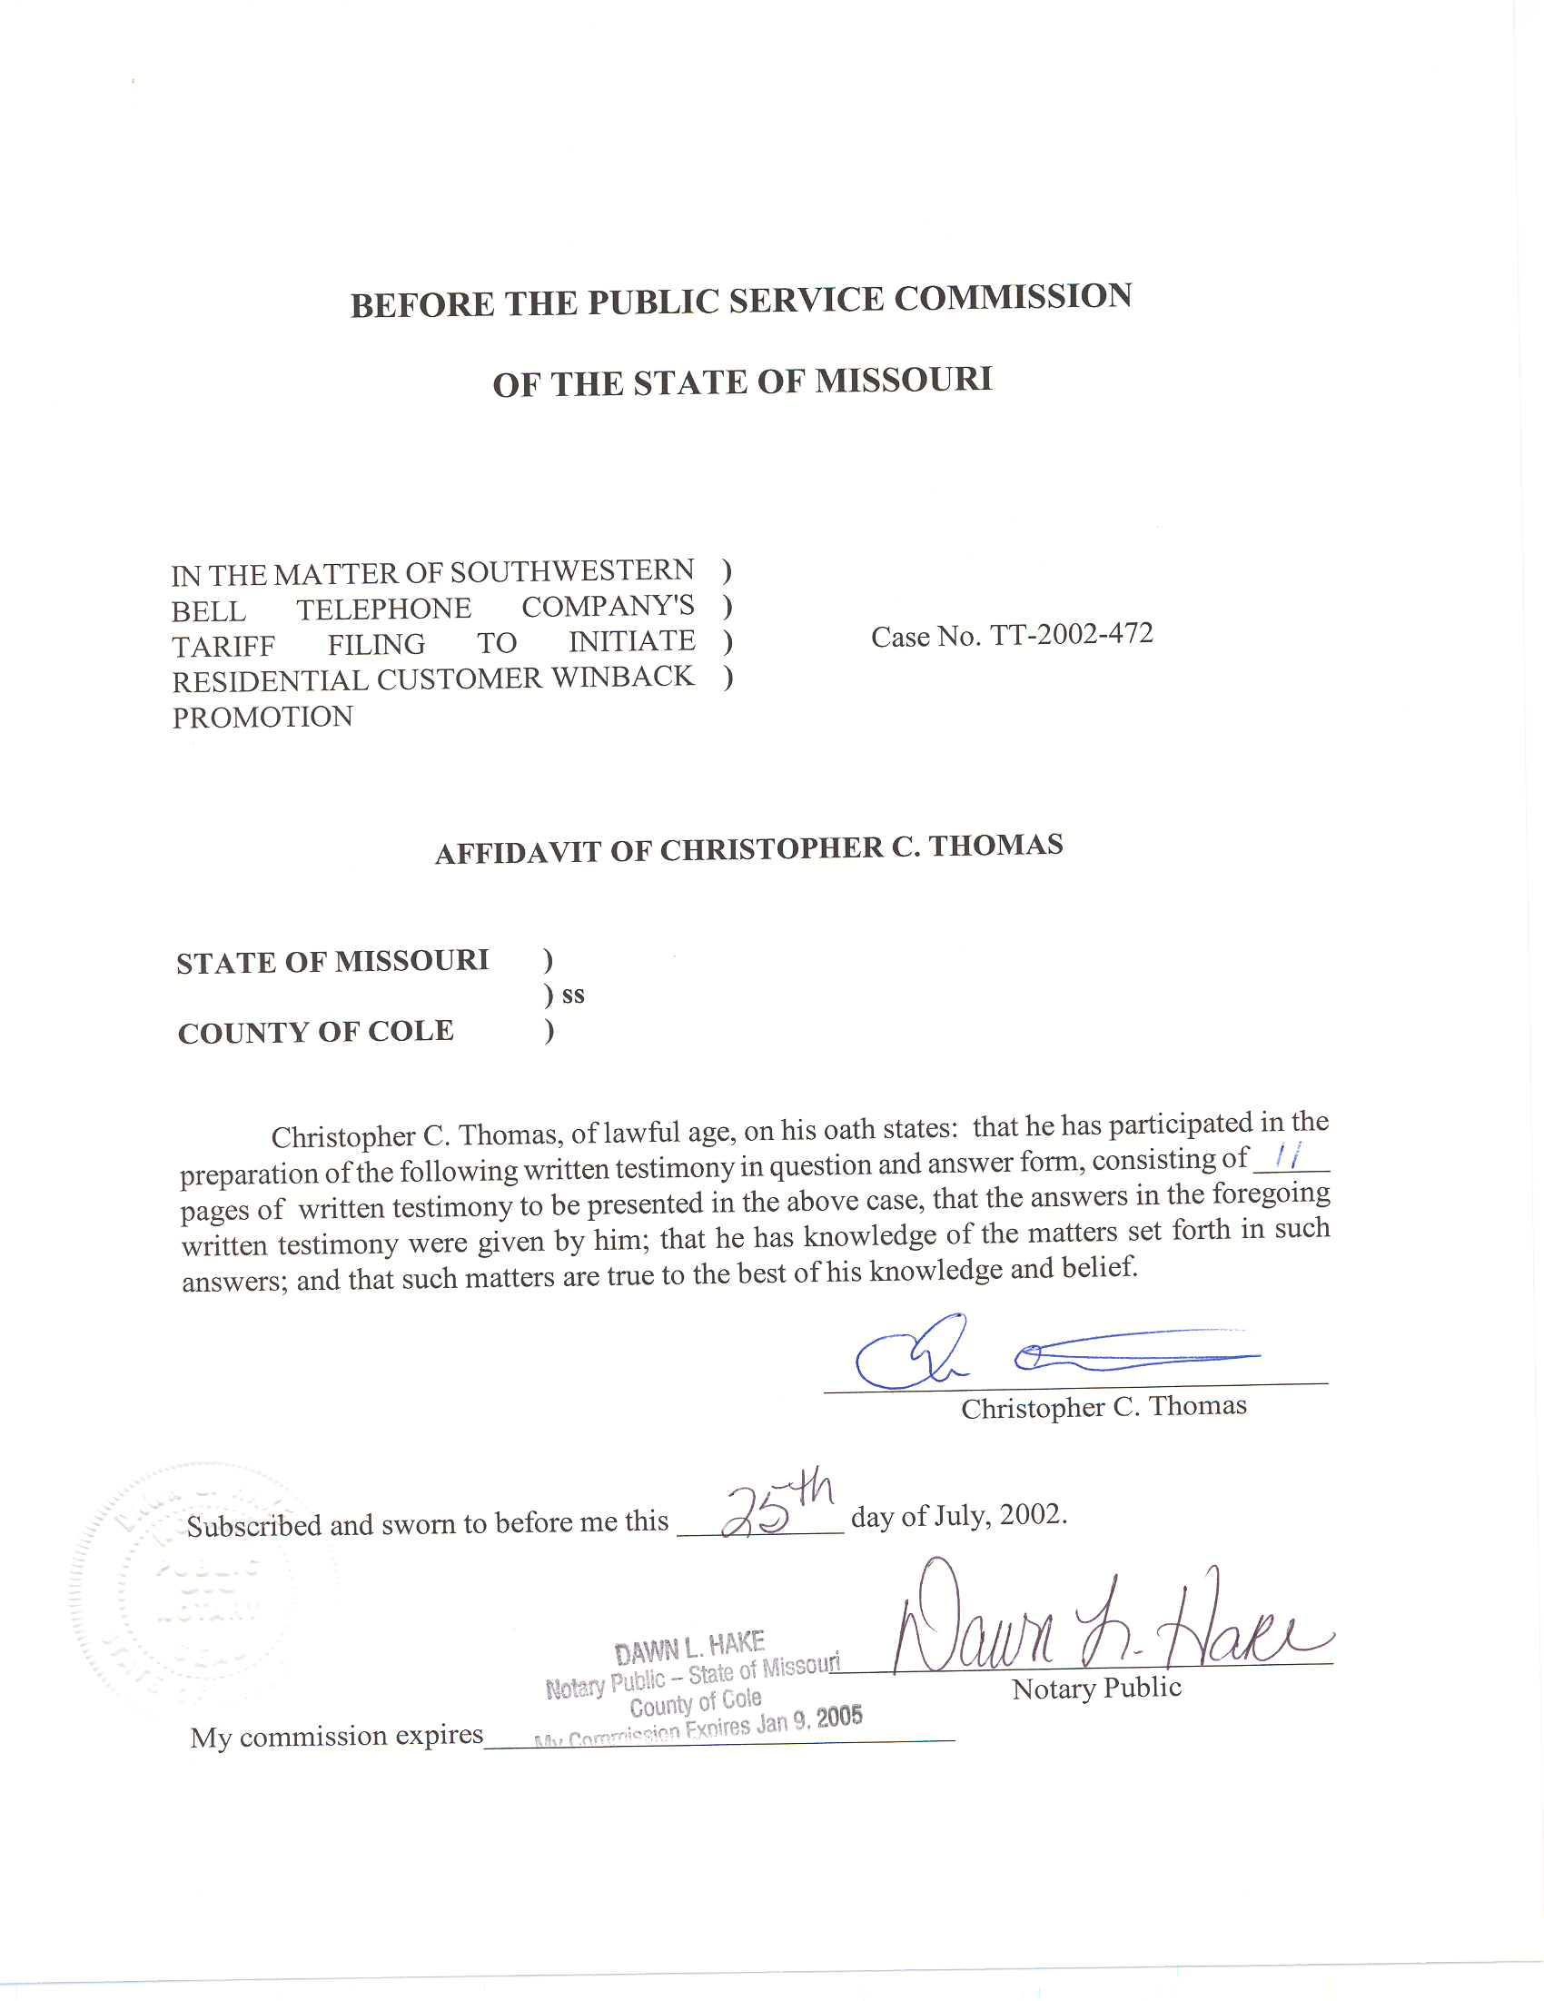
TABLE OF CONTENTS

Past Commission Decisions 2
Additional Concerns 5
Price Sensitivity 7
Cost Basis 8
Credit Restrictions 10
Summary 10

REBUTTAL TESTIMONY
OF
CHRISTOPHER C. THOMAS
CASE NO. TT-2002-472 et. al.

Q. Please state your name, employer, and business address.
A. My name is Christopher C. Thomas and I am employed in the Telecommunications Department of the Missouri Public Service Commission (Commission). My business address is 200 Madison Street, Jefferson City, Missouri, 65102.
Q. Please describe your work experience.
A. I am employed as a regulatory economist in the Telecommunications Department Staff (Staff) of the Commission. The duties of my position include reviewing, analyzing, and writing recommendations for controversial or contested tariff filings and other cases. I also provide expert testimony on costing theory and economic policy issues. I have previously filed testimony before the Commission in Case Nos.
TO-98-329, TT-2000-527/513, TT-2001-298, TO-2001-439, TO-2001-455,
TA-2001-475, and TO-2002-222.
Q. Please describe your educational background.
A. I received my Bachelor’s Degree in Business Administration with a concentration in Finance from Truman State University in 1998, and subsequently received my Master’s Degree in Economics and Finance from Southern Illinois University-Edwardsville in May of 2000.
Q. What is the purpose of your testimony?
A. The purpose of my testimony is to respond to the Direct Testimony filed in this proceeding by Southwestern Telephone, L.P. d/b/a Southwestern Bell Telephone Company (SWBT) witnesses Thomas Hughes and John Regan, Jr., to present the Staff’s positions on Tariff File Nos. 200200828 and 200200831, and to provide testimony to assist the Commission in reaching a decision that is, in Staff’s opinion, consistent with the public interest.
Q. Please describe Tariff File Nos. 200200828 and 200200831.
A. Both filings propose to waive the nonrecurring service connection and installation charges associated with various services for customers who have left SWBT and now wish to return. Tariff File No. 200200828 proposes to extend a waiver of the installation charges for business access lines, DigiLine® Service, SmartTrunk service and SuperTrunk service. Tariff File No. 200200831 proposes to waive the Service and Equipment Charge on residential lines and the non-recurring charges associated with certain SWBT service packages.

Past Commission Decisions
Q. Have recent Commission Orders addressed the use of winback marketing activities by SWBT?
A. Yes, as discussed in Staff’s Motion to Suspend and Reject Tariff Filing, the Report and Order issued in Case No. TT-2002-108, In the Matter of Southwestern Bell Telephone Company’s Tariff Filing to Initiate a Business MCA Promotion, stated:
Southwestern Bell’s save and winback provisions would have much the same impact on the health of competition in the local service market as would term agreements. But, in addition to the anticompetitive effects resulting from the use of term agreements by a dominant ILEC, save and winback provisions can cause further damage to the emerging competitive market. Such provisions are targeted directly at the customer base of the CLECs [competitive local exchange carriers]… Until the CLECs are in a strong enough position to effectively compete with Southwestern Bell, the use of save and winback provisions by Southwestern Bell is anticompetitive.

I must note here, as SWBT indicates in its Response to Staff’s Motion to Suspend and Reject Tariff Filing, it could be interpreted that a majority of the Commission has not addressed the contested issues in the instant proceeding. Nonetheless, the Staff believes that the Findings of Fact in Commission’s Order accurately characterizes the use of winback marketing activities by SWBT.
Q. Throughout the hearing in Case No. TT-2002-227, In the Matter of Southwestern Bell Telephone Company’s Proposed Revisions to PSC Mo. No. 26, Long Distance Message Telecommunications Service Tariff, there was uncertainty about the use of the term “anticompetitive”. Please explain in your own language the meaning of this term and your understanding of its use in Staff’s position and the above language from the Commission Order in Case No. TT-2002-108.
A. First of all, the term anticompetitive is not an accusation of anti-trust violations. Anticompetitive actions are a necessary but not sufficient condition to demonstrate anti-trust violations. In my opinion, anticompetitive is a term used to describe actions that may possibly discourage competition in a given marketplace. The Commission’s use of the term acknowledges that the local telecommunications marketplace is unique.
Q. Please describe what, in your opinion, make the local telecommunications marketplace unique.
A. Through the use of regulation, Congress is attempting to promote competition in a market that has historically been characterized by very substantial upfront capital investment in facilities and has been controlled by protected monopoly providers, who possess very large economies of scale. The Commission has realized this unique situation and has recognized that the market positions of competitors in the marketplace are drastically different. As Staff has previously posited, the incumbent, SWBT, is in a position to threaten the existence of competitors within its exchanges, while those competitors are not yet in a similar position. As an example, the Federal Communications Commission (FCC) has recently initiated its Triennial Unbundled Network Element (UNE) Review Docket that could potentially result in the removal of incumbent unbundling obligations, resulting in increased regulatory uncertainty for many competitive companies. This is largely due to the fact that many carriers have relied on the use of UNEs and resale in order to enter the marketplace.
Q. Mr. Regan demonstrates that through the first five months of 2002 SWBT’s retail lines have decrease by 2.1% (Regan Direct, pg. 5 lines 12-14). In Staff’s opinion, does this line loss substantially change SWBT’s position in local markets?
A. It does not. Mr. Regan does demonstrate that SWBT continues to lose market share to competitors. While this is evidence that competition is moving forward, it is not an indication of a significant change in the relative market position of players in the marketplace, as Mr. Hughes notes that CLECs serve a minimum of 12% of the market (Hughes Direct, pg. 7 lines 14-15). As the Commission found in TT-2001-108 (Report and Order, pg. 8), SWBT is in a different position in the local marketplace and needs to be subject to more stringent regulatory oversight if effective competition is to survive and prosper.

Additional Concerns
Q. Mr. Regan states, “[t]he fact that SWBT is providing such promotions demonstrates competition is working” (Regan Direct pg. 9 lines 20-21). Do you agree with his conclusion?
A. I do not. The fact that SWBT is providing such promotions only indicates that SWBT is concerned about its loss of revenue and market share. The Commission should not confuse functioning competition with loss of market share. If the Commission’s goal is to substitute competition for regulation, wherever possible, it is important to note that loss of market share and functioning competition are two very different concepts. SWBT can lose market share to CLECs without competition serving as effective price control. Many CLECs rely primarily on the use of UNEs and resale to provide service and SWBT’s obligations to provide such elements could be removed at any point. As Staff has indicated in previous cases on this issue, local markets are not yet at a point where competition can successfully substitute for regulation.
Q. If the Commission determined that local markets were at a point where competition could successfully substitute for regulation would Staff have any additional concerns with the instant filings?
A. Yes. Staff believes that even if the relative market positions of all competitors were the same, and competition was functioning effectively, there would still be issues with the proposed tariff filings. In Staff’s opinion, SWBT has not demonstrated that the proposed tariff filings are in the public interest.
Q. You state that Staff does not believe that SWBT has demonstrated that the proposed tariff filings are in the public interest. Please elaborate.
A. The Commission has laid out the legal standard in both its Report and Order in Case No. TT-2002-108 (Report and Order, pg. 11) and its Report and Order in Case No. TT-2002-227 (Report and Order, pg. 18). In those Orders the Commission stated that:
This statute [392.200.3, RSMo 2000] has been interpreted to “forbid discrimination in charges for doing a like or contemporaneous service with respect to communications by telephone under the same or substantially the same circumstances or conditions.” [State ex rel. DePaul Hospital v. PSC, 464 S.W.2d 737, 738 (Mo. App. 1970)] Rate differences are permitted only if there is any “reasonable and fair difference in condition which equitably and logically justifies a different rate. [Id. at 740]

In the Direct Testimony filed in this proceeding, both SWBT witnesses, Hughes (pg. 2 lines 27-28) and Regan (pg. 2 lines 6 and 23), refer to their beliefs that the proposed promotions are offered to all similarly situated customers. Staff is not convinced that there is a reasonable and fair difference in condition which equitable and logically justifies different rates, or non-recurring charges (NRC) waivers, as proposed in the tariff filings at issue. Neither witness provided any justification to help the Commission determine if there is a reasonable and fair difference that justifies different rates. Essentially SWBT has provided no testimony to demonstrate that there is a reasonable and fair difference between customers returning to SWBT from a CLEC and customers who are new to SWBT.
Q. Absent such a demonstration, do the instant filings segment local markets in a way that is contrary to the stated goals the of the Missouri legislature?
A. Yes, they do. SWBT’s desire to offer these promotions to customers is certainly comprehensible, as the company has lost market share to competitors. Mr. Regan demonstrates this in his testimony (Regan Direct, pg. 5 lines 11-18). SWBT’s management is responsible for the company’s profitability and their natural reaction is to respond to the loss of revenue and market share. However, as recognized by the Missouri Legislature in 392.200.4 (2), the intent of the Missouri telecommunications act, often referred to as SB507, is to bring the benefit of competition to all customers. Staff does not believe that allowing SWBT, or any other local exchange carrier (LEC), to segment the market based upon criteria such as price sensitivity is consistent with the goals set forth by the legislature.

Price Sensitivity
- What do you mean when you refer to price sensitivity?
A. Customers who have left SWBT for services provided by a CLEC have presumably done so out of a desire to lower their telecommunications expenditures. Many others, at most 88% of SWBT’s customers as of April 2002 (based upon data presented in Hughes Direct, pg. 7 lines 14-15), have not left SWBT due to factors such as their perceptions of either search costs or risk. In this sense, price sensitivity refers to only those customers whose desire to switch outweighs their perceptions of search costs or risk. It is possible that customers in other SWBT exchanges, or customer classes, may be just as sensitive to price changes but without similar alternatives, or choices. SWBT’s tariff filings target only those customers, whose price sensitivity has led them to actively engage in searching for better offers, which is virtually the entire pool of CLEC customers.
Q. From a policy perspective, why is it problematic to allow LECs to segment the market based upon criteria such as price sensitivity?
A. As a matter of policy, in Staff’s view, market segmentation based upon criteria such as price sensitivity does not promote the goal of bringing the benefits of competition to all customers in Missouri. Essentially SWBT is attempting to segment its customers based upon their willingness to pay, which is typically viewed as monopolistic price discrimination. Traditionally this behavior has been thwarted out of concerns for universally available and affordable telecommunications services within each customer class. These same concerns are still at the forefront of telecommunications regulation and present unique challenges to the implementation of local exchange competition. To allow price discrimination without cost justification would run contrary to the legislative goals of universal service and of bringing the benefits of competition to every Missouri citizen. Absent a demonstrated cost basis, Staff believes the LECs should be required to make their service offerings and promotions available to all customers that they serve.

Cost Basis
Q. Why would Staff consider cost justification to be a valid basis for allowing companies to price discriminate?
A. The tariff filings at issue in this proceeding propose to waive the non-recurring service connection and installation charges for creditworthy customers. It is not difficult to imagine a scenario where the removal of NRC associated with installation could help to promote a fluid marketplace. However, the traditional goal of regulation has been to maximize social welfare, by carefully and equally balancing the needs of all consumers with the needs of producers. Although the methods have changed, the goal remains. The Commission’s continuing responsibility is to maintain and advance the efficiency and availability of telecommunications services while ensuring that customers pay only reasonable charges for telecommunications service. Legacywise, customers have been grouped into customer classes by residence or business and by exchange. In moving towards competition, the Commission must be vigilant in ensuring that any further segmentation, or discrimination, is done in a just and reasonable manner, e.g. cost. In a competitive market, prices will be driven towards cost, as price is essentially set at average total cost, or marginal cost, in the long run model of a perfectly competitive market. It is clear to see that as prices are driven to cost there will be a definitive relationship between rates and costs. Thus there is a reasonable and fair basis for price discrimination based upon differences in cost of service among different customer classes.
Q. Has SWBT provided Staff with any cost justification to demonstrate that its proposed segmentation is reasonable and fair?
A. SWBT has made statements in response to a data request issued by Staff that indicates that there may be a difference in the company’s cost of installation and service connection between new and returning customers, e.g. SWBT may not have to perform credit checks or build facilities. Staff has also discussed this issue with other parties to this proceeding and they have indicated that SWBT’s cost of installation and service connection may actually be more for returning customers, e.g. there are questions about SWBT’s frame management policies and the use of intermediate distribution frames in the provision of UNEs to CLECs. In the absence of solid data to support the parties’ statements, Staff is unable to agree that SWBT’s costs are greater to install service to new customers.

Credit Restrictions
Q. Mr. Regan indicates that SWBT’s tariff filings are also restricted to customers who have never had: 1) service disconnected for non-payment, or 2) any past due bills for regulated service owed to the Company (Regan Direct pg. 3 lines 12-14, and pg. 4 lines 1-3). Does Staff have any concerns with these restrictions?
A. Yes, although Staff understands not offering the waivers to customers who owe money to the telephone company, it is difficult for Staff to support restrictions against customers who have had service disconnected for non-payment. As in
Case No. TO-2001-467, SWBT is quick to refer to all resale as competition, but it is clear from this tariff filing that SWBT is not actively interested in competing for customers who may have had to switch to a prepaid reseller due to financial difficulty or hardship. SWBT is still entitled to ask the customer for a deposit prior to service connection, and thus Staff believes the restriction for non-payment is not in the public interest. Essentially, customers who have been disconnected for non-payment but have settled their debt with the phone company are subject to undue discrimination.

Summary
- Please summarize your testimony for the Commission.
A. Staff recommends that the Commission reject SWBT’s proposed Tariff File Nos. 200200828 and 200200831. Staff has two basic concerns with SWBT’s proposed tariff filings: both the market position of SWBT relative to other competitors; and the public interest aspects of price discrimination in the local marketplace by any LEC. To be clear, Staff does not object to waiving NRCs in the local market. Waiving NRCs reduces transactions costs for customers and may help to promote a more fluid marketplace. However, in Staff’s view, SWBT has not yet demonstrated that Tariff File Nos. 200200828 and 200200831, and the price discrimination they propose, are in the public interest. The Staff believes that the tariff proposals filed by SWBT constitute price discrimination in local markets, and must be approached cautiously in order to ensure that the benefits of competition reach all of the citizens of Missouri.
Q. Does this complete your Rebuttal Testimony?
A. Yes, it does.

