BEFORE THE PUBLIC SERVICE COMMISSION
STATE OF MISSOURI

In the Matter of the Joint Application of )
Telrite Corporation and )
OneStar Long Distance, Inc. ) Case No. __________________
for Approval of the Acquisition of the Assets )
of OneStar Long Distance, Inc., by Telrite )
Corporation and for a Waiver )

JOINT APPLICATION

COME NOW Telrite Corporation and OneStar Long Distance, Inc. (“Joint Applicants”), by and through counsel, pursuant to Sections 392.290 and 392.300 RSMo., and 4CSR 240-2.060, and hereby jointly request Commission approval of a transaction whereby Telrite will acquire substantially all of the assets of OneStar Long Distance, Inc. (“OneStar”), including but not limited to, OneStar’s customer accounts in this state (the “Acquisition”), pursuant to an Asset Purchase Agreement dated July 12, 2004 (the "Agreement"). Joint Applicants also request a waiver of the subscriber authorization and verification requirements for the change of customers’ interexchange carrier in 4 CSR 240-33.150. Joint Applicants further request cancellation of OneStar’s Missouri certificate of service authority and tariff after consummation of the transfer of assets.
Since February 3, 2004, OneStar has been operating under the protection of the United States Bankruptcy Court for the Southern District of Indiana, Evansville Division, (the “Bankruptcy Court”). In connection with that bankruptcy proceeding, on June 30, 2004, the Bankruptcy Court conducted an auction of the OneStar assets. On July 16, 2004, the Bankruptcy Court determined that Telrite had won the auction for OneStar’s assets and issued an Order approving the sale of OneStar’s assets to Telrite.
Joint Applicants respectfully submit that the expeditious completion of the Acquisition is necessary to ensure uninterrupted service to OneStar’s customers. In particular, OneStar’s financial difficulties substantially limit its ability to compete effectively and hamper the company’s ability obtain the resources required to fulfill customer requests and continue to provide high quality services. Accordingly, to ensure that OneStar customer needs continue to be met, Joint Applicants will enter into a management agreement with OneStar whereby Telrite shall provide financial and managerial support to OneStar in order to fund the continued operations and provision of service and Telrite shall act as manager, subject to OneStar’s continuing oversight, until such time as all regulatory approvals have been obtained.
Joint Applicants emphasize that the Acquisition will not change the rates, terms and conditions under which OneStar’s customers will receive service. The Acquisition benefits OneStar customers by providing them with assurance that they will continue to receive the same high quality services previously rendered to them. In compliance with applicable law, customers of OneStar will be informed of the Acquisition and will be given the opportunity to switch their service from Telrite to a different carrier. Accordingly, approval of the Acquisition will not in any way be detrimental to the public interests of this State.
In support of this Application, Joint Applicants state the following:
I. THE PARTIES
1. Telrite Corporation is a privately held Georgia corporation with principal offices located at 1115 Church Street, Covington, Georgia 30014. Telrite provides long distance telecommunications services in this State pursuant to authority granted by this Commission in Case No. XA-2004-0197 (dated 11/18/03). Documentation from the Missouri Secretary of State was filed in Case No. XA-2004-0197, and is incorporated herein by reference pursuant to 4 CSR 240-2.060(1)(G). Telrite states that it does not have any outstanding Annual Reports or assessment fees owed to the Missouri Public Service Commission and it does not have any pending action or final unsatisfied judgments or decisions against it from any state or federal agency or court which involve customer service or customer rates, which action, judgment, or decision has occurred within three years of the date of this application.
2. OneStar is a privately held Indiana corporation with principal offices located at 7100 Eagle Crest Boulevard, Evansville, Indiana 47715. OneStar provides long distance telecommunications services in this State pursuant to authority granted by this Commission in Case No. TA-98-50 (dated 10/7/97). Documentation from the Missouri Secretary of State was filed in Case No. TA-98-50, and is incorporated herein by reference pursuant to 4 CSR 240-2.060(1)(G). OneStar states that it does not have any outstanding Annual Reports or assessment fees owed to the Missouri Public Service Commission and it does not have any pending action or final unsatisfied judgments or decisions against it from any state or federal agency or court which involve customer service or customer rates, which action, judgment, or decision has occurred within three years of the date of this application.
II. DESIGNATED CONTACTS
3. Copies of all Orders, Notices, and pleadings should be served on:
William D. Steinmeier
Mary Ann (Garr) Young
WILLIAM D. STEINMEIER, P.C.
2031 Tower Drive
P.O. Box 104595
Jefferson City, MO 65110-4595
Phone: (573) 659-8672
Fax: (573) 636-2305
Email: wds@wdspc.com
myoung0654@aol.com

With a copy of such correspondence also sent to:

EllenAnn G. Sands
Nowalsky, Bronston & Gothard
A Professional Limited Liability Company
3500 North Causeway Boulevard
Suite 1442
Metairie, Louisiana 70002
Telephone: (504) 832-1984
Telefax: (504) 831-0892

Tamar E. Finn
Douglas D. Orvis II
Swidler Berlin Shereff Friedman
3000 K St., NW, Ste. 300
Washington, DC 20007
Telephone: (202)-945-6941
Facsimile: (202)-434-7645

Telrite Corporation
Darryl Davis
1115 Church Street
Covington, GA 30014
By Fax: (678) 202-0762

OneStar Long Distance, Inc.
7100 Eagle Crest Blvd.
Evansville, IN 47715
Attn: Martin J. Huebschman
By Fax: (812) 437-7963

The Official Committee of Unsecured Creditors
Of OneStar Long Distance, Inc.
c/o Kilpatrick Stockton LLP
1100 Peachtree Street, Suite 2800
Atlanta, GA 30309-4530
Attn: Todd C. Meyers
Fax: (404) 815-6555

Mr. Steinmeier or Ms. Young should be contacted with any questions regarding this application.

III. REQUEST FOR APPROVAL OF THE ACQUISITION AND WAIVER
4. The Acquisition includes the following:
a. Telrite will receive ownership, right, title and interest in and to all of OneStar's assets, including its customer accounts, as defined in the Agreement.

b. The estate of OneStar will receive the purchase price set forth in the Agreement pursuant to the Order of the Bankruptcy Court.

5. The customers of OneStar will be given notice of the proposed transfer and the opportunity to switch their service from Motion to a different carrier. Those customers of OneStar who choose not to switch their service to a different carrier will continue to receive service pursuant to authority previously granted to OneStar by this Commission until such time as the Commission grants the instant application, at which time the customers will be serviced under Telrite’s certificate of service authority.
6. Prior to consummation of the Acquisition, Telrite intends to notify all current end-users of OneStar regarding the Acquisition and provide them the opportunity to switch their service to a substantially similar product offering of Telrite, or to choose a different carrier. The notification will be sent in the form of a bill insert, a copy of which is attached hereto as Exhibit “A”.
7. Telrite and OneStar seek waiver of 4 CSR 240-33.150, which contains subscriber authorization and verification requirements for the change of customers’ interexchange carrier. This waiver is appropriate and in the public interest because this is not the type of transfer to which the “anti-slamming” rule was intended to apply. In addition, Applicants submit that the notice to be provided to customers will reasonably and adequately advise them of both the change in their telecommunications services provider and their opportunity to choose another provider.
8. Telrite is well-qualified to consummate the transactions which are the subject of this Application. The technical, managerial and financial personnel of Telrite will, by virtue of a management agreement, assist with the transition and integration of the acquired Assets after the transaction and, along with the technical, managerial and financial personnel of OneStar, will continue to serve the transferred OneStar customers with the same high level of expertise to which they have become accustomed.
9. Because Telrite will acquire substantially all of the assets of OneStar and OneStar will thereafter cease operations in this state, OneStar will no longer require authority to provide service in this state. Joint Applicants therefore respectfully request that through this proceeding the Commission grant any authority necessary to permit OneStar to discontinue service upon consummation of the Acquisition and permit OneStar to relinquish its certification in this state, simultaneously with the effective date of the Acquisition.
IV. PUBLIC INTEREST CONSIDERATIONS
10. Critical to the Acquisition is the need to ensure the continuation of high quality, uninterrupted service to all customers currently served by OneStar. The Acquisition will serve the public interest in that it will ensure that current OneStar customers maintain uninterrupted service, notwithstanding OneStar’s financial difficulties.
11. The Acquisition will not have any impact on OneStar’s customers in terms of the services that they receive. In particular, although the Acquisition causes a change in preferred carrier for OneStar’s customers, the Acquisition will not cause any change to the rates, terms and conditions of service that OneStar’s customers receive. To the extent necessary, Telrite will incorporate such services into its tariffs by separate filing.
12. The Acquisition will also serve to create a heightened level of operating efficiency which generally will serve to enhance the overall capacity of Telrite to compete in the marketplace and to provide telecommunications services for a greater number of consumers in this state at competitive rates.
13. The transfer will have no impact on the tax revenues of any political subdivision in the state of Missouri.

V. NO TRANSFER OF CERTIFICATES
14. Applicants do not request transfer of OneStar's Certificate of Public Convenience and Necessity, or other operating authority, to Telrite. OneStar requests that its Missouri Certificate and tariffs be cancelled, upon completion of the instant transaction.

VII. CONCLUSION
WHEREFORE, for the reasons stated herein, Joint Applicants respectfully request that the Commission authorize Telrite and OneStar to consummate the Acquisition described hereinabove, approve waiver of 4 CSR 240-33.150, and cancel the certificate of service authority and tariff of OneStar Long Distance, Inc. upon notification from Telrite that the Acquisition has been consummated.
Respectfully submitted,
/s/ William D. Steinmeier
_____________________________________
William D. Steinmeier, Mo.Bar #25689
Mary Ann (Garr) Young, Mo. Bar #27951
William D. Steinmeier, P.C.
2031 Tower Drive
P.O. Box 104595
Jefferson City MO 65110-4595
Phone: 573-659-8672
Fax: 573-636-2305
Email: wds@wdspc.com
myoung0654@aol.com

DATED this 27th day of December, 2004.

Certificate of Service
I hereby certify that a copy of this document has been served electronically on the Office of the General Counsel of the Missouri Public Service Commission and the Office of Public Counsel, on this 27th day of December, 2004.

/s/ William D. Steinmeier

EXHIBIT “A”

Notice to Customers

Telrite Corporation OneStar Long Distance, Inc.

(Customer Name)
(Address)

Dear Customer:

Telrite Corporation ("Telrite") and OneStar Long Distance, Inc. ("OneStar") have entered into an Asset Purchase Agreement, whereby the telecommunications assets of OneStar will be acquired by Telrite, and Telrite will become your telecommunication service provider. Telrite anticipates becoming your telecommunications provider on or before December 30, 2004.

This change in ownership will not affect or in any way disrupt your current service. The rates and terms and conditions of the services offered by Telrite will be the same as those offered by OneStar. A copy of Telrite’s terms and conditions for long distance services is attached hereto along with your billed rate plan. No charges or fees will be imposed and no rate increase will occur as a result of this transaction. Telrite will inform you, by bill insert, of any post-transaction changes which may occur.

You have a choice of carriers. If you do not wish to remain a customer, you may change carriers and such change will be at Telrite’s expense. Telrite will make every effort to resolve outstanding OneStar customer complaints. The toll free Customer Service number will remain the same and if you have any questions, please call one of our Customer Service Representatives at 1-866-890-4135.

All customers receiving this notice, including those who have arranged preferred carrier freezes through their local service providers, will be transferred to Telrite.

We at Telrite are pleased to welcome you to our team and would like to express our appreciation for allowing us the opportunity of being your telecommunication service provider. We are confident that you will be pleased with the high quality of our service.
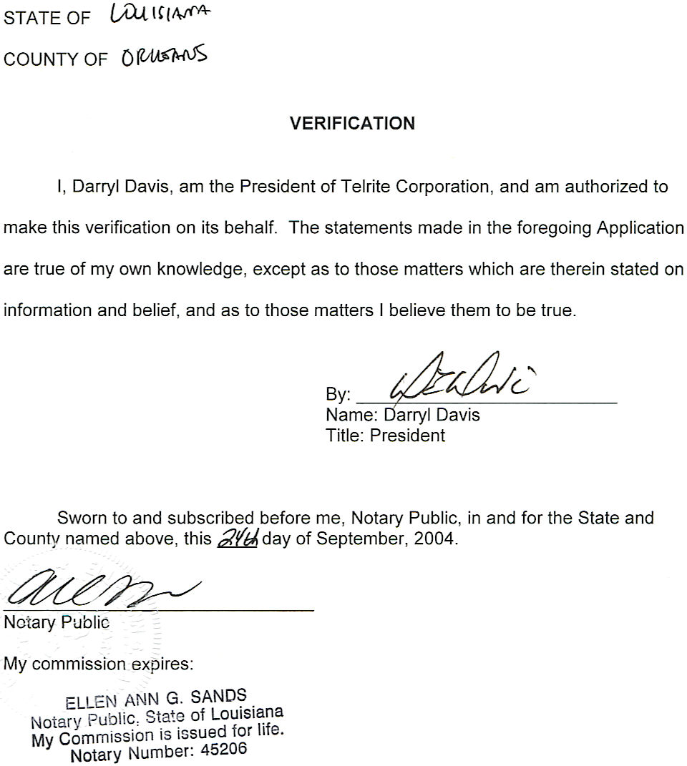
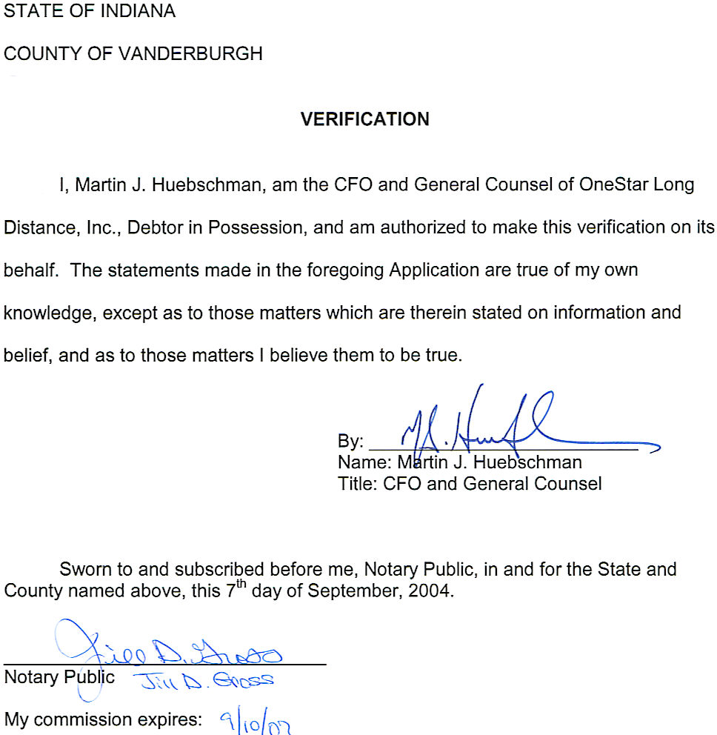

See In Re: OneStar Long Distance, Inc., Debtor, USBC So. Dist. Indiana, Evansville Division, Case No. 03-72697.
The proposed form of the customer notice is provided in Exhibit A.

