BEFORE THE PUBLIC SERVICE COMMISSION

OF THE STATE OF MISSOURI

In re the Application of John Doe ) Case No. TO-2005-xxxx
to File an Anonymous Complaint. )

NOTICE OF NEW CASE

This notice is being issued to create a case number in the Commission’s electronic filing system.
BY THE COMMISSION
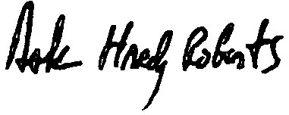

Dale Hardy Roberts
Secretary/Chief Regulatory Law Judge

( S E A L )

Dated at Jefferson City, Missouri,
on this 3rd day of February, 2005.

Roberts, Chief Regulatory Law Judge

