Diana M. Vuylsteke
Voice: 259-2543
dmvuylsteke@bryancave.com
April 8, 2004
Via electronic filing
Mr. Dale Hardy Roberts
Secretary/Chief Regulatory Law Judge
Missouri Public Service Commission
Governor Office Building
200 Madison Street
Jefferson City, Missouri 65101
Re: Case No. EE-2004-0268

Dear Mr. Roberts:
Attached for filing is River’s Edge Request for Hearing.
Thank you for your assistance in bringing this filing to the attention of the Commission, and please call me if you have any questions.

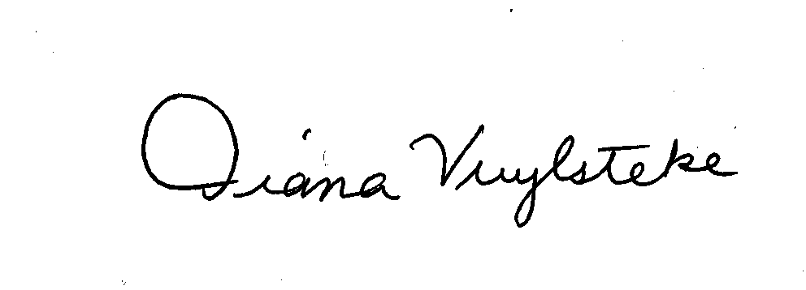
Very truly yours,
Diana M. Vuylsteke
DMV:rms

cc: All Parties

