Diana M. Vuylsteke
Voice: 259-2543
dmvuylsteke@bryancave.com
July 26, 2004
Via electronic filing
Mr. Dale Hardy Roberts
Secretary/Chief Regulatory Law Judge
Missouri Public Service Commission
Governor Office Building
200 Madison Street
Jefferson City, Missouri 65101
Re: Case No. TC-2004-0409

Dear Mr. Roberts:
Attached for filing is Officeplus’ Request for One-Week Extension of Deadline to File Brief.
Thank you for your assistance in bringing this filing to the attention of the Commission, and please call me if you have any questions.

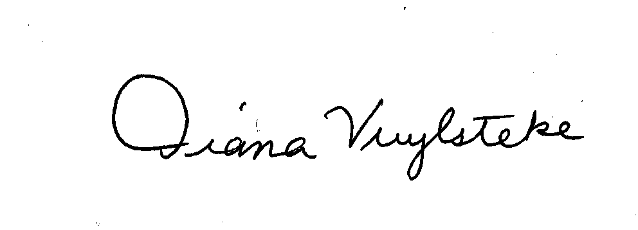
Very truly yours,
Diana M. Vuylsteke
DMV:rms

cc: Mary E. Weston by e-mail (mary.weston@psc.mo.gov)

