Case No. SA-2010-0063 Schedule DS-14

Figure 1: Monthly Sewer Rates
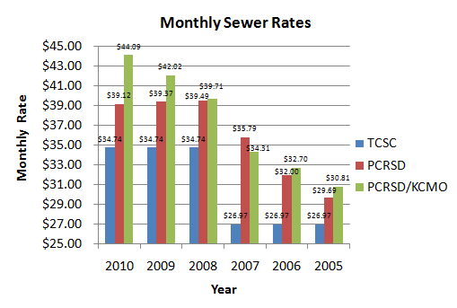
Table 1: Rate Comparison and Percentage Difference
Year | Timber Creek Monthly Rate | PCRSD Average Monthly Rate | Percentage Difference from Timber Creek | PCRSD/KCMO Average Monthly Rate | Percentage Difference from Timber Creek
2010 | $34.74 | $39.12 | 12.6% | $44.09 | 26.9%
2009 | $34.74 | $39.37 | 13.3% | $42.02 | 21.0%
2008 | $34.74 | $39.49 | 13.7% | $39.71 | 14.3%
2007 | $26.97 | $35.79 | 32.7% | $34.31 | 27.2%
2006 | $26.97 | $32.00 | 18.7% | $32.70 | 21.3%
2005 | $26.97 | $29.69 | 10.1% | $30.81 | 14.2%

