Diana M. Vuylsteke
Voice: 259-2543
dmvuylsteke@bryancave.com
November 24, 2004
Mr. Dale Hardy Roberts
Secretary/Chief Regulatory Law Judge
Missouri Public Service Commission
Governor Office Building
200 Madison Street
Jefferson City, Missouri 65101
Re: Case No. GO-2005-0119

Dear Mr. Roberts:
Attached for filing in the above-referenced case is the Application to Intervene of the Missouri Industrial Energy Consumers or “MIEC”.
Thank you for your assistance in bringing this filing to the attention of the Commission, and please call me if you have any questions.

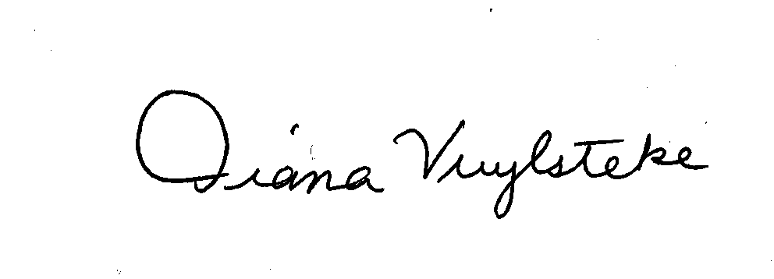
Very truly yours,
Diana M. Vuylsteke
DMV:rms

cc: All Parties

