Exhibit No.:
Issues: | Merger
Witness: | Arthur P. Kuss
Sponsoring Party: | MOPSC Staff
Type of Exhibit: | Surrebuttal Testimony
Case No.: | TM-2002-465
Date Testimony Prepared: | September 12, 2002

MISSOURI PUBLIC SERVICE COMMISSION

UTILITY OPERATIONS DIVISION

SURREBUTTAL TESTIMONY

OF

ARTHUR P. KUSS

In the Matter of the Joint Application of Northeast Missouri Rural Telephone Company and Modern Telecommunications Company for Approval to Merge Modern Telecommunications Company and Northeast Missouri Rural Telephone Company

CASE NO. TM-2002-465

Jefferson City, Missouri
September, 2002

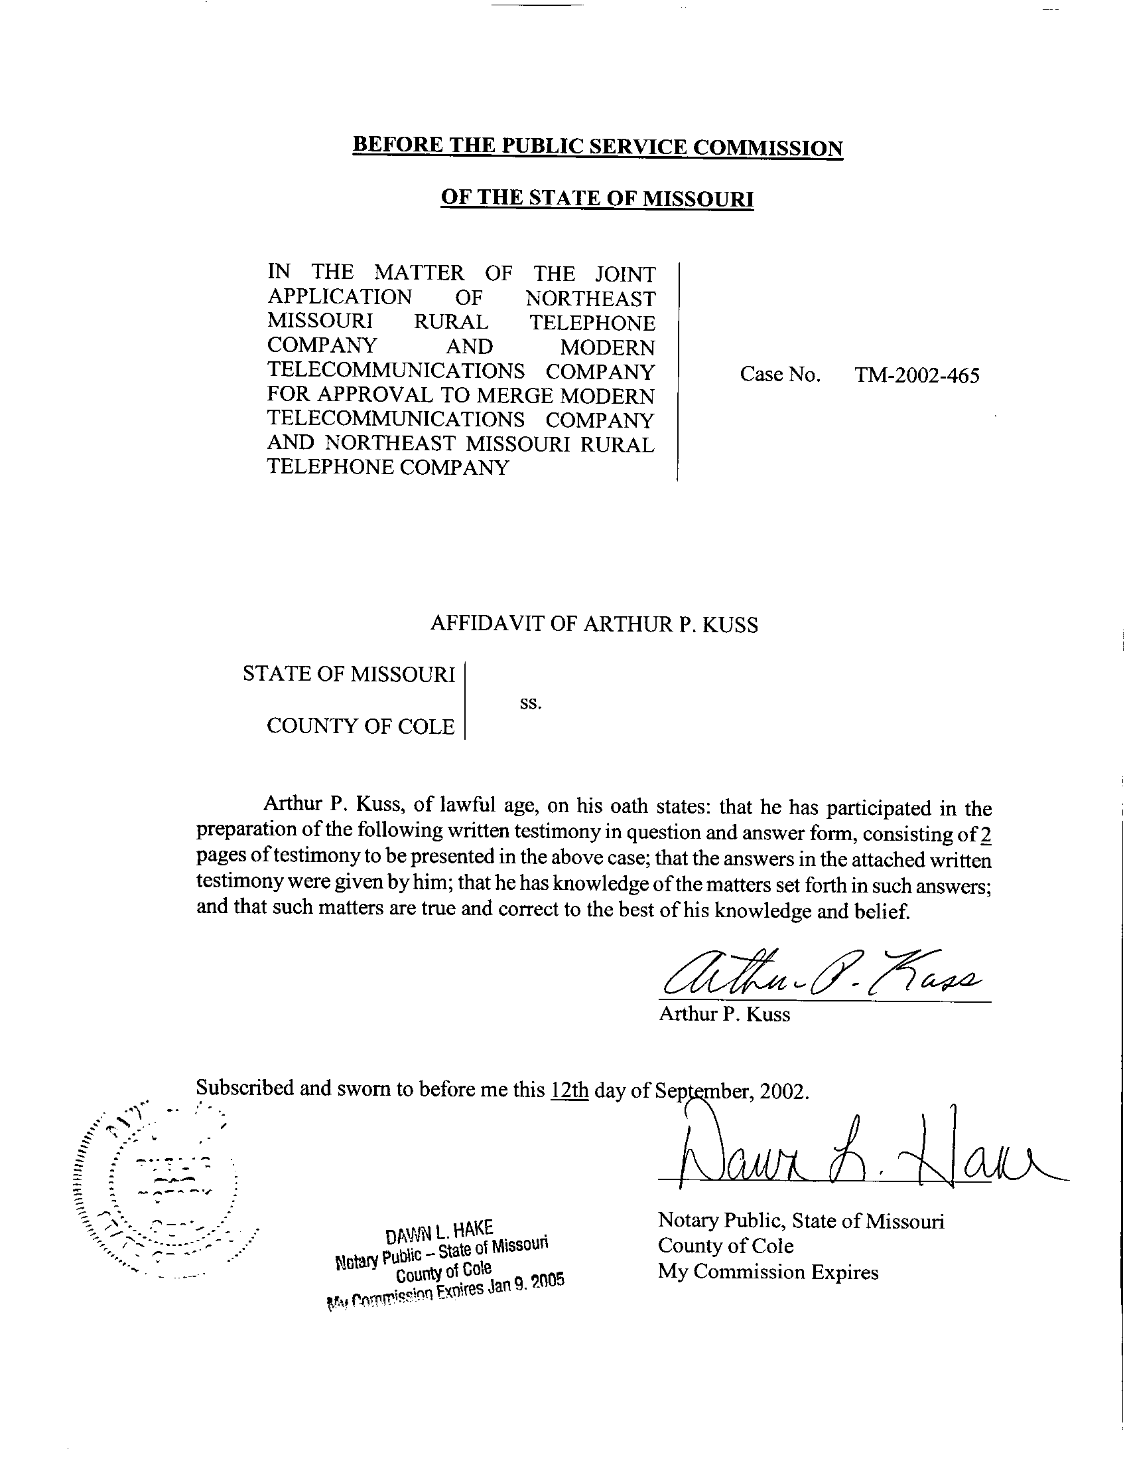

SURREBUTTAL TESTIMONY
OF
ARTHUR P. KUSS
CASE NO. TM-2002-465

Q. Please state your name and give your business address.
A. My name is Arthur P. Kuss, Governor Office Building, 200 Madison Street, Suite 500, P.O. Box 360, Jefferson City, Missouri 65102-0360.
Q. Are you the same Arthur P. Kuss who filed Rebuttal Testimony in this case?
A. Yes, I am.
Q. What is the purpose of your Surrebuttal Testimony?
A. My purpose is to respond to the Rebuttal Testimony of Mr. Jason Olson, representing Southwestern Bell Telephone, L.P. d/b/a Southwestern Bell Telephone Company (SWBT), in the matter of the merger of Northeast Missouri Rural Telephone Company (NEMO) and Modern Telecommunications Company (Modern).
Q. Is SWBT’s position toward the merger of NEMO and Modern compatible with Staff’s position?
A. Yes. Mr. Olson states that SWBT does not oppose the merger, which is compatible with my stated position in support of the merger. He also recommends NEMO and Modern maintain separate switched access rate structures. As stated in my rebuttal testimony I could support the merger with the current rate structures continued unchanged, but only for a temporary time period. A reasonable such temporary period should not exceed one (1) year, the period essentially authorized by the Order in Case TM-93-1, cited in my Rebuttal Testimony. My preference remains to blend NEMO’s and Modern’s access rates into one rate structure in order to eliminate discrimination concerns. Nevertheless I would not object to maintaining separate rate structures temporarily. Following the merger, I recommend that NEMO should propose a rate design where the two rate structures will be blended into one rate structure.
Q. Would you summarize your view of the Rebuttal Testimonies filed in this case?
A. I do not see that any Party objects to the proposed merger. Maintaining separate switched access rate structures is acceptable for a temporary time period.
Q. Does this conclude your Surrebuttal Testimony?
A. Yes, it does.

Rebuttal Testimony of Jason Olson, Page 2 line 14.
Case No. TM-93-1 In the matter of the application requesting authority (1) for GTE North Incorporated to transfer certain assets to GTE Midwest Incorporated, (2) for the merger of Contel of Iowa, Inc., Contel of Missouri, Inc., Contel of Minnesota, Inc., The Kansas State Telephone Company, Contel of Kansas, Inc., and Contel Systems of Missouri, Inc., into GTE Midwest Incorporated, and (3) for the transfer of certificates of public convenience and necessity.

