Commissioners

JEFF DAVIS

Chairman

CONNIE MURRAY

STEVE GAW

ROBERT M. CLAYTON III

LINWARD “LIN” APPLING

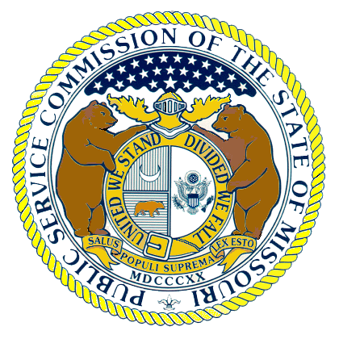

Missouri Public Service Commission

POST OFFICE BOX 360
JEFFERSON CITY MISSOURI 65102
573-751-3234
573-751-1847 (Fax Number)
http://www.psc.mo.gov

WESS A. HENDERSON

Director, Utility Operations

ROBERT SCHALLENBERG

Director, Utility Services

DALE HARDY ROBERTS

Secretary/Chief Regulatory Law Judge

DANA K. JOYCE

General Counsel

Local Exchange Company, LLC
Registered Agent Brydon, Swearengen & England
312 E. Capitol Avenue
Jefferson City MO 65102

Dear Sirs:

In lieu of producing the items as requested in the enclosed subpoena, if practicable, copies of the items may be filed in Commission Case No. TO-2005-0237 before the date they are to be produced in accordance with the subpoena.

Please contact Nathan Williams, Senior Counsel, or Dana K. Joyce, General Counsel, with any questions regarding the subpoena. They may be reached at 573-751-8702 and 573-751-2481, respectively.

Sincerely,

____________________________
Jeff Davis, Chairman
Public Service Commission

Appendix B

