Exhibit No.:
Issues: Detriment Standard; Merger Back-
ground; Acquisition Premium and
Increment Acquisition Costs;
Accumulated Deferred Income
Taxes; Tax Implications; Universal
Service Fund; Membership Fees;
Earnings Review; Summary
Witness: David G. Winter
Sponsoring Party: MoPSC Staff
Type of Exhibit: Rebuttal Testimony
Case No.: TM-2002-465
Date Testimony Prepared: August 15, 2002

MISSOURI PUBLIC SERVICE COMMISSION

UTILITY SERVICES DIVISION

REBUTTAL TESTIMONY

OF

DAVID G. WINTER

NORTHEAST MISSOURI RURAL TELEPHONE COMPANY

AND

MODERN TELECOMMUNICATIONS COMPANY

CASE NO. TM-2002-465

Jefferson City, Missouri

August 2002
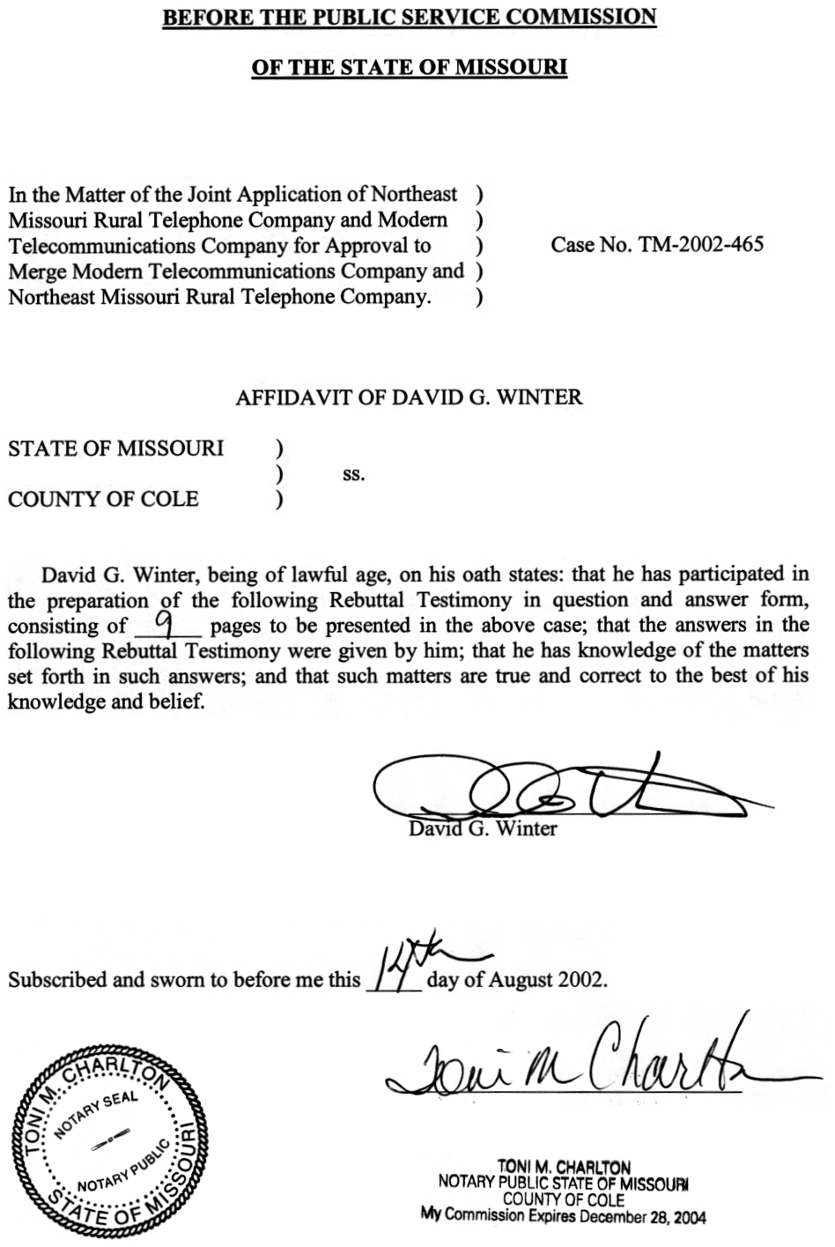
table of contents
rebuttal testimony of
david g. winter
CASE NO. TM-2002-465
DETRIMENT STANDARD 2
MERGER BACKGROUND 4
ACQUISITION PREMIUM AND INCREMENT ACQUISITION COSTS 4
ACCUMULATED DEFERRED INCOME TAXES 5
TAX IMPLICATIONS 6
UNIVERSAL SERVICE FUND 7
MEMBERSHIP FEES 8
EARNINGS REVIEW 8
SUMMARY 9

rebuttal TESTIMONY
OF

DAVID G. WINTER

Northeast Missouri Rural Telephone Company
and
Modern Telecommunications Company
CASE NO. TM-2002-465
Q. Please state your name and business address.
A. David G. Winter, P.O. Box 360, Jefferson City, Missouri 65102.
Q. By whom are you employed and in what capacity?
A. I am a Regulatory Auditor for the Missouri Public Service Commission (Commission).
Q. Please describe your educational background.
A. I graduated from Southwest Missouri State University in 1973 with a Bachelor of Science degree in Accounting. After receiving an Honorable Discharge from the United States Army in 1977, I began my employment with the firm of Williams-Keepers Certified Public Accountants, as a Staff Accountant. I began my employment with the Commission in 1979. I am a licensed Certified Public Accountant (CPA) in Missouri, a Certified Internal Auditor (CIA) and a Certified Government Financial Manager (CGFM).
Q. What is the purpose of your rebuttal testimony in this proceeding?
A. The purpose of this rebuttal testimony is fourfold. First, I will address the standard the Staff utilized to develop its recommendation regarding the proposed merger of the Joint Applicants, Northeast Missouri Rural Telephone Company (Northeast) and Modern Telephone Company (Modern). Second, I will present the Accounting Staff’s recommendations regarding the proposed transaction. In conjunction with this portion of my recommendation, I am submitting testimony regarding the following areas: (1) the acquisition premium/incremental acquisition costs; (2) accumulated deferred income taxes; and (3) the impact on tax revenues. I will also present testimony concerning the affect that this merger will have upon Northeast’s Federal Universal Service Fund high-cost support. Lastly, I will also address the Direct Testimony of Northeast/Modern witness Gary Godfrey concerning membership fees and the Staff’s earning investigation of Northeast and Modern.

DETRIMENT STANDARD
Q. What standard did the Staff utilize to develop its recommendation regarding the proposed merger of Northeast and Modern in this proceeding?
A. Staff utilized the “detriment to the public interest” standard, as it is similar in acquisition cases as well as merger cases. If the Joint Applicants fail to show that the merger of Northeast and Modern is not detrimental to the public interest in Missouri (i.e., if it is demonstrated that the Missouri public will be harmed by the proposed merger), then the Commission should reject this application and not approve the proposed merger. Staff Counsel has advised that the “not detrimental to the public interest” standard is based on case law such as State ex rel. City of St. Louis v. Public Serv. Comm’n, 73 S.W.2d 393 (Mo. banc 1934) and State ex rel. Fee Fee Trunk Sewer Co., Inc. v. Litz, 596 S.W.2d 466 (Mo. App. 1980) generally cited in Commission Orders. Staff Counsel also advises that the Commission has incorporated the “not detrimental to the public interest” standard in its rules. See 4 CSR 240-2.060(8)(D).
Q. How is Staff defining the term “public?”
A. Consistent with Staff’s position in other acquisition and merger cases, Staff views the members of the “public” that are to be protected as those consumers taking and receiving utility service from Modern and Northeast.
In this case, Staff would define “public interest” as referring to the nature and level of the impact or effect that this merger will have on Modern’s customers. There is a fundamental concern in the regulation of public utilities that the public being served will not be impacted adversely or harmed by those responsible for providing monopoly services. Public utilities in Missouri are charged with providing safe and adequate service at just and reasonable rates. If this merger results in adverse or negative impacts to Modern’s customers, then the Commission should not approve the Joint Applicants’ Merger Application or, in the alternative, impose conditions sufficient to overcome the detriments of the merger.
In the merger case involving Kansas Power & Light (KPL) and Kansas Gas & Energy (KGE), which occurred in 1991, the Commission identified the “public” as Missouri ratepayers. At pages 12 to 13 of its Report And Order (Case No. EM–91–213), the Commission stated the following:
The Commission has found no evidence in this record that KPL would be unable to render safe and adequate service to its Missouri ratepayers as a consequence of the proposed merger. However, the Commission has found that the savings sharing plan proposed by KPL as part of its merger application has the potential of exposing Missouri ratepayers to higher rates than would be the case without the merger which would be detrimental to the public interest. . . .
The Commission has also found that there is potential for a detrimental effect on Missouri ratepayers from the merger through increased A & G and capital costs. . . .
Clearly, the Commission was identifying the Missouri ratepayers as the relevant “public” in its Report And Order. This is the standard that is being applied by the Staff to the proposed merger of Northeast and Modern.

MERGER BACKGROUND
Q. Please provide the background to this proceeding.
A. In Case No. TM-95-142, the Commission approved the Joint Application (Schedule 1) of GTE Midwest Incorporated (GTE), Northeast and Modern for authority to transfer and acquire part of GTE’s Missouri franchise, facilities or system related to provision of telephone service in Memphis, Unionville and Queen City exchanges. The Commission’s Order approved a Stipulation And Agreement (Stipulation) proposed by the parties to the proceeding. Along with various other issues, the Stipulation addressed several accounting related issues to include the acquisition premium and incremental acquisition costs and income taxes.
Q. Please briefly describe the business relationship between Northeast and Modern.
A. Modern is a wholly-owned subsidiary of Northeast. Modern has no employees and all management and service work is performed under contract by Northeast. In practical terms, Modern and Northeast are operated and managed as a “single” company.

ACQUISITION PREMIUM AND INCREMENT ACQUISITION COSTS
- What were the agreed to terms of the Stipulation concerning the acquisition premium and acquisition costs?
A. The Stipulation provides that:
Modern agrees to separately identify on its books and records all costs of acquisition of the subject properties which exceed their associated book value (i.e., acquisition premium) as well as all incremental acquisition costs (e.g., incorporation expenses, regulatory approvals, due diligence review, associated sales tax, etc.) incurred in acquiring these properties. Modern further agrees to forgo recovery in future rates for intrastate telecommunications services of any acquisition premium or incremental acquisition costs.
Q. Has Northeast committed to abide by the agreed upon terms of the Stipulation pertaining to Modern’s acquisition premium and acquisition costs?
A. Yes. In response to Staff Data Request No. 9, Northeast has indicated that it will forego recovery in future rates for intrastate telecommunications services of any acquisition premium or incremental acquisition costs.
Q. Will this currently proposed transaction result in another “telecommunications acquisition adjustment?”
A. No. This transaction as structured will not generate a “telecommunications acquisition adjustment.”
Q. Does the Staff have any recommendations pertaining to any incremental acquisition costs?
A. Yes. The Staff would also propose as a condition of the merger that the Commission requires Northeast to formally track all transaction costs so that they may be excluded in future rate cases.

ACCUMULATED DEFERRED INCOME TAXES
- Did the Stipulation address accumulated deferred income taxes?
A. Yes. The terms of the Stipulation addressed accumulated deferred income taxes. Specially, the Stipulation stated that:
Modern agrees to use an additional offset to rate base in any Modern filing for a general increase in telecommunications rates in Missouri in the next ten years to compensate for rate base deductions eliminated by this transaction, unless Modern can show that its actual deferred tax reserve is the same as or greater than that reserve would have been, absent the sale of these exchanges.
- Would the Staff expect Northeast to continue to abide by this provision of the Stipulation?
- Yes. Northeast indicated in its response to Staff Data Request No. 9, that in any rate proceeding it would continue to use an additional income tax offset to rate base as stipulated in Case No. TM-95-142.
Q. Does the Staff have a recommendation?
A. Yes. The Staff recommends that any Commission order in this proceeding include language that would require Northeast to continue to abide by the accumulated deferred income tax provisions of the Stipulation.

TAX IMPLICATIONS
Q. The Joint Applicants state that the “merger should have no direct impact on the tax revenues of the political subdivisions in which the facilities of Modern and Northeast are located.” Do you agree with this statement?
A. Yes. The Staff reviewed the Joint Applicants’ representation regarding what impact, if any the merger proposal would have upon the “tax revenues of the political subdivisions in which any structures, facilities, or equipment of the companies involved in such disposition are located.” Further, the Staff reviewed the federal and state tax implications of this transaction.
The Staff agrees that upon the merger of Northeast and Modern, the character of the assets will not change (i.e., cost, title, right to its uses, transferable, etc.) nor will the tax liabilities for those assets change. Therefore, the new business organization that Northeast has chosen will not affect the “tax revenues of the political subdivisions in which any structures, facilities, or equipment of the companies involved in such disposition are located.”
There will, however, be a change in Modern’s current federal and state tax classification. Modern was formed as a “for-profit” corporate vehicle to purchase “GTE’s Missouri franchise, facilities or system related to provision of telephone service in Memphis, Unionville and Queen City exchanges.” Thus, for federal and state income tax purposes: Modern is currently a taxable entity. Upon consummation of the merger transaction, Modern will be classified as a tax-exempt cooperative.

UNIVERSAL SERVICE FUND
Q. How will this transaction affect Northeast and Modern’s Universal Service Fund high-cost support?
A. The merger should have minimal, if any, affect to the merged entities’ federal high-cost support. Currently, high-cost support for Northeast and Modern are included together in one study area and this will not change due to the merger.

MEMBERSHIP FEES
Q. On pages 13 through 15 of his direct testimony, Mr. Godfrey discusses Northeast’s proposal for a “membership fee” for Modern’s customers. What is Staff’s reaction to Northeast’s proposal?
A. Mr. Godfrey’s proposal is to “have Modern contribute the membership fees for the transferred Modern customers to Northeast.” The Staff considers Modern’s “contribution” to be an expense of the merger, thus classified as an acquisition cost. The Staff believes that Northeast should absorb the transaction costs and recommends that as a condition of the merger, that the Commission require Northeast to “forego recovery in future rates for intrastate telecommunications service of any…incremental acquisition costs.”

EARNINGS REVIEW
Q. On pages 11 and 12 of Mr. Godfrey’s direct testimony, he discusses the likelihood of an earnings review of the merged companies. What is your reaction?
A. The Staff is indeed reviewing the earnings of the merged companies.
Q. Is it a normal practice for the Commission to make rate determinations in non-rate case proceedings, such as asset sale or merger applications?
A. No. In my experience, the Commission reserves ratemaking determinations to general rate proceedings, wherein the Commission can appropriately consider all relevant ratemaking factors.
Q. What is the Staff’s ratemaking position regarding this transaction?
A. The Staff will not make any ratemaking recommendations as part of this proceeding. However, the Staff will continue to actively pursue any over-earnings of the merged companies. If the Staff does determine that the merged companies are in an over-earning situation, the Staff will use the appropriate procedural remedies to pursue any alleged over-earnings.

SUMMARY
Q. Please summarize your recommendations and conditions concerning this transaction.
A. The following is a list of recommendations and conditions that the Accounting Staff believes should be made part of any Commission approval of the merger in order that there not be a detriment to the public interest:
1) Northeast continues to abide by the terms of the Stipulation in Case No. TM-95-142 as it relates to the acquisition premium, incremental acquisition costs and accumulated deferred income taxes.
- Northeast agrees to account for transaction costs in a manner that will enable the Accounting Staff to quantify and exclude such costs from rates in any Missouri proceeding.
- Northeast agrees to “forego recovery in future rates for intrastate telecommunications service” of any member fees for the transferred Modern customers to Northeast.
  - Does this conclude your rebuttal testimony?
A. Yes it does.

GTE Midwest Incorporated is now registered to do business in the State of Missouri as GTE Midwest Incorporated d/b/a Verizon Midwest (Verizon). In Case No. TM-2002-232, the Commission approved the sale of the remaining Verizon Missouri exchanges to CenturyTel of Missouri, LLC.
Section 392.300, RSMo (2000.)

