P.S.C. MO NO. 2 1st Revised Sheet No. 2
Cancelling Original Sheet No. 2

Name of Utility: Timber Creek Sewer Company

Service Areas: Certificated Areas in Missouri

Map of Service Area

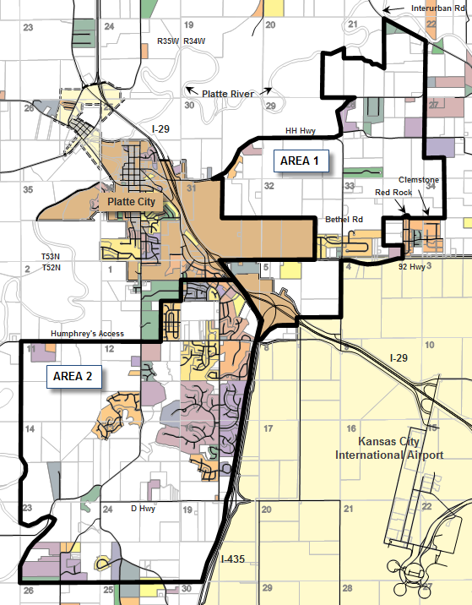

* Indicates new rate or text
+ Indicates change

DATE OF ISSUE: May 6, 2010 DATE EFFECTIVE: June 7, 2010
ISSUED BY: Derek Sherry, President P.O. Box 511, Platte City, MO 64079

P.S.C. MO NO. 2 1st Revised Sheet No. 3
Cancelling Original Sheet No. 3

Name of Utility: Timber Creek Sewer Company

Service Areas: Certificated Areas in Missouri

Rules Governing Rendering of
Sewer Service

Legal Description of Service Area – Platte County

Area 1
*
*
In Township 53N, Range 34W, in Platte County, Missouri: The East 1440 feet of Section 20 lying South of the Platte River; the West ½ of Section 21 lying South of the Platte River and the East ½ of Section 21 lying South of Interurban Road, except those properties owned by the Missouri Department of Conservation; all of Section 30 lying South of HH Highway, except any property within the Platte City corporate limits; all of Section 29 lying South and East of HH Highway; all of Section 28, except any property North and West of HH Highway; the Southwest Quarter of the Southwest Quarter of Section 27; all of Section 31 lying North and East of Platte City corporate limits; all of Section 32 lying North and East of Platte City corporate limits; all of Section 33 except those properties in the RedRock Subdivision; and the west 1400 feet of Section 34, except those properties in the Clemstone Subdivision.
*
*
*
*
*
*
*
*
In Township 52N, Range 34W, in Platte County, Missouri: all of Section 5 and Section 6, except
*
those properties within the Kansas City corporate limits and those areas South of Interstate
*
Highway 435; and all of section 4 North of Highway 92, except those properties within the
Kansas City corporate limits.
*

Area 2

Generally an area South of Platte City and West of Interstate 435, in Platte County, Missouri,
More particularily described as Follows:

All of the following property in Township 52N, Range 34W: all of the South ¾ of Section 6,
located South of Interstate Highway 29 and West of Interstate Highway 435; all of Section 7,
located West of Interstate Highway 435; and all of Sections 18 and 19, located West of Interstate Highway 435; and

All of the following property located in Township 52N, Range 35W: all of the East ½ of the

Southeast 1/4 of Section 1, all of Sections 11, 12, 13, and 24, and all of Sections 14 and 23,
lying east of the Platte River.

* Indicates new rate or text
+ Indicates change

DATE OF ISSUE: May 6, 2010 DATE EFFECTIVE: June 7, 2010
ISSUED BY: Derek Sherry, President P.O. Box 511, Platte City, MO 64079

