Exhibit No.:
Issues: Depreciation; Retirement of Production Plant
Witness: Rosella L. Schad
Sponsoring Party: MoPSC Staff
Type of Exhibit: Direct Testimony
Case No.: GR-2003-0517
Date Testimony Prepared: October 24, 2003

MISSOURI PUBLIC SERVICE COMMISSION

UTILITY SERVICES DIVISION

DIRECT TESTIMONY

OF

ROSELLA L. SCHAD

UNION ELECTRIC COMPANY
d/b/a AMERENUE

CASE NO. GR-2003-0517

Jefferson City, Missouri
October 2003
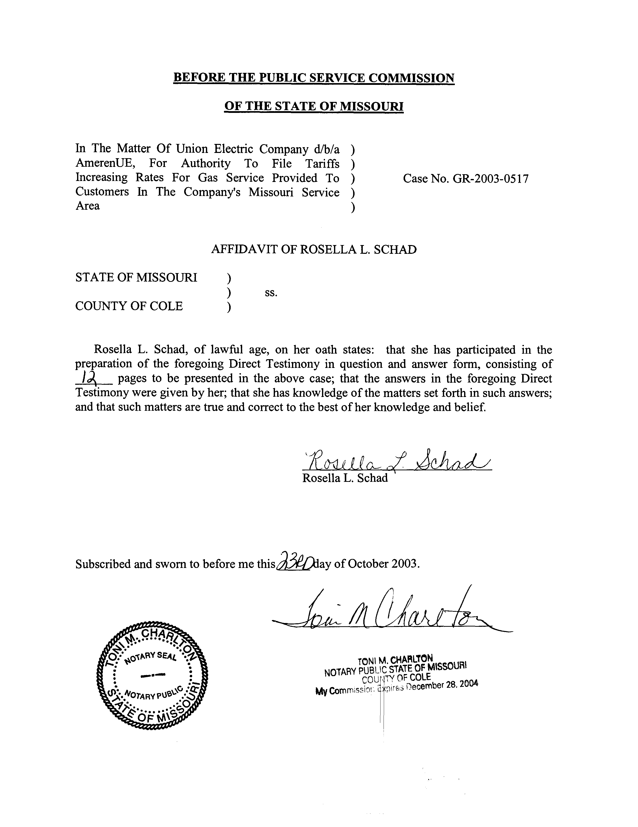
TABLE OF CONTENTS
DIRECT TESTIMONY OF
ROSELLA L. SCHAD
UNION ELECTRIC COMPANY
d/b/a AMERENUE
CASE NO. GR-2003-0517
DEPRECIATION ISSUES 2
DEPRECIATION STUDY 3
DEPRECIATION STUDY OF AMERENUE-MO GAS 7
DEPRECIATION RESERVE ANALYSIS 8
DEPRECIATION RESERVE ANALYSIS FOR AMERENUE-MO GAS 9
STAFF’S RECOMMENDATIONS 11

DIRECT TESTIMONY
OF
ROSELLA L. SCHAD
UNION ELECTRIC COMPANY
d/b/a AMERENUE
CASE NO. GR-2003-0517
Please state your name and business address.
Rosella L. Schad, P.O. Box 360, Jefferson City, MO 65102.
By whom are you employed and in what capacity?
I am employed by the Missouri Public Service Commission (PSC or Commission) as an Engineer in the Engineering and Management Services Department.
Please describe your educational training and professional background.
I received a Bachelor of Science degree (1978) in Mechanical Engineering from the University of Missouri-Columbia. I am a Licensed Professional Engineer in the State of Missouri. I am a member of the National Society of Professional Engineers and the Society of Depreciation Professionals. I was employed by Union Electric (now AmerenUE) as an Engineer Intern during the summer of 1977. I was employed as a Mechanical Engineer by Union Electric in its Nuclear Construction Department from 1978 to 1980. I have been with the Missouri Public Service Commission’s Staff since 1999. In my current position I have completed training in depreciation concepts, attended numerous industry seminars for electric, natural gas, telecommunications, water, and wastewater and made on-site tours of many of the electric, natural gas, telecommunications, water, and wastewater utilities operating in the State of Missouri.
Please describe your duties while employed by the Commission.
I am responsible for engineering analyses and depreciation rate determinations of companies regulated by the Commission.
Have you previously filed testimony before this Commission?
Yes. As shown in Schedule 1, attached to my testimony, is a list in which I have previously filed testimony and the issues that I addressed.

DEPRECIATION ISSUES
Please state the purpose of your testimony in this case.
The purpose of my testimony is to make recommendations for AmerenUE-MO Gas (Company) concerning the depreciation rates that will allow the Company to collect the original cost of its investment over the life of these assets. I will also offer testimony regarding the treatment of the retirement of the Jefferson City propane-air peaking facility.
Staff’s proposal in this case is:
1. That Staff’s Proposed Depreciation Rates based on Staff’s Average Service Lives (ASLs), as shown in the attached Schedule 3, be effective on the date of the Commission order in this case.
2. That the Company transfer $13.5 million for the over-accrued depreciation reserve of Account 380.00, Services to the under-accrued depreciation reserve of Account 376.00, Mains.
3. That the Company restore the accrued reserves for Account 305, Structures and Improvements and Account 311, LPG Equipment to reflect the retirement of the Jefferson City propane-air peaking facility at net book value and that the Company book the undepreciated amount of $340,545 to Account 182.10, Extraordinary Property Losses.
4. That the Company debit Account 182.10, Extraordinary Property Losses, with cost of removal expenses incurred with final retirement, abandonment and removal of the Jefferson City propane-air peaking facility.
5. That the Company credit Account 182.10, Extraordinary Property Losses, with the salvage value received for the Jefferson City propane-air peaking facility, including receipts for site-stored propane.
6. That any amortization necessary to cover the final unrecovered portion of the original cost and potential final net cost of removal expenses be considered in the next rate case when the amount may be known and measurable.
7. That the Company transfer the dollars associated with the land for the Jefferson City propane-air peaking facility to the electric operations of AmerenUE-MO Electric Company.
When were depreciation rates for the Company last revised by a Commission order?
Depreciation rates were last revised for the Company by a Stipulation And Agreement in Case No. GR-2000-512 and ordered by the Commission, effective October 27, 2000.

DEPRECIATION STUDY
What is the definition of depreciation?
Depreciation is the loss, not restored by current maintenance, which is due to all factors causing the ultimate retirement of the property. These factors embrace wear and tear, decay, inadequacy and obsolescence. Annual depreciation is the loss that takes place in a year. Thus, annual depreciation expense is the full recovery of the original cost of the utility plant assets distributed over the life of those assets.
Please describe the depreciation study of the Company’s gas property that you conducted in this case.
I performed a broad group-average life depreciation study. Under the broad group (BG) procedure, all units of plant within a particular depreciation category, usually a plant account or subaccount, are considered to be one group. Development of an accrual rate requires asset placement history, an estimation of the average service life (ASL), and dispersion characteristics of the asset retirements. ASL is a dynamic feature of assets in a plant account, and therefore must be periodically analyzed and revised. The ASL, in years, is the average expected life of all units of the group regardless of the placement date. The ASL is determined by an analysis of records of actual annual additions and retirements by vintage (year of placement).
What are the steps involved in life estimation?
The four primary steps involve: (1) reviewing the Company’s historical placement and retirement plant data for reasonableness and adequacy of sufficient data; (2) touring Company facilities and meeting with Company engineers and plant operations personnel, as well as other Staff, to discuss current developments that may affect the life of plant in service; (3) performing a statistical life analysis of the plant’s retirement experience using the Gannett-Fleming Depreciation Analysis Software; and (4) applying experience and informed judgment to the results of the Software analysis for reasonableness of the ASL results.
If the data are insufficient or the results of the analysis are unreasonable, how does Staff make life estimations?
Staff uses informed judgment and recognition of current developments to make a recommendation for life estimation.
How does the Gannett – Fleming Depreciation Software develop an ASL?
The Company’s historical plant data for an account are inputs to the depreciation analyses software. Plant data are plant additions ($) by year, called a vintage, and retirements ($) from each vintage, by calendar year. The software uses a mathematical computation to derive the percentage of dollars surviving, as a function of age, for all vintages. This resulting function is graphed as a survivor plot and, using a least squares method, is mathematically fitted to an Iowa-type curve. A numerical integration determines the ASL.
What are the Iowa-type curves?
The Iowa curves are widely used models of the life characteristics of utility property. The system of Iowa curves is a family of curve shapes empirically derived from analysis of mortality data of 176 types of utility and industrial property. The curves were developed at the Iowa Engineering Experiment Station at what is presently known as Iowa State University. The Iowa curves were first published in 1935 and reconfirmed in 1980.
What are some developments that may be potential reasons that an account’s ASL may change over time?
Current developments such as technology changes, regulatory requirements or accounting changes can modify an account’s ASL. Changes in the materials from which different vintages of plant were manufactured or changes in the construction process to place these different vintages of plant may create changes to the number of years newer plant remains in service. This would affect the ASL.
Please describe the depreciation system used by Staff.
A depreciation system can be defined with three components: a method, a procedure and a technique. The system used in Staff’s depreciation study is the Straight Line Method, a Broad Group Procedure, and the Whole Life Technique. Parameters estimated from service life studies, selection of an appropriate depreciation system, experience and informed knowledge must all be utilized to develop a depreciation accrual rate.
Why should depreciation studies be conducted periodically?
Depreciation studies are needed to assess the continuing reasonableness of parameters and accrual rates derived from prior estimates. These accounts contain many vintages of plant, placed in service over many years. While the plant function may be the same, the material and construction process may change significantly over time. Other factors that might affect ASL are accounting system changes for designation of unit of property or changes in the method of recording construction costs as current expense or capital investment.
How is an ASL used to establish the annual depreciation expense?
An account’s ASL divided into 100% (100% / ASL) derives the account’s depreciation rate, expressed as a percentage. The depreciation rate is used for recovery of original cost of plant over the used and useful life of each account’s plant. The Company’s annual depreciation expense is the sum of each account’s depreciation rate multiplied by the original cost of assets currently in that plant account for each year.
Why is Staff’s process for developing an appropriate annual depreciation accrual rate significant to both the Company and the ratepayer?
Annual depreciation expense is a portion of the Company’s revenue requirement. Allocating costs to the appropriate recovery period is important because it spreads the Company’s capital costs over the years that the Company’s assets provide services. Development of appropriate depreciation expense is important because the depreciation rates significantly influence the amount that customers will pay to the Company for the capital plant used to provide service.

DEPRECIATION STUDY OF AMERENUE-MO GAS
Did you perform a depreciation study of the Company’s capital plant?
Yes.
Did Staff find that all of the Company’s historical placement and retirement plant data were adequate for analysis?
No. Some accounts did not have sufficient retirement activity for the Software analysis. For example, the Production Plant accounts did not have sufficient historical plant data. The assets in the Mainframe Computer Account, 391.10, have been transferred to the Company’s corporate accounts. The account no longer exists for gas operations. For the portion of the computer assets allocated to gas operations, the rate will be 12.5%, which is the proposed depreciation rate for Computers, Account 391.200.
How did Staff make a determination of a life estimate for these accounts?
Staff made life estimates by using statistical life analyses for similar accounts within different functions. Actual aggregation is noted on Schedule 2.
Did Staff find the remainder of the Company’s historical plant asset placements and retirement data were adequate for analysis?
Yes.
What is Staff’s recommendation for depreciation rates for the Company’s plant accounts?
Staff’s recommendation for the Company’s plant accounts and for the portion of General electric plant assets allocated to gas service is to assign depreciation rates determined using Staff’s ASLs for each account.

DEPRECIATION RESERVE ANALYSIS
What other analyses are performed in a depreciation study?
Another analysis performed in a depreciation study is an examination of the adequacy of the booked depreciation reserve and identification of any reserve over- or under-recovery.
Why does Staff examine the booked depreciation reserve?
The analysis is performed to measure how the actual depreciation reserve compares to the dollars that should be in the depreciation reserve based on currently determined ASLs for each account.
Did Staff perform an analysis of the booked depreciation reserve?
Yes.
Please describe the analysis.
An analysis of the booked depreciation reserve is performed by comparing the amount of the booked depreciation reserve as of a certain date to a theoretical depreciation reserve amount that is determined with the revised average service life and dispersion characteristics of the Iowa-type curve selected on that same date. The theoretical depreciation reserve can be viewed as the difference between the original booked cost of plant presently in service and the summation of annual depreciation expense collected between now and the date of final retirement of that plant, using the ASL and dispersion characteristics of the Iowa-type curve selected as the basis for the future depreciation rates.

DEPRECIATION RESERVE ANALYSIS FOR AMERENUE-MO GAS
What were the results of Staff’s examination of the booked depreciation reserve?
Staff’s results found an approximate $5 million over-accrual of the depreciation accrued reserve and, specifically, the reserve for two accounts have large imbalances.
What are Staff’s bases for adjustment for any booked reserve imbalance?
The need for, the magnitude of, and the timing of the actual adjustment should be based upon consideration of several factors: the characteristics of the account, the causes of the difference, and the year-to year volatility of the accumulated provision for depreciation as well as the magnitude of the imbalance. Future service life cannot be estimated to a degree of certainty that guarantees that the actual life will not be different. In fact, it is possible that the currently determined ASL will differ from the ASL that occurs.
What are Staff’s recommendations regarding the booked reserve?
Staff has three recommendations regarding the booked reserve. The first item is that Staff’s calculation of an approximately $5 million over-accrual is of the magnitude of approximately one year’s accrual. At this level and at the current plant growth, Staff’s first recommendation is that no adjustment be made at this time.
The second item concerns the large imbalance that exists in the accrued reserve accounts for Account 380.00, Services and Account 376.00, Mains. Staff’s second recommendation is a correcting adjustment, transferring $13.5 million from the accrued reserve account of 380.00 to the accrued reserve account of 376.00.
The third item concerns the under-accrued reserve that exists for the Jefferson City propane-air peaking facility. As of June 30, 2003, the date of retirement for this life span facility, final cost of removal expenses had not been incurred and receipts of salvage value had not been realized. The magnitude of an amortization necessary to cover the final un-recovered portion of original cost and potential final net removal expenses is not known and measurable at this time. The Staff’s third recommendation is that any amortization necessary to cover the final unrecovered portion of original cost and potential final net removal expenses be addressed in the next rate case when the amount is known and measurable.
What are Staff’s recommendations for tracking and booking the undepreciated original cost of the Jefferson City propane-air peaking facility and associated cost of removal expenses and salvage value receipts?
Staff has four recommendations regarding the Jefferson City propane-air peaking facility. The first recommendation is that the Company restore the accrued reserves for Account 305, Structures and Improvements and Account 311, LPG Equipment to reflect the retirement of the Jefferson City propane-air peaking facility at net book value and that the Company book the undepreciated amount of $340,545 to Account 182.100, Extraordinary Property Losses. The second recommendation is that the Company debit account 182.100, Extraordinary Property Losses, with cost of removal expenses incurred with final retirement, abandonment, and removal of the Jefferson City propane-air peaking facility. The third recommendation is that the Company credit account 182.10, Extraordinary Property Losses, with the salvage value received for the Jefferson City propane-air peaking facility, including receipts for site-stored propane. The fourth recommendation is that any amortization necessary to cover the final unrecovered portion of original cost and potential final net removal expenses be considered in the next rate case when the amount may be known and measurable.

STAFF’S RECOMMENDATIONS
Can you provide a summary of Staff’s proposals for depreciation rates, accrued reserve, and retirement of the Jefferson City propane-air peaking facility?
Yes. Staff recommends the Commission order:
1. That Staff’s Proposed Depreciation Rates based on Staff’s ASLs, as shown in the attached Schedule 3, be effective on the date of the Commission order in this case.
2. That the Company transfer $13.5 million for the over-accrued depreciation reserve of account 380.00, Services to the under-accrued depreciation reserve of Account 376.00, Mains.
3. That the Company restore the accrued reserves for Account 305, Structures and Improvements and Account 311, LPG Equipment to reflect the retirement of the Jefferson City propane-air peaking facility at net book value and that the Company book the undepreciated amount of $340,545 to Account 182.10, Extraordinary Property Losses.
4. That the Company debit Account 182.10, Extraordinary Property Losses, with cost of removal expenses incurred with final retirement, abandonment, and removal of the Jefferson City propane-air peaking facility.
5. That the Company credit Account 182.10, Extraordinary Property Losses, with the salvage value received for the Jefferson City propane-air peaking facility, including receipts for site-stored propane.
6. That any amortization necessary to cover the final un-recovered portion of original cost and potential final net removal expenses be considered in the next rate case when the amount may be known and measurable.
7. That the Company transfer the dollars associated with the land for the Jefferson City propane-air peaking facility to the electric operations of AmerenUE-MO Electric Company.
Does this conclude your direct testimony?
Yes, it does.
CASE PROCEEDING PARTICIPATION

ROSELLA L. SCHAD

COMPANY | CASE NO./Filing | ISSUES
Iamo Telephone Company | TT-2001-116  Rebuttal | Depreciation Rates
Peace Valley Telephone Company | TT-2001-118  Rebuttal | Depreciation Rates
Holway Telephone Company | TT-2001-119  Rebuttal | Depreciation Rates
KLM Telephone Company | TT-2001-120  Rebuttal | Depreciation Rates
Ozark Telephone Company | TC-2001-402  Direct | Depreciation Rates
Osage Water Company | SR-2000-556  Direct | Depreciation
Osage Water Company | WR-2000-557  Direct | Depreciation
Northeast Missouri Rural Telephone Company | TR-2001-344  Direct, Surrebuttal | Depreciation Rates
Oregon Farmers Mutual Telephone Company | TT-2001-328  Rebuttal | Depreciation Rates
Laclede Gas Company | GR-2001-629  Direct | Depreciation
Laclede Gas Company | GR-2002-356  Direct | Depreciation
Union Electric Company d/b/a AmerenUE | EC-2002-1  Surrebuttal | Depreciation; Steam Production Plan Retirement Dates; Decommissioning Costs; Callaway Interim Additions
Northeast Missouri Rural Telephone Company and Modern Telecommunications Company | TM-2002-465  Rebuttal | Depreciation; Plant Upgrades and Improvements
Laclede Gas Company | GR-2002-356  Rebuttal | Decommissioning

