Exhibit No.:
Issues: Depreciation;
Plant Upgrades and
Improvements
Witness: Rosella L. Schad, P.E.
Sponsoring Party: MoPSC Staff
Type of Exhibit: Rebuttal Testimony
Case No.: TM-2002-465
Date Testimony Prepared: August 15, 2002

MISSOURI PUBLIC SERVICE COMMISSION

UTILITY SERVICES DIVISION

REBUTTAL TESTIMONY

OF

ROSELLA L. SCHAD, P.E.

NORTHEAST MISSOURI RURAL TELEPHONE COMPANY

AND

MODERN TELECOMMUNICATIONS COMPANY

CASE NO. TM-2002-465

Jefferson City, Missouri
August 2002
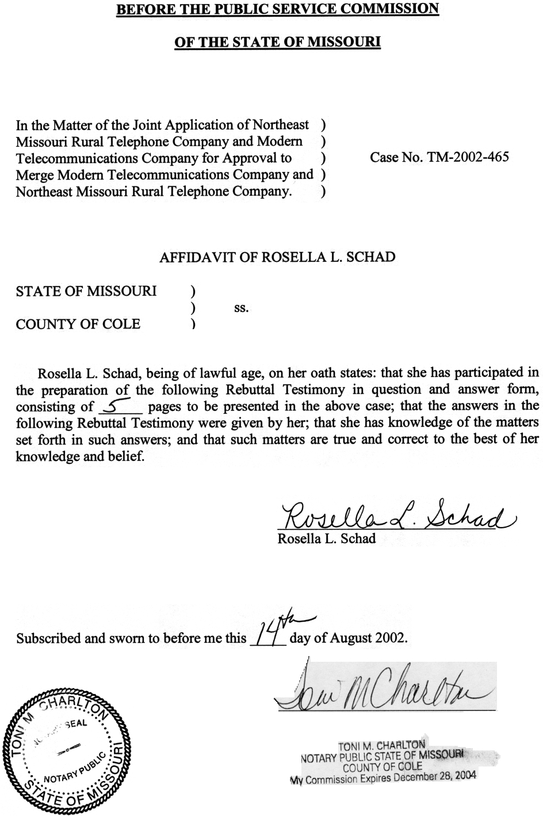
REBUTTAL TESTIMONY
OF
ROSELLA L. SCHAD, P.E.
NORTHEAST MISSOURI RURAL TELEPHONE COMPANY
and
MODERN TELECOMMUNICATIONS COMPANY
CASE NO. TM-2002-465
Please state your name and business address.
Rosella L. Schad, P.O. Box 360, Jefferson City, MO 65102
By whom are you employed and in what capacity?
I am employed by the Missouri Public Service Commission (PSC or Commission) as an Engineer in the Engineering and Management Services Department.
What are your duties as an Engineer?
I am responsible for depreciation determinations and engineering analyses of companies regulated by the Commission.
What are your qualifications, educational background and experience?
In 1978 I earned a Bachelor of Science degree in Mechanical Engineering from the University of Missouri-Columbia. I am a registered Professional Engineer in Missouri. I was employed by Union Electric Company (now AmerenUE) as an engineer intern during the summer of 1977 and employed as a mechanical engineer by Union Electric Company in its Nuclear Construction Department from 1978-1980. I joined the Missouri Public Service Commission Staff in the Depreciation Department in 1999.
Have you previously filed testimony before this Commission?
Yes. As shown in Schedule 1 attached to my testimony is a list in which I have previously filed testimony.
What is the purpose of your testimony in this case?
The purpose of my testimony in this case is to present a portion of Staff’s rebuttal position in connection with the merger of Northeast Missouri Rural Telephone Company (Northeast) and Modern Telecommunications Company (Modern).
What issues will you address?
I will address depreciation rates and plant upgrades and improvements.
Can you provide a summary of both Northeast’s and Modern’s currently ordered depreciation rates?
Yes. Northeast’s current depreciation rates were ordered in Case No.
TR-2001-344, as shown in Schedule 2. These are Staff’s current standardized telecommunications depreciation rates. Subsequently, Northeast filed in Case No.
TA-2002-61 an application pursuant to Section 392.280.2, RSMo, and 4 CSR 240-2.060, requesting a depreciation authority order to record depreciation expenses in excess of the minimum rates established in Case No. TR-2001-344. Northeast was authorized to book the higher depreciation rates, as shown in Schedule 3. Modern’s current depreciation rates were ordered in Case No. TM-95-142, as shown in Schedule 4. Modern also filed in Case No. TA-2002-61 an application pursuant to Section 392.280.2, RSMo, and
4 CSR 240-2.060, requesting a depreciation authority order to record depreciation expenses in excess of the minimum rates established in Case No. TM-95-142. Modern was authorized to book the higher depreciation rates, as shown in Schedule 5.
On page 4, line 12 of Northeast/Modern witness Gary Godfrey states,
“For legal and regulatory reasons and due to time constraints, a wholly-owned subsidiary of the Cooperative, Modern Telecommunications Company, was utilized by Northeast to acquire these exchanges. Northeast made certain commitments to the Missouri Public Service Commission with respect to the acquisition…”
Can you describe the actions required by Modern with regard to depreciation as provided in the “Order Approving Sale and Order Granting Certificate” (Order) in Case No.
TM-95-142.
Yes. The Order’s provisions for depreciation were,
“Depreciation: (A) Modern will: use the depreciation rates in Schedule 2, attached to the stipulation; establish accounts per Schedule 2; transfer accumulated reserve for plant acquired from GTE to these accounts and maintain the depreciation reserve by account per Schedule 2; complete the amortizations for accounts 2116.29 and 2123.29 and close these accounts; maintain continuing property records and establish a property unit catalogue, with copies submitted to the Commission’s Depreciation Department Manager within one year; and submit copies of a comprehensive depreciation study to the Depreciation Department manager within one year; and submit copies of a comprehensive depreciation study to the Depreciation Department Manager within three and one-half years, or at the time of a rate case whichever first occurs. (B) GTE will: record the fractional interests sold by account; maintain continuing property records to identify retirements of the plant sold from the normal retirement of other plant owned; and compute the accumulated reserves for depreciation up to the time of sale, using the theoretical reserve prospective method, and transfer those amounts by account to Modern.”
Has Modern provided the property unit catalogue and comprehensive depreciation study to the Depreciation Staff within the time-frame provided?
No, Modern has never complied with that Order.
What is Staff’s recommendation at this time regarding Modern’s submittal of a property unit catalogue and comprehensive depreciation study?
Staff’s review of Modern’s plant and plant records concludes that there is not sufficient plant retirement data to conduct a comprehensive depreciation study. Staff has developed and currently utilizes standardized depreciation rates for telephone companies (other than Southwestern Bell Telephone Company, CenturyTel of Missouri, LLC, and Sprint) in Missouri. As a result of its modernization plan and other improvements and upgrades in the three exchanges Modern acquired (Memphis, Queen City, and Unionville), the plant today is technologically different from the plant in service at the time Modern acquired the property from GTE, i.e.,
- All three electro-mechanical switches were replaced by digital switches
- Copper interexchange toll facility was replaced with fiber cable
- Analog circuit equipment was replaced with digital circuit equipment
- Fiber loop plant and digital carrier was installed in some areas to eliminate party lines and to accommodate growth.
In addition, a Staff engineer performed cable pair audits of Modern and Northeast exchanges in June of 2000 to determine if the physical characteristics of the existing telecommunications plant were in compliance with the quality of service requirements stated in 4 CSR 240-32.060 Engineering and Maintenance. The result of this engineering audit verifies the quality of service of plant and its maintenance, both of which affect the life of this facility.
The engineering analysis I performed of Modern’s operations and plant supports the use of the average service lives utilized in the Commission’s standardized telecommunications depreciation rates. This analysis also confirms Modern’s testified commitment of making significant investment in new plant to improve telephone service in these areas. Because sufficient historical plant mortality data for the three exchanges is unavailable and the engineering analysis has shown the appropriateness of Staff’s current standardized telecommunication depreciation rates to Modern’s plant assets, Staff recommends that upon a filing by Modern to request a waiver on it’s obligation to submit a comprehensive deprecation study to the Engineering and Management Services Department (EMSD), the Commission waive Modern’s obligation. Modern has indicated that it intends to file a request for a waiver during this proceeding.
With regard to the requirement for Modern to submit a property unit catalogue in Case No. TM-95-142, Staff recommends that Northeast submit a property unit catalogue of the combined properties to EMSD within four months after the date of the Order in this case. Northeast’s submittal of the merged company’s property unit catalogue is the most appropriate at this time and as such, Staff recommends that Modern not be required to submit a 1995 property unit catalogue for the three exchanges’ plant. Modern’s filing will also address this issue.
Staff recommends that the merged company retain Northeast’s currently ordered depreciation rates with the authorization to use accelerated rates for purposes of booking depreciation expenses in excess of the minimum rates, as shown in Schedule 6.
Does this conclude your testimony?
Yes.
CASE PROCEEDING PARTICIPATION

ROSELLA L. SCHAD

COMPANY CASE NO.
Iamo Telephone Company TT-2001-116
Peace Valley Telephone Company TT-2001-118
Holway Telephone Company TT-2001-119
KLM Telephone Company TT-2001-120
Ozark Telephone Company TC-2001-402
Osage Water Company SR-2000-556
Osage Water Company WR-2000-557
Northeast Missouri Rural Telephone Company TR-2001-344
Oregon Farmers Mutual Telephone Company TT-2001-328
Laclede Gas Company GR-2001-629
Laclede Gas Company GR-2002-356
Union Electric Company, dba AmerenUE EC-2002-1

