Exhibit No.:
Issues: Weather Normalization

Witness: Henry E. Warren
Sponsoring Party: Mo PSC Staff
Type of Exhibit: Direct Testimony
Case No.: GR-2004-0072
Date Testimony Prepared: January 6, 2004

MISSOURI PUBLIC SERVICE COMMISSION

Utility Operations DIVISION

DIRECT TESTIMONY

OF

Henry E. Warren, PhD

AQUILA, INC. d/b/a AQUILA NETWORKS-MPS-Gas
AND AQUILA NETWORKS-L&P-Gas

CASE NO. GR-2004-0072

Jefferson City, Missouri

January 2004

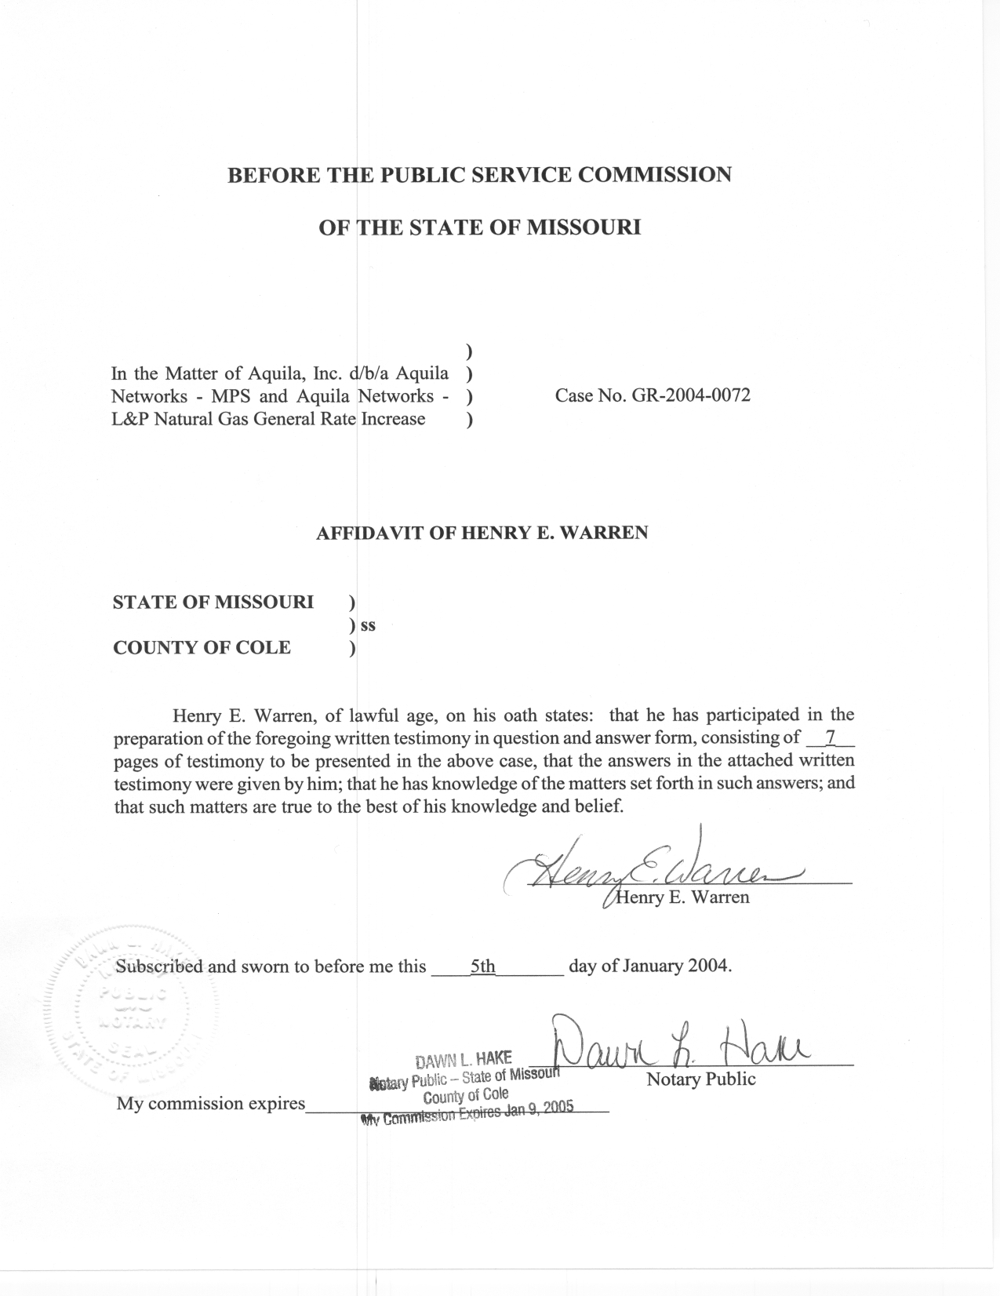
TABLE OF CONTENTS

SELECTION AND WEGHTING OF WEATHER STATIONS FOR THE COMPANY’S DIVISIONS 3

GENERAL SERVICE COMMERCIAL NORMAL BLOCK ALLOCATIONS 5

DIRECT TESTIMONY
OF
HENRY E. WARREN, PhD
AQUILA, INC. d/b/a AQUILA NETWORKS-MPS-GAS
AND AQUILA NETWORKS-L&P-GAS
CASE NO. GR-2004-0072

Q. Please state your name and business address.
A. My name is Henry E. Warren and my business address is P. O. Box 360, Jefferson City, Missouri, 65102.
Q. By whom are you employed and in what capacity?
A. I am employed by the Missouri Public Service Commission (PSC or Commission) as a Regulatory Economist in the Energy Department of the Utility Operations Division.
Q. How long have you been employed by the Commission?
A. I have worked at the Commission 11 years.
Q. What is your educational and professional background?
A. I received my Bachelor of Arts and my Master of Arts in Economics from the University of Missouri-Columbia, and a Doctor of Philosophy (PhD) in Economics from Texas A&M University. Prior to joining the PSC Staff (Staff), I was an Economist with the U.S. National Oceanic and Atmospheric Administration (NOAA). At NOAA I conducted research on the economic impact of climate and weather. I began my employment at the Commission on October 1, 1992, as a Research Economist in the Economic Analysis Department. My duties consisted of calculating adjustments to test-year energy use based on test-year weather and normal weather, and I also assisted in the review of Electric Resource Plans for investor owned utilities in Missouri. From December 1, 1997, until May 2001, I was a Regulatory Economist II in the Commission’s Gas Department where my duties still included analysis of issues in natural gas rate cases and were expanded to include reviewing tariff filings, applications and various other matters relating to jurisdictional gas utilities in Missouri. On June 1, 2001, the Commission organized an Energy Department and I was assigned to this Department. My duties in the Energy Department are similar to my duties in the Gas Department.
Q. Are you a member of any professional organizations?
A. Yes, I am a member of the International Association for Energy Economics and the Western Economics Association.
Q. Have you previously filed testimony before the Commission?
A. Yes, I have filed testimony in the cases listed in Schedule 1 attached to this testimony.
Q. What is the purpose of your Direct Testimony?
A. My Direct Testimony covers two areas. The first is selection of weather stations used in the calculation of actual and normal heating degree days (HDD, Base 65ºF) for the test year for the four divisions of Aquila, Inc., and subsequently the weighting of weather stations for two of the four divisions of Aquila, Inc. The four divisions of Aquila providing natural gas service include Aquila Networks-MPS-Gas Northern System (MPS-North), Aquila Networks-MPS-Gas Southern System (MPS-South), Aquila Networks-MPS-Gas Eastern System (MPS-East), and Aquila Networks-L&P-Gas FRT and Other (L&P). The definition of HDD and the description of the computation of actual and normal HDD are contained in the Direct Testimony of Staff Witness, Mr. Dennis Patterson, PSC Energy Department. A Table containing the weather stations and weights for the Company’s divisions are in Schedule 2.
Second, adjustments to test-year Ccf for MPS General Service Commercial customers are computed by Staff Witness Mr. James Gray, PSC Energy Department, based on the difference between test-year and normal HDD and billing cycle days. The monthly, computed percentage allocation to the rate blocks for these monthly adjustments are computed as contained in the three tables in Schedule 3 for the MPS-North, MPS-South, and MPS-East. Note that L&P does not have blocked rates.

SELECTION AND WEGHTING OF WEATHER STATIONS FOR THE COMPANY’S DIVISIONS

Q. What criteria were used in determining to use one or more than one weather station for a Division of Aquila Networks-Gas?
A. The criteria were determined in consultation with Mr. Dennis Patterson. The criteria are the geographic area covered by each of the Divisions of Aquila Networks-Gas and previous results in analyzing the relationship between the variation of HDD at a weather station and gas usage in the Division.
Q. What weather station was selected for the Aquila L&P service areas?
A. In previous rate cases Conception was used as the weather station for both the FRT and Other service areas of L&P. The L&P-FRT service area is entirely in one county and the L&P-Other Service area is in predominantly in two counties. Because of the proximity, distribution of customers, and previous experience, the Conception weather station was used for the L&P Service areas (Schedule 2).
Q. What weather station was selected for the MPS-East service area?
A. The MPS-East service area has not been previously analyzed. The service area is in three coterminous counties in the south-central part of the state. The Columbia weather station was selected because it has provided good results for other gas service areas in the central part of the state (Schedule 2).
Q. What weather stations were selected for the MPS-North service area?
A. The MPS-North service area covers five counties in the north-central part of the state. Salisbury and Brookfield were selected. A weight for each station was determined by assigning communities in the service area to each station. The number of residential customers assigned to the stations was used to determine the weight for each station, because residential customers are the largest and most weather sensitive class. Salisbury and Brookfield had previously been used in an analysis of weather sensitivity for the same area with good results. By combining the stations with weights one adjustment is made for the entire service area. This allows for consideration of weather variation in the service area without having inconsistent adjustments (Schedule 2).
Q. What weather stations were selected for the MPS-South service area?
A. The MPS-South service area is the largest. It covers nine counties in the west and west central part of the state. Kansas City (MCI), Marshall, Nevada, and Sedalia were selected. The process is similar to the MPS-North weighting of stations, a weight for each station was determined by assigning communities in the service area to each station. The number of residential customers assigned to the stations was used to determine the weight for each station. Also, these stations had previously been used in an analysis of weather sensitivity for the area with good results. Combining the stations with weights results in one adjustment for the entire service area. This allows for consideration of weather variation in the service area without having inconsistent adjustments (Schedule 2).
Mr. Dennis Patterson computed HDD for the Divisions using these stations and weights as described in his Direct Testimony. Mr. Gray used these HDD in analysis of the General Service Class in each Division as described in his Direct Testimony.

GENERAL SERVICE COMMERCIAL NORMAL BLOCK ALLOCATIONS

Q. What are the billing determinants established for the general service class by the current rate design and how are Mr. Gray’s usage adjustments for weather allocated according to these billing determinants?
A. The General Service (GS) Commercial and Industrial class rates are differentiated into four blocks. The first block for the commercial and industrial classes contains usage from 0 - 600 Ccf per billing cycle and the second block contains the usage from 601 to 1,400 Ccf, the third block contains usage from 1,401 to 2,400 Ccf and the fourth block or tail block contains all usage over 2,400 Ccf per month. My analysis of allocation of normal volumes to blocks is only for the MPS-GS Commercial Customers, Staff Witness Ms. Anne Ross, PSC Energy Department, will compute the adjustments for the MPS-GS Industrial Customers. In order for Staff Witness Mr. William Harris, PSC Accounting Department, to compute the revenues associated with the MPS-GS Commercial weather-adjusted Ccf, these Ccf must be properly allocated to the blocks to determine the rate at which they would be billed.
Q. What data are used to compute these billing determinants?
A. The Company provided Staff with test year billed Ccf by rate block for GS customer classes and rate codes. I used the Company's monthly blocked Ccf (January-December 2002) to determine the percentage of usage falling into each rate block for each month. Because the rates are the same for all MPS Divisions, a similar analysis was applied to the monthly data for each division for the GS commercial customers.
Q. How did you use that data to determine block percentages for normal Ccf for the test-year?
A. I applied the monthly percentage change for adjusting the test year Ccf for the GS Commercial class to normal computed by Mr. Jim Gray to each GS Commercial customer in the data supplied by the Company in the work papers of Company Witness, Mr. Thomas J. Sullivan. I then allocated these normal Ccf for each customer to rate blocks in each month. This equation was applied to each MPS-Gas division separately because the normal adjustment varies between divisions. The customers in each division were aggregated. Next the percent of total Ccf each month in each block was calculated to allocate the monthly, adjusted test-year Ccf to the blocks for the GS Commercial customers. These percentages are in the Tables in Schedule 3 for the MPS-Gas Divisions. The normal blocked billing units for the GS class are computed by Mr. Harris.
Q. What is the Staff's recommendation for weather adjusted gas usage for the MPS-GS Commercial customer class?
A. Adjustments to Ccf in each billing month of the test-year appear in Schedule 3. These monthly adjustments are computed for each block in each Division for the GS Commercial class. These adjustments were supplied to Mr. Harris for use in the revenue adjustments.
Q. Does this conclude your pre-filed Direct Testimony?
A. Yes, it does
AQUILA, INC. d/b/a AQUILA NETWORKS-GAS

CASE NO. GR-2004-0072

Previous Cases in which Prepared Testimony Was Presented by:

Henry E. Warren, PhD

Company Name Case Number
St. Joseph Light and Power Company GR-93-042
Laclede Gas Co. GR-93-149
Missouri Public Service GR-93-172¹
Western Resources GR-93-240¹
Laclede Gas Co. GR-94-220¹
United Cities Gas Co. GR-95-160¹
The Empire District Electric Co. ER-95-279¹
Laclede Gas Co. GR-96-193¹
Missouri Gas Energy GR-96-285¹
The Empire District Electric Co. ER-97-081¹
Union Electric Co. GR-97-393¹
Missouri Gas Energy GR-98-140¹
Laclede Gas Co. GR-98-374¹
St. Joseph Light & Power Company GR-99-246¹
Laclede Gas Co. GR-99-315¹
Union Electric Company (d/b/a AmerenUE) GR-2000-512¹
Missouri Gas Energy GR-2001-292¹
Laclede Gas Co. GR-2001-629¹
Laclede Gas Co. GR-2002-0356¹
Laclede Gas Co. GT-2003-0117
AQUILA, INC. d/b/a AQUILA NETWORKS-GAS
CASE NO. GR-2004-0072
TEST PERIOD JANUARY 2002 - DECEMBER 2002
AQUILA, INC. d/b/a AQUILA NETWORKS-GAS
CASE NO. GR-2004-0072
TEST PERIOD JANUARY 2002 - DECEMBER 2002
GENERAL SERVICE COMMERCIAL (GS-COMMERCIAL)

Testimony includes computations to adjust test year volumes, therms, or kWh to normal weather.

