Exhibit No.:
Issues: Interim Energy
Charge

Witness: James C. Watkins
Sponsoring Party: MO PSC Staff
Type of Exhibit: Surrebuttal Testimony
Case Nos.: ER-2004-0034
& HR-2004-0024
Date Testimony Prepared: February 20, 2004

MISSOURI PUBLIC SERVICE COMMISSION

Utility Operations DIVISION

SURREBUTTAL TESTIMONY

OF

JAMES C. WATKINS

Aquila, Inc. d/b/a Aquila Networks--MPS
and Aquila Networks--L&P

CASE NOS. ER-2004-0034
& HR-2004-0024

Jefferson City, Missouri
February 2004
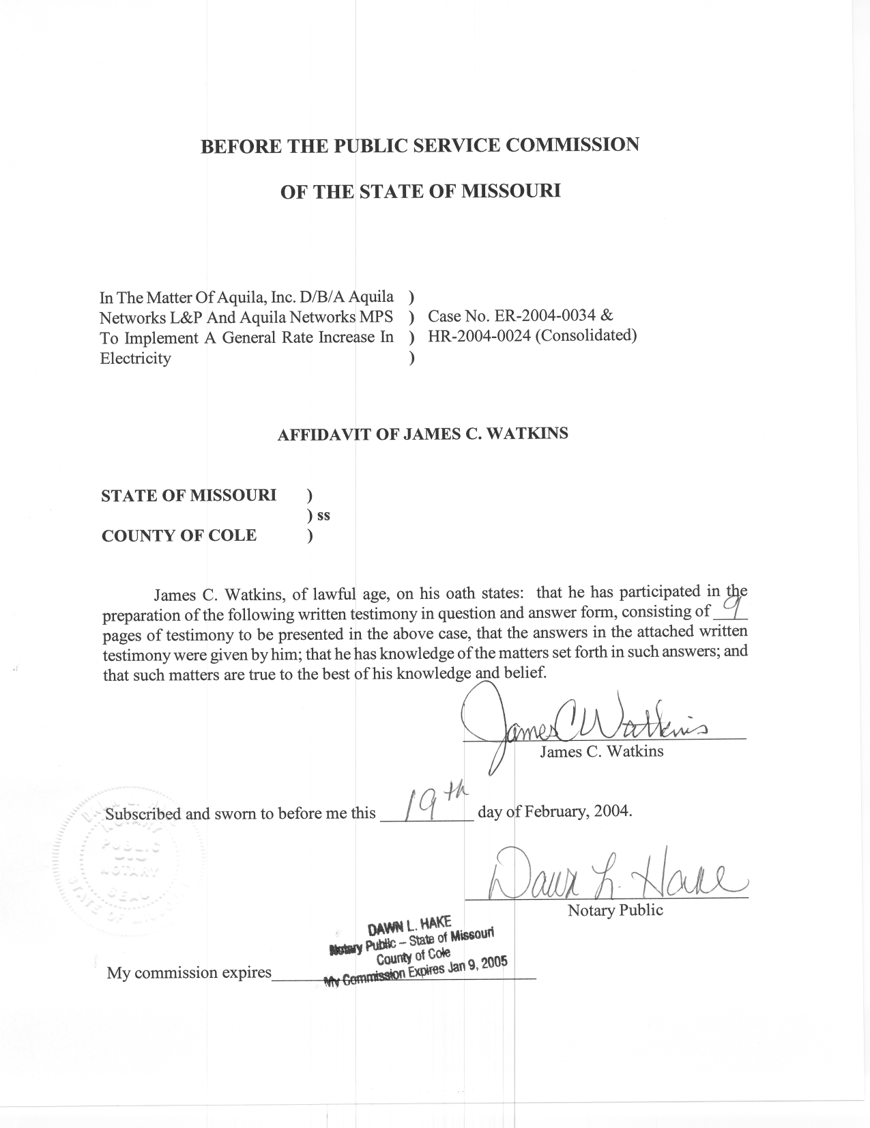
SURREBUTTAL TESTIMONY
OF
JAMES C. WATKINS
AQUILA, INC., d/b/a AQUILA NETWORKS-MPS (Electric)
and AQUILA NETWORKS-L&P (Electric and Steam)
CASE NOS. ER-2004-0034 AND HR-2004-0024
(Consolidated)
Q. Please state your name and business address.
A. My name is James C. Watkins and my business address is Missouri Public Service Commission, 200 Madison Street, P. O. Box 360, Jefferson City, Missouri 65102.
Q. What is your present position with the Missouri Public Service Commission (Commission)?
A. I am a Regulatory Economist in the Energy Department of the Operations Division.
Q. Please review your educational background and work experience.
A. I have a Bachelor of Arts Degree in Economics from William Jewell College, a year of graduate study at the University of California at Los Angeles in the Masters Degree Program, and have completed all requirements except my dissertation for a Ph.D. in Economics from the University of Missouri-Columbia. My previous work experience has been as an Instructor of Economics at Columbia College, the University of Missouri-Rolla, and William Jewell College. I have been on the Staff of the Missouri Public Service Commission (Staff) since August 1, 1982. A list of the major cases in which I have filed testimony before the Commission is shown on Schedule 1.

Q. Are you one of the Case Coordinators for this case?
A. Yes. I am primarily responsible for coordination within the Operations Division.
Q. What is the purpose of your Surrebuttal Testimony?
A. The purpose of my Surrebuttal Testimony is to present the Staff’s position regarding the Company’s recovery of fuel and purchased power costs in response to the rebuttal of Company witnesses John Browning in the area of natural gas pricing and Jerry Boehm in the area of purchased power pricing, and to demonstrate that the Commission’s approval of the Staff’s recommendation would also result in just and reasonable rates. I will also present the details of the Staff’s recommended Interim Energy Charge (IEC).
Q. What is shown on Schedule 2?
A. The results of the Staff’s fuel run for various natural gas price and purchased power price scenarios are attached to my testimony for convenience as Schedule 2. The information was developed by Staff witness David W. Elliott and is described in his Surrebuttal Testimony on the IEC.
Q. What is shown on Schedule 3?
A. The calculation of the percentage amounts of the IEC surcharges and the impact on customers served on each of Aquila’s rate codes are attached to my testimony for convenience as Schedule 3. The information was developed by Staff witness Janice Pyatte and is described in her Surrebuttal Testimony on the IEC.
Q. What is shown on Schedule 4?
A. An illustrative tariff sheet to implement the IEC is shown on Schedule 4.
Q. Do you have any prior experience with the mechanisms involved in the Staff’s recommendation?
A. Yes. During the mid-80’s, one of my responsibilities was to forecast fuel prices and determine an appropriate “allowance for forecasted fuel expense” to be included in the revenue requirement of electric utilities, subject to true-up and refund. I was also involved in setting up the mechanics of this process, participating in the true-up audits and monitoring any required refunds.
More recently, I played a key role in developing an IEC for The Empire District Electric Company (Empire) in Case No. ER-2001-299.
Q. Does the Staff’s recommendation in this case provide for a process similar to Empire’s IEC?
A. Yes. The Staff’s recommendation is based on Empire’s IEC; however, the Staff’s recommendation for Aquila has been refined to include only variable fuel and purchased power costs.
Q. Why does the Staff believe that it would be reasonable for the Commission to approve an Interim Energy Charge in this case?
A. The Staff believes that the magnitude of the effect on Aquila and its customers of guessing wrong as to the future direction of fuel and purchased power costs makes it reasonable to have a mechanism in place to limit this risk. The IEC basically represents the difference between a conservative forecast of fuel and purchased power costs that would limit this risk for consumers and a fairly aggressive forecast of costs that would limit this risk for the Company. The difference in these forecasts amounts to approximately $21 million per year on a Missouri jurisdictional basis for MPS (electric), $3 million for L&P (electric) and $2 million for L&P (steam).
If rates are set based on a conservative forecast and it turns out that actual costs are at the aggressively forecasted level, Aquila’s Net Operating Income could be significantly affected to the extent that Aquila could suffer serious financial consequences. If, on the other hand, rates are set based on aggressively forecasted costs and it turns out that actual costs are actually at conservatively forecasted levels, Aquila would experience a huge windfall and its customers would have been “overcharged” by a significant amount.
Q. Why does the Staff believe that approval of the Interim Energy Charge will result in just and reasonable rates?
A. Approval of the Interim Energy Charge will result in rates that recover at least the level of costs based on historical prices and at most the level of costs based on a more aggressive upward forecast of prices. It is intended that, within this range, the IEC will recover exactly Aquila’s prudently incurred actual fuel and purchased power costs. Furthermore, this approach shares the burden of the price risk between Aquila and its customers in such a way as to benefit both Aquila and its customers.
Q. If the Commission approves the Staff’s recommendation regarding fuel and purchased power expense, will that affect the Non-Unanimous Stipulation And Agreement Pertaining To Rate Design And Class Cost Of Service (Agreement)?
A. No. The Staff’s proposal modifies Empire’s IEC surcharge to be consistent with the Agreement, to which the Staff is one of the signatories. Rather than propose that the IEC surcharge be collected on an equal-cents-per-kilowatt-hour basis, as in Empire’s IEC, the Staff is proposing that the IEC surcharge be collected on an equal-percent-of-revenues basis.
Q. What are the details of the Staff’s proposal?
A. The details are as follows:
1. In addition to the amount approved by the Commission to be included in the Missouri jurisdictional cost of service and recovered in rates on a permanent basis, an IEC surcharge should be authorized to be collected for a period of two years on an interim and subject to true-up and refund basis. This proposal is designed to address the potential volatility in natural gas and wholesale electricity prices. The IEC surcharge should be reflected separately on Aquila’s Missouri electric and steam rate schedules as a surcharge in the form of a percentage of rate revenue.
2. The basis for the amounts of variable fuel and purchased power costs that should be included on a permanent basis are shown on the attached Schedule 2 in the column labeled “$3.5 Aquila Gas Prices, Staff Purchased Power.” The Missouri retail jurisdictional amounts would be:
Aquila Networks-MPS (electric) $89,062,868 x 0.9847% = $87,700,206
Aquila Networks-L&P (electric) $22,705,656 x 100% = $22,705,656
Aquila Networks-L&P (steam) $4,374,480 x 100% = $4,374,480
These amounts are somewhat less than the amounts proposed by the Staff in the absence of an IEC. The lower amounts are proposed in order to properly balance the risks and rewards between Aquila and its customers.
3. The basis for the incremental amount of variable fuel and purchased power costs that should be included on an interim and subject to true-up and refund basis is the difference between the amount shown on the attached Schedule 2 in the column labeled “$5.64 Aquila Gas Prices, Aquila Purchased Power” and the corresponding amount shown in the column labeled “$3.5 Aquila Gas Prices, Staff Purchased Power.” The Missouri retail jurisdictional amounts would be:
Aquila Networks-MPS (electric) ($110,093,468- $89,062,868) x 0.9847% = $20,708,832
Aquila Networks-L&P (electric) ($25,599,929 - $22,705,656) x 100% = $2,894,273
Aquila Networks-L&P (steam) ($6,577,882 - $4,374,480) x 100% = $2,203,402
4. The rate schedules to be filed by Aquila to implement the IEC should indicate that the IEC surcharge itself (as opposed to the terms and conditions applying to the IEC true-up and potential refund) will expire at 12:01 a.m. on the date that is two years after the original effective date of the tariff sheet.
5. Subsequent to the expiration of the IEC surcharge, a true-up audit will commence (“the IEC true-up audit”) in which the Staff, the Office of the Public Counsel (Public Counsel) and other parties will have the opportunity to audit Aquila’s actual fuel costs for the period during which the IEC was in effect, under the same terms and conditions that apply to audits in general rate cases before the Commission. If the IEC true-up audit determines that all or a portion of the revenue collected by Aquila pursuant to the IEC exceeds that portion of Aquila’s actual and prudently incurred variable fuel and purchased power costs in excess of the amount included in permanent rates on a retail Missouri jurisdictional basis during the IEC period, Aquila must refund the excess, plus interest at the prime rate. No refund will be made if Aquila’s actual and prudently incurred costs for fuel and purchased power during the IEC period equal or exceed the amount included in permanent rates plus the amount collected in the IEC surcharge.
6. The interest rate to be paid on the refund amount should be the same as the prime rate of interest (as found in the Money Rates section of the Wall Street Journal) in effect on the day the IEC expires. Interest (if there is a refund) should be applied for the period from the end of the first twelve months the IEC is in effect through the end of the calendar month prior to the billing month in which bill credits for the refund appear on customers’ bills. In other words, for the purposes of this calculation, it should be assumed that the total amount of any refund accrues during the first year and that interest applies thereafter.
7. Generally, any refund should be made as a one-time credit on the customer’s bill, except in cases where a customer is no longer a customer in the billing month in which bill credits appear on the bills of remaining customers. In that instance, Aquila should mail to the last known address of such former customer a check for the amount of the refund owed that former customer. Checks should not be issued to customers for refund amounts of less than $3.00. After the bill credits have been made and checks issued, any amount of the total refund plus interest which remains in Aquila’s possession six months after the end of the application of the bill credits, for example, due to the inability to locate a former customer, shall be donated by Aquila promptly to the American Red Cross to help fund its Project Help, or to a similar program.
8. During the period in which the IEC is in effect, Aquila should develop a tracking method to identify the monthly status of the IEC in terms of the accrued refund obligation and to provide the Staff and the Office of the Public Counsel with Aquila’s routine monthly revenue and sales reports which include the following data : (1) actual kWh sales for each Missouri retail rate code by billing month and by calendar month, and (2) the revenues from kWh sales, exclusive of taxes, for each Missouri retail rate code by billing month and by calendar month. The routine reports should also specifically identify the revenues associated with the IEC. Aquila should submit this data in electronic format to the Commission’s Energy Department on a quarterly basis by no later than one month after the end of each calendar quarter. Aquila should also submit the following information for the duration of the IEC to the Commission’s Auditing Department and to the Public Counsel:
1. monthly operating reports;
2. monthly fuel reports;
3. monthly purchase power and interchange sales report;
4. monthly outage reports including Iatan and Aries outages;
5. monthly fuel prices for a). coal and freight, b). natural gas (commodity and transportation separately) and c). oil; and
6. monthly statement identifying significant changes in fuel/rail contracts, capacity agreements and unusual operating conditions such as significant power plant outages, unusually high purchase power prices and natural gas prices, etc.
Aquila should also provide quarterly reports to the Staff and the Public Counsel relating to Aquila’s analysis and record keeping for any and all natural gas capacity release and off-system natural gas sales opportunities and transactions. In this report, Aquila will provide information showing the amount of natural gas capacity that was available for its own use, the amount used, the amount available for capacity release, the amount released, the party to whom the capacity was released, the price of the release, and its duration, along with any other relevant information related to the transaction. This quarterly report shall also provide information showing the amount of off-system natural gas sales, the entity to which each off-system natural gas sale was made, the price of the sale, and its duration, along with any other relevant information related to the transaction. This report will also include Aquila’s analysis as to the natural gas market conditions during the time period covered, with explanations as to why Aquila did or did not make any natural gas capacity releases or off-system natural gas sales during that period. Any revenues collected by Aquila due to the release of unused natural gas capacity or net revenues from off-system sales of natural gas during the duration of the IEC will be used to offset the calculation of the cost of fuel and purchased power supplied to Aquila’s ratepayers on a dollar-for-dollar basis.
9. At its own expense, Aquila should post bond, or otherwise provide adequate assurance, to guarantee that any refund amounts due to its customers upon the expiration of the IEC surcharge will remain unencumbered in the event Aquila becomes insolvent or reorganizes its corporate structure.
Q. What is your recommendation to the Commission regarding fuel and purchased power expense?
A. I recommend that the Commission adopt the Staff’s proposal contained herein regarding fuel and purchased power expense as the most reasonable resolution of the related issues and as the resolution of the issues most likely to result in just and reasonable rates.
Q. Does this conclude your prefiled surrebuttal testimony in support of the Staff’s position regarding fuel and purchased power expense?
A. Yes.
- The Empire District Electric Company Case No. ER-83-42
- Kansas City Power & Light Company Case No. ER-83-49
- Union Electric Company Case No. ER-83-163
- Arkansas Power & Light Company Case No. ER-83-206
- The Empire District Electric Company Case No. ER-83-364
- Kansas City Power & Light Company Case No. EO-84-4
- Union Electric Company Case No. EO-85-17
- Arkansas Power & Light Company Case No. ER-85-20
- Arkansas Power & Light Company Case No. EO-85-146
- Union Electric Company Case No. ER-85-160
- Kansas City Power & Light Company Case Nos. ER-85-128 & EO-85-185
- Arkansas Power & Light Company Case Nos. ER-85-265 & ER-86-4
- Union Electric Company Case Nos. EC-87-114 & EC-87-115
- St. Joseph Light & Power Company Case No. HR-88-116
- Union Electric Company Case No. EO-87-175
- Missouri Public Service Case No. ER-90-101
- The Empire District Electric Company Case No. ER-90-138
- Kansas City Power & Light Company Case No. EM-91-16
- St. Joseph Light & Power Company Case No. EO-88-158
- The Empire District Electric Company Case No. EO-91-74
- Missouri Public Service Case No. EO-91-245
- Missouri Public Service Case No. EO-93-37
- St. Joseph Light & Power Company Case No. ER-93-41
- St. Joseph Light & Power Company Case No. EO-93-351
- St. Joseph Light & Power Company Case No. ER-94-163
- The Empire District Electric Company Case No. ER-94-117
- Citizens’ Electric Corporation Case No. ER-97-286
- The Empire District Electric Company Case No. ER-97-81
- The Empire District Electric Company Case No. ER-97-491
- Missouri Public Service Case Nos. ER-97-394 & ET-98-103
- St. Joseph Light & Power Company Case Nos. EC-98-573 & ER-99-247
- Citizens’ Electric Corporation Case No. ET-99-113
- Union Electric Company Case No. EO-96-15
- Union Electric Company Case No. EO-2000-580
- The Empire District Electric Company Case No. ER-2001-299
- Missouri Public Service Case No. ER-2001-672 & EC-2002-265
- Union Electric Company Case No. EC-2002-1
- Citizens’ Electric Corporation Case No. ER-2002-217
- The Empire District Electric Company Case No. ER-2001-1074 (ER-2001-425)
- The Empire District Electric Company Case No. ER-2002-424

Schedule 3-1
Schedule 3-2

INTERIM ENERGY CHARGE
RIDER IEC

APPLICATION:

This Interim Energy Charge Rider is applicable to all electric service billed under any electric rate schedule, metered or unmetered, subject to the jurisdiction of the Missouri Public Service Commission (MPSC) as reflected separately on each rate schedule. The revenue from this rider will be collected on an interim and subject to true-up and refund basis under the terms ordered in Case No. ER-2004-0034.

RATE:

In addition to the charges that Aquila makes for electric service set forth in its approved and effective rate schedules, the following percentage amount will be added:

Aquila Networks MPS (electric)………………………………………………………….……………………………………...6.67%
Aquila Networks L&P (electric)……………………………………………………………….…………………………….…...3.28%
Aquila Networks L&P (steam)…………………………………………………………………….………………………….…31.82%

CONDITIONS:

This interim rider shall be in effect for two (2) years from the original effective date of this tariff. Subsequent to the expiration a true-up audit will determine if any portion of the revenues collected exceed Aquila’s actual and prudently incurred cost for fuel and purchased power during the interim period, and refunds, if warranted will be issued. Interest will be equal to the prime rate in effect on the day the IEC expires and will be applied to any amount to be refunded. No refund will be made if Aquila’s actual and prudently incurred costs for fuel and purchased power during the IEC period equal or exceed the revenues collected.

Such refunds, if any, shall be based upon the billing units of the customer to which these amounts were applied. Any refund will appear as a one-time credit on the customer’s bill.

