Exhibit No.:
Issues: IEC Rate Design

Witness: James C. Watkins
Sponsoring Party: MO PSC Staff
Type of Exhibit: Rebuttal Testimony
Case No.: ER-2004-0570
Date Testimony Prepared: November 4, 2004

MISSOURI PUBLIC SERVICE COMMISSION

UTILITY OPERATIONS DIVISION

REBUTTAL TESTIMONY

OF

JAMES C. WATKINS

THE EMPIRE DISTRICT ELECTRIC COMPANY

CASE NO. ER-2004-0570

Jefferson City, Missouri
November 2004
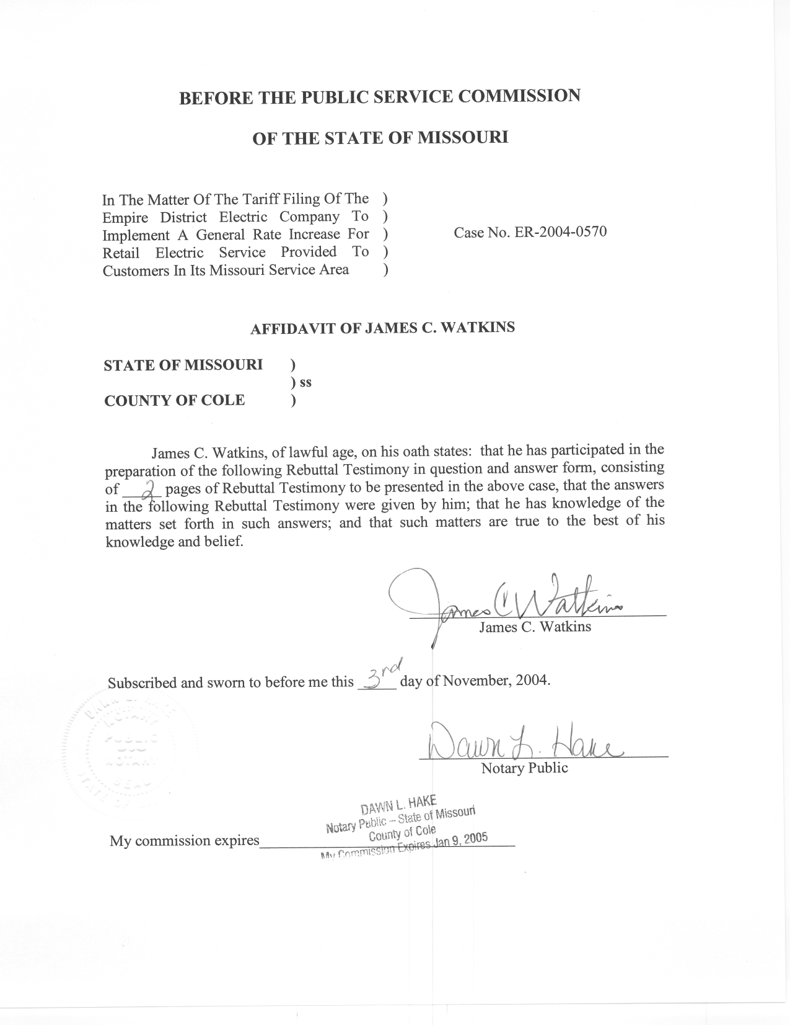
REBUTTAL TESTIMONY
OF
JAMES C. WATKINS
THE EMPIRE DISTRICT ELECTRIC COMPANY
CASE NO. ER-2004-0570
Q. Please state your name and business address.
A. My name is James C. Watkins and my business address is Missouri Public Service Commission, 200 Madison Street, P. O. Box 360, Jefferson City, Missouri 65102.
Q. Are you the same James C. Watkins who filed Direct Testimony on September 27, 2004 and October 4, 2004, on behalf of the Staff of the Missouri Public Service Commission (Commission)?
A. Yes.
Q. What is the purpose of this testimony?
A. The purpose of my testimony is to rebut the recommendation of Maurice Brubaker who testified on behalf of Explorer Pipeline Company and Praxair, Inc., regarding the appropriate mechanism for recovering and refunding an Interim Energy Charge (IEC).
Q. What cost-recovery mechanism does Mr. Brubaker recommend?
A. In the Fuel and Purchased Power Cost Recovery section on pages 8 and 9 of his Direct Testimony, Mr. Brubaker recommends that a percentage adder be applied to the base revenues of each rate schedule to collect the refundable portion of fuel costs.
Q. Has Mr. Brubaker provided a rationale to explain why this approach is appropriate?
A. No. Mr. Brubaker has not provided in his Direct Testimony any foundation for his recommendation. It appears contrary to any reasonable cost-causation principle with which I am familiar because fuel costs are not the same percentage of each customer’s bill.
Q. Has Mr. Brubaker provide an explanation of his true-up and refund mechanism?
A. Mr. Brubaker has not provided in his Direct Testimony any explanation of how the amount of any “refund entitlement” would be determined. Mr. Brubaker has not explained in his Direct Testimony how “base rate revenues” would be determined at the time of the refund. He merely states that “the refund entitlement . . . would be divided by base rate revenues and refunded to each rate schedule and each customer within each schedule a uniform percentage of base rate revenues.” (Direct, page 9, lines 4-7).
Q. Is Mr. Brubaker’s proposal workable?
A. Mr. Brubaker has not provided enough information regarding his proposal to make that determination.
Q. What is your recommendation to the Commission regarding Mr. Brubaker’s proposal?
A. Mr. Brubaker’s proposal should be rejected.
Q. Does this conclude your testimony?
A. Yes, it does.

