Exhibit No.:
Issues: IEC Rate Design

Witness: James C. Watkins
Sponsoring Party: MO PSC Staff
Type of Exhibit: Direct Testimony
Case No.: ER-2004-0570
Date Testimony Prepared: October 4, 2004

MISSOURI PUBLIC SERVICE COMMISSION

UTILITY OPERATIONS DIVISION

DIRECT TESTIMONY

OF

JAMES C. WATKINS

THE EMPIRE DISTRICT ELECTRIC COMPANY

CASE NO. ER-2004-0570

Jefferson City, Missouri
October 2004
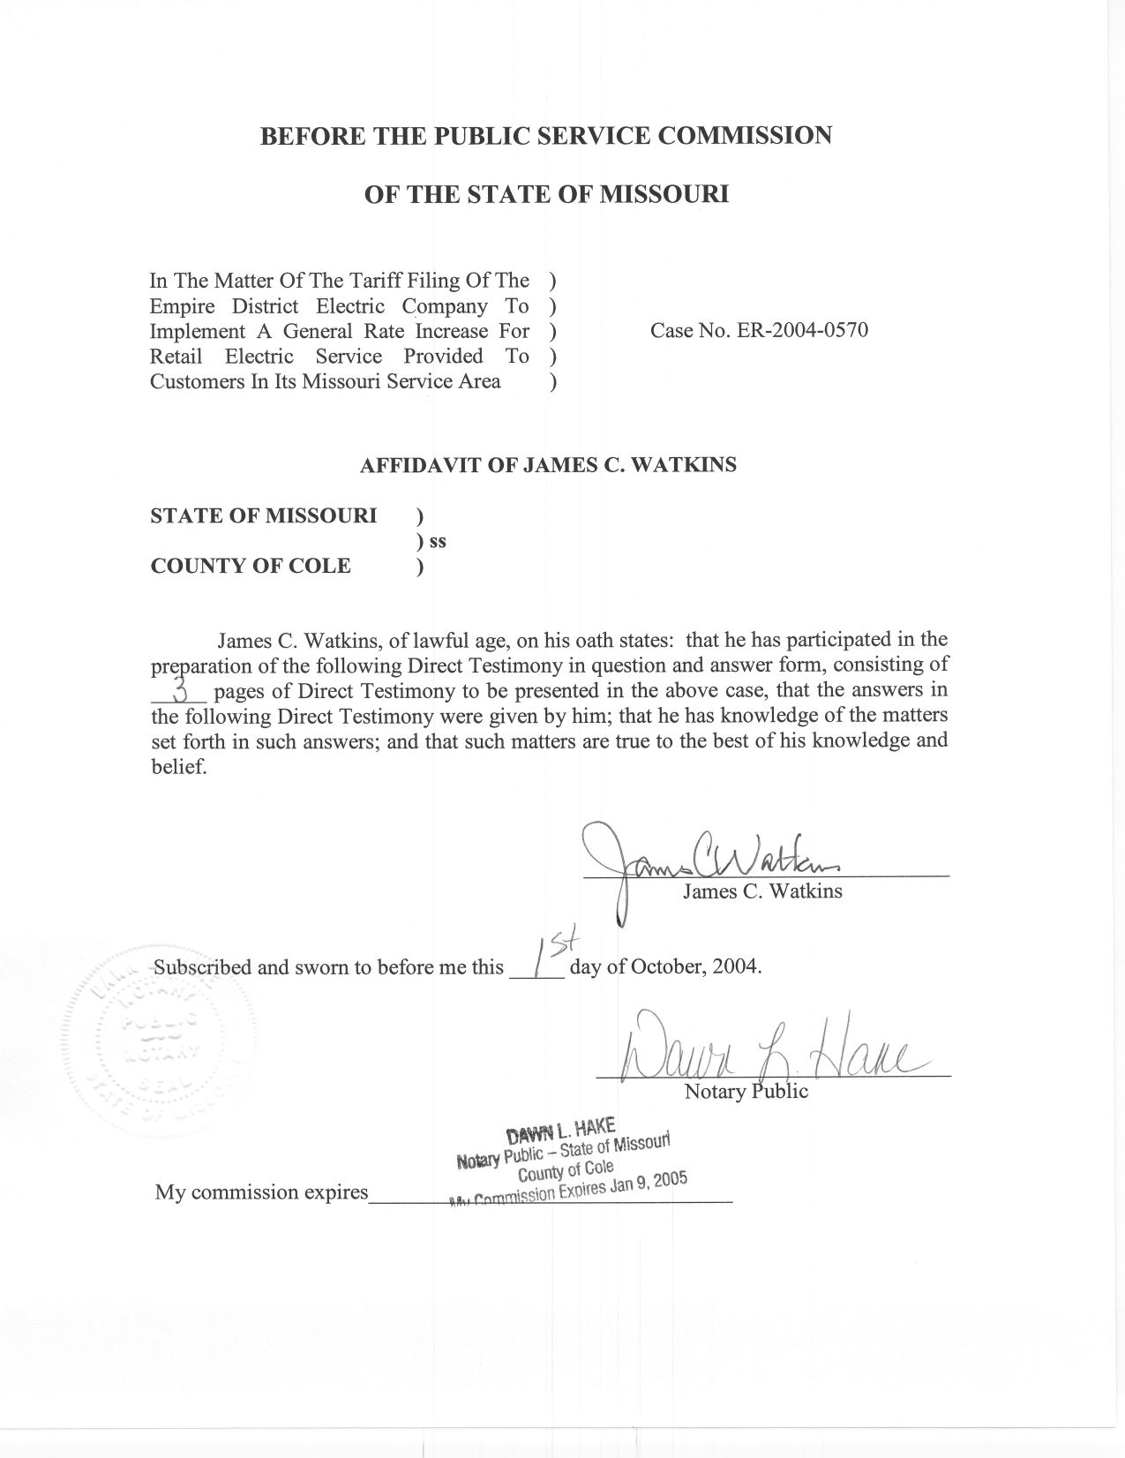
DIRECT TESTIMONY
OF
JAMES C. WATKINS
THE EMPIRE DISTRICT ELECTRIC COMPANY
CASE NO. ER-2004-0570
Q. Please state your name and business address.
A. My name is James C. Watkins and my business address is Missouri Public Service Commission, 200 Madison Street, P. O. Box 360, Jefferson City, Missouri 65102.
Q. Are you the same James C. Watkins who filed direct testimony on September 27, 2004, on behalf of the Staff of the Missouri Public Service Commission (Commission)?
A. Yes.
Q. What is the purpose of this testimony?
A. The purpose of my testimony is to recommend the appropriate rate for the Interim Energy Charge (IEC) proposed by the Staff. The IEC rate will collect the portion of variable fuel and purchased power expense that is subject to true-up and refund.

Rate Design

Q. What rate do you recommend?
A. I recommend that all customers pay an IEC rate of $0.0050 / kWh, subject to true-up and refund.
Q. How did you determine this rate?
A. I calculated this rate based on the Staff’s variable fuel and purchased power costs and Missouri retail sales. The system fuel and purchased power costs were developed by Staff witness Leon C. Bender and can be found in his direct testimony filed on September 20, 2004. The Missouri retail sales were developed by Staff witness Janice Pyatte and are described in her direct testimony filed on September 20, 2004. My calculation is shown in Schedule 1.
Q. Why are you recommending an IEC rate that will recover the portion of variable fuel and purchased power expense that is subject to true-up and refund on an equal-$/kWh basis for all classes.
A. First, this rate design is consistent with sound cost allocation principles. The cost of energy (variable fuel and purchased power) varies directly with usage (sales) and should be allocated to customer classes on that basis. This is one cost allocation principle that is almost universally accepted. In fact, all of the class cost-of-service studies filed in this case have allocated energy costs on the basis of sales. The effect of this method of cost allocation is that the energy costs allocated to every class are equal, on a $/kWh basis.
Second, expressing the rate in this fashion allows the “base” and “ceiling of the variable fuel and purchased costs to be expressed in the same manner. This is extremely important because the “base” and “ceiling” amounts are not fixed in terms of dollars, they are only fixed on a $/kWh basis. Thus, as load grows, additional costs will be incurred, even if fuel prices are unchanged. Rather than the entire cost increase being above a fixed-dollar “base,” a portion of this cost increase will be in “base” costs and will be recovered in permanent rates, and a portion of the cost increase will be above the “base” costs and will be recovered in the IEC rate, subject to true-up and refund.
Third, having only one rate that is the same for every customer makes the true-up and refund process much simpler and less prone to error.
Finally, because this is the way Empire’s previous IEC was set up, the Company has all of the required infrastructure in place for billing, monthly reporting, record retention, and refunding any over collections. This infrastructure has been tested and proven. No additional costs will be incurred to develop new infrastructure.
Q. Does this conclude your testimony?
A. Yes, it does.
 |  | Calculation of IEC Rate
“Ceiling” Run | Bender | Schedule 2-2 |  | $109,770,669.86
“Base” Run | Bender | Schedule 2-1 | - | $86,319,146.03
 |  |  |  | $23,451,523.83
Staff | Accounting | Schedule 9 | x | 82.49%
 |  |  |  | $19,345,162.01 | = | $0.0050 | / kWh
MO Retail Sales | Pyatte* | Schedule 3-1 |  | 3,879,584,897 | = | $0.0050 | / kWh
 | *Pyatte | Schedule 3-1 |  | 3,879,580,994
+ | Cogeneration Purchases |  | + | 3,903
 |  | MO Retail Sales |  | 3,879,584,897
References are to the Staff's Direct Testimony filed September 20, 2004.

