Exhibit No.:
Issues: Class Cost of Service; Rate Design; Low-Income-Fund
Witness: James C. Watkins
Sponsoring Party: MoPSC Staff
Type of Exhibit: Rebuttal Testimony
Case No.: ER-2002-424
Date Testimony Prepared: September 24, 2002

MISSOURI PUBLIC SERVICE COMMISSION

UTILITY OPERATIONS DIVISION

REBUTTAL TESTIMONY

OF

JAMES C. WATKINS

THE EMPIRE DISTRICT ELECTRIC
COMPANY

CASE NO. ER-2002-424

Jefferson City, Missouri
September, 2002

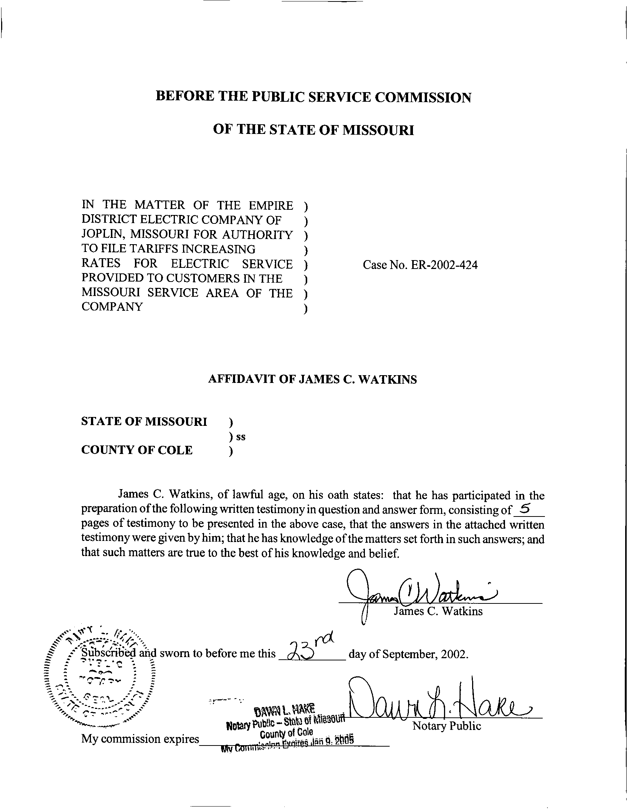
TABLE OF CONTENTS

Class Cost-Of-Service and Rate Design 1
Low-Income-Fund 5

REBUTTAL TESTIMONY
OF
JAMES C. WATKINS
THE EMPIRE DISTRICT ELECTRIC COMPANY
CASE NO. ER-2002-424

Q. Please state your name and business address.
A. My name is James C. Watkins and my business address is Missouri Public Service Commission, 200 Madison Street, P. O. Box 360, Jefferson City, Missouri 65102.
Q. Are you the same James C. Watkins who filed direct testimony on customer class cost of service and rate design in this case on August 30, 2002?
A. Yes, I am.
Q. What is the purpose of your rebuttal testimony in this case?
A. The purpose of my rebuttal testimony is to address the appropriate allocation of production capacity costs, both in regard to the overall allocation methodology and in particular to the treatment of interruptible loads. I will also address Empire’s proposed low-income fund.

Class Cost-Of-Service and Rate Design
Q. To what do you attribute the difference between the results of the various studies?
A. Almost all of the difference is due to the choice of production and transmission allocators. The Staff allocated these costs based on the “Time-of-Use” allocation methodology. The Office of the Public Counsel (OPC) allocated capacity costs based on an “Average & Peak” allocation methodology (not to be confused with “Average & Excess” methodology) and energy costs based on class contribution to sales. The OPC’s methodology represents an approximation of the “Time-of-Use” methodology, as is evidenced by the similarity in the results of the Staff’s and the OPC’s studies.
Both Empire and Praxair use a version of the “Average & Excess” method of allocating capacity costs, and use class contribution to sales to allocate energy costs.
Q. What is the “Average & Excess” method?
A. “Average & Excess” is a “Peak Responsibility” method of allocating capacity costs. In using this method, it is each class’s demand in one or a few hours of the year that is the determinant of the capacity costs allocated to each class. The demands in every other hour are ignored and usage throughout the year plays no role.
Q. Is the “Average & Excess” method a reasonable method for allocating production capacity costs to the customer classes?
A. No. Only a cost allocation methodology that gives weight to both class peak demands (amount of capacity) and class energy consumption (type of capacity) could be considered reasonable. The allocation of the cost of a generating unit should be based on the demands in every hour that the capacity of that unit is utilized to serve load.
Q. Has the Commission previously addressed the issue of production and transmission allocations?
A. The Commission’s Report And Order in Union Electric Case Nos. EO-85-17 and ER-85-160 contains the following discussion by the Commission:
The main concern of the Commission is to determine which theory most reasonably reflects the causation of production costs on the UE system. As stated earlier, the Commission has accepted in prior decisions, and again accepts, the [“Time-Of-Use”] method as the most reasonable method for allocating the production costs of serving the various classes. The Commission thinks that Staff’s position concerning causation is the most accurate and reasonable concerning the UE system. The Commission finds the evidence in this case supports the adoption of the TOU method. To adopt a [“Peak Responsibility”] method, one must first accept the contention that UE only builds new capacity to meet peak demand. The Commission cannot accept this. It is obvious Callaway was built to meet both base load and peak demand, and its cost should be shared on that basis. The Callaway plant is the first plant in UE’s loading order and UE will operate the Callaway plant as long as possible year-round. (Pages 148-149).

Q. Is there an additional problem with the allocation methodology employed by Praxair’s witness Maurice Brubaker?
A. Yes. The customer class cost-of-service study prepared by Mr. Brubaker allocates generating capacity costs to Praxair based only on that portion of its load that is firm (740 kW). (Brubaker direct, page 8, lines 14-15).
Q. Why is this a problem?
A. Praxair, like other interruptible customers, utilizes Empire’s generating capacity throughout the year to provide its power needs. In fact, in 1999 Praxair utilized 8,409 kW of Empire’s generating capacity at the time of system peak. In 2000, Praxair utilized 7,267 kW of Empire’s generating capacity at the time of system peak, vastly in excess of its 740 kW of “firm” load.
To allocate generation capacity costs, including not only generating plant, but general overhead costs as well, to only the firm portion of a customer’s load is unreasonable. The Commission has approved avoided-cost based interruptible credits for each of the electric utilities in Missouri. Under this scheme, costs are allocated to the entire load; then avoided-cost credits are paid to those customers that are willing to have their loads interrupted when called upon. The level of the credits is based on the costs that are saved by the utility by interrupting customers.
Q. Are there other significant differences between the class cost-of-service studies filed by the parties in this case?
A. There are other differences between the studies; however, these differences do not become significant in this case because none of the parties has recommended that the results of its class cost-of-service study should be the sole basis for determining class revenue responsibility in this case.
Q. What action do you recommend that the Commission take with regard to customer class cost-of-service issues?
A. I recommend that the Commission find: (1) that the “Average & Excess” peak responsibility method is not a reasonable method for allocating production and transmission costs; (2) that the Staff’s “Time-of-Use” (TOU) allocation of production and transmission costs is the most reasonable method; (3) that generating capacity costs should be allocated to each class’s entire load, not just to the “firm” portion of its load; and (4) that the Staff’s customer class cost-of-service study is therefore the most reasonable study presented for the Commission to consider in this case.
I further recommend that the Commission order that any overall rate increase ordered by the Commission be applied in a manner consistent with the Staff’s class cost-of-service study results as proposed in my direct testimony and illustrated in the direct testimony of Staff witness Janice Pyatte.

Low-Income Fund
Q. Does the Staff have a position on Empire’s proposed Experimental Low Income Rider?
A. The Staff is generally supportive of Empire’s proposal. The Commission recently approved a stipulation and agreement containing a very similar proposal for Missouri Gas Energy (MGE) in Case No. GR-2001-292.
Q. Are there details of Empire’s proposal that still need to be worked out?
A. Yes. These details, including a revised tariff sheet and the appropriate duration of the experimental program, should be worked out through a collaborative effort of interested parties and presented to the Commission for approval.
Q. Does this conclude your prefiled rebuttal testimony?
A. Yes.

