Exhibit No.:
Issues: IEC Rate Design

Witness: James C. Watkins
Sponsoring Party: MO PSC Staff
Type of Exhibit: Surrebuttal Testimony
Case No.: ER-2004-0570
Date Testimony Prepared: November 24, 2004

MISSOURI PUBLIC SERVICE COMMISSION

UTILITY OPERATIONS DIVISION

SURREBUTTAL TESTIMONY

OF

JAMES C. WATKINS

THE EMPIRE DISTRICT ELECTRIC COMPANY

CASE NO. ER-2004-0570

Jefferson City, Missouri
November 2004
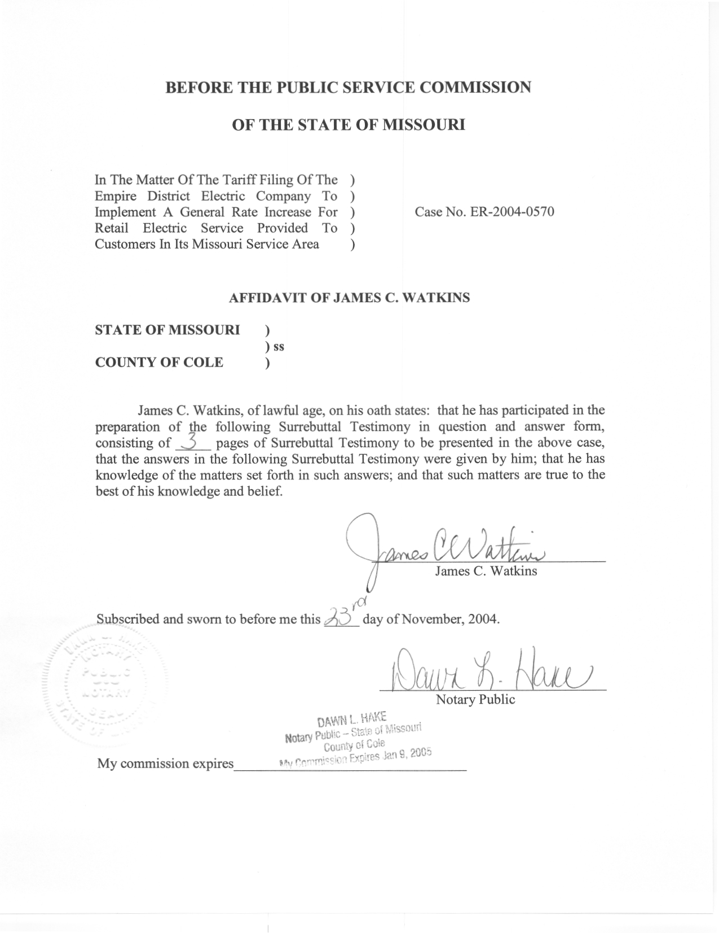
SURREBUTTAL TESTIMONY
OF
JAMES C. WATKINS
THE EMPIRE DISTRICT ELECTRIC COMPANY
CASE NO. ER-2004-0570
Q. Please state your name and business address.
A. My name is James C. Watkins and my business address is Missouri Public Service Commission, 200 Madison Street, P. O. Box 360, Jefferson City, Missouri 65102.
Q. Are you the same James C. Watkins who filed Direct Testimony on September 27, 2004 and October 4, 2004 and Rebuttal Testimony on November 4, 2004, on behalf of the Staff of the Missouri Public Service Commission (Commission)?
A. Yes.
Q. What is the purpose of this testimony?
A. The purpose of my testimony is to address the criticisms of my rebuttal testimony by Maurice Brubaker, who testified on behalf of Explorer Pipeline Company and Praxair, Inc., regarding the design of an Interim Energy Charge (IEC).
Q. What are Mr. Brubaker’s criticisms?
A. Briefly stated, Mr. Brubaker’s criticisms are as follows:
1. Allocating an increment to fuel cost on an equal-cents-per-kilowatt-hour basis is inappropriate because the base portion of fuel costs cannot be said to have been allocated to customer classes on the same basis.
2. Because of differences in losses, customers served at different voltage levels should not be charged the same rate for the IEC charge.
3. Because of differences in load patterns, different customer classes should not be charged the same rate for the IEC charge.
Q. Regarding Mr. Brubaker’s first point, would it be inappropriate to properly allocate incremental fuel costs in a situation where base fuel costs may not have been allocated by that method?
A. No. The Commission will determine the appropriate (just and reasonable) permanent rates for each customer class. The Interim Energy Charge collects only the additional cost of producing energy associated with higher fuel and purchased power prices. Collecting, and refunding, these additional costs caused by higher fuel and purchased power prices on an equal-cents-per-kilowatt-hour basis from all customers is much more reasonable than the arbitrary method proposed by Mr. Brubaker to the benefit of his clients.
Q. Regarding Mr. Brubaker’s second point, should losses be accounted for in determining the IEC charges for each rate schedule?
A. Yes.
Q. Regarding Mr. Brubaker’s third point, should the difference in load patterns be accounted for in determining the IEC charges for each rate schedule?
A. Mr. Brubaker has not indicated why he thinks that an increase in fuel costs due to higher fuel and purchased power prices would be affected by differences in load patterns, once these differences are accounted for in the permanent rates. Higher fuel and purchased power prices affect all hours of the year, not just peak hours in the summer.
Q. What is your recommendation to the Commission regarding Mr. Brubaker’s criticisms?
A. Mr. Brubaker’s criticisms should be rejected.
Q. Does this conclude your testimony?
A. Yes, it does.

