Exhibit No.:
Issues: Cost of Service
Rate Design

Witness: James C. Watkins
Sponsoring Party: MO PSC Staff
Type of Exhibit: Direct Testimony
Case No.: ER-2004-0570
Date Testimony Prepared: September 27, 2004

MISSOURI PUBLIC SERVICE COMMISSION

UTILITY OPERATIONS DIVISION

DIRECT TESTIMONY

OF

JAMES C. WATKINS

THE EMPIRE DISTRICT ELECTRIC COMPANY

CASE NO. ER-2004-0570

Jefferson City, Missouri
September 2004
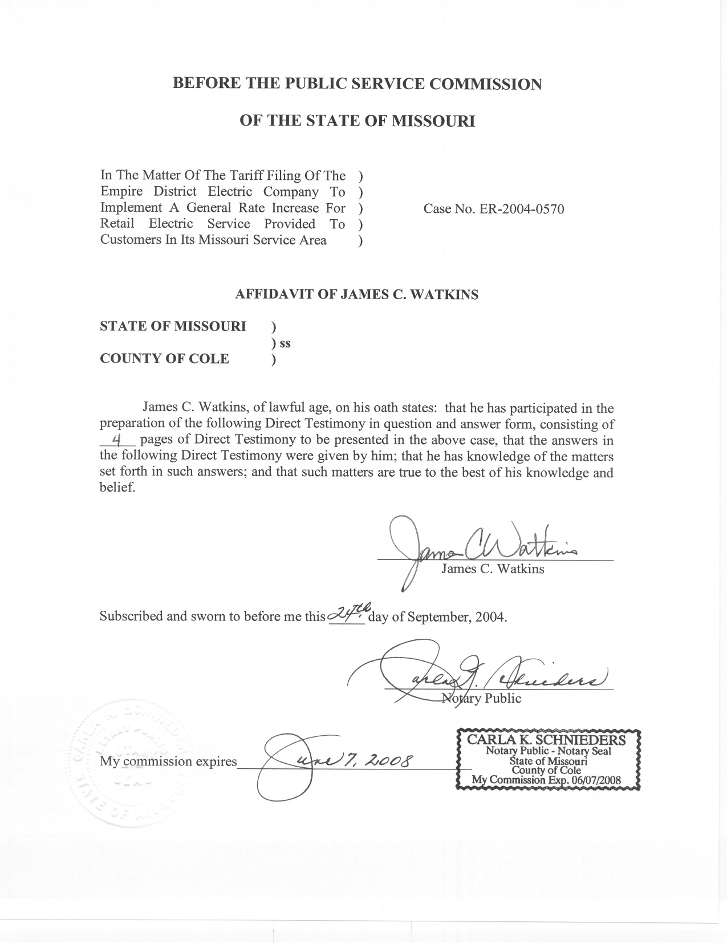
TABLE OF CONTENTS

Class Cost of Service 2
Rate Design 3

DIRECT TESTIMONY
OF
JAMES C. WATKINS
THE EMPIRE DISTRICT ELECTRIC COMPANY
CASE NO. ER-2004-0570
Q. Please state your name and business address.
A. My name is James C. Watkins and my business address is Missouri Public Service Commission, 200 Madison Street, P. O. Box 360, Jefferson City, Missouri 65102.
Q. What is your present position with the Missouri Public Service Commission (Commission)?
A. My title is Manager, Economic Analysis, Energy Department, Operations Division.
Q. Please review your educational background and work experience.
A. I have a Bachelor of Arts Degree in Economics from William Jewell College, a year of graduate study at the University of California at Los Angeles in the Masters Degree Program, and have completed all requirements except my dissertation for a Ph.D. in Economics from the University of Missouri-Columbia. My previous work experience has been as an Instructor of Economics at Columbia College, the University of Missouri-Rolla, and William Jewell College. I have been on the Staff of the Missouri Public Service Commission (Staff) since August 1, 1982. A list of the major cases in which I have filed testimony before the Commission is shown on Schedule 1.
Q. Are you one of the Case Coordinators for this case?
A. Yes. I am primarily responsible for coordination within the Operations Division and for the Class Cost of Service and Rate Design filings.
Q. What is the purpose of your Direct Testimony in this case?
A. The purpose of my Direct Testimony is to recommend appropriate shifts in customer class revenue responsibility based on the results of the Staff’s class cost-of-service study.

Class Cost of Service

Q. Did the Staff perform a customer class cost-of-service study in this case?
A. Yes. The study was prepared by Staff witness Hong Hu and is presented in her testimony.
Q. How would you evaluate the results of that study?
A. I would evaluate the results in terms of the class revenue shifts that would be required to equate revenue to cost of service for each class after each class’s revenue is increased (or decreased) by an equal percentage to recover the overall revenue requirement (total cost of service); i.e., by expressing the results on a “revenue-neutral” basis.
Q. Please describe the results on that basis.
A. The adjusted current rates for the Residential Class would recover within five percent (5%) of the class’s cost of service; as would the adjusted current rates for the non-residential classes, in the aggregate. Residential rates would recover somewhat less than the cost of service. Non-residential rates recover somewhat more than the cost of service.
Within the non-residential classes, adjusted current rates would recover about six percent (6%) more than the cost of service for the Small General Service and Large General Service classes; however, the adjusted rates of the Large Power class would recover about one percent (1%) less than the cost of service, and the adjusted rates of the Special Contract class would recover about ten percent (10%) less than the cost of service.

Rate Design

Q. What are your rate design recommendations in this case?
A. At this time, I am reluctant to make any recommendation for disproportionate changes to the permanent rates of any of the classes. It is my opinion that the revenue shifts indicated by the class cost-of-service study, given the quality of the input data, may not rise to such a level of significance that disproportionate adjustments to the rates are required. Furthermore, such adjustments, in combination with an Interim Energy Charge and any rate design changes, may significantly and adversely impact particular segments within each class.
Aside from the Special Contract class, whose revenues are more than ten percent (10%) below the cost of providing service to them, the two classes that would most need adjusting are the Large General Service and Large Power Service classes. Disproportionately changing these rates would cause some Large Power customers to switch to the Large General Service rate. The effects of this would be a reduction in the Company’s revenues that cannot be quantified by the Staff.
Q. Will you re-evaluate your recommendation after the Staff has completed its seasonal class cost-of-service study and incorporated the effects of the Interim Energy Charge?
A. Yes. The Staff will file its overall rate design recommendation on October 4, 2004.
Q. Does this conclude your testimony?
A. Yes, it does.
- The Empire District Electric Company Case No. ER-83-42
- Kansas City Power & Light Company Case No. ER-83-49
- Union Electric Company Case No. ER-83-163
- Arkansas Power & Light Company Case No. ER-83-206
- The Empire District Electric Company Case No. ER-83-364
- Kansas City Power & Light Company Case No. EO-84-4
- Union Electric Company Case No. EO-85-17
- Arkansas Power & Light Company Case No. ER-85-20
- Arkansas Power & Light Company Case No. EO-85-146
- Union Electric Company Case No. ER-85-160
- Kansas City Power & Light Company Case Nos. ER-85-128 & EO-85-185
- Arkansas Power & Light Company Case Nos. ER-85-265 & ER-86-4
- Union Electric Company Case Nos. EC-87-114 & EC-87-115
- St. Joseph Light & Power Company Case No. HR-88-116
- Union Electric Company Case No. EO-87-175
- Missouri Public Service Case No. ER-90-101
- The Empire District Electric Company Case No. ER-90-138
- Kansas City Power & Light Company Case No. EM-91-16
- St. Joseph Light & Power Company Case No. EO-88-158
- The Empire District Electric Company Case No. EO-91-74
- Missouri Public Service Case No. EO-91-245
- Missouri Public Service Case No. EO-93-37
- St. Joseph Light & Power Company Case No. ER-93-41
- St. Joseph Light & Power Company Case No. EO-93-351
- St. Joseph Light & Power Company Case No. ER-94-163
- The Empire District Electric Company Case No. ER-94-117
- Citizens’ Electric Corporation Case No. ER-97-286
- The Empire District Electric Company Case No. ER-97-81
- The Empire District Electric Company Case No. ER-97-491
- Missouri Public Service Case Nos. ER-97-394 & ET-98-103
- St. Joseph Light & Power Company Case Nos. EC-98-573 & ER-99-247
- Citizens’ Electric Corporation Case No. ET-99-113
- Union Electric Company Case No. EO-96-15
- Union Electric Company Case No. EO-2000-580
- The Empire District Electric Company Case No. ER-2001-299
- Missouri Public Service Case No. ER-2001-672 & EC-2002-265
- Union Electric Company Case No. EC-2002-1
- Citizens’ Electric Corporation Case No. ER-2002-217
- The Empire District Electric Company Case No. ER-2001-1074 (ER-2001-425)
- The Empire District Electric Company Case No. ER-2002-424
- Aquila, Inc. (MPS & L&P) Case Nos.ER-2004-0034 & HR-2004-0024

