Exhibit No.:
Issues: ETC Designation

Witness: Adam C. McKinnie
Sponsoring Party: MO PSC Staff
Type of Exhibit: Surrebuttal Testimony
Case No.: TO-2003-0531
Date Testimony Prepared: January 14, 2004

MISSOURI PUBLIC SERVICE COMMISSION

Utility Operations Division

SURrebuttal TESTIMONY

OF

Adam C. McKinnie

Missouri RSA No. 7 Limited Partnership
d/b/a Mid-Missouri Cellular

CASE NO. TO-2003-0531

Jefferson City, Missouri
January 2004

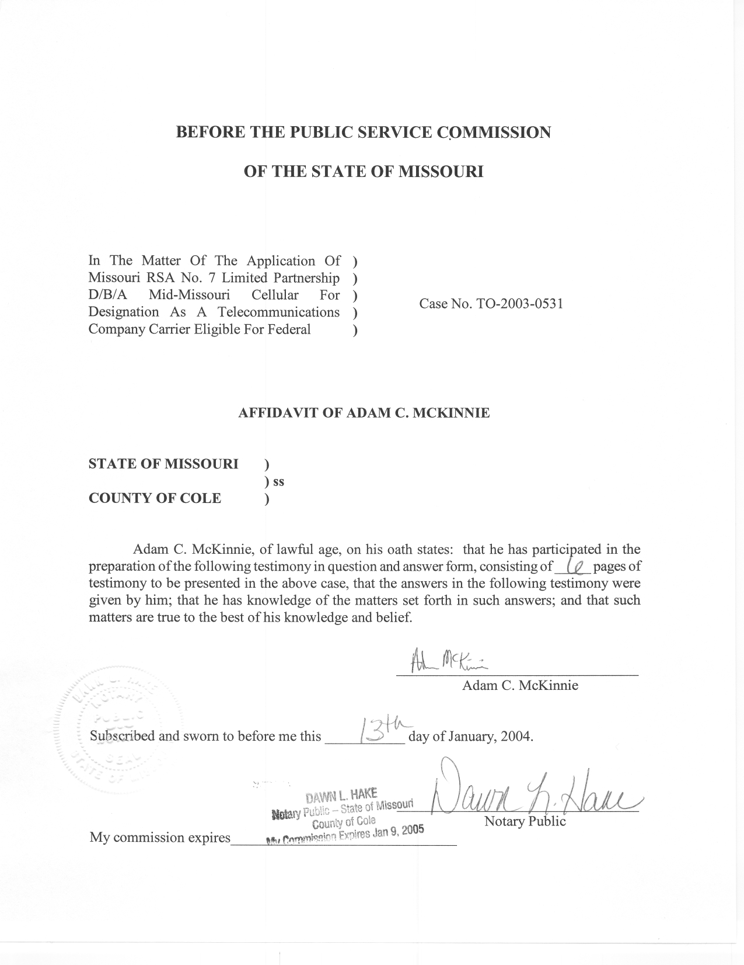
SURREBUTTAL TESTIMONY OF
ADAM C. MCKINNIE
MISSOURI RSA NO. 7 LIMITED PARTNERSHIP
D/B/A MID-MISSOURI CELLULAR
TO-2003-0531

Q. Are you the same Adam McKinnie that filed Rebuttal Testimony in this case?
A. Yes, I am.
Q. What is the purpose of your Surrebuttal Testimony?
A. The purpose of my Surrebuttal Testimony is to respond to the Rebuttal Testimony of Arthur Martinez from CenturyTel of Missouri, Inc. and to clarify Staff’s position as stated in my Rebuttal Testimony.
Q. Starting on page 9, line 30 of his Rebuttal Testimony, CenturyTel witness Martinez states:
“When ETC status is granted to a competitive carrier, the Commission is essentially determining that there is more than one provider in the designated areas that is fully capable and willing to provide basic telecommunications services throughout these areas. Once this occurs, basic service should immediately be declared subject to effective competition and the incumbent should be regulated on the same basis as the competitor, including total pricing flexibility on basic service rates.” (emphasis added)

Q. Has the Commission taken a position on this issue in the past?
A. Yes, it has. In its discussion of the state of competition in the Sprint Effective Competition Case, IO-2003-0281, the Commission noted that as an Eligible Telecommunications Carrier (ETC), ExOp was required to offer its services to customers throughout an exchange. However, ExOp was not required to have facilities in place to serve all customers in an exchange. The Commission stated in its Report and Order the following regarding the relationship between ETC status and effective competition:
Although ExOp is an ETC in Platte City, and may someday be able to serve a larger proportion of the customers in that exchange, its status as an ETC does not immediately make it an effective competitor for Sprint.
Q. Is it reasonable for a company to expect to have competitive status bestowed on their basic local service in an exchange where another company has been granted Eligible Telecommunications Carrier (ETC) status?
A. No, it is not. Missouri Statutes at Section 392.185 and 392.245 provide guidance on the determination of effective competition. Section 392.245.5 states:
392.245(5) Each telecommunications service of an incumbent local exchange telecommunications company shall be classified as competitive in any exchange in which at least one alternative local exchange telecommunications company has been certified under Section 392.455 and has provided basic local telecommunications service in that exchange for at least five years, unless the commission determines, after notice and a hearing, that effective competition does not exist in the exchange for such service. The commission shall, from time to time, on its own motion or motion by an incumbent local exchange telecommunications company, investigate the state of competition in each exchange where an alternative local exchange telecommunications company has been certified to provide local exchange telecommunications service and shall determine, no later than five years following the first certification of an alternative local exchange telecommunication company in such exchange, whether effective competition exists in the exchange for the various services of the incumbent local exchange telecommunications company.
Competitive classification occurs five years following the certification of an alternative local exchange telecommunication company in such exchange, absent a Commission investigation which finds otherwise.
Q. Is there a way for an ILEC to price on an exchange specific basis without going through an effective competition case?
A. Yes, there is. 392.200.4(2) RSMo states that an incumbent local exchange company in an exchange where an alternative local exchange company is providing basic local or switched access service can submit a tariff filing as stated in 392.200.4(2)(a) RSMo to price and market services:
(a) For services proposed on an exchange-wide basis, it shall be presumed that a tariff which defines and establishes prices for a local exchange telecommunications service or exchange access service as a different telecommunications service in the geographic area, no smaller than an exchange, within which such local exchange telecommunications service or exchange access service is offered is reasonably necessary to promote the public interest and the purposes and policies of this chapter;

Mid Missouri Family Relationship:
- You stated an additional purpose of your testimony was to provide clarification of Staff’s position in its Rebuttal Testimony. Have you received additional information that would assist the Commission?
A. Yes. I have. The company provided additional information in response to supplemental Data Requests (DRs) submitted by Staff.
Q. Can you explain?
A. Staff, in its Rebuttal Testimony, expressed concerns about intercompany transactions as depicted in company financials and their impact on Mid Missouri Cellular (MMC) receiving support from the universal service fund. Staff sent supplemental DRs seeking additional information on shared transactions.
Q. What is the current state of transactions between Mid Missouri Cellular and Mid Missouri Telephone?
A. After having discussions with Mid Missouri representatives and receiving Data Request Responses from Mid Missouri Cellular, Staff has learned that only the following transactions currently take place between MMC and Mid Missouri Telephone Company (MMT):
  - Mid-Missouri Cellular (MMC) leases four phone lines from Mid- Missouri Telephone Company (“MMT”).
b. MMC leases two cell sites from MMT and land and a small building for a third cell site.
- MMC leases seven T-1 circuits from MMT.
- MMC leases from MMT a 6.7 mile fiber link from MMT’s Marshall Central Office to MMC’s Marshall cell site. MMC also leases from MMT a fiber link from Pilot Grove to MMC’s Boonville cell site.
e. MMC leases MMT’s voice mail system for MMC’s customers’ use.
- MMT is a sales and service agent for MMC.
- MMT receives cellular service from MMC.
h. MMT leases fiber between Alma and Marshall from MMC.
- MMT leases four T-1 circuits from MMC.
Q. Do you have any additional information to provide about the current state of past accounting and billing services for Mid Missouri Cellular that were performed by Mid Missouri Telephone employees?
A. Yes, I do. Mid Missouri Cellular submitted responses to Staff Data Requests that stated the following:
Up to and including April 2002 when MMC acquired its own billing system, MMT employees provided billing services to MMC. After this acquisition, there was a transition period of approximately thirty to sixty days when MMT employees had some involvement in the billing function on behalf of MMC.

With respect to accounting, MMT employees provided those services up to and including Nov. 4, 2003, when MMC engaged its own in-house accountant, who was trained by MMT personnel for approximately six weeks from the date of hire. MMC anticipates that its in-house accountant will receive approximately one or two additional days of training from MMT personnel in 2004. With this minor exception, MMC now performs all billing and accounting functions with MMC employees. As a result, MMC’s financials for 2004 will be the first year that reflect MMC billing and accounting functions being performed entirely by MMC personnel (with the exception of the limited training discussed above).

Q. What conclusions can you draw from this additional information?
A. Many of the concerns about MMC and MMT both receiving support from Universal Service Fund (USF) for shared services and or networks that Staff had in Rebuttal Testimony have been addressed. Staff has been presented with information by MMC that the billing systems and accounting functions of Mid Missouri’s wireline and wireless companies are now being handled separately. Staff has also been presented with information regarding the current transactions between the two Mid Missouri companies. The accounting safeguards regarding separate affiliate transactions are designed to provide proper allocation of transactions. Theoretically, the separate affiliate safeguards should prevent USF monies being delivered to both Mid Missouri companies for any remaining shared activities; thus, alleviating Staff’s concerns.
Q. Does this additional information change Staff’s ultimate recommendation to the Commission regarding the application at hand?
A. No, it does not. As stated in Staff’s Rebuttal Testimony, Mid Missouri Cellular has not provided evidence regarding the public interest. If the Commission is going to make a finding that MMC should be granted ETC status, the Commission must make a finding that it is in the public interest.
Q. Please summarize your testimony.
A. The main purpose of my testimony is to respond to the Rebuttal Testimony of Arthur Martinez from CenturyTel of Missouri, Inc. As I have discussed, an ILEC’s basic local service in an exchange should not be automatically granted effectively competitive status just because another company has been granted ETC status in that exchange. Missouri statutes outline the processes for determining when services are deemed effectively competitive or when a company can price on an exchange-specific basis. My testimony also clarifies Staff’s Rebuttal Testimony as a result of receiving additional information in response to supplemental Staff Data Requests. Finally, my testimony reinforces Staff’s recommendation that MMC’s application for ETC status should be denied because the company has not provided evidence for the Commission to make a public interest finding.
Q. Does this conclude your surrebuttal testimony?
A. Yes, it does.

