

The Empire District Electric Company

Demand-Side Resource Potential Study
2011-2013

Prepared for:
The 2010 Integrated Resource Plan

Prepared by:
Applied Energy Group on behalf of

The Empire District Electric Co.
August, 2010

Table of Contents
Executive Summary 1
Market Assessment 2
Program Portfolio Overview 4
Program Budgets, Savings, and Cost-Effectiveness 4
Study Contents 13
1. Introduction 14
Empire Philosophy 14
Study Development Process Overview 14
Multi-Criteria Approach 16
Additional External Considerations for the Analysis 27
Assessments of Potential 29
Measure and Program Screening 29
2. Potential Assessment 30
Analysis Methodology 30
Technical Potential 34
Economic Potential 34
Achievable Potential 35
3. General Program Design Approach 37
Delivery Mechanisms 37
Qualifying Energy-Efficiency Measures 37
Participation 37
Impacts 38
Eligibility 38
Training 39
Budgets 39
Program Evaluation 39
4. Energy-Efficiency Programs 40
Introduction 40
Low-Income Assistance Program 43
Residential High Efficiency Lighting 45
Residential High Efficiency Cooling Program 47
Refrigerator Pickup Program 49
Home Performance With Energystar 50
Home Energy Comparison Reports 52
Energy Star Appliance Rebates 53
Direct Load Control 55
Commercial Prescriptive Rebate Program 56
Commercial Custom Rebate Program 64
Large C&I Turnkey Energy-Efficiency Program 65
Small Business Direct Install 68
Building Operator Certification Program 69
Large C&I Voluntary Interruptible/Peak Load Reduction Program 70
List of Appendices 73

Executive Summary
The Empire District Electric Company (“Empire” or the “Company”) is pleased to present this Demand-Side Resource Potential Study (Study) in connection with its 2010 Integrated Resource Plan (“IRP”) filing. Energy efficiency has been an increasing component of Empire’s operations in Missouri since 2005, with numerous programs serving the needs of different customer types throughout the service territory. The two key tenets of Empire’s programs are:
- The service area benefits from energy-efficiency programs. As part of the overall strategy for meeting the needs of its customers, cost-effective energy-efficiency programs are a less costly alternative to construction of infrastructure and purchase of fuel for generation.
- Empire customers benefit from energy-efficiency programs. Energy efficiency can result in lower bills; so participants in Empire’s programs immediately benefit from a reduction in their consumption of electricity. Furthermore, the programs are designed to be inclusive; so all customers have the opportunity to benefit from Empire’s energy-efficiency programs.
Guided by these tenets, the creation of this study has adhered to a rigorous planning process. The various phases of this process are shown in Figure ES.1 and are specific to the development of Empire’s demand-side resource portfolio.

FigureES1: Program Planning Process
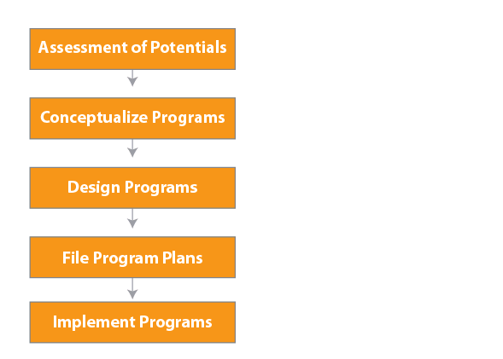

Market Assessment
The assessment’s starting point is based on three different types of demand side management potential that are defined and used to describe savings from energy-efficiency measures(EEMs): technical, economic, and achievable.Technical potential assumes total and continuous conversion to the most efficient technologies, regardless of cost. It provides the broadest and highest definition of DSM potential since it estimates savings that would result if all installed equipment and processes were replaced by the best available equipment and processes in all markets.
For the assessment of economic potential, estimates are based on modified savings for new construction, equipment replacement, and retrofit EEMs using the maximum savings only where measures and technologies are cost-effective. The assessment of maximum achievable potential is based on the same savings estimatesused for economic potential, with modifications residing in assumptions of market penetration on Empire’s programmatic successes, best practice studies, regulatory input and feedback from trade allies. Whereas economic potential estimates assume 100 % market penetration, the achievable potential estimates rely on these realistic penetration rates achieved from actual utility energy-efficiency programs. Achievable potential is further refined to reflect other considerations, such as budgets or market barriers. (The refined estimate of achievable potential is often referred to as realistic achievable potential.)
For the purposes of this analysis four separate 20-year program scenarios were developed using different assumptions regarding avoided cost. Scenario 1 assumed no value associated with carbon savings, while Scenario 4 assumed a high value associated for carbon offsets. Annual budgets for the portfolios run from $1.187M for the no carbon adder scenario to $4.670M for the high value carbon adder scenario.
Tables ES-1 through ES-2 provide the energy savings estimated in the technical potential, economic potential, and achievable potential studies performed as part of the analysis for this Study.

Table ES.1: Potential Estimates (kWh):
 | Technical | Economic | Achievable
Residential | 915,965,277 | 551,882,020 | 45,190,194
Commercial | 448,836,606 | 328,349,329 | 24,626,200
Industrial | 118,775,076 | 86,420,187 | 6,481,514
Total | 1,483,576,959 | 966,651,536 | 69,816,394

Table ES.2: Potential Estimates (Percent of baseline):
 | Technical | Economic | Achievable
Residential | 49% | 29% | 8%
Commercial | 27% | 18% | 1%
Industrial | 18% | 13% | 1%
Total | 25% | 17% | 1%

Program Portfolio Overview
Empire has developed four scenarios for screening measures, developing efficiency programs and designing the Company’s energy-efficiency portfolio. Each scenario is based on different assumptions regarding avoided cost; and is consistent with the scenarios developed for the Company’s IRP filing. The avoided costs were based on different levels of probable environmental costs. The Company developed the following four scenarios:
- Scenario 1avoided costs do not include a future carbon cost case
- Scenario 2 avoided costs include a low carbon cost case
- Scenarios 3 avoided costs include medium level carbon taxes (this is also referred to as the “base” case)
- Scenario 4 avoided costs assumes high carbon cost case
For the base case (Scenario 3) the Company included CO₂costs in its forecast. The Company also assumed that a cap-and-trade program will be implemented across all sectors beginning in 2015. In addition, for the base case, retirement of certain units was also assumed.
Empire’s energy-efficiency portfolio is composed of residential, commercial and industrialprograms, with each designed to address the needs of various customer types. The residential programs include options for low income customers, lighting and appliance rebates, home energy comparison analysis, refrigerator recycling and more. The commercial and industrial programs include prescriptive and custom rebates and small business direct installation. There are also programs targeted specifically towards Building Owner Certification and “turnkey” installations which include both technical assistance and incentives.

Program Budgets, Savings, and Cost-Effectiveness
Development of this study has provided an opportunity for Empire to review its program offerings and explore both program improvements and innovative new offerings.The total annual budget for the first year of program operation (2011) for each of the four scenarios is presented in Table ES.3. Additional detail for future program years is contained in Appendix A. The portfolio provides a comprehensive suite of programs and assures that each customer has an opportunity to participate.
Table ES.3: Program Budget Summary by Scenario

Program | Scenario 1 | Scenario 2 | Scenario 3 | Scenario 4
Total All Programs | $1,187,800 | $2,098,217 | $2,682,917 | $4,669,667
Total Residential | $826,300 | $1,226,300 | $1,723,750 | $3,174,750
Low-Income Assistance | $99,750 | $99,750 | $199,500 | $399,000
Refrigerator Pick Up | $90,000 | $90,000 | $135,000 | $360,000
Energy Star Appliance - Refrigerator | $0 | $0 | $30,000 | $135,000
Energy Star Appliance – Washing Machines | $0 | $0 | $16,250 | $32,500
Energy Star Appliance - Dehumidifiers | $0 | $0 | $0 | $16,250
Residential High Efficiency Lighting | $7,800 | $7,800 | $78,000 | $117,000
Residential High Efficiency Cooling | $81,250 | $81,250 | $130,000 | $390,000
Home Performance with EnergyStar | $100,000 | $150,000 | $150,000 | $200,000
Home Energy Comparison Reports | $97,500 | $97,500 | $110,000 | $150,000
Residential Direct Load Control | $350,000 | $700,000 | $875,000 | $1,375,000
Total C&I | $361,500 | $871,917 | $959,167 | $1,494.917
Commercial/Industrial Prescriptive Rebate | $126,500 | $126,500 | $189,750 | $253,000
Commercial/Industrial Custom Rebate | $154,000 | $154,000 | $154,000 | $308,000
Small Business Direct Install | $0 | $0 | $0 | $318,500
Building Operator Certification (BOC) | $35,000 | $35,000 | $35,000 | $35,000
Large C&I Turnkey Energy Efficiency | $0 | $510,417 | $510,417 | $510,417
Large C/I Voluntary Interruptible/Peak Load Reduction | $46,000 | $46,000 | $70,000 | $ 70,000

The above program budget options reflectEmpire’s commitment toward obtaining the greatest amount of cost-effective, energy-efficiency savings feasible over the planning horizon, and an equitable balance of the energy-efficiency costs between participants and ratepayers.
The analysis of the program’s cost-effectiveness is an important part of the planning process, both in terms of meeting regulatory requirements and in selecting and designing the various programs.

Table ES.4showsthe energy savings for each program for each scenario; Table ES.5showsdemand savings by program for each scenario; Table ES.6showsthe cost-effectiveness test resultsfrom the Total Resource Cost (TRC) test by program for each scenario;and Table ES.9 showsthe participation levels. Tables ES.4, ES.5 and ES.6 represent results for first program year (2011). Additional detail for future program years is contained in Appendix A.
Table ES.4:KWh Energy Savingsby Scenario

Program | Scenario 1 | Scenario 2 | Scenario 3 | Scenario 4
Total All Programs | 4,684,827 | 7,436,483 | 11,798,795 | 19,134,775
Total Residential | 3,489,848 | 3,623,424 | 7,622,409 | 13,173,008
Low-Income Assistance | 72,451 | 72,451 | 144,903 | 289,806
Refrigerator Pick Up | 441,868 | 441,868 | 662,802 | 1,767,472
Energy Star Appliance - Refrigerator | 0 | 0 | 94,037 | 423,167
Energy Star Appliance – Washing Machines | 0 | 0 | 128,233 | 256,465
Energy Star Appliance - Dehumidifiers | 0 | 0 | 0 | 158,688
Residential High Efficiency Lighting | 288,523 | 288,523 | 2,885,232 | 4,327,848
Residential High Efficiency Cooling | 199,829 | 199,829 | 319,726 | 959,179
Home Performance with EnergyStar | 203,035 | 304,552 | 304,552 | 406,070
Home Energy Comparison Reports | 2,252,084 | 2,252,08 | 3,002,778 | 4,504,168
Residential Direct Load Control | 32,058 | 64,116 | 80,145 | 80,145
Total C&I | 1,194,978 | 3,813,059 | 4,176,386 | 5,961,767
Commercial/Industrial Prescriptive Rebate | 470,186 | 470,186 | 705,279 | 940,372
Commercial/Industrial Custom Rebate | 511,072 | 511,072 | 511,072 | 1,022,143
Small Business Direct Install | 0 | 0 | 0 | 948,386
Building Operator Certification (BOC) | 181,663 | 181,663 | 181,663 | 272,494
Large C&I Turnkey Energy Efficiency | 0 | 2,618,081 | 2,618,081 | 2,618,081
Large C/I Voluntary Interruptible/Peak Load Reduction | 32,508 | 32,058 | 160,291 | 160,291

Table ES.5:kW Demand SavingsbyScenario
Program | Scenario 1 | Scenario 2 | Scenario 3 | Scenario 4
Total All Programs | 2,835 | 4,517 | 9,755 | 11,291
Total Residential | 1,516 | 2,632 | 3,477 | 4,661
Low-Income Assistance | 21 | 21 | 41 | 83
Refrigerator Pick Up | 55 | 55 | 82 | 220
Energy Star Appliance - Refrigerator | 0 | 0 | 12 | 53
Energy Star Appliance – Washing Machines | 0 | 0 | 16 | 33
Energy Star Appliance - Dehumidifiers | 0 | 0 | 0 | 106
Residential High Efficiency Lighting | 8 | 8 | 75 | 113
Residential High Efficiency Cooling | 230 | 230 | 368 | 1,103
Home Performance with EnergyStar | 58 | 87 | 87 | 116
Home Energy Comparison Reports | 59 | 59 | 78 | 117
Residential Direct Load Control | 1,087 | 2,174 | 2,717 | 2,717
Total C&I | 1,319 | 1,884 | 6,278 | 6,631
Commercial/Industrial Prescriptive Rebate | 92 | 92 | 139 | 185
Commercial/Industrial Custom Rebate | 100 | 100 | 100 | 201
Small Business Direct Install | 0 | 0 | 0 | 186
Building Operator Certification (BOC) | 39 | 39 | 39 | 59
Large C&I Turnkey Energy Efficiency | 0 | 565 | 565 | 565
Large C/I Voluntary Interruptible/Peak Load Reduction | 1,087 | 1,087 | 5,435 | 5,435

Benefit Cost Tests

There are many methods used to assess the cost-effectiveness of an energy efficiency measure. Empire focuses on the Total Resource Cost Test (TRC) as the primary method to determine cost-effectiveness. The TRC Test is a widely-accepted methodology that has been used across the United States for over twenty-five years. For Empire, the use of the TRC calculation includes varying costs for carbon as described above in the definition of the four scenarios used in this analysis.

Total Resource Cost Test

TRC measures the net costs of a demand-side management program as a resource option based on the total costs of the program, including both the participants’ and the utility’s costs. This test represents the combination of the effects of a program on both customers participating and those not participating in a program. The benefits calculated in the Total Resource Cost Test are the avoided supply cost: the reduction in transmission, distribution, generation and capacity costs valued at marginal cost for the periods when there is a load reduction. The costs in this test are the program costs paid by the utility and the participant plus the increase in supply costs for the periods in which load is increased. Thus, all equipment costs, operation and maintenance, cost of removal and administration costs, no matter who pays for them, are included in this test. For Empire, the TRC also includes various estimates of avoided costs associated with carbon emissions. In some instances because of the addition of these environmental costs TRC may also be referred to as the Societal Cost Test.
The benefit-cost resulting from the application of this test is the ratio of the discounted total benefits of the program to the discounted total costs over a specified time period. A benefit-cost ratio above one indicates that the program is beneficial to the utility and its ratepayers on a total resource cost basis.

Cost-Effective Measures for Empire

In order to determine energy-efficiency measures that should be considered opportunities for achievable energy savings in Empire’s service area, a comprehensive benefit-cost analysis was conducted on a wide range of measures that effect electric consumption across all customer classes. The TRC test was performed using data specific to the Company. When the TRC test results produce a value greater than one for any given measure or bundle of measures, it is judged to be a cost-effective application, implying that it is more beneficial to implement the energy-efficient technology instead of utilizing a supply-side resource to provide electricity. Measures passing the TRC test become eligible for inclusion in programs. Cost-effective measures are bundled into programs and budget amounts are allocated. Then the TRC test is run again on each program, or bundle of measures, to determine cost-effective achievable energy savings potential for the utility service area. Table 6 presents the key results of this modeling effort.
Table ES. 6:Cost Effectiveness Test (TRC) Resultsby Scenario

Program | Scenario 1 | Scenario 2 | Scenario 3 | Scenario 4
Total All Programs | 2.80 | 2.63 | 3.85 | 3.28
Total Residential | 3.13 | 2.99 | 3.50 | 3.13
Low-Income Assistance | 0.48 | 0.54 | 0.55 | 0.61
Refrigerator Pick Up | 2.42 | 2.60 | 2.67 | 2.88
Energy Star Appliance - Refrigerator | 0 | 0 | 1.07 | 1.19
Energy Star Appliance – Washing Machines | 0 | 0 | 1.08 | 1.19
Energy Star Appliance - Dehumidifiers | 0 | 0 | 0 | 6.36
Residential High Efficiency Lighting | 5.83 | 6.07 | 6.14 | 6.43
Residential High Efficiency Cooling | 2.26 | 2.36 | 2.43 | 2.51
Home Performance with EnergyStar | 1.05 | 1.16 | 1.19 | 1.32
Home Energy Comparison Reports | 1.08 | 1.09 | 1.28 | 1.41
Residential Direct Load Control | 1.74 | 1.74 | 1.74 | 1.11
Total C&I | 2.37 | 2.32 | 4.29 | 3.50
Commercial/Industrial Prescriptive Rebate | 1.04 | 1.14 | 1.18 | 1.29
Commercial/Industrial Custom Rebate | 1.23 | 1.35 | 1.40 | 1.52
Small Business Direct Install | 0 | 0 | 0 | 1.76
Building Operator Certification (BOC) | 0.82 | 0.82 | 0.82 | 1.02
Large C&I Turnkey Energy Efficiency | 0 | 2.19 | 2.27 | 2.47
Large C/I Voluntary Interruptible/Peak Load Reduction | 1.86 | 1.86 | 9.31 | 9.31

Table ES.7:Participation Levels by Scenario
Program | Scenario 1 | Scenario 2 | Scenario 3 | Scenario 4
Total All Programs | 10,475 | 11,530 | 25,505 | 42,370
Total Residential | 10,400 | 11,450 | 25,400 | 42,100
Low-Income Assistance | 50 | 50 | 100 | 200
Refrigerator Pick Up | 500 | 500 | 750 | 2,000
Energy Star Appliance - Refrigerator | 0 | 0 | 1,000 | 4,500
Energy Star Appliance – Washing Machines | 0 | 0 | 500 | 1,000
Energy Star Appliance - Dehumidifiers | 0 | 0 | 0 | 500
Residential High Efficiency Lighting | 1,000 | 1,000 | 10,000 | 15,000
Residential High Efficiency Cooling | 250 | 250 | 400 | 1,200
Home Performance with EnergyStar | 100 | 150 | 150 | 200
Home Energy Comparison Reports | 7,500 | 7,500 | 10,000 | 15,000
Residential Direct Load Control | 1,000 | 2,000 | 2,500 | 2,500
Total C&I | 75 | 80 | 105 | 270
Commercial/Industrial Prescriptive Rebate | 40 | 40 | 60 | 80
Commercial/Industrial Custom Rebate | 10 | 10 | 10 | 20
Small Business Direct Install | 0 | 0 | 0 | 125
Building Operator Certification (BOC) | 20 | 20 | 20 | 30
Large C&I Turnkey Energy Efficiency | 0 | 5 | 5 | 5
Large C/I Voluntary Interruptible/Peak Load Reduction | 5 | 5 | 10 | 10

Study Contents
In addition to the Executive Summary, this document consists of the following chapters and appendices:
- Chapter 1 contains an explanation of the study development process and discusses the various components that went into creating the energy-efficiency portfolio.
- Chapter 2 describes the technical, economic and achievable potential analysis.
- Chapter3 describes the overall program development strategy.
- Chapter 4 describes in detail the residential, commercial and industrial programs, respectively, that create the overall energy-efficiency portfolio. These chapters contain general discussions of topics relevant to the programs as well as detailed descriptions of individual programs. This includes budgets, participation, measures, impacts, and, where applicable, cost-effectiveness results.
- Appendix A–Summary of 20 year program impacts by scenario. These files present inputs for Empire’s IRP analysis for the four scenarios defined above. The IRP inputs include load shapes resulting from program impacts for all hours of the year for each year in the planning horizon.
- Appendix B – Benefit Cost model results for each scenario
- Appendix C – Executive Summary from Residential Appliance Saturation Survey conducted in 2008
- Appendix D - Commercial Baseline Sample Determination for audits conducted in 2009
- Appendix E – List of Measures Evaluated

Introduction

Empire Philosophy
Empire is pleased to present this Demand Side Resource PotentialStudy. The Company’s study represents a commitment by Empire to enhance value to customers through its implementation of an innovative and flexible portfolio of demand-side management (DSM) solutions. These solutions will deliver immediate economic benefits to customers and reduce the environmental impact resulting from energy production and consumption. In addition, the Company’s DSM investments will strengthen the economy across Empire’s service territory supporting the growth of the local economy through the development of an energy efficiency delivery industry, by increasing consumers’ disposable income, and by boosting the bottom line of Empire’s business customers.

Study Development Process Overview
Figure 1 represents the primary steps in Empire’s demand side resourceplanning process. The first phase is to produce assessments of the technical, economic and achievable potential for energy-efficiencyacross Empire’s territory.For these assessments, well researched input parameters for energy-efficiency measures (EEMs) savings were employed, with savings estimates calibrated to the utility’s customer and load forecasts.
Phase 2, the development of Empire’s Study, takes the results of potential assessmentsand combines them with numerous other elements to develop a portfolio of demand side programs.

Multi-Criteria Approach
Although many of the steps in the process outlined in the above figure follow a specific sequence, in which the results of one activity will impact the next, the final portfolio of demand side programs is dependent on multiple criteria,with influence throughout the planning process.Additional information was obtained and analyzed as part of the analysis employed to develop the final portfolio. Measure identification and measure applicability is part art and part science. Applied Energy Group (“AEG”) used a combination of factors, including informed judgment based on experience in other jurisdiction and reported results from best-in-class programs. In addition, AEG relied on primary research to aid in structuring decision making. Examples of primary research data results used by AEG in its analysis include:
- Results from the Company’s recent Empire Electric Energy Management Survey 2008 (2008 Customer Survey). This was a Residential Appliance Saturation Survey (RASS).
- Results from audits conducted at representative sample of customer facilities (see Additional External Considerations for the Analysis)
- This study covers the Company’s entire electric service area. Empire provides electricity to residents and businesses in all or part of 16 Missouri counties: (Barton, Barry, Cedar, Christian, Dade, Dallas, Greene, Hickory, Jasper, Lawrence, McDonald, Newton, Polk, St. Clair, Stone and Taney;), one county in northwest Arkansas, three counties in northeast Oklahoma, and one county in southeast Kansas.See Figure 2 for a map of Empire’s electric service area.
- The U.S. Census Bureau reported nearly 317,000 residents in the Missouricounties in 2008.
- The median household size for these Missouricounties is 2.58 persons.
- U.S. Census Bureau income data were available for 10 of the 16 Missouricounties served. In 2008 PolkCounty had the lowest median annual household income at $35,634 and Christian county reported the highest at $49,868. In addition, these 10 counties combined reported 41,675 households with annual income less than $15,000. (See Figure 3 for percent of low-income households by county.)
- As of November 2009, Empire reported 141,477 residential customers.
- Empire’s 2008 Customer Survey shows that 83% of the company’s customers live in single-family homes, while 9% live in multi-family dwellings, and 8% reside in mobile homes.
- Fifteen percent of Empire’s customers are renters.
- The 2008 Customer Survey shows that 43% of Empire’s customers heat their homes with natural gas, compared to 62% of households statewide. Likewise, 41% of the utility’s customers use electricity for space heating compared with 19% statewide.
- Empire’s service area also has a higher saturation of electric water heating than across the state of Missouri. The 2008 Customer Survey found that 56% of the utility’s customers use electricity for water heating compared with 41% for all Missouri households.
- Nearly forty thousand of Empire’s customers live in homes that are more than 40 years old.
- The average home in Missouri has 2,065 square feet of conditioned space.
- Average annual electricity usage for an Empire customer is somewhat higher at 13,244 kWh than that of the average home in Missouri, which consumes 11,930 kWhs per year.
- Empire’s 2008 Customer Survey helps quantify the number of appliances in the utility’s service area. (See Figure 4.)
- Across the Empire service territory, space heating accounts for 24% of residential electricity usage; space cooling for 19%; lighting for 15%, water heating for 12%; and refrigerators and electric clothes dryers contributing 7% each. (See Figure 5.)
- Residential electric space heating accounts for 449.6 million kWh/year. (See Figure 6.)
- According to the U.S. Dept of Energy, the average-size home in a climate representative of Empire’s service area uses 7,752 kWh annually for space heating.
- There are 58,000 homes in the service territory that use electricity for space heating. There are over 21,000 homes with heat pumps, which results in nearly 37,000 homes with electric resistance heat.
- More than 5,500 heat pumps, or 26%, are over 10 years old. (See Figure 7.)
- If all heat pumps in the service area, regardless of age, were replaced with geothermal heat pumps with desuperheaters, Empire would save 70.2 million kWh per year.
- Ninety-seven percent of households in the Empire service area have some type of air conditioning.
- The next highest contributor to household electricity consumption is space cooling. There are over 96,000 residences with non-heat pump central air conditioning.
- If all non-heat pump central air conditioners were replaced with SEER 15 energy efficient models, Empire would realize a technical potential energy savings of nearly 72 million kWh annually.
- At 35%, nearly 34,000 of these central air conditioners are over 10 years old. (See Figure 8.)
- The average household with central air conditioning in Empire’s service area uses 2,643 kWh per year while the average household with room air conditioner(s) uses 2,482 kWh per year.
- There are nearly 20,000 room air conditioning units in Empire’s service area.
- Over 8,700 or 44% of these room air conditioners are more than 5 years old. (See Figure 9.)
- The efficiency level of a room air conditioning unit purchased in 2000 is likely to be 9.3 EER, and a unit over 15 years old would most likely have an 8.7 or lower EER rating. Comparatively, an ENERGY STAR room air conditioner today could have an EER rating of 10.8 or greater.
- Technical potential energy savings associated with the replacement of existing room air conditioners with high-efficiency ENERGY STAR models is 1.6 million kWh/year.
- Substantial technical potential energy savings from dwellings using electric resistance space heat could reach 239.7 million kWh annually by making building envelope improvements such as: increased ceiling, wall, floor, and duct insulation as well as the installation of ENERGY STAR windows. Space cooling savings for homes with non-heat pump central air conditioners that make these energy efficiency improvements would save a total of 153.9 million kWh per year.
- Building envelope improvements in all homes with heat pumps across the service area will yield a technical potential energy savings of 86.7 million kWh.
- If programmable thermostats are installed in homes with electric resistance heat, heat pumps and/or central air conditioners, Empire will realize a potential savings of 28.6 million kWh from residential space heating and 20.3 million kWh from space cooling requirements.
- Another considerable source of household energy consumption is lighting. The average home contains 37 incandescent bulbs and 1 compact fluorescent bulb resulting in annual usage of 1,975 kWh.
- Given that every household utilizes electric lighting, the impact of residential lighting in the Empire service area is nearly 280 million kWh each year.
- The technical potential resulting from the conversion of all incandescent lighting to CFLs produces an annual savings of 225 million kWh, or an 80% energy savings.
- Fifty-six percent of Empire’s customers use electricity to meet their hot water needs.
- Electric water heaters consume 217 million kWhs per year across the service area.
- Technical potential savings for residential water heating can also be substantial. For example, if all households in the utility’s service territory installed low-flow showerheads in every shower and aerators on every faucet, an additional 26 million kWh could be saved each year.
- Due in part to the high saturation of electric water heaters in the service area, ENERGY STAR dishwasher and clothes washers could contribute significantly to water heating savings, with technical potential energy reductions of 6.3 million kWh/yr and 11.2 million kWh/yr respectively.
- In addition to the water heating savings, the technical potential for appliance energy savings from the installation of ENERGY STAR dishwashers is 3.1 million kWh/yr and 931,000 kWh from ENERGY STAR clothes washers themselves. However, consumers realize a savings in clothes dryer when ENERGY STAR clothes washers are used. Across the Empire service area, the technical potential for clothes drying with standard electric dryers used in conjunction with ENERGY STAR clothes washers totals 10.3 million kWh/yr. The savings are quite meaningful due to the 88% saturation level of electric clothes dryers in the service territory, as reported in the 2008 Customer Survey.
- There are more than 175,000 refrigerators in the Empire service area, including the 24% of households that report 2 or more refrigerators.
- The age of a household’s refrigerator is important because electricity consumption of refrigerators has declined substantially since 1974 with new refrigerators consuming approximately 70% less than their peak. (See Figure 10.)
- In Empire’s service territory there are nearly 37,000 primary refrigerators that are over 10 years old. (See Figure 11.)
- There are approximately 15,562 primary refrigerators that are over 15 years old, and 21,222 primary refrigerators that are 10-15 years old. If all these refrigerators were replaced with new ENERGY STAR models, the technical potential energy savings would reach 9.6 million kWh annually.
- Technical potential energy savings for all primary refrigerators in the service area less than 10 years old is estimated to produce an additional 9.7 million kWh per year.
- Based on the saturation rate of multiple refrigerators determined by the utility’s 2008 Customer Survey; and recognizing that many times a home’s secondary refrigerator is an older, less efficient model, the technical potential for non-primary refrigerators is estimated at 46 million kWh annually.
- Technical potential for the replacement of standard freezers with ENERGY STAR models produces savings of 6.5 million kWh/year.
- The early retirement of all dehumidifiers in Empire’s service area would produce technical potential energy savings of 4.7 million kWh annually.

Figure 2: Empire’s ElectricServiceTerritory Map
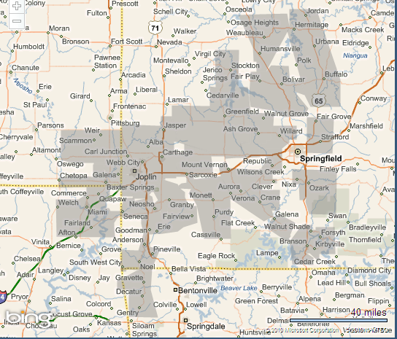

Figure 3: MissouriLow-Income Households by County
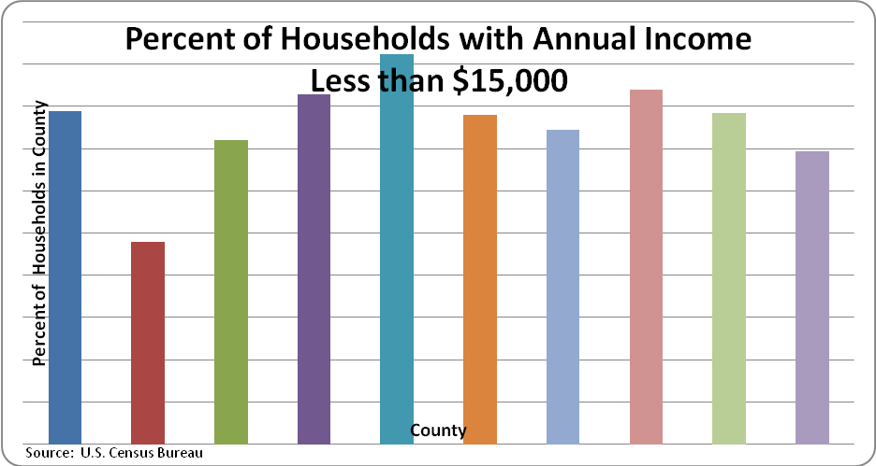
Figure 4: Appliances in Service Area

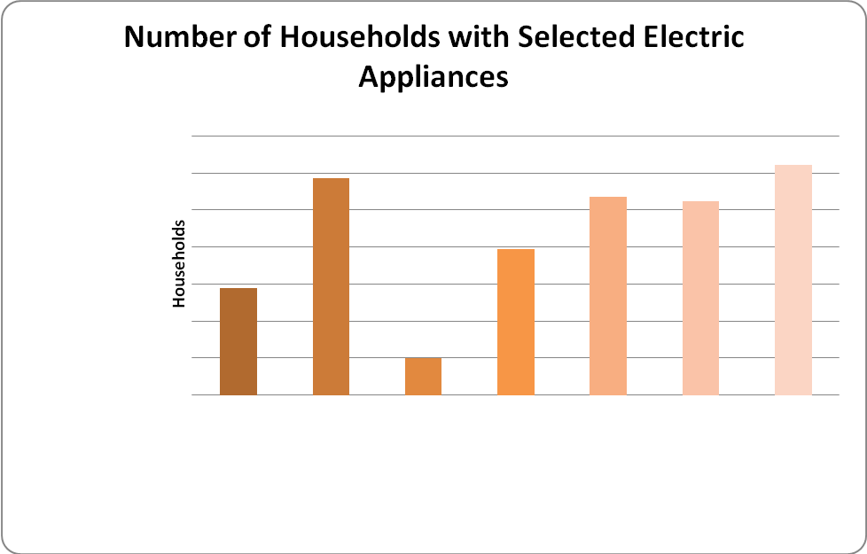
Source: Analyst derived estimates
Figure 5: End-Use Electricity Allocation
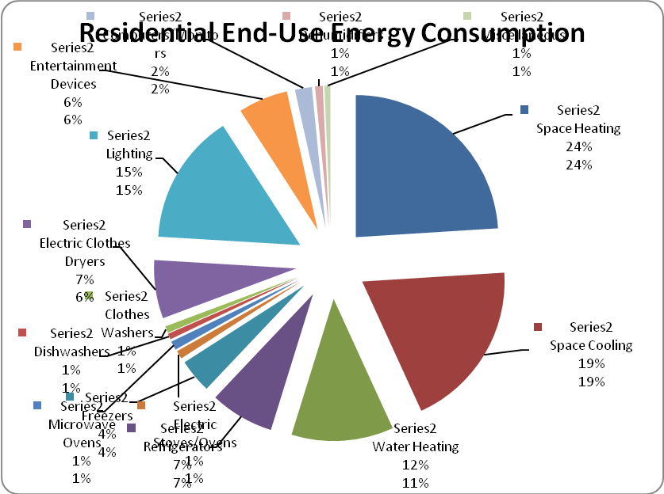
Source: Analyst derived estimates

Figure 6: Electricity Consumption by End-Use
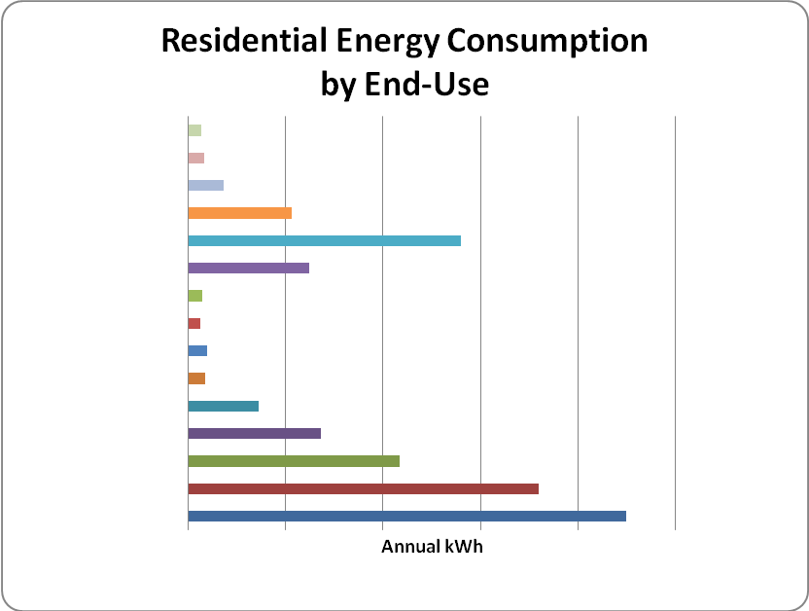
Source: Analyst derived estimates
Figure 7: Heat Pump Age Distribution
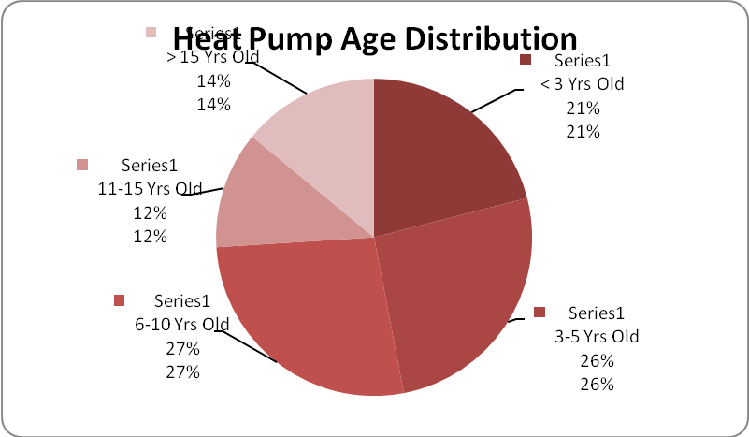
Source: 2008 Customer Survey

Figure 8: Non-Heat Pump Central Air Conditioner Age Distribution

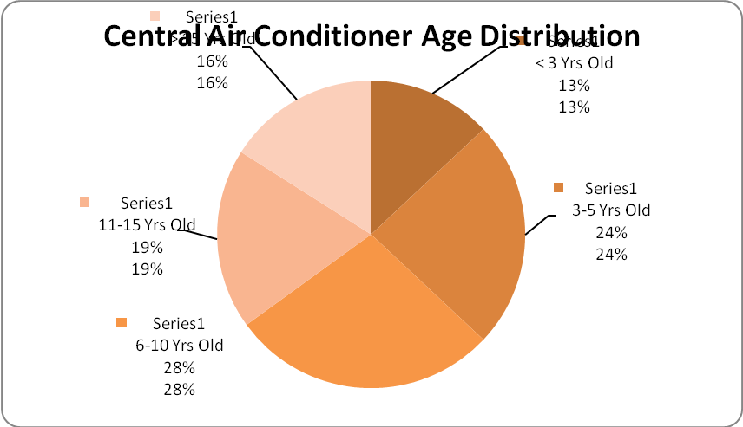
Source: 2008 Customer Survey

Figure 9: Room Air Conditioner Age Distribution
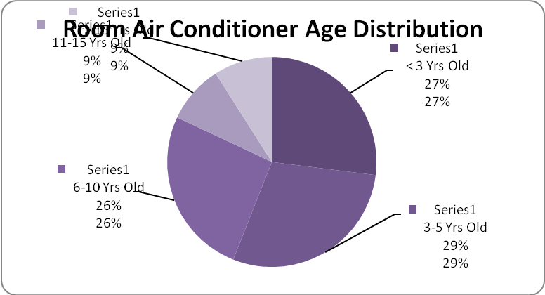
Source: 2008 Customer Survey

Figure 10: National Refrigerator Efficiency Gains
National Resource Defense Council Study¹¹

Figure 11: Refrigerator Age Distribution

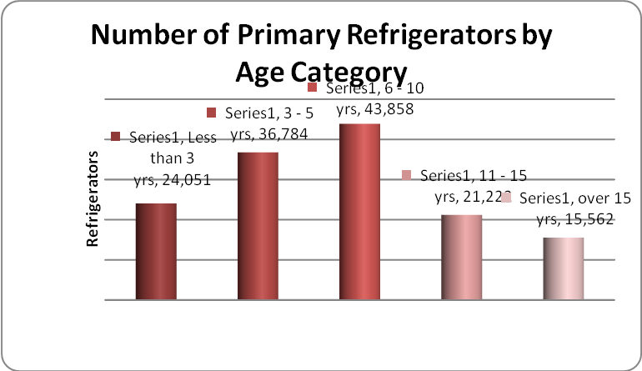
Source: Analyst derived estimates and 2008 Customer Survey

Additional External Considerations for the Analysis
An important task associated with the development of the potential study was to provide input to the IRP being developed by Empire. In order to provide the most robust set of analyses to the Company, AEG endeavored to use as much primary data unique to Empire’s entire service area as possible. One task undertaken by AEG was the development of a commercial baseline study audit sample which would be used by the Company (or one if it’s consultants) to perform on-site data collection in commercial customer facilities.
The objective of this task was to develop a profile of Commercial and Industrial customers (C&I) that would include end use breakdown and other equipment statistics (e.g. unit sizes, ages, types) that would be used to assess the potential improvements that could be made through measures or equipment replacement that would reduce energy consumption. Based on analysis of the full account list of C&I customers (approximately 25,000), a sample was designed to segment the population by business type and usage stratum to recognize the two principal variables that affect usage components for facilities. This minimized the required sample by isolating the two principal variables. Approximately 150 sites were identified and approximately 120 sites were successfully surveyed by auditors. Results were then weighted to account for the population and usage contributions of each business type and usage stratum.
The largest facilities within each group were excluded from the sample selection list since they could be extraordinarily expensive to survey and would not necessarily provide different characteristics than the large facilities included in the sample lists. These sites often represent large national corporations whose inclusion could skew the sample results. Data from Empire key account reps or the facilities could be added later.
The results of the approximately 120 sample audits were compiled and reviewed. In about 20% of the cases, samples were re-assigned to different groups to reflect their actual business usage and a Public Assembly segment (mainly religious facilities) was extracted from the Miscellaneous group due to their specialized usage pattern. Annual energy consumption by business type and for total commercial sector, including the large accounts previous excluded from the sample, were compiled.
For several end uses, sample audit data was analyzed to determine existing characteristics, including:
- Lighting – Fixture counts by type (e.g. T12, T8, T5) for both interior and exterior lighting were calculated and multiplied by hours use estimates by business type (from load shapes – see below) to segment total consumption into lighting types for use in identifying potential savings reductions (e.g. from T12 to T5 types).

- Cooling – Tonnage breakdown was calculated and hours use estimates by business types (from load shapes) to segment total consumption into types (e.g. RTU, Split, PTAC). Age breakdown was also calculated from sample audit data to assist in estimating energy reduction potential. Unit sizes were also developed from the sample audit data to enable estimates of the typical unit sizes for per-unit program benefit/cost calculations.
- Ventilation – Unit size breakdowns, along with associated energy use consumption estimates were developed, to assist in estimating potential energy reductions, which are driven by size. Unit sizes and total number of units were also calculated to enable typical unit estimates for program B/C analysis.
- Other end uses – For other end uses, sample audit data was reviewed to assist in identifying typical unit sizes, ages and types.
For each end use, a library of load shapes was developed by modifying other utility and industry load shape profiles, adjusting for weather specific to Empire, and characteristics of programs (e.g. solar). For each end use, separate load shapes were developed by business type. The load shape statistics consisted of percentage of peak vs. off-peak usage by month, monthly percentage of annual usage, and additional ratios that enabled estimates of annual maximum (non-coincident peak) and contribution to Empire summer system peak hour. An “hours use” estimate was developed for each load shape that converted annual kWh to summer coincident peak kW. Each load shape was then developed into hourly annual values (8,760 hours) scalable to each applicable program and end use impact. Additional load shapes were developed for direct load control, wind and solar program types, based on estimates of performance attributable to those measures. Even though load shapes were developed for the renewable technologies none of these technologies proved to be cost effective and were therefore not included in any of the program scenarios.
In addition, the following tasks were undertaken by AEG:
- Benefit/Cost Test Development - For each program (11 Residential and 6 commercial/industrial), sector (Residential and C&I) and total Company, AEG developed estimates for typical participant size, description, annual energy, peak/off-peak energy breakdown by month, non-coincident peak, coincidence factor, coincident peak and participant counts. These were then used in the benefit/cost tests and decisions to include the programs ultimately comprising the DSM portfolio, and for sector and portfolio totals.
- Program Impact Projections – For each program, sector and total company portfolio, annual energy, monthly and annual peak contributions and program costs were developed and compiled by year and for cumulative totals for 20 years.
- Generate hourly load shapes – For each program, sector and total company portfolio, the Project Team developed estimates for hourly DSM impacts (8,760 hours/year) for use in 20-year program projections and worked with Empire’s consultant to develop required impacts to generation dispatch models.

Assessments of Potential
An important aspect in the development of this studywas the formulation of ambitious yet realizable goals. For the program development process, one of the primary means of establishing goals has been the assessment of energy-savings potential. This began with the assessment of technical and economic potentials during the first phase of the project and continued with the assessment of achievable potential in the second phase.
This three-tiered approach (technical, economic, and achievable) provides an upper bound based on the potential of viable technologies,and then applies real-world constraints to bring the assessment within reasonable levels.Chapter 3 and Tables ES.1 and ES.2provide a discussion of the methodology and results of the three different assessments of potential (technical, economic, and achievable).
The assessments of potential contributed to the development of the program portfolio in two key aspects. First, the benefit-cost ratioswere evaluated for each energy-efficiency measure. Second, the potential contributes to the selection of programs. Because the model used for assessments was based on Empire’s own customer and energy forecast, outputs from the model provided data useful in determining the number of potential participants for the various programs. For example, the model simulates the turnover of end-use appliances, providing a rough estimate of the number of customers in each year that would be in the market for, say, a new refrigerator.

Measure and Program Screening
A critical element in the planning process was the stipulation that programs must be cost-effective from a total resource cost perspective. From the perspective of ratepayers and the utility, this ensures the investments made in energy-efficiency will yield sufficient benefits to warrant their costs.The importance of the cost-effectiveness requirement first came into play during the screening of EEMs. All EEMs included in the programs passed the total resource cost test for cost-effectiveness.
The process of analyzing program cost-effectiveness was not one of merely comparing the savings benefitsof the EEMs to their incremental costs. Rather, the analysis was a matter of incorporating administrative costs, an appropriate mix of EEMs, and reasonable goals for program participation into the calculations. Savings associated with EEMs in a program, multiplied by the participants, had to produce enough savings to cover costs of the EEMs,expenses associated with administration and marketing of the program, and training expenses.
The combination of different elements resulted in an iterative process where programs were refined to balance costs and savings—in terms of budget, participation, or EEMs—until the appropriate mix was found. In all cases, a program’s design was rooted in the best data available from sources discussed in this chapter, providing all of Empire’s programs with a firm footing in reality that bodes well for their success.

2. Potential Assessment
An important step in the development of realizable energy savings goals for Empire’s energy-efficiency programs was an assessment of potential electric savings associated with EEMs. The first part of this study was todevelop estimates oftechnical and economic,energy-efficiency potentials over a 20-year horizon. This timeframe was chosen to look far enough into the future to ensure the programs offer the key EEMs with the greatest long-term potential and to be consistent with the Company’s IRP process.This chapter first describes the methodology underlying these assessments of potential,followed by summarizing the resulting estimates for Empire’s energy and capacity savings.
Empireengaged Applied Energy Group (AEG) to determine the potential for energy-efficiency in the utility’s service area. The focus of this study was to determine the technical, economic and achievable potential for electric energy-efficiency. The analysis was conducted by class of service. Estimates were made for a twenty-year period (2011 – 2030). As part of its analysis AEG has determined the efficiency potential at a high level, relying mainly on available primary data and the consultant’s experience with potential analyses elsewhere.
AEG has analyzed the efficiency potential at three levels:
- Technical potential, or the total feasible efficiency savings using all efficiency technologies and design practices, unconstrained by budgets or cost effectiveness;
- Economic potential, or the feasible efficiency savings unconstrained by budgets, but using only cost-effective efficiency measures (based on the societal cost-effectiveness tests); and
- Achievable potential (budget-constrained potential), or the efficiency savings feasible using cost-effective efficiency measures within specific budget targets.

Analysis Methodology
The figure below provides a high-level overview of the methodology used for the efficiency savings analysis.
Figure 9: Overview of Efficiency Savings Analysis
- Avoided Costs
- By energy period ($/kWh)
- Summer peak ($kW-yr)

- Measure Characterizations & Penetrations
- Residential, Commercial, Industrial

- Budgets
- Non-incentive
- Incentive/rebate

- Load Shapes
- Monthly on-peak & off-peak
- 8,760

- Portfolio Screening Tool Calculations
- Measure level
- Program level
- Portfolio level

- Screening Outputs
- Energy & Demand Savings
- Other costs/savings

At thecore of the analysis is AEG’s benefit-cost measure, program and portfolio screening tool (Ben-Cost), a demand-side management (DSM) model for calculating the costs and benefits associated with various efficiency measures (technologies and design practices). Expanding on Figure 9above, the analysis of energy-efficiency potential, whether technical, economic or achievable, can be summarized as follows:
- Identify the avoided costs of energy, line loss factors and related inputs to the DSM model (e.g., retail rates, stakeholder discount rates).
- Determine the potential efficiency measure characterizations, including costs and savings relative to the baseline if not implementing the efficiency measures. Determine measure penetration rates based on analysis by market sector.
- Identify program budgets (for each of the four avoided cost scenarios).
- Develop load shapes for distributing energy savings for all hours of the year. (It should be noted that this analysis is somewhat unique. Typically load shapes are developed by period, e.g., summer and non-summer, by month or by on-peak and off-peak periods by month.
- Apply these inputs into Ben-Cost, which calculates both the energy and demand savings, and other costs and savings, by efficiency measure and for the total portfolio. Because Empire is the midst of an integrated resource planning process it was necessary to provide hourly impacts in order to assess the full potential of energy efficiency in the Company’s mix of both supply-side and demand-side resources.
Empire and AEG developed thegeneral input dataset for the model. These included: the avoided costs of electric energy anddemand line loss factors; and the nominal discount rate for discounting the value of future benefits and costs.
Efficiency Measure Characterizations
AEG relied upon efficiency measure characterizations based on the recent residential appliance saturation survey conducted by the Company and the commercial customer surveys recently conducted by the Company. In addition, AEG conducted independent analysis, as indicated in Chapter 1. AEG also relied on its experience and research for similar potential studies completed elsewhere. When appropriate, AEG adjusted the measure energy savings based on cooling and heating degree days for theEmpireservice territory. Characterizations of energy efficiency measures rely on current and comprehensive information to ensure accuracy. The data used by AEG to determine measure impacts include:
- Measure lives
- Incremental implementation cost (over the baseline of standard, non-efficient equipment)
- Annual energy (kWh) savings
- Maximum load (kW) reduction and associated peak coincidence factor
- For retrofit measures:
  - the deferred replacement cost, which is a benefit that eliminates the need to replace the existing (retrofitted) equipment at the end of its normal life, due to implementation of the efficiency measure, and
  - An adjustment of savings at the time the existing equipment would have been replaced, due to having more efficient baseline equipment at that time.
- Operation and maintenance savings (or increased costs)
- Free ridership (the portion of program participants who would have installed efficient equipment even without a DSM program) and spillover (those who install efficient equipment due to the program being in place, but never collect the incentives). AEG’s estimates of achievable potential include free ridership and spillover effects.
AEG’s DSM planning framework provides for the implementation of efficiency measures in four general markets (three for existing buildings and one for new construction):
- Existing buildings
- Retrofit opportunities, for which functioning equipment is replaced with more efficient equipment
- Equipment purchase or replacement due to equipment failure, expansion, performance concerns or similar drivers
- Remodeling/renovation, similar to equipment replacement, but affecting an entire system or multiple systems
- New construction
One efficiency measure may have very different characteristics depending upon the market. For example, in the residential sector, a homeowner would evaluate the full cost of a new ENERGY STAR® rated clothes washing machine when considering the replacement of an old, inefficient, but serviceable unit; in thenew home market or someone looking to purchase a new clothes washer(i.e., their current one no longer operates), the cost of the ENERGY STAR® unit is only the additional cost above a standard-efficiency unit. The energy and demand savings also differ – the savings for a retrofit are compared to the old, inefficient unit (at least until the homeowner would have needed to replace the unit at the end of its life), while the savings for new construction or replacement are compared to a new, standard unit.
Top-down and Bottom-up Approaches to the Analysis
Analysis of the actual potential savings started with a review of sales data for the service territory by sector: residential, commercial,and other industrial. For the residential sector, AEG disaggregated sales by end-use based on various types of information including results of the 2008 Residential Appliance Saturation Survey, insights from Empirestaff, Census information, and data from other utilities located in states near Missouri.
For thecommercial sector, AEG disaggregated sales by building type and end-use based on the results of the commercial audits that the Company conducted in conjunction with publically available data from sources such as the Commercial Buildings Energy Consumption Survey (CBECS) census data from the Energy Information Agency, and experience with similar potential studies elsewhere.
In many studies,sales forecasts serve as the basis for a “top-down” analysis of the efficiency potential, which arrives at measure savings by determining the percentage of the electric sales forecast that may be offset by the installation of a given energy-efficiency measure in each year. The top-down approach develops costs relative to energy savings, and then multiplies that “cost per energy saved” by the measure’s energy savings each year to determine each year’s installed costs. For the commercial and industrial sectors, sales are disaggregated by building type and end-use, and by existing buildings and new construction. Each commercial and residential efficiency measure is characterized based on these disaggregated sales projections.
For the residential and commercial/industrial sectors, AEG applied a “bottom-up” analysis, which develops savings information for a specific measure (e.g., the installation of one compact fluorescent lamp), and then multiplies those costs and savings by the number of measures (lamps) installed. The bottom-up approach was suitable for theanalysis since data wasavailable to estimate the number of residential and non-residential buildings and the expected rates for adopting efficiency measures. Although commercial and industrial buildings vary greatly in size and in their energy usage, in this instance suitable data was available to use a bottom-up approach.
Regardless of approach, all methodologies need to develop factors for the following measure characteristics:
- Applicabilityusing a bottom-up analysis is the number of customers eligible for a given measure.
- Feasibility is the fraction of the applicable number of customers or end-use sales for which it is technically feasible to install the high efficiency technology. Numbers less than 100% reflect engineering or other technical barriers that would preclude adoption of the measure. Feasibility is not reduced for economic or behavioral barriers that would reduce penetration estimates. Rather, it reflects technical or physical constraints that would make measure adoption impossible or ill advised.
- Turnover is the number or percentage of existing equipment that will be naturally replaced each year due to failure, remodeling, or renovation. This only applies to replacement/purchase and remodel/renovation markets. In general, turnover factors are assumed to be one(1) divided by the measure life (e.g., assuming 10% of existing stock of equipment is replaced each year for a measure with a 10-year estimated life.)
- Baseline Adjustment adjusts the savings downward in future years for retrofit measures to account for the fact that newer, standard equipment efficiencies are higher than older, existing stock efficiencies (e.g., the phase out of incandescent lighting).
Using these factors together provides a maximum (technical) potential savings for each measure. The appropriate measures and penetration rates are then applied to determine each of the efficiency potentials, technical, economic and achievable, as described further in the following section.
Stock Adjustments and Measure Interactions
New measures can be installed in existing buildings either on an early retirement (retrofit) basis, at the time of natural replacement, or at the time of renovation or remodeling. To avoid double counting, AEG’s planning framing tracks the eligible stock of equipment over time, based on the assumed measure penetrations for each existing building market. This is particularly applicable for planning horizons that extend out 20 years. For example, if 10% of existing lighting fixtures are retrofitted with high efficiency models in 2011, then only 90% of the original population of lighting remains eligible for efficiency upgrades in non-retrofit markets during 2012. However, assuming the fixtures had only a 5-year measure life, the original 10% of lighting fixtures would again become eligible for replacement in 2016 (five years after original installation date). Similarly, once a building is renovated or remodeled, the opportunity for retrofit is diminished until the end of the measure lives for those measures installed under the market-driven (non-retrofit) scenarios.
Some of the technologies modeled are mutually exclusive – one or the other could be installed, but not both. For example, standard metal halide high-bay fixtures can be replaced with pulse start metal halides or fluorescent high-bay fixtures. When two or more measures compete with one another, an estimate of the penetration of the measure offering the most per unit savings was first estimated. The penetration of the next competing measure is then estimated based on the remaining potential.

Technical Potential
Technical potential is typically defined as the total energy-efficiency potential unconstrained by budgets or measure cost-effectiveness. Note that the same technical potential savings could be achieved by a different mix of efficiency measures. For example, the savings due to retrofit measures could be replaced by savings due to market-driven (non-retrofit) measures. Given the methodology for selecting measures and maximizing penetration rates, the results should be viewed with a focus on the total savings results rather than on the specific measures used to achieve them.

Economic Potential
The economic potential starts with the same list of potential efficiency measures as the technical potential, but includes only those efficiency measures that are found to be cost-effective as determined using the Societal Test, which compares the total costs and benefits to society – including the utility and its customers.
Societal costs include:
- incremental installed cost (above baseline equipment)
- non-incentive programs costs (e.g., administration and marketing)
Societal benefits include:
- avoided costs of electric energy savings and demand reduction
- operation and maintenance savings
- deferred replacement credit (for retrofit measures)
- electric externalities (e.g., due to reduced air pollution)
Measure incentives are considered a pass-through payment from one party to another; thus they are not considered to be a cost or a benefit. Electric externalities were assumed at four different levels which drove each of the scenarios presented in the Executive Summary.
The societal costs and benefits are determined for each year of the measure life and discounted back to the base year (2011). Cost-effectiveness is measured by the Net Benefits, equal to the benefits minus the costs. A measure is considered to be cost-effective if theNet Benefits are greater than or equal to one.
Measures that failed the Societal Cost-effectiveness Test in most markets or building types (for Commercial measures) were removed from the analysis. For example, some measures were not cost effective in the “no future carbon cost case” (scenario 1) but were cost effective in the higher carbon cost cases (scenario 3 or scenario 4).
Please refer to the Executive Summary for additional discussion on cost effectiveness.

Achievable Potential
Theachievable potential represents AEG’s best estimate of what Empirecan achieve given the information that we have about the service territory. The achievable potential measure budgets were based on the avoided cost inputs for each scenario applied at the level of representative programs. The goal of the achievable analysis was not to develop a program design, but measures were assigned to representative programs for the purpose of allocating associated program costs. AEG’s experience was used to determine the non-measure (non-incentive) program costs as a portion of the incentive budgets (which were determined directly from the measure incentives and penetration rates). AEG’s experience is based on results from established DSM programs in other service territories.
Once the achievable potential for each measure was estimated, the measures were bundled into a mix of program offerings. AEG selected a typical set of DSM programs for this analysis, but with the understanding that the program design significantly affects the savings that can be achieved for a given budget. A different program design would likely result in different overall savings, and different savings by sector or customer group.
The programs that were considered for the achievable potential analysis include:
- Residential
  - Low-Income Assistance
  - Refrigerator Recycling
  - EnergyStar Appliance
    - Refrigerators
    - Clothes Washers
    - Dehumidifier
  - Lighting
  - High Efficiency Central Air Conditioning
  - Home Performance with EnergyStar
  - Home Energy Comparison Reports
  - Direct Load Control
- Commercial and Industrial
  - Commercial Prescriptive Rebate Program
  - Commercial Custom Rebate Program
  - Small Business Direct Install
  - Business Owner Certification
  - Large Commercial/Industrial Turnkey
  - Interruptible

The achievable potential was based upon the most cost-effective relevant efficiency measures found in successful DSM programs elsewhere. AEG set penetration rates at levels deemed appropriate for the programs and their specific measures given the characteristics of Empire’s service territory. The total portfolio savings were calculated with AEG’s Ben-Cost model, and the penetration rates set at levels comparable to other successful utility DSM programs.
Note that there is a great deal of variability in the efficiency measures that could be selected depending on the program design. While we have attempted to select measures and penetration rates suitable for a generic efficiency program, many other combinations and permutations of programs and efficiency measures are possible. The actual mix of measures and their installation rates will depend on the measures and incentives offered to customers, how the efficiency programs are marketed, the level of engagement with third-party contractors and many related factors. These and other factors should be taken into consideration as part of the program design. The results of the achievable potential assessment arepresented in Tables ES.1 and ES.2.
It should also be noted that an analysis of renewable technologies including solar photovoltaics and packaged wind solutions were also evaluated. Neither of these technologies had characteristics (energy savings, demand savings, associated costs, etc) that made these technologies cost effective and therefore not included in the final analysis.

3. General Program Design Approach
This section discusses the general program design approach. As discussed in Chapter 1, Empire has incorporated information from various sources throughout the development of its portfolio. The objective was to create a comprehensive and innovative set of programs to serve the needs of Empire’scustomers by advancing efficient energy use.

Delivery Mechanisms
The primary mechanism for program delivery consists of customers purchasing high-efficiency equipment and/or services directly from existing market actors (i.e., contractors, equipment dealers, and retailers). Consequently, the successful promotion and administration of programs requires going beyond a “customer-only” focus. Targeting trade allies and leveraging Empire’s relationships with them will increase both awareness among consumers and the availability of high-efficiency equipment.
Although the emphasis continues to be customer incentives, components of several programs include strategies to encourage cooperation with trade allies, other utilities, and state and local agencies. In some programs,for example, portions of the budget have been reserved to conduct training and informational outreach activities with trade allies, including dealers and providers of maintenance services. These activities are intended to keep the key trade allies apprised of the changes in the various programs, which will allow them to provide assistance to customers and to ensure they maintain high-efficiency equipment in their stock.

Qualifying Energy-Efficiency Measures
Qualifying EEMs represent either more efficient models of end-use appliances, such as a central air-conditioner or compact fluorescent lighting, or technological improvements that can make an end-use appliance more efficient in its use of energy, such as an energy management system. Nearly all the programs encourage the adoption of at least one EEM. EEMs that qualify for each program are intended to represent a substantial improvement over the standard efficiency available on the market.

Participation
Establishing a participation goal for each program requires a balancing of numerous factors, including the pool of eligible participants, the available budget, and past program performance.
Each program budget is developed in a way that balances best practices, including the share of technology costs paid directly by participants as compared to the incentive subsidy. Incentives need to be sufficiently large to encourage participation, yet be of a size that maximizes available resources. Similarly, marketing and administrative budgets should be adequate to promote and operate the programs, but not be so large they negatively impact cost-effectiveness.
Finally, in setting goals for participation, two additional factors need to be considered. AEG’s experience and its’ review of program performance in other stateshas served as a guide to which programs have been able to meet or exceed their goals and which have fallen short. Given similar incentive and outreach structures, we expect to achieve participation consistent withother efforts. The second factor to consider is thatwe are proposing several new programs in the Empire service territory.

Impacts
These programs seek to save energy and peak demand;therefore goals for impacts are a critical element of program design, and the portfolio has been designed to aggressively pursue this goal. Throughout this process,Empire has sought to identify targets where energy savings can most effectively be achieved. The knowledge derived from these efforts has influenced the program design;programs are designed to address the major end-uses in the residential and C&I sector where technologies exist to significantly improve energy-efficiency.
Because impacts are driven primarily by participation and the respective savings of qualifying EEMs, these components have been tailored to maximize the program’s total impacts. The overall portfolio includes programs that capture a wide variety of potential savings.As discussed previously, programs have been designed to maximize participation given best practice marketing and incentive designs. In addition to ensuring participation while efficiently using budget resources, incentives have been targeted to promote the adoption of EEMs that maximize savings and minimize lost opportunities. In many cases, incentives have been structured to encourage the adoption of EEMs with the highest levels of efficiency.

Eligibility
Where feasible to facilitate participation, eligibility has been defined as broadly as possible to make the programs more inclusive. For most residential programs, eligible participants include customers living in every type of residential structure, including single-family, multifamily, and manufactured homes. Though the low-income program has specific income requirements, low-income customers are not precluded from participation in the other residential programs. For other programs, the only limitations on participation are circumstances where a customer has recently participated in a program and repeated participation would not render sufficient savings to justify the expense.

Training
To improve participation and quality of service, training will be a high priority in this study. Empire is committed to contractor and trade ally education and training. The training sessions willbe on a variety of topics, such as:
- Proper sizing and installation of HVAC equipment, including duct sealing and proper charging (to support programs such as Home Performance with Energy Star)
- Green building techniques (to support programs such as the commercial rebate or commercial turnkey programs)

Budgets
Program budgets are developed with consideration to the following areas of expenditure:
- Administrative costs, including planning and design
- Delivery
- Marketing
- Incentives, both customer and trade ally
- Evaluation costs

Program Evaluation
Evaluation is a necessary component of each program for several reasons. At a minimum, evaluations help determine if the overall portfolio is achieving its objective. Verification of energy savings for the programs via impact evaluations establishes whether a program is achieving the intended impacts. At a higher level, process evaluations reveal when a program is not operating as well as it could; hence they can contribute to significant improvements in performance. All programs will have both impact and process evaluations to ensure the portfolio does not fall short of its goals.

4. Energy-Efficiency Programs

Introduction

Based on the Achievable Potential Studya portfolio of DSM programs was developed. The twenty-year DSM portfolio represents the “base case”. Participation rates reflect the need to develop necessary infrastructure, trade ally relationships and marketing momentum to support full-scale implementation levels.

This document contains descriptions of Empire’s portfolio DSM programs that reflect the following:

- Tested Program Design – DSM program designs are based upon other utilities’ successful program designs including Empire’s experience in thestates it serves.

- Coverage – The programs provide services to all classes of customers for all income levels and cover retrofit and replacement measures as well as some measures for new construction.
- Goals – Participation goals are reasonable, based upon Empire’s service territory and other utilities’ experience.

- Budgets – Budgets include sufficient funds to properly manage, administer, and market the programs.

- Cost Effectiveness – All measures contained in the different programs have undergone benefit/cost screening consistent with theCalifornia Standard Practice Manual.

- Program Design Assumptions – All measures and associated costs, which were developed in the achievable potential analysis, have been bundled into different programs by customer class. These assumptions include consideration of all the following factors:

  - Administrative costs – The overall annual costs for the utility to implement the program. This includes the utility cost for incentives, administration, evaluation, etc. for each year that the program is planned. Utility incentives must be provided separately as these costs are handled differently from other utility costs in certain benefit/cost tests.

  - Direct Participant Cost – The incremental cost of each energy savings measure ($ per measure) before utility incentives. This represents what the customer would have to pay to achieve the benefits of the specified energy-efficient measure. This is a one-time cost.

  - Project Life – The estimated lifetime that a project/measure will yield energy savings (years). Measure life should be consistent with equipment life but in some instances the utility may choose to limit the savings to a predetermined life (e.g., 15 years maximum) for analysis purposes.

  - Demand Savings – The amount of demand reduction that the particular measure will yield (kW). This represents the rated reduction on power.

  - Coincidence Factor – A factor applied to Demand Savings to determine the value of demand reduction that will be achieved during the hour of the utility peak (in percent).

  - kWh/Participant Savings – The energy savings component of a particular measure (annual kWh). This is defined as the savings achieved for each measure.

  - Number of Participants – The participation goal for a particular program.

  - Incentive per Participant – The value of the utility incentive for each particular measure included in a program. This value multiplied by the Number of Participants will yield the total utility incentive.

- General Project Management and Marketing – These are costs that are not specific to an individual program, such as preparation of regulatory filings, general oversight, broad-based message marketing, etc

- Evaluation – Program evaluation is budgeted at 5% of program costs per year.

- Program Descriptions – Each program write-up contains the following information for the first program year:

  - Program Description – A general overview of the program.

  - Peak Demand and Energy Savings – This is an estimate of the kW and kWh savings that can be expected to occur given the assumptions for each particular program.

  - Participation – The participation targets reflect the results of the Achievable Potential Study.

  - Program Budgets – Each program budget contains categories for program administration, delivery, marketing, incentives and evaluation.

Low-Income Assistance Program

PROGRAM DESCRIPTION

Qualifying low-income customers can receive help in managing their energy use and bills through Empire’s Low-Income Assistance Program. The program will work directly with local community action program (CAP) agencies that already provide services to low-income customers through the Department of Energy (DOE) and other state agencies.

Empirewill provide funds forcustomers with income levels as specified by the federal Low Income Weatherization Assistance Program (“LIWAP”). While the CAPs will provide many of the leads for this program, Empirewill supplement their efforts through its own marketing. CAP agencies offer a cost-effective implementation capability, which allows most of the funds allocated to this program to go directly to the purchase and installation of energy-efficiency equipment. Participants can be an Empire residential customer in a one to four-unit structure. CAP agencies expect to spend an average of $2,000 of Empire funds (including measures and delivery) to go along with their DOE funds. Empire funds will focus on measures that reduce electricity usage such as electric heat, air conditioning, refrigeration, lighting, etc. CAP agencies will have discretion to use the funds as they wish for weatherization. In addition, they may also spend up to $200 towards the purchase of an ENERGY STAR® rated refrigerator and $100 towards the purchase of ENERGY STAR® rated CFLs and lighting fixtures.

While the CAPs will have the primary responsibility to obtain leads for this program, Empire can supplement their efforts, as necessary, by targeting low income customers in arrearage that would benefit from reduced utility bills.
This program helps low income customers reduce their energy costs at no cost to the customer. CAP agencies offer a cost effective implementation capability, which allows most of the funds allocated to this program to go directly to the purchase and installation of energy efficiency measures.

Program Participation, Energy and Demand Savings

Participants per Year | Demand (kW) | Energy (kWh)
100 | 41 | 144,903

PROGRAM BUDGET, COST EFFECTIVENESS AND COST PER KWH

Program Delivery | Admin. | Marketing | Customer Incentives | Evaluation | Total | TRC | Cost per kWh (year 1)
$144,500 | $30,000 | $15,000 | $0 | $10,000 | $199,500 | 0.55 | $1.38

Since this is a direct install program which pays money directly to the CAP agencies, no funds are listed under customer incentive. The budget assumes an administration cost of 15% and marketing costs of 7.5%.

EVALUATION
Budget assumes 5% of annual project cost. CAP agencies will be required to provide a list of the measures for each home served that Empire’s funds were used. This program is similar to many other low-income programs that are being implemented throughout theU.S. The impact evaluation should reflect the actual mix of all electric homes (electric space heat). A process evaluation will be conducted during the second year of implementation and every other year thereafter.

Residential High Efficiency Lighting

PROGRAM DESCRIPTION

ENERGY STAR® encourages every American to change out the fixtures they use most at home (or the light bulbs in them) to ENERGY STAR® qualified lighting. The most frequently used lights typically include the kitchen ceiling dome light, living room table lamp, living room floor lamp, bathroom vanity light and outdoor porch or post lamp.
Not only do ENERGY STAR® qualified compact fluorescent lamps (CFLs) use up to 75% less energy than typical incandescent light bulbs, but CFLs also offer superior performance by lasting up to 10 times longer than incandescent bulbs, reducing the need to change hard-to-reach light bulbs. The current generation of CFLs offer bright and warm light and are available in a wide variety of shapes and sizes. CFL technology continues to mature, with recess lighting lamps costing little more than incandescent and 3-way CFL lamps becoming more affordable.
This program offers residential customers the ability to purchase up to ten CFLs at a local retailer at a reduced cost. The assumption used in this analysis is that rebates would be limited to one per household per year. Specific rebate levels will be determined through arrangements negotiated with retailers in the service territory.
Rebates would be available for different wattage sizes, different configurations (standard and recessed), different styles (3-way), etc. Rebate levels may vary depending upon the type of CFL and its associated retail cost.
In 2012, the Electricity-Related Provisions in H.R. 6 “Energy Independence and Security Act of 2007” will take effect. Starting in 2012, incandescent lamps will require lower wattages as shown in the table below:

Year Effective | Typical Wattage | New Standard | Reduction %
2012 | 100 | 75 | 25.00%
2013 | 75 | 53 | 29.33%
2014 | 60 | 43 | 28.33%
2014 | 40 | 29 | 27.50%

Because of this legislation the Residential High Efficiency Lighting Program will be eliminated in 2018. While a customer will be eligible to purchase up to 10 CFLs per year, the energy savings assumptions assume that the average customer will purchase 6 CFLs.

Program Participation, Energy and Demand Savings

Participants per Year | Demand (kW) | Energy (kWh)
10,000 | 75 | 2,885,232

PROGRAM BUDGET, COST EFFECTIVENESS AND COST PER KWH

Program Delivery | Admin. | Marketing | Customer Incentives | Evaluation | Total | TRC | Cost per kWh (year 1)
$6,000 | $3,500 | $5,000 | $60,000 | $3,500 | $78,000 | 6.14 | $0.03

EVALUATION
Budget assumes 5% of annual project cost. Empirecan compare their program to evaluations conducted by the EPA and ENERGY STAR®. A process evaluation will be conducted in the second year of implementation and every other year thereafter.

Residential High Efficiency Cooling Program

PROGRAM DESCRIPTION
The Residential High Efficiency Cooling Program will encourage residential customers to purchase and install energy-efficient evaporative coolers, central air-conditioning and heat pumps by providing financial incentives to offset a portion of the equipment’s higher initial cost. The program’s long-range goal is to encourage contractors/distributors to use energy-efficiency as a marketing tool, thereby stocking and selling more efficient units and moving the entire market toward greater energy-efficiency.
As part of the program, Empire may also provide contractors with incentives for “quality installs” which will focus on air and duct sealing. Empire may require that HVAC contractors participate in training to be eligible to install eligible equipment for this program.
Empirewill randomly inspect installations to ensure measures are implemented properly.
Customer incentives will be offered for the following measures:

Measure | Incentive
- Split Central Air Conditioners: SEER>=14.5 and EER >= 12  - Air Source Heat Pumps: SEER>=14.5 and EER >= 12, HSPF>= 8.5  - Ductless Mini Split Systems: SEER>=14.5 and EER>=11.5 | $250
- Split Central Air Conditioners: SEER>=15 and EER >= 12.5  - Air Source Heat Pumps: SEER>=15 and EER >= 12.5, HSPF>= 8.5  - Ductless Mini Split Systems: SEER>=15 and EER>=12 | $400
- Split Central Air Conditioners: SEER>=16 and EER >= 13  - Air Source Heat Pumps: SEER>=16 and EER >= 135, HSPF>= 8.5  - Ductless Mini Split Systems: SEER>=16 and EER>=12.5 | $600

An additional feature of the program will be to offer training in Manual J calculations and System Charging and Airflow for HVAC contractors. Manual J is the industry standard residential load calculation method. The training offers step-by-step examples of properly sizing equipment and also addresses principles of heat transfer. The training teaches HVAC contractors to accurately perform and document cooling load calculations and reduces over-sizing. The System Charging and Airflow training course covers airflow and charging procedures, standards and includes hands-on training in the use of testing equipment. Once enough contractors have undergone this training, Empiremay mandate that these calculations take place in order to qualify for the incentive.
Program delivery costs cover the contractor training courses in Manual J calculations and System Charging and Airflow. Administration is set at approximately 3% of program costs which is a lower percentage than in other programs. The Company’s assumption is that program administration can be leveraged across residential programs. Marketing is assumed to be 7.5% of program cost as well.

Program Participation, Energy and Demand Savings

Participants per Year | Demand (kW) | Energy (kWh)
400 | 368 | 319,726

PROGRAM BUDGET, COST EFFECTIVENESS AND COST PER KWH

Program Delivery | Admin. | Marketing | Customer Incentives | Evaluation | Total | TRC | Cost per kWh (year 1)
$10,000 | $3,500 | $10,000 | $100,000 | $6,500 | $130,000 | 2.43 | $0.41

Program delivery costs include contractor training courses in Manual J calculations, System Charging and Airflow.
EVALUATION
Budget assumes 5% of annual project cost. The evaluation will include on-site inspections. Spot metering and runtime data can also be collected to verify the connected load and full load hour estimates used in engineering analysis. A process evaluation will be conducted in the second year of implementation and every second year thereafter.

Refrigerator Pickup Program

PROGRAM DESCRIPTION
TheRefrigerator Pickup Program will encourage residential or small business customers to turn in old inefficient refrigerators. Refrigerators must be between 10 and 30 cubic feet in size. The refrigerators must also be in operating condition. The program’s goal is to get these inefficient refrigerators off the electric system and dispose of them in an environmentally safe and responsible manner. The Company’s consultant, AEG has had preliminary discussions with JACO Environmental, a company that specializes in this program and has access to a disposal facility in Albuquerque which they could use for this program.
As part of the program, an incentive or bounty will be provided to the customer. Initially, a $30 rebate will be offered per qualifying unit.
The contractor would handle scheduling, transportation and disposal. The contractor would also provide nameplate data on units to assist in impact evaluation.
Program delivery costs for the contractor are budgeted at $110/unit. Marketing and program administration costs are budgeted at approximately $15 per unit
Based on discussions with JACO Environmental regarding participation levels that they have experienced with other utilitiesan annual goal of 750 units has been established.

Program Participation, Energy and Demand Savings

Participants per Year | Demand (kW) | Energy (kWh)
750 | 82 | 662,802

PROGRAM BUDGET, COST EFFECTIVENESS AND COST PER KWH

Program Delivery | Admin. | Marketing | Customer Incentives | Evaluation | Total | TRC | Cost per kWh (year 1)
$82,500 | $11,750 | $11,750 | $22,500 | $6,500 | $135,000 | 2.67 | $0.20

EVALUATION
Budget assumes 5% of annual project cost. Evaluationsmay include measurement of energy use on equipment. A process evaluation will be conducted in the second year of implementation.

Home Performance With Energystar

PROGRAM DESCRIPTION
Home Performance with ENERGY STAR® is a unique program which enhances the traditional existing home energy audit service. This program uses the ENERGY STAR® brand to help encourage and facilitate whole-house energy improvements to existing housing. This program focuses on the private-sector contractors and service professionals who currently work on existing homes – replacing HVAC systems, adding insulation, installing new windows, etc. The Missouri Home Performance with ENERGY STAR® Initiative requires contractors to be accredited under Building Performance Institute (BPI) standards. Technicians must possess appropriate skills and are field-tested to obtain certification, further lending credibility to services offered. Empire will assist contractors in becoming accredited and certified by BPI. In addition, Empire will arrange to have a random sample of jobs inspected.
The program strives to provide homeowners with consumer education, value, and a whole-house approach. A participating BPI-certified Home Performance contractor can identify and fix a variety of home energy efficiency problems, including poor insulation, air leaks through cracks and gaps, and ineffective moisture control by first performing a home assessment. Upon completion of the inspection, the contractor will provide an itemized cost estimate for each suggested improvement.

Contractors are trained to provide "one-stop" problem solving that identifies multiple improvements that, as a package, will increase the home’s energy efficiency. While the program goal is saving energy, its market-based approach and message focus on addressing a variety of customer needs – comfort, energy savings, durability, and health & safety. It also encourages the development of a skilled and available contractor/provider infrastructure that has an economic self-interest in providing and promoting comprehensive, building science-based, retrofit services.
The benefits for a customer that participates in the program include:
- Significant savings on energy bills
- Higher home resale value
- A quieter, more comfortable living environment
- Improved air quality for better health
- Greater home durability with lower maintenance
- Increased environmental safety and energy efficiency

Empire will work to leverage program funds by “piggybacking” with similar programs used by neighboring utilities.

Program Participation, Energy and Demand Savings

Participants per Year | Demand (kW) | Energy (kWh)
150 | 87 | 304,552

PROGRAM BUDGET, COST EFFECTIVENESS AND COST PER KWH

Program Delivery | Admin. | Marketing | Customer Incentives | Evaluation | Total | TRC | Cost per kWh (year 1)
$112,500 | $15,000 | $15,000 | $0 | $7,500 | $150,000 | 1.19 | $0.49

EVALUATION
Budget assumes 5% of annual project cost. Empire will track whole-house evaluations that are performed by certified contractors in their service territory. Evaluation performed by ENERGY STAR® or other utilities with the same program can be monitored and used to estimate the benefits from this program. A process evaluation looking at best practices could be conducted at the beginning of thesecond year and every three years thereafter.

Home Energy Comparison Reports

PROGRAM DESCRIPTION

This is a program that uses a software platform that combines energy usage data with customer demographic, housing and GIS data to develop specific, targeted recommendations that educate and motivate consumers to reduce their energy consumption.
One company offering such a platform is OPower’s Home Energy Reporting System. The Home Energy Reporting System is a proven energy efficiency program that successfully leverages large-scale consumer engagement to drive measurable, predictable and sustainable energy savings.
The Home Energy Reports are a targeted direct mailing to a utility’scustomers that provide specific recommendations and incentives to motivate recipients to reduce their energy consumption. The individualized reports show customers:

- Electricity use compared to the average of 100 neighbors in similar-sized homes with similar characteristics.
- Targeted efficiency recommendations based on analysis of the household’s energy usage, demographics and housing characteristics teach residents how to save and become a more efficient neighbor.
- How recipients can easily take action to reduce their consumption based on their individual circumstances.
In addition, the selected vendor for this programwill be required todeploy an online tool suite that gives customers greater insight into their energy consumption and what they can do to become more energy efficient. It is anticipated that the online suite would include:

- Customer electricity usage
- Efficiency recommendation database with ratings and reviews.
- Customer comments collected and analyzed regionally on which tips work best for customers in the region.

Program Participation, Energy and Demand Savings

Participants per Year | Demand (kW) | Energy (kWh)
10,000 | 78 | 3,002,778

PROGRAM BUDGET, COST EFFECTIVENESS AND COST PER KWH

Program Delivery | Admin. | Marketing | Customer Incentives | Evaluation | Total | TRC | Cost per kWh (year 1)
$74,500 | $15,000 | $15,000 | $0 | $5,500 | $110,000 | 1.28 | $0.04

EVALUATION
Budget assumes 5% of annual project cost. A combination of bill analysis and process evaluations will be conducted on an annual basis.

Energy Star Appliance Rebates

PROGRAM DESCRIPTION
The goal of this program is to acquire cost-effective energy efficiency by increasing sales of certain Energy Star qualified appliances to residential (and is some cases small business customers). Under this program the Company will be educating consumers (build awareness and branding) through advertising and promotions to purchase Energy Star qualified refrigerators and clothes washers.
Participating customers will receive a rebate of $25 for each qualifying refrigerator or washing machine purchased.

Program Participation, Energy and Demand Savings

Participants per Year | Demand (kW) | Energy (kWh)
1500 | 28 | 222,270

PROGRAM BUDGET, COST EFFECTIVENESS AND COST PER KWH

Program Delivery | Admin. | Marketing | Customer Incentives | Evaluation | Total | TRC | Cost per kWh (year 1)
$2,250 | $1,000 | $2,000 | $37,500 | $3,500 | $46,250 | 1.07 | $

EVALUATION
Budget assumes 7.6% of annual project cost which is a higher than other programs. However, the total budget for evaluation is relatively low even at the allocation used. Empire can compare their program to evaluations conducted by the EPA and ENERGY STAR®. A process evaluation will be conducted in the second year of implementation and every other year thereafter.

Direct Load Control

PROGRAM DESCRIPTION

An Direct Load Control or A/C Cycling Program can reduce residential and small commercial air conditioning load during peak summer days. This reduction is achieved by sending a signal to a control device attached to the customer’s air conditioner. The control device then turns the air conditioner off and on over a period of time depending on the control and load reduction strategy establish by the company. There are a number of different products in the market. The primary differences are control type (thermostat versus outside control switch) and communications (2-way versus 1-way). While the achievable savings is similar from the different options, the ability to market, keep customers in the program, and verify the savings differ significantly. A 1-way communication protocol was assumed for the program represented below. For Scenario 4 a 2-way communication protocol was used.

Program Participation, Energy and Demand Savings

Participants per Year | Demand (kW) | Energy (kWh)
2500 | 2,717 | 80,145

PROGRAM BUDGET, COST EFFECTIVENESS AND COST PER KWH

Program Delivery | Admin. | Marketing | Customer Incentives | Evaluation | Total | TRC | Cost per kWh (year 1)
$735,500 | $50,000 | $50,000 | $0 | $40,000 | $875,500 | 1.74 | $10.92

EVALUATION
Budget assumes 5% of annual project cost. Annual evaluations to assess customer participation are conducted, providing that the program was activated.

Commercial Prescriptive Rebate Program

PROGRAM DESCRIPTION
The Commercial Prescriptive Rebate Program will provide standardized pre-determined rebates to commercial customers that install, replace or retrofit electric savings measures of pre-qualified performance. These measures include lighting, HVAC, chillers, and electric motors, including variable frequency drives. Measures are proven technologies that are readily available with known performance characteristics. This includes T5 fluorescent lighting systems, high performance T8 lamp and ballast combinations, high bay fluorescent fixtures, pulse start metal halide lamps, high efficiency unitary HVAC and NEMA premium electric motors. A $40,000 cap will be imposed per facility or building for the first nine months of each program year cycle. However, if funds are still available in the last three months of the program year, the cap may be exceeded.
All commercial customers are eligible to participate in this program. The same customer can participate multiple times, e.g., retrofit a lighting system and upgrade to a more efficient HVAC system. Different end-uses have different potential participation levels. Lighting equipment can be replaced at any time, thus all customers are eligible to participate immediately. Conversely, motors and HVAC equipment are generally only replaced at the end of their useful lifetime, thus the eligible participants would be 10% of all customers in any given year assuming a 10-year life for the equipment. A two-year roll up to full scale program participation levels has been assumed as well.
The following pages contain a list of measures that will be eligible for prescriptive rebates. This list is similar to what other utilities with similar programs are currently offering as well as consistent with other utilities’ in other states.

General Lighting
Fluorescent T8 Lamps with Electronic Ballasts
Replace incandescent or T12 systems with T8 systems |  |  | 4' or less | 1-2lps | $5 | per system
 |  |  | 4' or less | 3-4lps | $9 | per system
 |  |  | 5' to 8' | 1-2lps | $8 | per system
High Performance T8
Lamps must have mean lumens of >=90 and be matched with selected instant start or programmed start electronic ballast |  |  | 1-2lps |  | $9 | per system
 |  |  | 3-4lps |  | $18 | per system
Low-Wattage Fluorescent T8 Lamps
4', 28 watt or less lamp. |  |  |  | T8 | $0.50 | per lamp
Fluorescent w/specular reflectors
Each unit shall have a minimum reflectivity of 87% |  |  | 4' |  | $12 | per fixture
 |  |  | 2 - 4' tandem wired |  | $12 | per fixture
 |  |  | 8' |  | $16 | per fixture
 |  |  | 2 - 8' tandem wired |  | $16 | per fixture
High-bay Fluorescent Lamps with Electronic Ballasts
Replace 400W HID systems with 6-8 lamp T8 or 4-5 lamp T5HO systems. |  |  | T8, 4' | 6-8 lamps | $75 | per fixture
 |  |  | T5HO, 4' or less | 4-5 lamps | $75 | per fixture
 |  |  | T5HO, 4' or less | 6 lamp | $40 | per fixture
Replace 100W HID systems with 12 - 18 lamp T8 or 8 - 14 lamp T5HO systems. |  |  | T8, 4' | 12-18 lamps | $125 | per fixture
 |  |  | T5HO, 4' or less | 8-14 lamps | $125 | per fixture
Hardwired or Modular Compact Fluorescent Fixtures
Replace incandescent systems with hardwired or modular CFL systems. Does NOT include screw-base CFLs. |  |  | 18w or less |  | $8 | per fixture
 |  |  | 19w to 32w |  | $18 | per fixture
 |  |  | 33w or greater |  | $24 | per fixture
Industrial Multi-CFL Fixtures
Replace fluorescent T12 or HID systems with Multi-CFL systems. |  |  |  |  | $25 | per fixture
Pendant & WallMt. Indirect
Fixture efficiency must meet or exceed 80% and contain no more than 3lps with an indirect or direct/indirect distribution |  |  | T8 or T5 |  | $24 | per 4' sect.
Recessed Indirect
Fixture efficiency must meet or exceed 80% and contain no more than 3lps with an indirect or direct/indirect distribution |  |  | T8 or T5 |  | $16 | per fixture

High-Efficiency Fluorescent
Fixture efficiency shall meet or exceed 75% for parabolic and 83% for prismatic and shall contain no more than 3lps |  |  |  | 1lp |  | $4 | per fixture
 |  |  |  | 2lp |  | $8 | per fixture
 |  |  |  | 3lp |  | $8 | per fixture
Metal Halide
Replace incandescent, high pressure sodium or mercury vapor with Metal Halide |  |  |  | 150w or less |  | $17 | per fixture
 |  |  |  | 151w to 250w |  | $28 | per fixture
 |  |  |  | 251w or greater |  | $45 | per fixture
Pulse-Start Metal Halide Fixtures
Replace incandescent, mercury vapor, high pressure sodium, or metal halide systems with pulse-start metal halide systems |  |  |  |  | 175w or less | $25 | per fixture
 |  |  |  |  | 176w to 319w | $40 | per fixture
 |  |  |  |  | 320w to 749w | $55 | per fixture
 |  |  |  |  | 750w or greater | $65 | per fixture
Fluorescent Controls
Passive infrared and/or ultrasonic detector. Units with manual “ON” overrides are not eligible |  |  |  | Ceiling Mtd |  | $30 | per control
 |  |  |  | Wall Mtd |  | $12 | per control
Daylight Controlled On/Off |  |  |  | Photosensor |  | $12 | per control
Unit shall be mounted on fixture with an On/Off control |  |  |  | Fixture Mtd |  | $28 | per control
HID Controls
Each unit shall control HID Lamps. Fixtures controlled On/Off are not eligible. |  |  |  | Occupancy controlled Hi-Low |  | $35 | per fixture
 |  |  |  | Daylight controlled Dimming |  | $35 | per fixture

HVAC/Heat Pumps/Geothermal

Package A/C & Split Systems
Type and Size | Min. Efficiency | $/Ton
Single Phase Package or Split Systems <5.4 tons | 14 SEER | $92
Package or Split Systems >5.4 tons and <= 11 tons | 11.5 EER | $73
Package or Split Systems >11 tons and <= 20 tons | 11.5 EER | $79
Package or Split Systems >20 tons and <= 30 tons | 10 EER | $79
Water Source Heat Pump Systems
Tons  <= 30 | Min. Efficiency | $/Ton
Tons  <= 30 | 14 SEER | $64
Geothermal Heat Pumps
New Installation
Tons  <=150 tons | Min Efficiency | $/Ton
Tons  <=150 tons | 16.5 EER | $480
Replacement
Tons  <=150 tons | Min Efficiency | $/Ton
Tons  <=150 tons | 16.5 EER | $70
Chillers
Equipment | Min. Efficiency | Base Unit Incentive per ton | Additional Incentive
Air Cooled Chiller with condenser >= 30 and <=300 Tons | 10 EER and IPLV 12 EER | $20 | $5/ton for each 0.1 EER point above min. criteria
Water Cooled Chiller >=30 and <150 Tons | .72 kW/ton and IPLV .62 kW/ton | $12 | $8/ton for each .01 kW/ton below min. criteria
Water Cooled Chiller >=150 and <300 Tons | .63 kW/ton and IPLV .51 kW/ton | $12 | $2/ton for each .01 kW/ton below min. criteria
Water Cooled Chiller >= 300 and <= 1000 Tons | .56 kW/ton and IPLV .51kW/ton | $5 | $4/ton for each .01 kW/ton below min. criteria

Variable Frequency Drives
VFD Rebates used for HVAC fans, pumps, cooling towers, process equipment and industrial fans and operate in excess of 4,000 hours will qualify. | 1hp to 200hp | $30 per hp

OPEN DRIP-PROOF (ODP) |  |  |  |  |  | TOTALLY ENCLOSED FAN-COOLED (TEFC)
Motor Size (HP) | Speed (RPM) |  |  | Incentive ($/Motor) |  | Motor Size (HP) | Speed (RPM) |  |  |  |  | Incentive ($/Motor)
Motor Size (HP) | 1200 | 1800 | 3600 | Incentive ($/Motor) |  | Motor Size (HP) | 1200 | 1800 |  | 3600 |  | Incentive ($/Motor)
Motor Size (HP) | NEMA Nominal Efficiency |  |  | Incentive ($/Motor) |  | Motor Size (HP) | NEMA Nominal Efficiency |  |  |  |  | Incentive ($/Motor)
1 | 82.5% | 85.5% | 77.0% | $10 |  | 1 | 82.5% |  | 85.5% |  | 77.0% | $10
1.5 | 86.5% | 86.5% | 84.0% | $15 |  | 1.5 | 87.5% |  | 86.5% |  | 84.0% | $15
2 | 87.5% | 86.5% | 85.5% | $20 |  | 2 | 88.5% |  | 86.5% |  | 85.5% | $20
3 | 88.5% | 89.5% | 85.5% | $25 |  | 3 | 89.5% |  | 89.5% |  | 86.5% | $25
5 | 89.5% | 89.5% | 86.5% | $35 |  | 5 | 89.5% |  | 89.5% |  | 88.5% | $35
7.5 | 90.2% | 91.0% | 88.5% | $50 |  | 7.5 | 91.0% |  | 91.7% |  | 89.5% | $50
10 | 91.7% | 91.7% | 89.5% | $65 |  | 10 | 91.0% |  | 91.7% |  | 90.2% | $65
15 | 91.7% | 93.0% | 90.2% | $75 |  | 15 | 91.7% |  | 92.4% |  | 91.0% | $75
20 | 92.4% | 93.0% | 91.0% | $100 |  | 20 | 91.7% |  | 93.0% |  | 91.0% | $100
25 | 93.0% | 93.6% | 91.7% | $125 |  | 25 | 93.0% |  | 93.6% |  | 91.7% | $125
30 | 93.6% | 94.1% | 91.7% | $150 |  | 30 | 93.0% |  | 93.6% |  | 91.7% | $150
40 | 94.1% | 94.1% | 92.4% | $200 |  | 40 | 94.1% |  | 94.1% |  | 92.4% | $200
50 | 94.1% | 94.5% | 93.0% | $250 |  | 50 | 94.1% |  | 94.5% |  | 93.0% | $250
60 | 94.5% | 95.0% | 93.6% | $300 |  | 60 | 94.5% |  | 95.0% |  | 93.6% | $300
75 | 94.5% | 95.0% | 93.6% | $350 |  | 75 | 94.5% |  | 95.4% |  | 93.6% | $350
100 | 95.0% | 95.4% | 93.6% | $450 |  | 100 | 95.0% |  | 95.4% |  | 94.1% | $450
125 | 95.0% | 95.4% | 94.1% | $500 |  | 125 | 95.0% |  | 95.4% |  | 95.0% | $500
150 | 95.4% | 95.8% | 94.1% | $550 |  | 150 | 95.8% |  | 95.8% |  | 95.0% | $550
200 | 95.4% | 95.8% | 95.0% | $600 |  | 200 | 95.8% |  | 96.2% |  | 95.4% | $600

Incentives are targeted to cover approximately 50% of the installed incremental cost.

Program Participation, Energy and Demand Savings

Participants per Year | Demand (kW) | Energy (kWh)
60 | 139 | 705,279

PROGRAM BUDGET, COST EFFECTIVENESS AND COST PER KWH

Program Delivery | Admin. | Marketing | Customer Incentives | Evaluation | Total | TRC | Cost per kWh (year 1)
$7,750 | $5,000 | $3,000 | $165,000 | $9,000 | $189,750 | 1.18 | $0.27

EVALUATION
Budget assumes 5% of annual project cost. Impacts are generally based upon engineering analysis which can be specific for building type. Site visits will be conducted for a random sample of each technology type. A process evaluation will be conducted in the second year of implementation and everysecond year thereafter.

Commercial Custom Rebate Program

PROGRAM DESCRIPTION
All equipment that does not qualify for a prescriptive rebate will be eligible for a custom rebate. The Custom Rebate Program evaluates the costs and benefits of individual projects against program benchmarks, and rebates are paid based on the following criteria:
Custom rebates are calculated as the lesser of the following:
    - 50% of the incremental cost
    - $0.30 per kWh savings

The cost per kWh criterion provides a cap on incentives for projects that are relatively expensive for the amount of kW and kWh saved.
One customer may submit multiple custom rebate applications for different measures. Each individual measure will be evaluated on its own merits. Similar measures that are proposed in different facilities or buildings will be evaluated separately. A $40,000 cap will be imposed per facility or building for the first nine months of each program year cycle. However, if funds are still available in the last three months of the program year, the cap may be exceeded. This cap includes any incentives received through the Prescriptive Rebate Program.
Custom rebates will cover measures that do not fall under the C/I Prescriptive Rebate Program.

Program Participation, Energy and Demand Savings

Participants per Year | Demand (kW) | Energy (kWh)
10 | 100 | 511,072

PROGRAM BUDGET, COST EFFECTIVENESS AND COST PER KWH

Program Delivery | Admin. | Marketing | Customer Incentives | Evaluation | Total | TRC | Cost per kWh (year 1)
$7,750 | $5,000 | $3,000 | $130,250 | $8,000 | $154,000 | 1.52 | $0.30

EVALUATION
Budget assumes 5% of annual total project cost. Depending upon the specific project, various levels of engineering analysis will be required to estimate theimpacts or this project. For larger projects, Empire may wish to conduct some metering. A process evaluation will be conducted in the second year of implementation and every other year thereafter.

Large C&I Turnkey Energy-Efficiency Program

PROGRAM DESCRIPTION
Empire has a wide variety of large commercial industrial end-users. All of these end-users represent significant loads on Empire’s system. Industrial customers are characterized by complex operations, specialized processes and equipment, and very diverse end-uses. A two-pronged program design approach wouldbe employed as follows:
1. Energy Auditing and Technical Assistance
Thefirst part of the program offersdetailed energy audits and technical support to eligible customers. One of the most common needs among industrial energy users is objective technical expertise. Very few of these users have access to the kind of information needed to make decisions about energy-efficiency projects. As a result, many efficiency opportunities are lost. To assist in program delivery local energy-efficiency experts couldbe engaged to provide auditing services through Empire. Empirecouldalso train or contract with energy-efficiency experts to evaluate customer sites and potential projects. Energy audits may be provided on a cost-shared basis to encourage participation. Audits should be targeted to manufacturers with multiple processes and end-uses.
2. Incentives and Continued Technical Support
Following audits and technical assistance, rebates are commonly used to encourage utility customers to purchase high efficiency equipment and to improve overall process efficiency. The wide variety of processes and end-uses in the industrial sectors, coupled with wide variability of impacts, necessitate using a custom rebate approach.
The program would evaluate the costs and benefits of individual projects against program benchmarks, and rebates would be paid on the same basis as described for the Commercial Custom Rebate Program. The rebates will be paid based on the following criteria:
Rebates are calculated as the lesser of the following:
    - 50% of the incremental cost
    - $0.25 per kWh savings

The cost per kWh criterion provides a cap on incentives for projects that are relatively expensive for the amount of kW and kWh saved.
One customer may submit multiple custom rebate applications for different measures. Each individual measure will be evaluated on its’ own merits. Similar measures that are proposed in different facilities or buildings will be evaluated separately. A cap may be imposed per facility for the first nine months of each program year cycle. However, if funds are still available in the last three months of the program year, the cap may be exceeded.
Monitoring and verification (M&V) audits should be conducted for a sample of all projects to ensure customer compliance with program rules.
The average rebate per participant for this program is assumed to be about $80,000. Program delivery is set at almost 20% of incentive cost. This will cover the informational, audit and engineering support required to implement this program.

Program Participation, Energy and Demand Savings

Participants per Year | Demand (kW) | Energy (kWh)
5 | 565 | 2,618,081

PROGRAM BUDGET, COST EFFECTIVENESS AND COST PER KWH

Program Delivery | Admin. | Marketing | Customer Incentives | Evaluation | Total | TRC | Cost per kWh (year 1)
$60,666 | $15,000 | $7,500 | $415,251 | $12,000 | $510,417 | 2.27 | $0.19

EVALUATION
The evaluation budget is set at approximately 3% of annual total project cost. Depending upon the specific project, various levels of engineering analysis will be required to estimate theimpactsfor this project. For larger projects, Empire may wish to conduct some metering. Given the low number of targeted customers process evaluations will not be conducted.

Small Business Direct Install

PROGRAM DESCRIPTION

The small business sector has historically been a very difficult sector to effectively reach with energy efficiency. This is due to many factors, including a general lack of energy information, lack of available capital, lack of time to investigate energy saving opportunities and options, lack of time to effectively select and manage an installation contractor and others. This program is specifically designed to address these barriers by simplifying this process as much as possible while including a customer commitment (20% of the cost) to insure that value in the process is maintained.
The purpose of this program is to directly reduce the electric consumption of small commercial facilities (less than 40kW) in Empire’s service territory, facilitating both the understanding of savings options available and the actual installation of energy savings measures. This will be accomplished through a “One Stop Shop” process that will include (a) a free on-site building energy assessment, (b) actually installing energy efficient measures such as lighting, refrigeration/cooling improvements, and equipment control (EMS, sensors, setbacks, etc.) and (c) referring additional potential efficiency improvement measures to the C&I rebate programs if applicable.
After receiving the free energy assessment, the customer will be eligible for the installation of energy saving measures by agreeing to a co-payment equal to 20% of the installation cost. The remaining 80% of the installation costs will be borne by this program.
The Small Business Direct Installation program is only included under scenario 4. Therefore, the following program detail would only apply if scenario 4 were implemented.

Program Participation, Energy and Demand Savings

Participants per Year | Demand (kW) | Energy (kWh)
125 | 186 | 948,386

PROGRAM BUDGET, COST EFFECTIVENESS AND COST PER KWH

Under scenario 4 the assumed budget for the program is $318,500 and the program has an estimated benefit to cost ratio of 1.76

Building Operator Certification Program

PROGRAM DESCRIPTION
The Building Operator Certification (BOC) Program is a professional development program in the energy and resource efficient operations of buildings. To receive certification an individual must attend a series of one to two-day classes in facility maintenance and operation and demonstrate competence in technical areas by completing course tests and projects.
There are two levels of certification: Level I - Building System Maintenance and Level II - Equipment Troubleshooting and Maintenance. Development support for BOC was original provided by the Northwest Energy Efficiency Council(NEEC), a non-profit group of electric utilities, state governments, public interest groups, and industry representatives committed to promoting affordable, energy-efficient products and services. Today, the NEEC is leading efforts to make BOC a nationally recognized standard.
The Midwest Energy Efficiency Alliance (MEEA) is administering BOC in theMidwest region with support from the Illinois Department of Commerce and Economic Opportunity, Missouri Department of Natural Resources, the Minnesota Department of Commerce, and the Ohio Department of Development. Empire is currently operating this program in cooperation with the Missouri Department of Natural Resources in Missouri with verbal agreements that customers may participate with some neighboring utilities, including KCP&L and City Utilities. The program is targeted towards customers with facilities that employ full-time building operators.

Program Participation, Energy and Demand Savings

Participants per Year | Demand (kW) | Energy (kWh)
20 | 39 | 181,663

PROGRAM BUDGET, COST EFFECTIVENESS AND COST PER KWH

Program Delivery | Admin. | Marketing | Customer Incentives | Evaluation | Total | TRC | Cost per kWh (year 1)
$23,500 | $5,000 | $5,000 | $0 | $1,500 | $35,000 | 0.82 | $0.19

EVALUATION
Budget assumes 3% of project cost. Empire will keep track of each customer that participates in the program. Impacts can be based upon methodologies developed by other utilities and stakeholders (e.g., the Missouri Department of Natural Resources). A process evaluation could be conducted at the beginning of the third year of implementation and every three years thereafter.

Large C&I Voluntary Interruptible/Peak Load Reduction Program

PROGRAM DESCRIPTION

The C&I Peak Load Reduction Program is a partnership between businesses and Empire to assure that electric demand can be met on certain days during the summer and winter when customer demand for electricity might exceed the available supply. The program would be multi-tiered based on length of contract. The voluntary load shedding program would require customers to interrupt a minimum of fifty (50) kilowatts, while the contract programs would require the ability to interrupt a minimum of two hundred (200) kilowatts. The customer’s load must be available for interruption during the most likely peak demand periods. Each interruption will be a minimum of four (4) hours in duration.

This program is intended as a load shedding strategy to be used where system peak demand exceeds available capacity or extreme energy prices are expected. The purpose of such load shedding is to avoid the occurrence of involuntary load curtailments and/or excessive purchased energy prices. While still under analysis a representative scenario of the program might be: under the voluntary program, the Customer will be compensated by a one-time credit on the Customer's next bill equal to 45 cents per kW per hour of requested load curtailment. Under the contract program, customers will be compensated by a credit of 19 cents per kW per hour of verified curtailed load. These customers will also receive monthly credits ranging from $1.25 to $2.75 per kW of contracted curtailable load.

In addition to standby generation, customers may also reduce demand by:

- Reducing Cooling
- Reducing Lighting
- Deferring production to a later time or shift
- Shutting down non-essential equipment

Program Participation, Energy and Demand Savings

Participants per Year | Demand (kW) | Energy (kWh)
10 | 5,435 | 160,291

PROGRAM BUDGET, COST EFFECTIVENESS AND COST PER KWH

Program Delivery | Admin. | Marketing | Customer Incentives | Evaluation | Total | TRC | Cost per kWh (year 1)
$21,500 | $10,000 | $5,000 | $30,000 | $3,500 | $70,000 | 9.31 | $0.44

EVALUATION
Budget assumes 5% of project cost. All participants will have hourly load recorders and their impacts can be measured through statistical analysis of this data. Evaluations are done every year as long as the program has been activated.

List of Appendices
Appendix A – Summary of 20 year program impacts by scenario. These files present inputs for Empire’s IRP analysis for the four scenarios defined above. The IRP inputs include load shapes resulting from program impacts for all hours of the year for each year in the planning horizon.
Appendix B – Benefit Cost model results for each scenario
Appendix C – Executive Summary from Residential Appliance Saturation Survey conducted in 2008
Appendix D - Commercial Baseline Sample Determination for audits conducted in 2009
Appendix E – Measures Evaluated By Sector
Appendix A
Summary of 20 year program impacts by scenario
See electronic file attached: 20 Year Program Impacts.xls
Appendix B
Benefit Cost model results for each scenario

See electronic files attached: There are 4 excel files, one for each Scenario titled as follows…
Scenario 1.xls
Scenario 2.xls
Scenario 3.xls
Scenario 4.xls
Appendix C
Executive Summary from Empire Electric Energy Management Survey 2008 (Residential Appliance Saturation Survey
See electronic file attached: Executive Summary—3.pdf

Appendix D
Commercial Baseline Sample Determination for audits conducted in 2009

Empire District Electric – Commercial Baseline Sample
By Applied Energy Group, Inc. 10/6/09

Methodology:

An account list for all C&I customers (approximately 25,000) was provided by Empire, including Annual kWh Usage and Annual Peak Demand. The sample was designed to segment the population by business type and usage stratum to recognize the two principal variables that affect usage components for facilities.
The sample list was examined to check the quality of the SIC and NAICS codes to decide which statistic to use to identify business type and how to correct any obvious inaccuracies. Very few (about 5%) contained NAICS codes, so SIC codes (80% included) were used. In cases where the SIC Codes were missing, a manual inspection of customer names (including internet lookups of company names) were used to assign 2-digit SICs for the larger customers, where possible, so they would be represented. Also, SICs longer than 4 digits were reviewed and corrected to 2 digits. Based on 2-digit SICs and a mapping to business types used for previous regulatory studies by AEG, the following were assigned:
SIC Group SIC Codes
AGMINCON 1-17
INDUSTRIAL 10-17
OTHER 1-9
INDUSTRIAL 20-39
OFFICE 40-49,60-67,73-81,83,87,89,91-96
RETAIL 52-53,55-57,59,72,76
SCHOOL 82
HEALTH 80
GROCERY 54
RESTAURANT 58
HOTEL 70
WAREHOUSE 50-51
MISC 75,78-79,84,86,97
NONE/BLANK 0
OTHER 18,68,69,71,74,77,85,90,98

The sample list file contains a detailed breakdown for each 2-digit SIC.

Sample Design

In order to most efficiently segment the population into usage stratum, based on annual kWh, a technique common to load research studies was used called Dalenius & Hodges. This technique assigns a value to each usage interval, which is then used to identify the optimal stratum usage boundaries by approximating contribution to weighted variance across the usage strata, after which a technique known as Neyman Allocation is used to assign the number of sample points, typically approximately equal for each stratum. This technique was used for each of the sampled business type, with Industrial and AGMINCON (Agriculture, mining and construction) excluded from the sample frame, and “Other” (unassigned SICs) not sampled but, instead, will be modeled on the net characteristics of the total Commercial sample frame.

The largest facilities within each group were excluded from the sample selection list since they could be extraordinarily expensive to survey and would not necessarily provide different characteristics than the large facilities included in the sample lists. These sites often represent large national corporations (e.g. Wal-Mart) and their inclusion could skew the sample results. Data from Empire key account reps or the facilities could be added later.

Allocation of samples across business types was based on approximately equalizing the sampling error, with a target of 150 samples for completed surveys.

Sample Selection

The Selection List file contains list of samples with alternates, instructions on number to be completed, all account info fields provided by Empire and coded IDs (SAMCODE) to be used to identify sites in any reporting. Only loads associated with the designated account should be included in surveyed information.

Usage Stratum: 1 – 4 for Samples

The SamCode column is coded as follows:
Characters Description
1 – 3 First 3 Characters of Business Type
4 Dash
- “S”
- Stratum Code (1 -4)
- Dash
- “P” for Pick (how many to pick)
- # indicating how many in the group must be completed
- Dash
- #### - Index number (cumulative count by business type in descending usage order)

There are approximately 3 accounts in the sample pool for each targeted completion, which allows for alternates when the samples cannot be used for some reason (business closed, customer refuses, cannot schedule)

For each sample group, a header indicates how many to select. The list is already randomized, so surveyors just need to go down the list in order.

All completed surveys must use the SamCode designation so we can identify what group it is in.

Once results are obtained, the statistics will be re-weighted to produce extrapolated totals by business type and total Commercial population by ratio based on annual usage.

Square footage estimates are based on a 1995 DOE study and are not necessarily accurate, but are used to provide an estimate of the size breakdown of the sample.

Source for est. kWh/sf: EIA/DOE
http://www.eia.doe.gov/emeu/consumptionbriefs/cbecs/pbawebsite/summarytable.htm

Appendix E
Measures Evaluated By Sector
RESIDENTIAL | Air-Source Heat Pump Replacement with 15 SEER (Space Cooling (SC) Only)
RESIDENTIAL | Air-Source Heat Pump Replacement with 8.2 HSPF (Space Heating (SH) Only)
RESIDENTIAL | Air-Source Heat Pump Replacement with 15 SEER (Annual Savings)
RESIDENTIAL | Air-Source to Ground-source Heat Pump Replacement (SC Only)
RESIDENTIAL | Air-Source to Ground-source Heat Pump Replacement (SH Only)
RESIDENTIAL | Air-Source to Ground-Source Heat Pump Replacement (Annual Savings)
RESIDENTIAL | Ceiling Insulation Installation (SC Only)
RESIDENTIAL | Ceiling Insulation Installation (SH Only)
RESIDENTIAL | Ceiling Insulation Installation (Annual Savings)
RESIDENTIAL | Central A/C Replacement to 15 SEER
RESIDENTIAL | Central A/C Tune-up
RESIDENTIAL | CFL Installation
RESIDENTIAL | Duct Efficiency Improvement (SC Only)
RESIDENTIAL | Duct Efficiency Improvement (SH Only)
RESIDENTIAL | Duct Efficiency Improvement (Annual Savings)
RESIDENTIAL | ESTAR Clothes Washer Replacement (Appliance Only Savings)
RESIDENTIAL | ESTAR Clothes Washer Replacement (Electric Clothes Dryer Energy Savings)
RESIDENTIAL | ESTAR Clothes Washer Replacement (Electric Water Heat Savings)
RESIDENTIAL | ESTAR Clothes Washer Replacement (Average Annual Savings)
RESIDENTIAL | ESTAR Color TVs
RESIDENTIAL | ESTAR Dehumidifier Replacement
RESIDENTIAL | ESTAR Dishwasher Replacement (Appliance Savings Only)
RESIDENTIAL | ESTAR Dishwasher Replacement (Electric Water Heat Savings)
RESIDENTIAL | ESTAR Dishwasher Replacement (Average Annual Savings)
RESIDENTIAL | ESTAR Freezer Replacement
RESIDENTIAL | ESTAR Personal Computers
RESIDENTIAL | ESTAR Refrigerator Replacement
RESIDENTIAL | ESTAR Window Installation (SC Only)
RESIDENTIAL | ESTAR Window Installation (SH Only)
RESIDENTIAL | ESTAR Window Installation (Annual Savings)
RESIDENTIAL | Faucet Aerator Retrofit
RESIDENTIAL | Floor Insulation Installation (SC Only)
RESIDENTIAL | Floor Insulation Installation (SH Only)
RESIDENTIAL | Floor Insulation Installation (Annual Savings)
RESIDENTIAL | Freezer Early Retirement
RESIDENTIAL | Infiltration Reduction (Caulking & Weatherstripping) - SH Only
RESIDENTIAL | Infiltration Reduction (Caulking & Weatherstripping)- SC Only
RESIDENTIAL | Infiltration Reduction (Annual Savings)
RESIDENTIAL | Low-flow Showerhead Retrofit
RESIDENTIAL | Programmable Thermostat Installation (SC Only)
RESIDENTIAL | Programmable Thermostat Installation (SH Only)
RESIDENTIAL | Programmable Thermostat (Annual Savings)
RESIDENTIAL | Refrigerator Early Retirement
RESIDENTIAL | Room A/C Replacement
RESIDENTIAL | Storm Window Installation (SC Only)
RESIDENTIAL | Storm Window Installation (SH Only)
RESIDENTIAL | Storm Window Installation (Annual Savings)
RESIDENTIAL | Tankless Installation from Storage Water Heater
RESIDENTIAL | Wall Insulation (SC Only)
RESIDENTIAL | Wall Insulation (SH Only)
RESIDENTIAL | Wall Insulation (Annual Savings)
RESIDENTIAL | Water Heater Blanket Installation
RESIDENTIAL | Water Heater Pipe Wrap Installation
RESIDENTIAL | High Efficiency Water Heater Replacement
RESIDENTIAL | Renewable Energy : Photovoltaic [PV]; Wind
COMMERCIAL | Interior Lighting; Fluorescent; T12; ---> HPT8 retrofit
COMMERCIAL | Interior Lighting; Fluorescent; T8; ---> standard T8 to HPT8
COMMERCIAL | Interior Lighting; Fluorescent; T5; ---> none
COMMERCIAL | Interior Lighting; HID; Metal Halide [MH]; ---> replace with PSMH
COMMERCIAL | Interior Lighting; HID; Metal Halide [MH]; ---> replace with HIF
COMMERCIAL | Interior Lighting; HID; Mercury Vapor [MV]; ---> replace with PSMH
COMMERCIAL | Interior Lighting; HID; Mercury Vapor [MV]; ---> replace with HIF
COMMERCIAL | Interior Lighting; HID; High Pressure Sodium [HPS]; ---> replace with PSMH
COMMERCIAL | Interior Lighting; HID; High Pressure Sodium [HPS]; ---> replace with HIF
COMMERCIAL | Interior Lighting; Other; Incandescent; ---> replace with CFL
COMMERCIAL | Interior Lighting; Other; Incandescent; ---> replace with CMH
COMMERCIAL | Interior Lighting; Other; Compact Fluorescent [CFL]; ---> none
COMMERCIAL | Interior Lighting; Other; LED; ---> none
COMMERCIAL | Interior Lighting; Controls; daylighting, fluorescent; ---> implement daylight harvesting for fluorescent
COMMERCIAL | Interior Lighting; Controls; daylighting, HID; ---> implement daylight harvesting for HID
COMMERCIAL | Interior Lighting; Controls; occupancy, fluorescent; ---> install occupancy sensors for fluorescent
COMMERCIAL | Interior Lighting; Controls; occupancy, HID; ---> install occupancy sensors for HID
COMMERCIAL | Exterior Lighting; Fluorescent; all; ---> high efficiency fluorescent replacement
COMMERCIAL | Exterior Lighting; HID; all; ---> replace with PSMH
COMMERCIAL | Exterior Lighting; HID; ; ---> replace with LED
COMMERCIAL | Exterior Lighting; Other; Incandescent; ---> replace with PSMH
COMMERCIAL | Exterior Lighting; Other; CFL; ---> replace with LED
COMMERCIAL | Exterior Lighting; All; controls; ---> photecell and astronomic clock
COMMERCIAL | Space Cooling; AHU; n/a; --->
COMMERCIAL | Space Cooling; RTU; ; ---> replace with high efficiency
COMMERCIAL | Space Cooling; PTAC; ; ---> replace with high efficiency
COMMERCIAL | Space Cooling; Split; ; ---> replace with high efficiency
COMMERCIAL | Space Cooling; Other; ; ---> replace with high efficiency
COMMERCIAL | Space Cooling; All; controls; ---> economizers; setback; DCV, etc.
COMMERCIAL | Ventilation; Motors; fractional; ---> ECM
COMMERCIAL | Ventilation; Motors; >= 1 HP; ---> Premium Motors
COMMERCIAL | Ventilation; Variable Frequency Drives [VFD]; VFD for fans; ---> add VFD
COMMERCIAL | Ventilation; Variable Frequency Drives [VFD]; VFD for pumps, cooling; ---> add VFD
COMMERCIAL | Ventilation; Variable Frequency Drives [VFD]; VFD for pumps, heating; ---> add VFD
COMMERCIAL | Space Heating; electric; resistance; ---> replace with heat pump
COMMERCIAL | Space Heating; electric; heat pump; ---> replace with high efficiency
COMMERCIAL | Space Heating; electric; heat pump; ---> replace with geothermal heat pump
COMMERCIAL | Water Heating; DHW; ; ---> replace with high efficiency storage DHW
COMMERCIAL | Water Heating; DHW; ; ---> replace with tankless DHW
COMMERCIAL | Cooking ; ; ; --->
COMMERCIAL | Refrigeration; ; ; --->
COMMERCIAL | Kitchen Equipment; ; ; --->
COMMERCIAL | Office Equipment; ; ; --->
COMMERCIAL | Other; Miscellaneous; ; --->
COMMERCIAL | Other; Compressed Air; ; --->
COMMERCIAL | Other; Existing Building Commissioning; ; --->
INDUSTRIAL | Boiler & CHP
INDUSTRIAL | Process Heating
INDUSTRIAL | Process Cooling & Refrigeration
INDUSTRIAL | Machine Drives
INDUSTRIAL | Electro-Chemical Processes
INDUSTRIAL | Facility HVAC
INDUSTRIAL | Facility HVAC : cooling, high efficiency AC
INDUSTRIAL | Facility HVAC : ventilation, premium motors
INDUSTRIAL | Facility HVAC : ventilation, variable speed drives
INDUSTRIAL | Facility Lighting
INDUSTRIAL | Facility Lighting : fluorescent, T12 retrofit
INDUSTRIAL | Facility Lighting : fluorescent, high intensity T5HO
INDUSTRIAL | Facility Lighting : HID, pulse start metal halide
INDUSTRIAL | Facility Lighting : controls, occupancy sensors
INDUSTRIAL | Other & Misc

Because Missouri is the largest franchise area covered by the analysis in this Study baseline analysis was largely based on Missouri specific data.
Midwest Energy Efficiency Alliance, Midwest Residential Market Assessment and DSM Potential Study, March 2006, Table 4-14, page 40.
Midwest Energy Efficiency Alliance, Midwest Residential Market Assessment and DSM Potential Study, March 2006, Table 4-16, page 43.
Opinion Research Specialists, Empire Electric Energy Management Survey 2008, page 2.
Midwest Energy Efficiency Alliance, Midwest Residential Market Assessment and DSM Potential Study, March 2006, Table 4-10, page 35.
Derived from the utility’s reported kWh residential sales divided by the number of residential customers.
Midwest Energy Efficiency Alliance, Midwest Residential Market Assessment and DSM Potential Study, March 2006, Table 4-7, page 32.
U.S. Energy Information Administration, 2008 Buildings Energy Data Book, Table 5.7.7 Room Air Conditioner and Energy Efficiencies (Shipment-Weighted Averages), page 5-28
U.S. Energy Information Administration, 2008 Buildings Energy Data Book, Table 5.6.6 2001 Lamp Wattage, Number of Lamps, and Hours of Use (Weighted Average), page 5-21.
Natural Resources Defense Council, Out with the Old, In with the New; Why Refrigerator and Room Air Conditioner Programs Should Target Replacement to Maximize Energy Savings, November 2001, Figure 2, page 7.
The age of secondary refrigerators is unknown.
Shaded area represents the service territory. This includes southeast Kansas, southwest Missouri, northwest Arkansas, and northeast Oklahoma.
Specifically: Black Hills Power, KCPL, Rochester Gas & Electric, Cheyenne Light Fuel and Power
The Societal and other cost-effectiveness tests are described in theCalifornia Standard Practice Manual: Economic Analysis of Demand-Side Programs and Projects, revised July 2002.
In Empire’s IRP four different sensitivities are modeled. See page ES-4 for a description of the scenarios. The base case is assumed to be most representative of a most likely scenario.
Subtitle B - Lighting Energy Efficiency; Sec. 321 -Efficient Light Bulbs. Amends Section 321 (30) of EPCA to mandate new energy efficiency standards for general service incandescent light bulbs, intermediate base lamps, and candelabra base incandescent lamps initially excluded from these standards, including appliance lamps, bug lamps, reflector lamps, rough service lamps, and 3-way incandescent lamps.
Empire and its consultant AEG are reviewing results of similar programs where in certain cases contractors receive incentives for quality installs and in other cases they do not receive any incentive for any specific service. Should Empire determine that such incentives would contribute to the success of the program the budget will be modified accordingly. Contractor incentives typically range from $75 to $200.
A BPI-Certified Home Performance Contractor must be certified by BPI, a national resource for building science technology that sets standards for assessing and improving the energy performance of homes. A certified Home Performance contractor can performance-test a home using the most advanced whole house testing technologies and produce a Comprehensive Home Assessment report. Note that Empire does not warrant the products and/or services of participating contractors.
All customer benefits are included in program delivery. However, the Company is in the process of considering whether a portion of the delivery costs should continue to be paid to customers in the form of an incentive, or if a change to focus more on the delivery portion of the program should be made.
For Scenarios 1 and 2 this program is not part of the Company’s portfolio. Under Scenario 4 this program would also include Energy Star qualified dehumidifiers
For program planning purposes it was assumed that there would be 1,000 participants purchasing refrigerators and 500 participants purchasing clothes washers.
Cost per kWh is $0.32 for refrigerators and $0.13 for clothes washers
Incremental cost will be based on the difference in cost between a baseline (“standard efficiency” option) and the proposed high-efficiency option. The baseline will vary according to the technology and end-use. Customer savings will be based on the estimated reduction in billed energy and demand.
$.30 represents, conceptually, the upper limit of cost effective projects requiring utility investment.
Incremental cost will be based on the difference in cost between a baseline (“standard efficiency” option) and the proposed high-efficiency option. The baseline will vary according to the technology and end-use. Customer savings will be based on the estimated reduction in billed energy and demand.
A rebate of $0.25 per kWh is estimated to result in a two-year payback for the customer.
This program is only included in Scenario 4. However, the Company believes this is a potential program offering and wanted to provide a general description of the program offering.

