Exhibit No.:
Issues: Geographic Market
Determination; Cut-Off
Point

Witness: Christopher C. Thomas
Sponsoring Party: MO PSC Staff
Type of Exhibit: Rebuttal Testimony
Case No.: TO-2004-0207
Date Testimony Prepared: January 9, 2004

MISSOURI PUBLIC SERVICE COMMISSION

Utility Operations DIVISION

REBUTTAL testimony

OF

CHRISTOPHER C. THOMAS

IN THE MATTER OF A COMMISSION INQUIRY INTO THE POSSIBILITY OF IMPAIRMENT WITHOUT UNBUNDLED LOCAL CIRCUIT SWITCHING WHEN SERVING THE MASS MARKET

CASE NO. TO-2004-0207

Jefferson City, Missouri
January 2004

NP
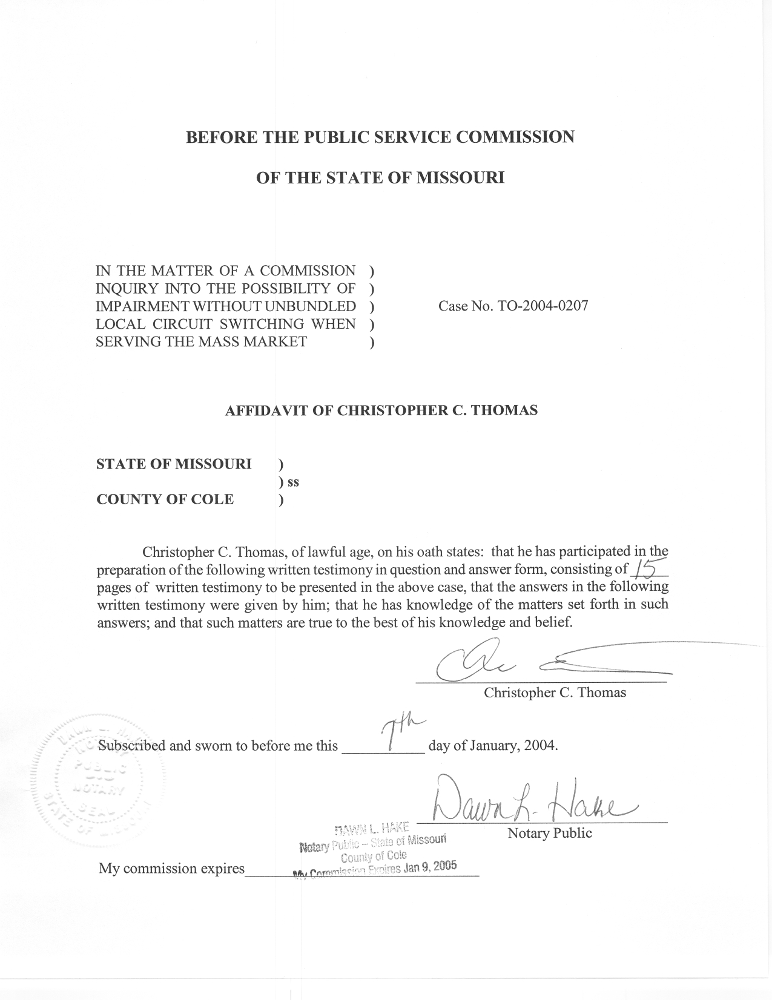
TABLE OF CONTENTS

Purpose 2
Cut-off Between Mass Market and Enterprise Customers 2
Market Determination 9
Summary 15

REBUTTAL TESTIMONY
OF
CHRISTOPHER C. THOMAS
CASE NO. TO-2004-0207

Q. Please state your name, employer, and business address.
A. My name is Christopher C. Thomas and I am employed in the Telecommunications Department of the Missouri Public Service Commission (Commission). My business address is Governor Office Building, Suite 500, 200 Madison Street, Jefferson City, Missouri, 65101.
Q. Please describe your work experience.
A. I am employed as a regulatory economist in the Telecommunications Department Staff (Staff) of the Commission. The duties of my position include reviewing, analyzing, and writing recommendations for controversial or contested tariff filings and other cases. I also provide expert testimony on costing theory and economic policy issues. I have previously filed testimony before the Commission in Case Nos.
TO-98-329, TT-2000-527/513, TT-2001-298, TO-2001-439, TO-2001-455,
TA-2001-475, TO-2002-222, TT-2002-472, and IT-2004-0015.
Q. Please describe your educational background.
A. I received my Bachelor’s Degree in Business Administration with a concentration in Finance from Truman State University in 1998, and subsequently received my Master’s Degree in Economics and Finance from Southern Illinois University-Edwardsville in May of 2000.

Purpose
Q. What is the purpose of your testimony?
A. My testimony will examine the parties’ proposals concerning the appropriate cut-off point between mass market and enterprise customers and will present the Staff’s position with respect to each proposal presented. My testimony will also examine the issue of determining the appropriate geographic market. This issue is also addressed in Staff witness Walter Cecil’s testimony. Both Mr. Cecil and I recommend the Commission use the exchange as the appropriate geographic market. My testimony demonstrates Staff’s recommended approach satisfies the FCC’s established criteria. Mr. Cecil’s testimony compares and contrasts the parties’ proposals with Staff’s recommendation.

Cut-off Between Mass Market and Enterprise Customers
Q. Have you reviewed the testimony filed by the parties in this case, with respect to the appropriate multiline customer cut-off between mass market customers served via DS0 (voice grade) loops and enterprise customers served via DS1 loops (hereafter referred to as the cut-off point)?
A. I have. Specifically, I have reviewed the testimony filed by Joseph Gillan (CLEC Coalition), John F. Finnegan (AT&T), James M. Maples (Sprint), Gary A. Fleming (SBC), Arthur Martinez (CenturyTel), Robert W. McCausland (Sage) and Michael Starkey (Sage).
Q. Could you please briefly summarize the parties’ positions on this issue for the Commission?
A. The parties to this proceeding have taken four different approaches in recommending an appropriate cut-off point. These approaches can be summarized as follows:
- Mr. Starkey tentatively concludes that the cut-off point should be driven solely by the technology used to serve each individual customer. As an example, if a CLEC chooses, for whatever reason, to serve a 24-line customer via 24 individual DS0 loops, rather than a single DS1 loop then that customer should be considered part of the mass market, even if the customer chooses, as a condition of service, that they be served in such a fashion.
- SBC and Century-Tel recommend that the Commission adopt the FCC’s tentative cut-off point of 4 lines. Mr. Fleming has provided an analysis demonstrating that such an approach is justifiable, provided that CLECs are able to generate sufficient revenues from the sale of additional data services to their customers. Under this approach, customers who purchase two voice lines, a line dedicated to their credit card terminal, and a line dedicated to a fax machine will be considered part of the enterprise market.
- Sprint has proposed a cut-off point of 10 lines. Mr. Maples has provided an analysis simply comparing the cost of customer premise equipment (CPE) used to provide voice service to customers via a DS1 loop and a statewide average cost of purchasing the DS1 loops from an ILEC to a statewide average cost of purchasing individual DS0 loops from ILECs. Under this approach, customers who purchase 10 voice grade equivalent lines will be considered part of the enterprise market.
- AT&T has proposed a cut-off point of 13 lines. Mr. Finnegan has taken an approach similar to the analysis undertaken by Mr. Maples. The primary difference is in the level of detail incorporated into the analysis. Mr. Finnegan has provided a comparison of the estimated costs a firm might incur when providing service via a DS1 to the costs a firm might incur by providing service via a UNE-P arrangement. Under this approach, customers who purchase 13 voice grade equivalent lines will be considered part of the enterprise market.
Q. Which approach does Staff support as appropriate for this proceeding?
A. The FCC provided guidance to the Commission in paragraph 497 of the Triennial Review Order (TRO):
Therefore, as part of the economic and operational analysis discussed below, a state must determine the appropriate cut-off for multi-line DS0 customers as part of its more granular review. This cross over point may be the point where it makes economic sense for a multi-line customer to be served via a DS1 loop.

The FCC codified its directives to state commissions in 47 CFR 51.319(d)(2)(iii)(B)(4):
…the state commission shall establish a maximum number of DS0 loops for each geographic market that requesting telecommunications carriers can serve through unbundled switching when serving multiline end users at a single location. Specifically, in establishing this “cutoff,” the state commission shall take into account the point at which the increased revenue opportunity at a single location is sufficient to overcome impairment and the point at which multiline end users could be served in an economic fashion by higher capacity loops and a carrier’s own switching and thus be considered part of the DS1 enterprise market.

An approach that takes into account the relative economics of serving customers via DS0 and DS1 loops is the most appropriate given the FCC’s directives as emphasized above. The technology specific approach advocated by Mr. Starkey is not appropriate for this proceeding, as it does not analyze or ‘take into account the point at which the increased revenue opportunity at a single location is sufficient to overcome impairment” nor “the point at which multiline end users could be served in an economic fashion by higher capacity loops and a carrier’s own switching”.
In Staff’s opinion, the approach advocated by Mr. Fleming and supported by both SBC and CenturyTel is also flawed. Mr. Fleming’s analysis concludes that a cut-off point of 4 lines is feasible provided the CLEC is able to generate sufficient data revenues in each UNE Density Zone. In Staff’s opinion, there are two inter-related problems with this approach:
- Requiring CLECs to generate substantive data revenues to overcome impairment essentially creates an entry barrier that prohibits firms that do not offer data services from entering Missouri’s local exchange markets. While such revenues may be available to CLECs, many companies, but specifically ILECs, provide data services through lesser-regulated affiliates. For purposes of the impairment analysis, Staff believes the Commission should examine only those revenues available to competitors in the local exchange markets, and should not rely on unregulated, although related, revenues to establish a cut-off point.
- A cut-off point of 4 lines ensures that businesses with 2 voice grade lines, a line dedicated to a credit card terminal, and a line dedicated to a fax machine will be considered part of the enterprise market. Neither SBC nor CenturyTel have provided data detailing the distribution of customers within the marketplace. This information is likely very voluminous and includes sensitive customer specific data. Staff can easily foresee a large subset of small business customers being left without competitive alternatives, as they do not utilize data services of the scale necessary to generate revenues of sufficient size for the serving CLEC to overcome impairment.
Since the revenue stream available to CLECs is uncertain, in Staff’s opinion, the best method to examine the cut-off point is to determine when the cost of purchasing an unbundled DS1 loop is less than the continued use of multiple DS0 loops purchased as UNEs for voice service. Mr. Gillan, in his Direct Testimony, detailed this sort of analysis. Mr. Gillan identified two approaches. The first is a simple formula comparing the costs of CPE and serving via UNE DS1 loops to the cost of serving via UNE DS0 loops. Staff believes this is the sort of analysis undertaken by Mr. Maples of Sprint. Mr. Gillan also explains how this simple analysis might be expanded to include the additional cost that a firm incurs when using UNE-Loop (UNE-L) over UNE-Platform (UNE-P), including cost of installation and maintenance of CPE, and the costs to collocate in an ILECs central office and backhaul traffic to the CLECs own switch. Mr. Finnegan has attempted this sort of analysis in his direct testimony.
Q. Which type of analysis does Staff support as appropriate for this proceeding?
A. Ideally, Staff supports the type of analysis preformed by Mr. Finnegan, as it appears to be the most comprehensive study of the cost differential between providing service using DS0 and DS1 loops on an unbundled basis, including additional costs that a firm incurs when using UNE-Loop (UNE-L) over UNE-Platform (UNE-P). However, given the information presented in testimony, Staff is unable to support Mr. Finnegan’s analysis at this time. In Staff’s opinion, more detailed cost information is necessary if this analysis is to be accepted by the Commission. Specifically Mr. Finnegan should provide the following information as described below:
- Additional supporting information for the marketing cost differential between marketing to mass market and enterprise customers of $625 as identified on page 6 of Mr. Finnegan’s Direct Testimony;
- Detailed analysis of the monthly UNE-P rate that Mr. Finnegan calculated, including supporting information for the 1,668 minutes used to estimate usage sensitive charges, identified in footnote 27 on page 14 of Mr. Finnegan’s Direct Testimony;
- Supporting information for the 30% discount that Mr. Finnegan identifies as the discount that efficient CLECs would likely obtain from CPE suppliers, and the source of the Adtran channel bank equipment, AC/DC power supply and battery charger and backup battery system prices;
- Supporting information for the time estimates used in calculating the cost of installing CPE equipment;
- Supporting information used to develop the average CPE maintenance cost per year;
- Supporting information for the time estimates used in calculating the cost of CPE removal;
- Supporting information detailing the cost of the Edgelink 100 multiplexer;
- Support detailing the monthly recurring cost to backhaul a CLEC customer’s DS1 circuits to on the transport DS3.
Q. If Mr. Finnegan, in his Rebuttal Testimony, is unable to present, to your satisfaction, the information you identified, do you have an alternate recommendation for the Commission?
A. Yes. The analysis performed by Mr. Maples is a good proxy for the cut-off point. Although it is not as detailed as the analysis performed by Mr. Finnegan, it is a reasonable analysis of the economic cut-off point between serving customers via DS0 and DS1 loops.
Q. You appear to support Mr. Finnegan’s recommendation of 13 lines, but are asking for information and ultimately recommending that the Commission adopt the analysis supporting a cut-off point of ten lines. Can you please clarify?
A. Staff supports the approach that Mr. Finnegan professes in his testimony. However, given the lack of supporting information presented in that testimony, Staff supports the analysis performed by Mr. Maples as a good proxy. Mr. Maples analysis establishes “the point at which multiline end users could be served in an economic fashion by higher capacity loops and a carrier’s own switching”. Staff expects Mr. Finnegan to respond in rebuttal testimony to the eight suggestions outlined in my testimony. Therefore, I will be prepared to address the adequacy of that supporting documentation during the evidentiary hearing.

Market Determination
Q. Have you reviewed the testimony filed by the parties in this case, with respect to the appropriate geographic market determination for use in later phases of this proceeding?
A. Yes. I have reviewed the testimony filed in this proceeding by Robert W. McCausland (Sage), Michael Starkey (Sage), Joseph Gillan (CLEC Coalition), August H. Ankum (MCI), Mark D. Harper (Sprint), Gary A. Fleming (SBC), Timothy J. Tardiff (SBC), and Arthur P. Martinez (CenturyTel). Staff Witness Walter Cecil discusses Staff’s position on the parties’ proposals regarding the establishment of the appropriate geographic market definition for use in later phases of this proceeding. Mr. Cecil also identifies deficiencies in both proposals. My testimony will examine a proposal, not addressed by any of the parties to this proceeding, that Staff believes to be the appropriate geographic market definition for the purposes of examining impairment of local circuit switching in Missouri’s local exchange markets.
Q. In Staff’s opinion, what is the appropriate geographic market definition for purposes of examining impairment of local circuit switching in Missouri?
A. In contrast to the recommendations made by other parties in this case, Staff recommends the exchange is the appropriate geographic market for examining impairment of local circuit switching in Missouri. Staff suggests that defining markets on an exchange basis could reduce the number of consumers left without competitive alternatives while recognizing that CLECs market their services to consumers in areas wider than a wire center. A listing of the exchanges by ILEC throughout the state is included as Schedule 1 HC to this testimony. The data utilized in this schedule was provided to Staff in Highly Confidential documents and therefore Staff has marked it as such.
Q. Please define the term exchange for the Commission.
A. The Missouri legislature defined the term “exchange” in 386.020(16) RSMo 2000 as “a geographical area for the administration of telecommunications services, established and described by the tariff of a telecommunications company providing basic local telecommunications service”. I have modified Mr. Fleming’s Schedule GAF-2HC to incorporate the location of each wire center by exchange using data collected by the Commissions’ Engineering and Management Services Department and included it as Schedule 2HC. Although I’m confident in the information utilized to modify this schedule I will acknowledge there may be minor errors in the schedule because Staff’s information and Mr. Fleming’s information did not always correspond adequately. While this will not affect the Commission’s ability to examine exchanges within the three largest MSAs, Staff would suggest that if the Commission chooses to define geographic markets on an exchange basis, then prior to the next phase of this proceeding the Commission should order the ILECs to file comprehensive listings of the wire centers throughout the state and the tariffed exchange boundaries served by each wire center.
It is Staff’s understanding that the majority of the exchanges throughout the state are comprised of a single wire center. In the metropolitan areas of St. Louis, Kansas City, and Springfield, SBC has defined the exchanges to encompass multiple wire centers. Although ILECs are currently only challenging impairment for unbundled local switching in these three MSAs, it is important to note there are other exchanges in Missouri, where impairment may be challenged in the future, that are comprised of more than one wire center.
Q. Does the Missouri Legislature provide guidance on how “market” should be defined within the state of Missouri?
A. Yes. The legislature has given guidance in the effective competition portion of the price cap statute.

392.245.5 Each telecommunications service of an incumbent local exchange telecommunications company shall be classified as competitive in any exchange in which at least one alternative local exchange telecommunications company has been certified under section 392.455 and has provided basic local telecommunications service in that exchange for at least five years, unless the commission determines, after notice and a hearing, that effective competition does not exist in the exchange for such service. The commission shall, from time to time, on its own motion or motion by an incumbent local exchange telecommunications company, investigate the state of competition in each exchange where an alternative local exchange telecommunication company has been certified to provide local exchange telecommunications service and shall determine, no later than five years following the first certification of an alternative local exchange telecommunication company in such exchange, whether effective competition exists in the exchange for the various services of the incumbent local exchange telecommunications company. If the commission determines that effective competition exists in the exchange, the local exchange telecommunications company may thereafter adjust its rates for such competitive services upward or downward as it determines appropriate in its competitive environment. If the commission determines that effective competition does not exist in the exchange, the provisions of paragraph (c) of subdivision (2) of subsection 4 of section 392.200 and the maximum allowable prices established by the provisions of subsections 4 and 11 of this section shall continue to apply. The commission shall from time to time, but no less than every five years, review the state of competition in those exchanges where it has previously found the existence of effective competition, and if the commission determines, after hearing, that effective competition no longer exists for the incumbent local exchange telecommunications company in such exchange, it shall reimpose upon the incumbent local exchange telecommunications company, in such exchange, the provisions of paragraph (c) of subdivision (2) of subsection 4 of section 392.200 and the maximum allowable prices established by the provisions of subsections 4 and 11 of this section, and, in any such case, the maximum allowable prices established for the telecommunications services of such incumbent local exchange telecommunications company shall reflect all index adjustments which were or could have been filed from all preceding years since the company's maximum allowable prices were first adjusted pursuant to subsection 4 or 11 of this section. (Emphasis added)

The legislature has given the Commission the authority to determine whether effective competition exists within the exchanges of price cap carriers. This grant of authority makes it relatively clear that the legislature expects competition to develop on an exchange-wide basis. Defining the relevant market on an exchange basis for this proceeding would be consistent with the legislative approach for relieving price cap carriers from their price cap obligations. Staff acknowledges that there is no legal authority linking these two concepts. However, conceptually, if there is no impairment in an exchange then there should be the potential for effective competition to develop.
- Are there any other relevant Missouri statutes that could provide guidance in defining a market?
A. Yes. Section 392.200.4(2)(a), 2(b), and 392.455(3). Both statutes establish the service areas of Missouri carriers as areas no smaller than an exchange and 392.200.4 (2)(b) discusses methods for defining services in areas smaller than an exchange.
Q. Is defining geographic markets on an exchange basis consistent with the FCC’s directives in the TRO?
A. Yes. The Commission was given wide latitude in defining the geographic markets within the state for the purposes of this proceeding, as follows in paragraph 497 of the Triennial Review Order (TRO):
The triggers and analysis described below must be applied on a granular basis to each identifiable market. State commissions must first define the markets in which they will evaluate impairment by determining the relevant geographic area to include in each market. State commissions have discretion to determine the contours of each market, but they may not define the market as encompassing the entire state. Rather, state commissions must define each market on a granular level, and in doing so they must take into consideration the locations of customers actually being served (if any) by competitors, the variation in factors affecting competitors’ ability to serve each group of customers, and competitors’ ability to target and serve specific markets economically and efficiently using currently available technologies. While a more granular analysis is generally preferable, states should not define the market so narrowly that a competitor serving that market alone would not be able to take advantage of available scale and scope economies from serving a wider market. State commissions should consider how competitors’ ability to use self-provisioned switches or switches provided by a third-party wholesaler to serve various groups of customers varies geographically and should attempt to distinguish among markets where different findings of impairment are likely. The state commission must use the same market definitions for all of its analysis. (Emphasis added and Footnotes omitted)

The FCC codified its directives to state commissions in 47 CFR 51.319(d)(2)(i); Market definition. A state commission shall define the markets in which it will evaluate impairment by determining the relevant geographic area to include in each market. In defining markets, a state commission shall take into consideration the locations of mass market customers actually being served (if any) by competitors, the variation in factors affecting competitors’ ability to serve each group of customers, and competitors’ ability to target and serve specific markets profitably and efficiently using currently available technologies. A state commission shall not define the relevant geographic area as the entire state.
In Staff’s opinion, the exchange level is granular enough to consider the criteria the FCC has identified effectively, while still broad enough to effectively consider the scale and scope economies available to CLECs serving areas broader than a wire center.
Q. Has Staff examined the data provided in Mr. Fleming’s testimony on an exchange basis?
A. Yes. An analysis of Mr. Fleming’s Schedule GAF 2 HC with wire centers grouped by exchange for the three major MSAs within the state, as found in Schedule 3HC, indicates competition exists, at least by the methods Mr. Fleming uses to determine the existence of competition, mainly within the metropolitan exchanges of Kansas City, Springfield, and St. Louis. Furthermore, a review of this schedule makes it obvious that competition is less widespread outside the metropolitan exchanges. By determining impairment on an MSA basis, customers in the outer areas of the three largest MSAs could be left without competitive alternatives.
Q. Does defining markets on the exchange level preclude the Commission from finding impairment throughout each entire MSA?
A. It does not. Defining markets on an exchange basis makes it easier for the Commission to find that there is still impairment in the outer areas of each MSA, but does not in any way preclude the Commission from finding that no impairment exists in these areas. Staff believes that defining markets at the exchange level recognizes that there are scale and scope economies to be obtained from serving areas wider than a wire center, while providing the Commission the opportunity to ensure that competitive alternatives exist in the outer areas of the MSAs.

Summary
Q. Please summarize your testimony for the Commission.
A. I have analyzed the parties proposals regarding the appropriate cut-off point between mass market and enterprise customers, and have indicated Staff supports a cut-off point which is a result of a study of the relative costs of serving customers via DS0 and DS1 loops. At this time, Staff supports the ten line cut-off point proposed by Mr. Maples as a good proxy for determining the appropriate DS0/DS1 cut-off point; however, I have identified the additional information necessary for Staff to support Mr. Finnegan’s recommendation of 13 lines.
In addition, my testimony has demonstrated that the exchange level is the appropriate geographic market determination for examining local circuit switching impairment in the next phase of this proceeding. Defining geographic markets on an exchange level recognizes that there are scale and scope economies to be obtained from serving areas wider than a wire center, while allowing the Commission the ability to ensure that competitive alternatives exist in the outer areas of the MSAs.
Q. Does this conclude your testimony?
A. Yes, it does.

