Exhibit No.:
Issues: Fuel and Purchase Power Expense
Witness: Graham A. Vesely

Sponsoring Party: MoPSC Staff
Type of Exhibit: Surrebuttal Testimony
Case No.: ER-2002-424
Date Testimony Prepared: October 16, 2002

MISSOURI PUBLIC SERVICE COMMISSION

UTILITY SERVICES DIVISION
SURREBUTTAL TESTIMONY
OF
GRAHAM A.VESELY

THE EMPIRE DISTRICT ELECTRIC COMPANY
CASE NO. ER-2002-424

Jefferson City, Missouri

October 2002
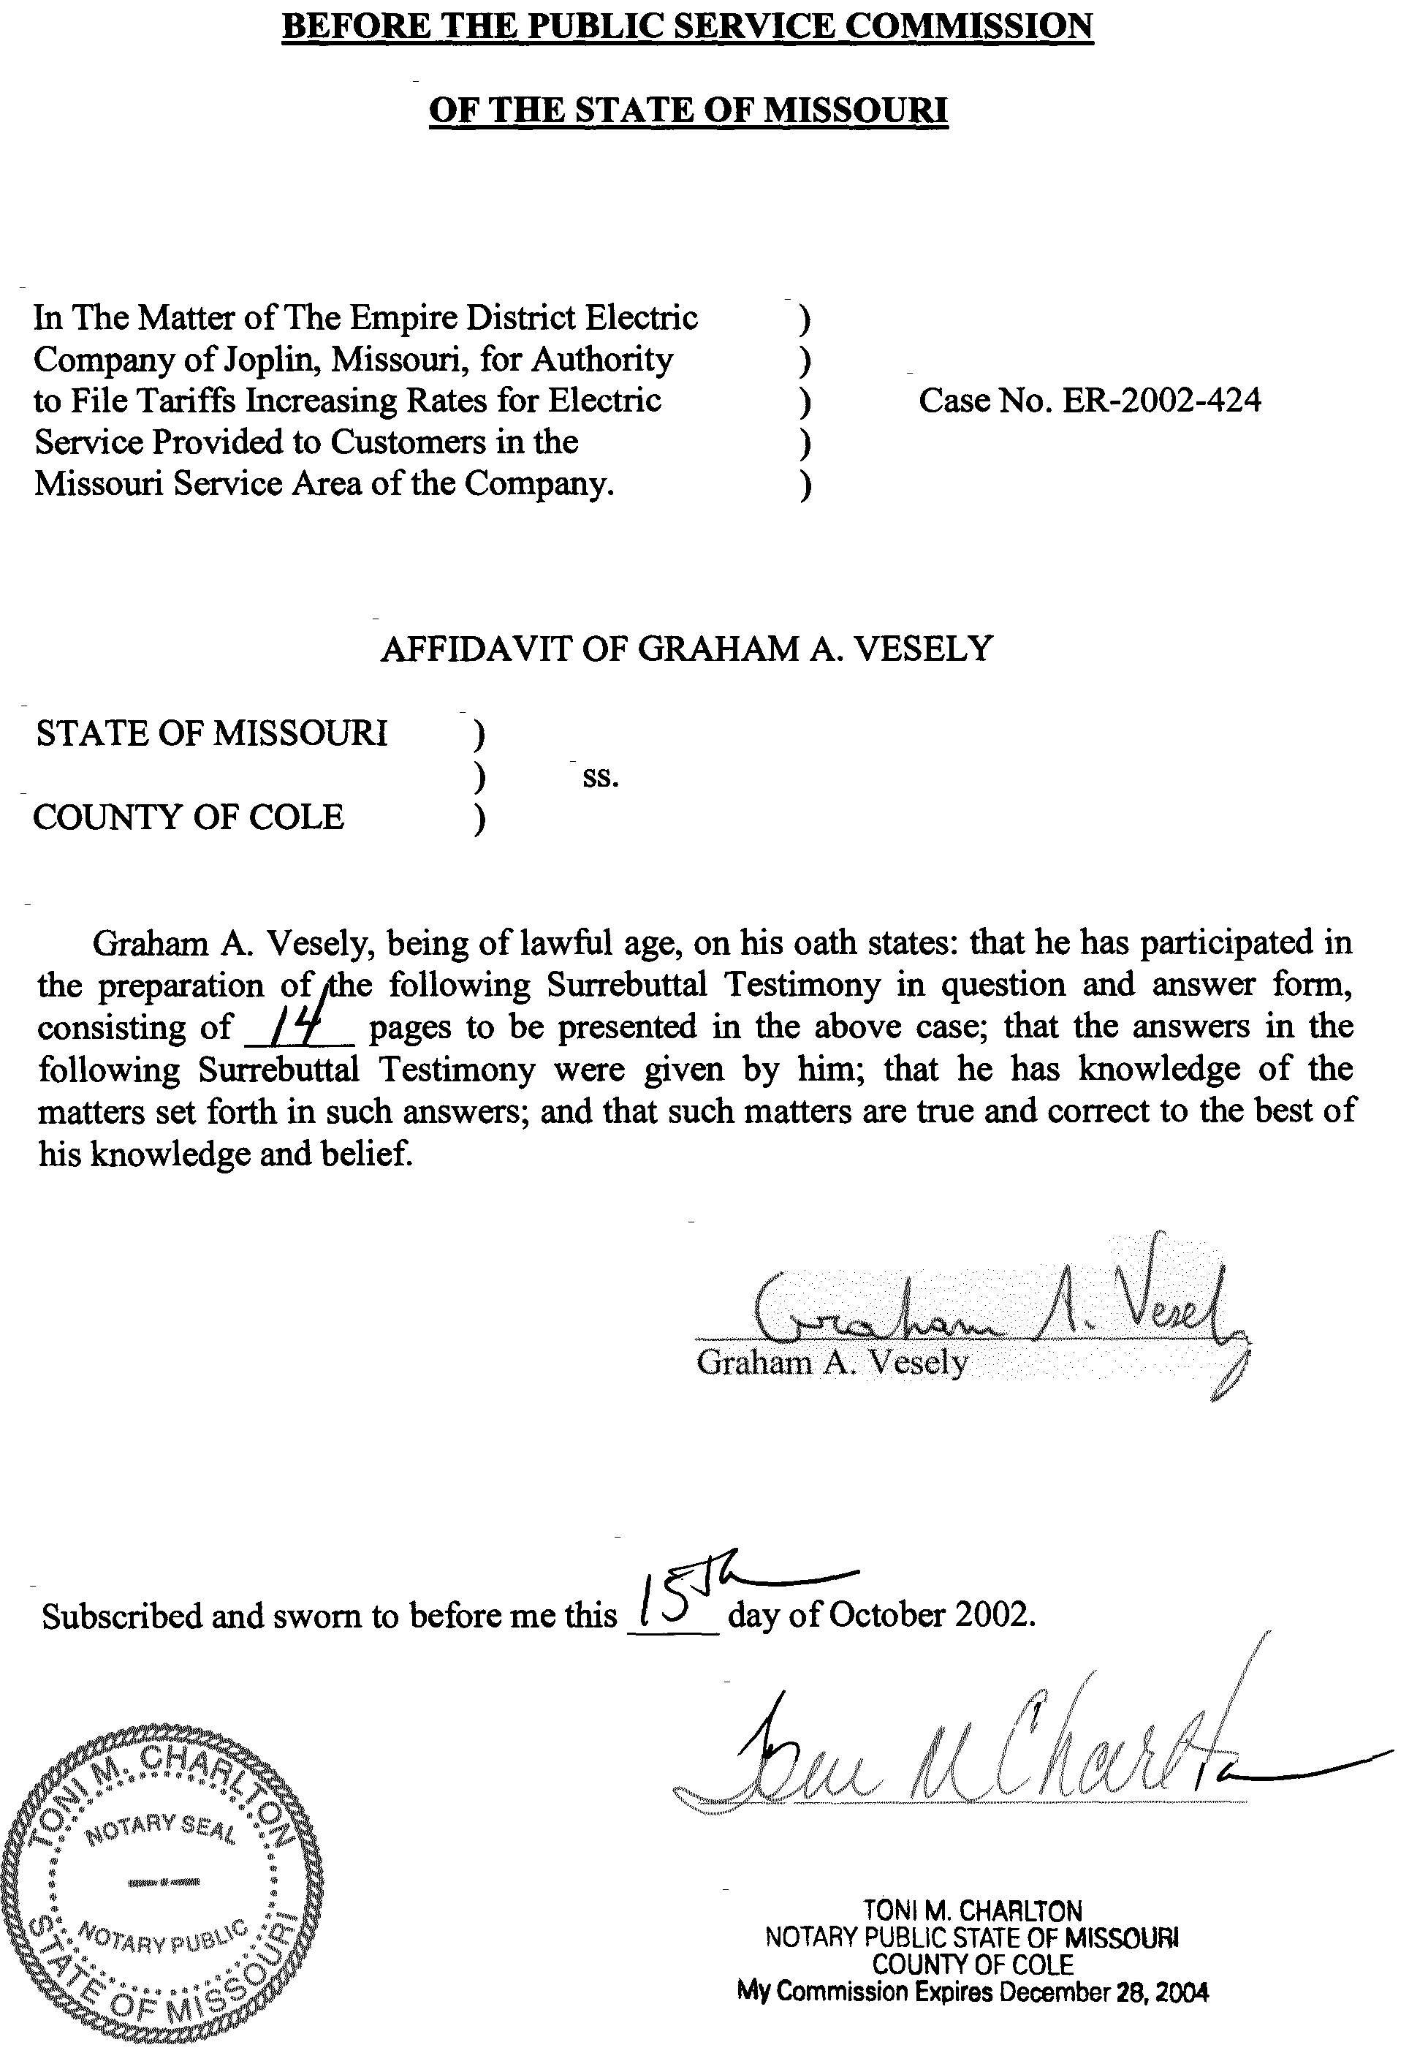
TABLE OF CONTENTS
SURREBUTTAL TESTIMONY
OF
GRAHAM A. VESELY
CASE NO. ER-2002-424

FUEL EXPENSE 1
PURCHASED POWER EXPENSE 13

SURREBUTTAL TESTIMONY
OF
GRAHAM A. VESELY
THE EMPIRE DISTRICT ELECTRIC COMPANY
CASE NO. ER-2002-424
Q. Please state your name and business address.
A. Graham A. Vesely, 3675 Noland Road, Suite 110, Independence, Missouri 64055.
Q. Are you the same Graham A. Vesely who has previously filed direct testimony in this case?
A. Yes, I am.
Q. What is the purpose of your surrebuttal testimony?
- The purpose of my surrebuttal testimony is to respond to the rebuttal testimony of Empire District Electric Company (Empire or Company) witness Brad P. Beecher related to fuel and purchased power expense.

FUEL EXPENSE
- Do you agree with Mr. Beecher, on page 4 of his rebuttal testimony, that natural gas costs for 2003 should be used to set rates in this Case No. ER-2002-424 because they are known and measurable?
- No. It is doubtful whether 2003 natural gas prices are known and it is certain that they are not measurable; it is equally certain that they are outside of the June 30, 2002 update period and, therefore, are not appropriate for setting rates in this case.
- Please explain what you mean.
- The spot market price for natural gas in and throughout the year 2003 cannot be known in advance. This is also true in general for all of Empire’s other cost of service items. It is true that utilities enter into agreements for the purpose of establishing the price of natural gas to be delivered at a future date, under those agreements. Empire enters into a variety of such transactions as part of its natural gas hedging program. However, even Empire acknowledges that as of July 1, 2002 the Company had hedged 68% of its anticipated natural gas requirements for 2003. The price of the remaining 32% of anticipated natural gas requirements continued to fluctuate each day with the spot market price.
Q. Does this mean that the hedged 68% of the costs of the natural gas Empire expects to need for its 2003 operations is known and measurable and suitable for inclusion in rates in this case?
- No. Empire’s energy Risk Management Policy, or RMP (a copy of which was filed as Schedule BPB-5 attached to Brad P. Beecher’s rebuttal testimony), allows the hedged percentage of natural gas to vary, in order to support the Company’s stated objective of “mitigating price volatility.” Therefore, within the guidelines specified by the RMP, it seems quite likely that prudent management will require Empire, as it monitors changes in the spot market price of natural gas over the passing of time, to rearrange its hedged position. This feature makes it impossible to consider even the hedged portion of 2003 natural gas costs to be known, much less measurable.
Q. What is the “known and measurable” concept, as that term is used in the ratemaking process?
A. The concept that is referred to as “known and measurable” relates to the setting of rates based on actual events that occur in providing utility service, that result in material changes to the revenue requirement determination. These actual events have a material impact on the revenue, expense and rate base investment relationship that the Commission has consistently used to determine rates that utilities operating in the state of Missouri can charge their customers for utility service. Known and measurable changes are the revenue requirement effects for “known” changes to revenue, expense and rate base investment relationship and “measurable” changes to these revenue requirement components. The changes to revenues, expenses and rate base investments must be “known”---i.e., certain to occur--- and must be quantifiable or “measurable.” The natural gas prices used by the Company in this case fail to meet the “known and measurable” test.
Q. Would you describe the use of 2003 natural gas prices in this Case No. ER-2002-424 as an out-of-period adjustment?
A. Yes. It is essential to keep in mind that since Empire’s hedging transactions govern the details of the price of natural gas to be delivered to the Company at a future date, the prices resulting from hedging transactions necessarily include an allowance for the fact that the natural gas is to be delivered in the future. Natural gas scheduled for delivery in the year 2003, apart from the method used to attempt to forecast its price, is not a cost incurred to provide utility service during the test year or the update period of this case, and therefore should not affect how rates are set in this case. Any attempt to bring into this case an expense, revenue or rate base item that occurred, let alone one that merely might occur, after the update period the Commission ordered for this case is an out-of-period adjustment. The Commission has long rejected this practice by any of the parties to a rate proceeding, stating in particular in Case No. ER-83-49, Kansas City Power & Light rate case:
The Commission has no desire to entertain isolated adjustments, but seeks a “package” of adjustments designed to maintain the proper revenue-expense-rate base match at a proper point in time. Evidence of “picking and choosing” by a party with the intent of simply raising or lowering revenue requirement will not be condoned.
[Commission Report And Order, Case No. ER-83-49, page 8]
Q. Are natural gas purchases made under Empire’s hedging policy considered a “contract” price?
A. No, at least not in the sense of other typical contracted costs, such as those that involve the purchase of coal as a fuel source.
Staff sees key differences in the way Empire both procures and prices natural gas and coal. However, the Staff's approaches to determining the prices of these two fuel sources are consistent in terms of regulatory principles.
Q. Please explain what you mean by key differences in the way Empire procures and prices coal and natural gas in this case.
A. The Company buys most of its coal under multi-year contracts that typically have a provision for adjusting the price on an infrequent basis, such as once a year. Apparently, the fact that the spot market price of coal does not vary much permits both parties to the contract to feel reasonably confident that this method of doing business is economical. The coal contracts that Empire has entered into identified the prices the Company was paying for coal as of June 30, 2002, and the Staff and Empire were able to agree to use these prices in this case.
Q. Are the purchases of natural gas under the Company’s hedging policy considered a “final” contract price?
A. No. Natural gas purchases made under Empire’s hedging approach are not actual purchases until the time when the purchase is actually made. A final price for natural gas purchased through hedging cannot be determined until such time as the purchase is actually made. As an example, a hedged gas purchase may be made in advance for what Empire expects natural price to be trading at in some future market, say in the year 2003. Until the actual purchase for the month in question occurs, no one will actually know what the price will be for certain. The expected price of the natural gas may not be the actual price paid because, in many instances, Empire will have the option to “exercise” the hedged price. If Empire can purchase natural gas at a lower price than the hedged price (identified in some cases months in advance) then it will not exercise the hedged option and purchase the lower priced natural gas. Thus, to say that the hedged pricing of natural gas is known in advance of the actual purchase is simply not true. If electric rates were to be set using a higher hedged price for natural gas purchase rather than the actual lower purchase price, fuel expense would be overstated.
Q. Would Empire benefit from such an overstatement of fuel costs?
A. Yes, Empire would directly benefit from such an overstatement of fuel expense. Any such windfall in fuel costs would flow directly to the Company’s earnings, benefiting shareholders.
Q. On page 5 of his rebuttal testimony, Mr. Beecher states:
The natural gas price utilized in the Staff’s fuel run is not representative of Empire’s currently hedged position. In essence, by utilizing historical gas prices and ignoring our known and measurable contracts, Staff is disallowing our prudently incurred costs without presenting any evidence that the contracts were entered into imprudently.
Do you agree with this statement?
- No. I have explained above the Staff's reasons for considering Empire's current figure for hedged 2003 natural gas as not being known and measurable. Simply stated, the natural gas prices that Empire is supporting in this case are neither “known” nor “measurable.” The Staff’s figure of $3.29 per MMBtu (which is higher than the Company’s originally filed $2.98 per MMBtu) was arrived at using exclusively historical known and measurable data on gas prices actually paid by the Company right up through the end of the update period for this case, June 30, 2002. Empire’s updated position of $3.37 per MMBtu, on the other hand, results from a forecasting process that attempts to determine what 2003 natural gas prices will be, rather than from historical known and measurable data. This process is contrary to the manner in which every other item of expense, revenue and rate base was calculated in this case. For example, though the Company likely has a reasonable expectation of incurring increased payroll costs at some future date, possibly already set by contract, as with the case of union bargaining agreements, it has not attempted to have any forecasted level of such future costs included in this Case No. ER-2002-424. Neither has the Company requested that plant expected to be placed in service in June 2003, for which it likely has a forecasted cost, be included in rate base in this case. Likewise, for its part, the Staff has not attempted to look beyond the June 30, 2002 cut-off date and bring into this case any items that would reduce revenue requirement.
Q. Has Staff disallowed any of Empire’s hedged costs?
A. No. Staff has not made any such disallowance in this case. The issue between the Company and Staff concerns the appropriate time horizon for considering natural gas prices. Empire has used natural gas prices all the way out to the end of 2003 to develop its fuel costs. Staff has used natural gas prices as of June 30, 2002, based on actual purchases made by the Company. This is an important distinction because all aspects of this case are based on this critical date. All revenues, expenses, rate base investment and capital structure, are based on the cut-off-date of June 30, 2002. All elements of the revenue requirement utilize this June 30 cut-off. The importance of the “as of” June 30, 2002, cannot be over-emphasized. All “known” material events are quantified and measured “as of” June 30, 2002. Consistent with all other components of the revenue requirement, Staff has used natural gas prices based on actual purchases made by the Company “as of” June 30, 2002.
Q. Has Staff ignored Empire’s hedging policy in this case?
A. No. Since Staff arrived at its natural gas price using actual historic prices, to the extent that known and measurable, historical prices reflected Empire's hedging program, the Staff has captured those effects in this case. Staff determined natural gas pricing using the 12 months ended June 30, 2002. Most of the months of this period reflected results of actual purchases made through Empire’s hedging policy. Therefore, Staff has neither ignored, nor made any disallowances of purchases made through the hedging policy.
Q. If the 2003 natural gas prices were known and measurable, would it be appropriate to include these prices in this case?
A. No. While the 2003 natural gas prices can be neither “known” nor “measurable,” as discussed throughout this surrebuttal, even if these natural gas prices met the test of known and measurable (which they do not), they should in no way be considered part of this case. The cut-off of information is June 30, 2002, not 2003. In any event, the “hedged” prices for expected 2003 natural gas purchases are outside the scope of this case, just as are other costs increases or decreases.
Q. Did the Company agree to the use of June 30, 2002 as the cut-off for the known and measurable period?
A. Yes.
Q. Did the Commission adopt June 30, 2002 as the cut-off for known and measurable period?
A. Yes. In its Suspension Order and Notice (Suspension Order) dated April 2, 2002, the Commission authorized the use of June 30, 2002 as the date of the update period. The Commission stated in its April 2nd Suspension Order at page 2:
On March 22, 2002, Empire, the Staff of the Missouri Public Service Commission, Praxair, Inc., and the Office of the Public Counsel jointly filed a Joint Recommendation Regarding Test Year and Proposed Procedural Schedule. The parties have agreed to a proposed procedural schedule and to an updated test year. The parties propose the 12-month period ending December 31, 2001, as the test year with an update period ending on June 30, 2002. The parties agreed that with the update period, no true-up hearing will be necessary.
In the Ordered section of the Suspension Order, paragraph 4, the Commission stated:
That the test year in this matter shall be the 12-month period ending December 31, 2001, updated for known and measurable changes through June 30, 2002. Empire District Electric Company shall update its accounting information consistent with the test year.
Q. Did events dictate that June 30, 2002 be used as the update period in this case?
A. Yes. As stated at page 2 of the direct testimony filed by David W. Gibson, currently Vice President – Regulatory Services, Empire proposed what the test year and update period it believed needed to be used for this case. Mr. Gibson stated:
Empire is filing this case based on a test year ending September 30, 2001updated for a common equity issuance which will occur in June 30, 2002. It is our understanding that the Commission Staff would prefer to have a test year ending December 31, 2001. A December 31, 2001 test year is acceptable to Empire so long as the common equity issuance, which is projected for June 2002 is included in the update. If the December 31, 2001 test year is agreement to all parties and approved by the Commission, the Company will file supplemental direct testimony and schedules to reflect that test year.
The common equity issuance and the maturity of long-term debt resulted in the need for the update period in this case to be June 30, 2002. The Company requested this period for these reasons and the parties, including Staff, agreed to this update period. Thus, it was events that were occurring at Empire and dictated the timing and ultimately, the updated period that the Company believed appropriate and what led the Commission to authorize the use of the update period being June 30, 2002.
Q. On page 8 of his rebuttal testimony, Mr. Beecher states, “The other disconcerting fact that has continued since at least the mid-1990’s is Staff’s ever-changing basis for establishing natural gas costs. I have been directly involved in cases where the Staff has recommended the twelve-month ending cost, or if the twelve-month ending cost didn’t suit their needs they supported a three-year historical average.” Please respond to this.
- The Staff has traditionally reviewed natural gas prices over an historical period, beginning with the test year (updated if applicable) and going back several years, with the goal of determining what a normal level of price is. In this case, I calculated the average natural gas price Empire has paid for several historical periods, as shown below:
5 years ended June 30, 2002 $2.50/MMBtu
3 years ended June 30, 2002 $3.49/MMBtu
2 years ended June 30, 2002 $3.94/MMBtu
12 months ended June 30, 2002 $3.29/MMBtu
These figures result from a sharp rise in natural gas prices beginning in mid-2000, reaching an all-time peak in the winter of 2000/2001, and then a steady decline beginning in the early spring of 2001. Prices continued to decline throughout the rest of 2001, and through the period after Empire filed its original direct testimony position on March 8, 2002 in this case. The Company’s fuel expense and purchased power adjustment in its original case was negative, indicating that its annualized fuel expense was lower than its test year fuel expense. The chart found below graphically illustrates the instability of natural gas prices during the indicated historical period:
Q. Why did Staff select $3.29 per MMBtu as the normalized price for natural gas in this case?
- From a review of Empire’s monthly fuel reports the Staff determined that $3.29 per MMBtu is the average price the Company paid for natural gas in the twelve months ending with the June 30, 2002 update period. The Staff made its selection because this price has the benefit of including the most up-to-date twelve-month cost data in the case, which compared with the historical experience, appears to yield a reasonable estimation of a normal natural gas price. It neither overstates natural gas prices by giving undue weight to peak gas prices, nor assumes prices will return to their low pre-2000 levels. Lastly, the Staff’s analysis relies only on historical prices that Empire is known to have paid for natural gas. Staff did not attempt to “guess” what prices might do in the future, since the Staff agrees with Mr. Beecher that no one knows what gas prices will be in the future, as stated in his direct testimony at page 5, line 19.
- What price for natural gas did the Company use in its direct filing?
A. Empire used a value of $2.98 per MMBtu to calculate its annualized fuel and purchased power expense in its March 8, 2002 direct filing. On page 9 of Empire witness Beecher’s supplemental direct testimony (filed on March 28, 2002), he states that the Company used “natural gas commodity prices [based] on the monthly average prices Empire has hedged for the year 2002.” In Empire’s rebuttal testimony, filed on September 24, 2002, Mr. Beecher is now supporting the use of hedged natural prices for the year 2003.
Q. What would the Company’s position be on natural gas prices if it used the same methodology it employed in its supplemental direct filing?
A. Using the natural gas position report updated as of June 30, 2002, Empire's proposed natural gas price would be $2.51 per MMBtu compared with the $3.37 per MMBtu amount it is supporting in Mr. Beecher’s rebuttal testimony. Schedule 1 attached to my surrebuttal testimony is the July 1, 2002 Gas Position Summary report, which compares to the March 25, 2002 Gas Position Summary report Mr. Beecher attached to his supplemental direct testimony as Schedule BPB-1. Note that the amount in the July-December 2002 column as of March 25, 2002 is $2.95 per MMBtu, which is close to the $2.98 per MMBtu amount Empire supported in its supplemental direct filing made on March 28, 2002. Clearly, Empire has changed its approach to the pricing of natural gas for use in its fuel expense calculation, from that which it filed in direct testimony, to the amount in its rebuttal case.
Q. On page 5, line 3, of his rebuttal testimony, Mr. Beecher states, “the Staff failed to include a proper amount for the GSR charges assessed by FERC.” How do you respond to this statement?
A. The Staff became aware of the existence of the Gas Supply Realignment (GSR) charge after the filing of its original case. After being presented with the relevant information at the prehearing conference (attached as Schedule 2 to this testimony), the Staff included the remaining unpaid, unamortized $135,816 balance in its case. Mr. Beecher is requesting that $267,333 be added to the case. This figure is arrived at by treating the $23,149 monthly payment as if it were ongoing, for an entire year, instead of ending once the $135,816 balance is paid off. The Staff considers this incorrect.
Q. Please explain.
A. As of the June 30, 2002 update period, the remaining unpaid $135,816 balance is known and measurable. By the Staff including this amount in its case, the Company’s rates will be designed to fully recover this amount during the first twelve months that rates set in this case are in effect. After twelve months, Empire's rates should be revised to not include repayment of this item in order to avoid over-collecting from ratepayers. This approach is similar to the treatment afforded other instances amortizable items, such as rate case expense. When amortization is expected to end within the known and measurable period, Staff recommends ending the amount of the amortization.

PURCHASED POWER EXPENSE
Q. Did you perform any work in the area of purchased power to support the Staff's position?
A. Yes. In the past the Staff of the Accounting Department has collected data on Empire’s purchases of electrical energy from other companies. These data have been arranged into a spreadsheet that shows, on a monthly basis, the quantity of electrical energy purchased and the cost of each purchase. Using data provided by the Company in its response to Staff Data Request No. 47, I have updated this spreadsheet to include purchases of power since the last Empire rate case.
Q. What is the purpose of this collection of purchase data?
A. This information gives the Staff the ability to review the trend of purchased power quantities and prices throughout the test year and update period. It also serves as a reasonableness check when the Staff's production cost model results are compared to the historical experience. Importantly, since the purchased power spreadsheet contains several years worth of data, it gives the reviewer a sense of whether the 2001 test year in this case was normal in terms of purchased power quantities and prices. The following figures are extracted from the update I performed to the Staff's ongoing purchased power analysis:
The quantity of power purchased by Empire over the periods indicated in the table support the reasonableness of Staff witness David W. Elliott's position on normalized purchased power quantities. In addition, the amounts of purchased power over a several year historical period identified in Mr. Beecher’s supplemental direct testimony on Schedule BPB-3 dated February 19, 2002 provide further support for the reasonableness of Staff witness David W. Elliott’s position. For example, for the year 2000 Empire purchased 2.3 million MegaWatt-hours of energy.
Q. Does this conclude your surrebuttal testimony?
A. Yes, it does.

