Exhibit No.:
Issues: Rate Design

Witness: William L. Voight
Sponsoring Party: MO PSC Staff
Type of Exhibit: Supplemental Direct
Testimony
Case No.: TC-2002-1076
Date Testimony Prepared: October 22, 2004

MISSOURI PUBLIC SERVICE COMMISSION

Utility Operations DIVISION

SUPPLEMENTAL DIRECT
RATE DESIGN

OF

wILLIAM L. vOIGHT

Missouri Public Service Commission

CASE NO. TC-2002-1076

Jefferson City, Missouri
October 2004

**Denotes Highly Confidential Information**

NP
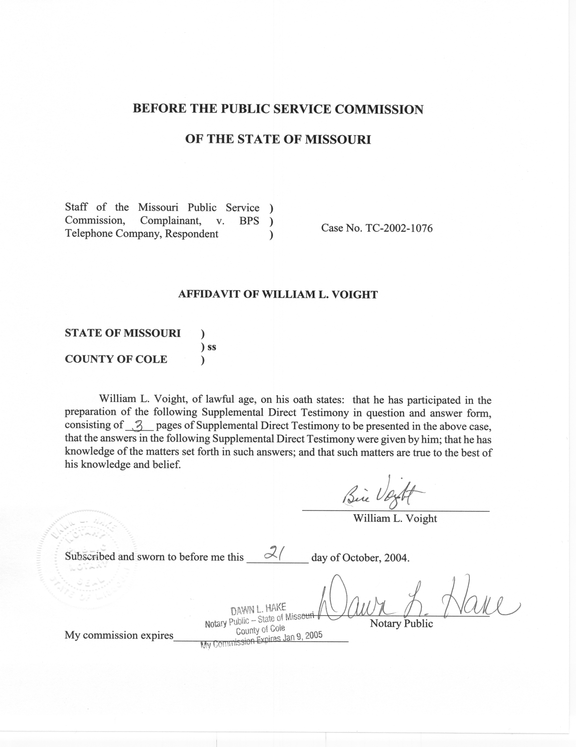
SUPPLEMENTAL DIRECT TESTIMONY
OF
WILLIAM L. VOIGHT
MISSOURI PUBLIC SERVICE COMMISSION
Case No. TC-2002-1076

Q. Are you the same William Voight who filed Direct Testimony in this case?
A. Yes.
Q. What is the purpose of your Supplemental Direct Testimony?
A. My testimony proposes new intrastate access rates for BPS Telephone Company. The Staff’s proposed rate reductions fully transfer BPS’s overearnings into lower intrastate access rates. Staff specifically proposes reducing the following rates: Originating Carrier Common Line (CCL), Terminating CCL, and Local Switching (LS). Staff did not propose changes to the Local Transport rate element, which is currently set at $0.00053186 per minute per mile.
Issues Discussion
Q. What are the current and Staff’s proposed new Intrastate IntraLATA and InterLATA access rates?
A. Current
CCL Originating $0.02990131
CCL Terminating $0.07141421
LS $0.02815218
Line Termination $0.00491350

Proposed
CCL Originating $0.00670285
CCL Terminating $0.01600862
LS $0.00741219 (includes line termination)

- What was Staff’s goal regarding redesigning BPS’s rates?
A. Staff purposefully set out to propose intrastate access rates that result in yearly revenue reductions equal to the amount of BPS’s overearnings in 2004.
Q. How did Staff calculate these rates?
A. Using originating and terminating usage data provided by BPS (Originating and Terminating usage data is 2004 data) and current intrastate access rates, the proposed rates were changed to result in a revenue reduction equal to the amount of BPS’s overearnings. The following expression provides the proposed revenue as a percentage of current revenue.
Z= proposed revenue as a percentage of current revenue
R=current revenue
X= overearnings

X=adjusted overearnings
Z= (R-X)/R

R=originating minutes*originating price + terminating minutes*terminating price
(Calculated in HC Schedule 1)

X= overearnings amount

Z= 0.22416574
Z is multiplied by current rates resulting in Staff’s proposed rates. In the final step, Line Termination was added to Local Switching. That aggregate charge retains the Local Switching moniker.
Under Staff’s proposed rates, BPS’s overearnings of $932,459 will be eliminated.
Q. Why was 2004 data used?
A. Usage data from 2004 is the most recent data available.
Q. Why is Staff recommending the entire overearnings be applied to exchange access rate reductions?
A. In my view, the current rates paid by BPS’s retail end user customers are reasonable. For example, the monthly rate for one-party residential basic local telephone service in Parma, Bernie, and Steele is $6.50, $7.00, and $7.00, respectively. Similar rates for business services are $13.00, $14.00, and $14.00. These rates include touch-tone service and customers of BPS pay no mileage additives. Although the local calling scope of BPS customers is limited, and although the amount of money that customers are required to actually pay for local telephone service is much more due to various surcharges and taxes, the Staff nevertheless considers these rates reasonable.
Q. If the Staff’s access rate design were accepted, how would BPS’s access rates compare to other Missouri local exchange carriers?
A. Out of 43 incumbent local exchange carriers, BPS currently has the 11th highest access rates in Missouri. Staff’s proposal would have BPS providing the 39th highest rates on an average basis. For information purposes, a copy of Staff’s Switched Access Rate Comparison chart is attached as Schedule 2.
Q. Does this conclude your Supplemental Direct Testimony?
A. Yes.

SCHEDULE 1 IS DEEMED
HIGHLY CONFIDENTIAL IN ITS ENTIRETY

