Exhibit No.:
Issue: Customer Service
Witness: Gary Bangert
Sponsoring Party: MoPSC Staff
Type of Exhibit: Direct Testimony
Case No.: GR-2003-0517
Date Testimony Prepared: October 24, 2003

MISSOURI PUBLIC SERVICE COMMISSION

UTILITY SERVICES DIVISION

DIRECT TESTIMONY

OF

GARY BANGERT

UNION ELECTRIC COMPANY
d/b/a AMERENUE

CASE NO. GR-2003-0517

Jefferson City, Missouri
October 2003
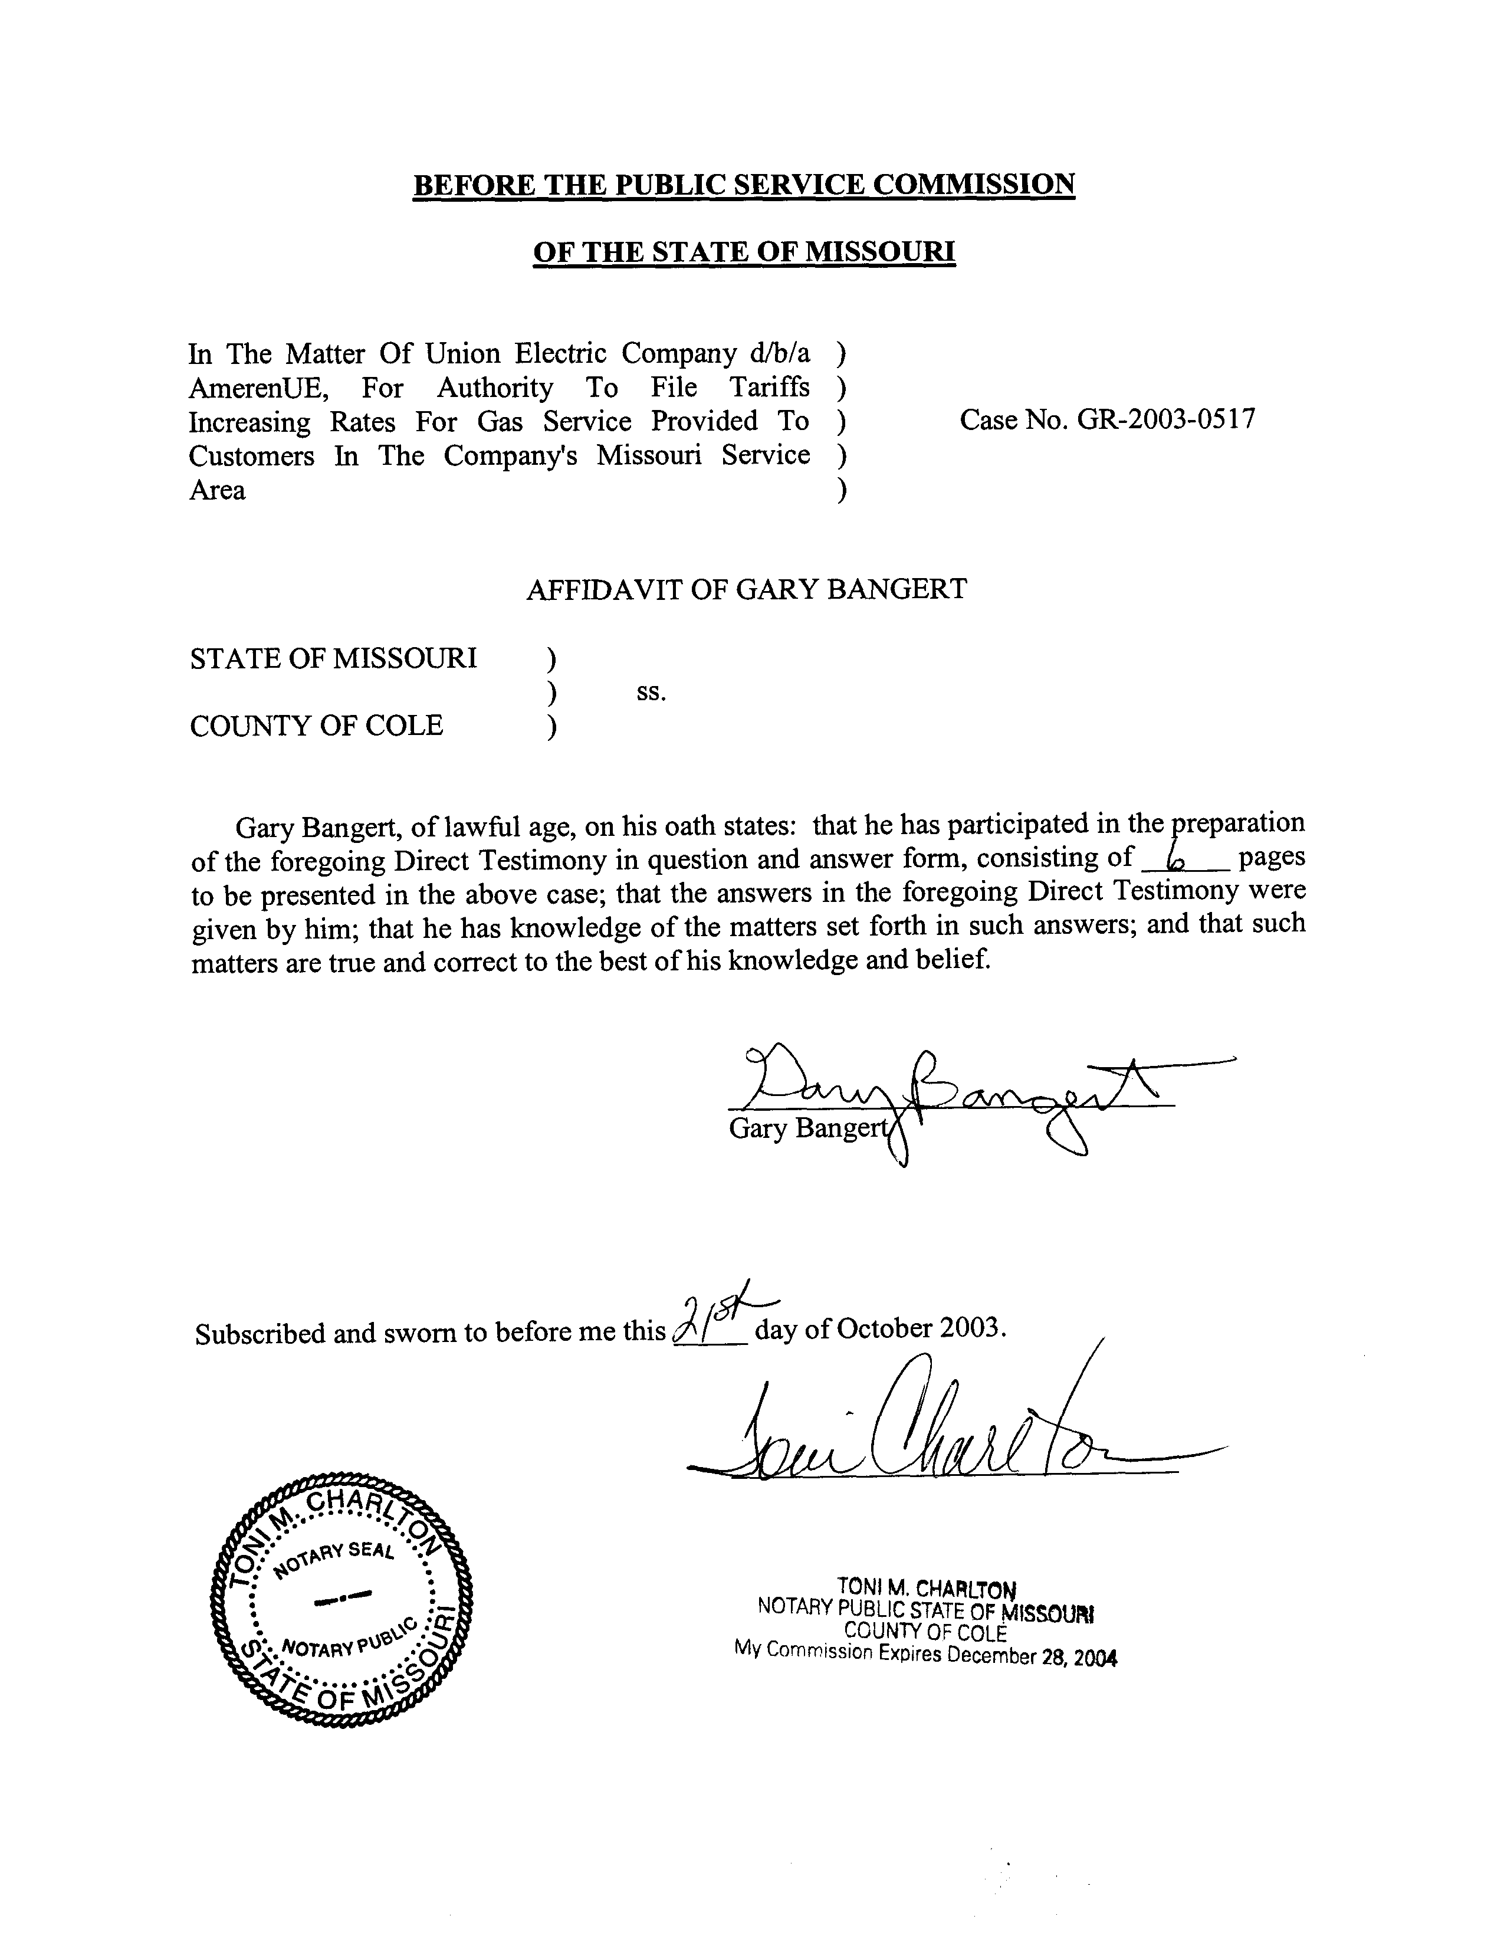

DIRECT TESTIMONY
OF

GARY BANGERT
UNION ELECTRIC COMPANY
d/b/a AMERENUE

CASE NO. GR-2003-0517
Q. Please state your name and business address.
A. Gary Bangert, P.O. Box 360, Jefferson City, Missouri 65102.
Q. By whom are you employed and in what capacity?
A. I am a Utility Management Analyst III for the Missouri Public Service Commission (Commission).
Q. Describe your educational background.
A. I graduated from Concordia Teachers College in Seward, Nebraska, in 1973 with a Bachelor of Science degree in Education. I continued my education in 1975 by doing graduate work in mathematics at the University of Evansville in Evansville, Indiana.
Q. Please describe your duties while employed by the Commission.
A. I have been employed by the Commission since 1977 when I entered the Management Services Department as a Management Analyst. My responsibilities at the Commission include planning, performing, and directing reviews of management operating and control systems at utility companies under the Commission's jurisdiction. I serve as the Commission's representative on the State of Missouri Homeland Security Advisory Committee and as project manager on special project assignments. The name of the Management Services Department was changed to the Engineering and Management Services Department in February 2000.
Q. Have you previously filed testimony before this Commission?
A. Yes. Schedule 1 is a list of the cases in which I have filed testimony.
Q. What matter will you address in your testimony?
A. I will discuss customer service measurements and their relation to the provision of quality service.
Q. What knowledge, skill, or experience do you have in this matter?
A. I have over 26 years of experience in planning, performing, and directing reviews of management operating and control systems at utility companies under the Commission's jurisdiction. My first work experience at the Commission involved a review at Union Electric Company where I had specific responsibility for evaluating customer service. I have had direct responsibility in numerous studies for evaluating many aspects of company operations that affect customer service. These topics have included processes and practices related to meter reading, customer billing, call center, payment remittance, credit and collections, and disconnection and reconnection.
Q. What is the purpose of your testimony?
A. The purpose of my testimony is to address the general value of customer service measurements and to recommend the establishment of a reporting requirement on certain key customer service performance indicators.
Q. What is the purpose of customer service measurements?
A. The ability of a utility to provide quality service to its customers is always an important concern for utility consumers and companies, as well as for the regulatory agencies that have the responsibility to ensure the provision of quality service. Customer service measurements are established by utilities to assist them in evaluating the level of customer service they are providing to their customers. Customer service measurements can also provide some assurance, not only to the company, but also to its customers and to regulatory agencies, that a certain level of customer service is being provided by the utility. Once developed, these customer service measurements provide a benchmark over time to measure any changes to the service received by the customers. These measurements are a useful tool for monitoring changes and trends in specific areas and for alerting the company and Staff to deviations from the intended or required level of customer service and of potential problems. Many utilities maintain customer service measurement data related to call center performance.
Q. What is a call center?
A. A call center is a facility that receives incoming telephone calls from customers of the company. A company may have one or more call centers. A call center provides a critical function by serving as a primary company contact opportunity for customers. This purpose has grown increasingly important as companies continue to reduce the local business office presence. The calls received at a call center could be in regard to a variety of issues including a billing problem, a request for new service, an outage, or a meter problem. A call center is staffed by customer service representatives who respond to customer inquiries and requests for service that are not handled by the company’s Interactive Voice Response (IVR) system.
An IVR system is a telecommunication system that allows customers to access a database of information and service over the telephone through menu-driven vocal messages. Customers are able to retrieve information or provide information to the company by pressing keys on their touch-tone phone. The calls handled by the company’s IVR system could include calls regarding the current month’s bill information, a balance due, or payment of a bill.
Q. Does AmerenUE operate a call center?
A. Yes. AmerenUE operates a call center out of three Missouri locations. Those locations are in St. Louis, Jefferson City and Cape Girardeau.
Q. Does the Call Center at AmerenUE use customer service performance indicators to measure its level of customer service?
A. The Staff was not aware of the number of customer service performance indicators used by the Company. Consequently, the Staff submitted Data Request No. 3901 on October 8, 2003, in which it asked the Company to "Please provide all measures, benchmarks, and standards the Company uses to determine the level of customer service it is providing its customers." Company personnel have not yet submitted a response to this request. However, based on a Staff review of customer service operations completed in 1999, the Staff is aware of several customer service performance indicators used by the Company, at that time, to help measure customer service performance. Two of these important measures are the Abandoned Call Rate (ACR) and the Average Speed of Answer (ASA).
Q. Please describe and explain the importance of the ACR and the ASA.
A. The ACR measures the percentage of the total calls received by the company that are terminated by customers before their calls can be handled by call center representatives. The ASA measures the average amount of time required by call center representatives to respond to customers' calls. Average Speed of Answer is also known as the average delay time customers experience before call center representatives answer their calls. Customers are directly impacted by a company's ACR and ASA performance; consequently, customer satisfaction is greatly affected.
Q. Can customer service measurements such as ACR and ASA provide complete assurance that customer service is adequate?
A. No. While ACR and ASA are valuable management tools that can provide some indication of the level of customer service, positive ACR and ASA results cannot ensure the absence of deficiencies in other customer service activities. These indicators only provide information on a small portion of company customer service activities that affect customer satisfaction. Meter reading, customer billing, credit and collections, and disconnection and reconnection activities are some of the other customer service activities that influence a company's customer service performance level.
Q. What is Staff's recommendation in this case?
A. The Staff requests that AmerenUE be ordered by the Commission to report its monthly ACR and ASA performance data to the Staff on a quarterly basis, within 21 days after the end of each quarter. In addition, due to the direct impact on ACR and ASA performance, the Staff requests that the Company be ordered to report its monthly Call Center staffing levels and total call volumes on a quarterly basis. The information on staffing should be provided by position classification.
Q. Are there other performance measures that the Staff needs in order to monitor the Company's level of customer service?
A. As previously mentioned, in Data Request No. 3901, the Staff has requested the Company to provide a listing of the measures it uses to determine the level of customer service it provides to its customers. The Staff anticipates that the Company would be willing to provide selected data it is currently tracking that would help the Staff monitor its level of customer service.
Q. Why is the Staff requesting this customer service measurement data?
A. The Commission has a regulatory responsibility to ensure that Missouri ratepayers receive safe and adequate service. The Call Center ACR and ASA customer service measurement data and other measurements provided by the Company will help the Staff in its role to monitor the quality of service provided to AmerenUE customers.
Q. Does the Staff receive reports on customer service performance data from other utilities?
A. Yes. The Staff receives reports from Missouri Gas Energy, Atmos Energy Corporation, the Missouri Public Service Division of Aquila, Inc., and Missouri-American Water Company.
Q. Does the Staff's request for customer service performance data create an undue burden upon the Company?
A. No. The Company maintains all of the data requested by the Staff.
Q. Does this conclude your direct testimony?
A. Yes, it does.
TESTIMONY SUMMARY

GARY R. BANGERT

DATE FILED | ISSUES | CASE NUMBER | FILING TYPE | COMPANY NAME
7/15/1983 | Management Efficiency | ER83163 | Rebuttal | Union Electric Company
8/3/1983 | Management Efficiency | ER83206 | Direct | Arkansas Power & Light Company
1/27/1984 | Management Efficiency | EO8473 | Direct | Union Electric Company
8/4/2000 | Billing | GR2000512 | Direct | Union Electric Company d/b/a AmerenUE
5/22/2001 | Customer Service | GR-2001-292 | Rebuttal | Missouri Gas Energy

