Exhibit Number: | ________
Issues: | Customer Class Cost of Service & Customer Rates
Witness Name: | Wendell R. Hubbs
Type of Exhibit: | Direct Testimony
Sponsoring Party: | MoPSC Staff
Case Number: | WR-2003-0500 and  WC-2004-0168
Date Testimony Prepared: | October 10, 2003

Missouri Public Service Commission

Utility Operations Division

Water & Sewer Department

Direct Testimony

of

Wendell R. Hubbs

Case No. WR-2003-0500 and
WC-2004-0168

Missouri-American Water Company

Jefferson City, Missouri
October 2003
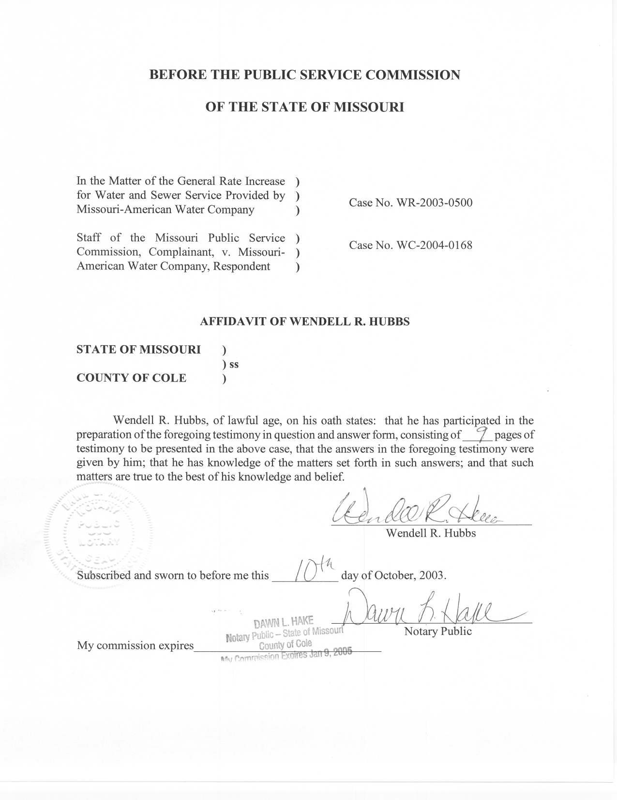

Direct Testimony

of

Wendell R. Hubbs

Case No. WR-2003-0500
Missouri - American Water Company
Q. Please state your name and business address.
A. My name is Wendell R. Hubbs and my business address is Governor Office Building, Suite 500, 200 Madison Street, Jefferson City, Missouri 65101.
Q. By whom are you employed and in what capacity?
A. I work for the Missouri Public Service Commission (Commission) and my position at the Commission is Rate & Tariff Examination Supervisor in the Water & Sewer Department (W/S Department) of the Utility Operations Division.
Q. What are your educational and experience qualifications?
A. In May 1979, I received a Bachelor of Science degree in Accounting from Lincoln University of Jefferson City, Missouri.
From July 1979 to October 1981, I worked in the Accounting Department of the Commission, where my duties were to assist with the audits and examinations of the books and records of public utility companies operating within the State of Missouri. Those audits focused on proposed utility rate increases and determining whether utility books and records were being maintained in compliance with the Uniform System of Accounts.
From October 1981 to September 1983, I held the position of Rate Economist II in the Gas Department of the Commission, where my duties consisted of tariff review, allocations and rate design.
From September 1983 to November 1990, I held the position of Assistant Manager-Rates in the Gas Department, where my duties consisted of tariff review, rate design, cost of service, accounting and administrative functions.
From November 1990 till May 1995, I held the position of Assistant Manager-Rates in the Energy Department, where my duties were expanded to include electric and steam operations.
From May 1995 till January 1998, I held the position of Regulatory Auditor IV in the Rates Section of the Energy Department, where my duties consisted of application analysis, tariff review, rate design, cost of service and accounting functions.
In January 1998, I assumed my current position in the W/S Department where my duties consist of application analysis, tariff review, rate design, cost of service and accounting functions.
Q. What is the purpose of your direct testimony in this case?
A. The Commission’s Staff (Staff) has filed an overall cost-of-service applicable to Missouri-American Water Company (MAWC or Company) providing service to its Missouri customers. That cost of service determination was made on an operating district basis, as well as on a total company basis.

My testimony explains how I allocate the Staff's cost-of-service to the Company’s various rate classes, and also how I develop the customer rates necessary to recover the costs allocated to each customer class. Both of those functions utilize the Staff’s "district specific" cost-of-service computations.
Q. How did you utilize the district cost of service information just discussed to allocate costs to each customer class and develop customer rates?
A. I allocated each district’s cost-of-service to each class in the district using the "base-extra capacity" method, which involves allocating various cost-of-service components to the customer classes based on data pertaining to operating costs, operating revenues, system capacity and customer usage. The results of such allocations yield the relative cost levels that should be recovered from each customer class. Rates are then designed to recover the costs that are allocated cost to each class.
I do need to note, however, that the customer class allocation factors I developed are based on the Staff's district cost-of-service calculations without including the Staff's Auditing Department's "true-up allowance" for the district, and that the customer rates that I developed thus also do not reflect recovery of the true-up allowance for each district.
Q. Please describe the "base-extra capacity" allocation method you used.
A. In the "base-extra capacity" method, costs are generally separated into four primary cost components: (1) base costs; (2) extra capacity costs; (3) customer costs; and (4) direct fire protection costs.
"Base costs" tend to vary with water consumption and are allocated to customer classifications on the basis of the amount of water consumed.
"Extra capacity costs" are those costs associated with meeting the requirements that are in excess of the average load conditions. They are divided into costs to meet "maximum-day extra demand" and "maximum-hour extra demand."
"Customer costs" comprise those costs associated with customers that are irrespective of consumption. They include customer accounting and collection expenses, meter reading expenses and billing expenses. They also include "return on and of plant" related to meters and services.
"Fire protection costs" are those costs that can be directly assigned to fire protection functions.
Q. Please describe the development of the class cost of service amounts.
A. Allocation of each cost is accomplished by applying class allocation factors. These class allocation factors are applied to the annualized and normalized expenses, plant, rate base, return of investment, and return on investment to determine the total costs to be recovered from each customer class in each district.
Q. How are customer rates in a district determined?
A. Rates are developed to recover from each customer class in the district, the cost-of-service allocated to each class in the district. The rates generally consist of a fixed customer charge and a usage/commodity charge, which are generally based upon the number of customers in the class and the usage characteristics of those customers.
Q. Are the customer class allocation and rate design methods you are using in this case, and the results of those methods, consistent with the methods upon which the Company's current customer rates were established?
A. Regarding the class cost of service study, the class cost allocation method I am using in this case is generally consistent with the allocation method used in the previous cases in which the Company's current rates were established. (The "base-extra capacity" method is the basis of the Staff's class cost of service studies in all of the relevant cases).
Regarding the calculation of customer rates, the method I am using in this case is not consistent with the method used in the previous cases in which the Company's current rates were established. In this case, the fixed monthly or quarterly customer charge was developed using meter costs, service costs and billing and collection costs pursuant to the “base-extra capacity” method of cost accumulation, which is different from how the current customer charges were developed.
An important item to note here is that the Company's current customer rates were established in three different cases before the Commission, all of which took place before the merger of Jefferson City Water Works Company and St. Louis County Water Company with and into Missouri-American Water Company. The fact that existing rates were established for three different companies in three different cases, somewhat complicates the analysis of this subject matter.
Q. You state above that the customer class cost allocation and rate design methods you are using in this case are either "generally consistent" or "not consistent" with the methods used in the previous cases in which the Company's current rates were established. Can you provide examples of any differences that exist in the methods you are using in this case, and the results of those methods, as compared to the methods used to establish the Company's existing rates?
A. Yes, I can provide several examples of such differences.
The first example comes from the decision the Commission issued on rate design in MAWC's last pre-merger rate case (Case No. WR-2000-281). In that case, the Commission adopted the Staff's proposed district-specific pricing methodologies regarding cost-of-service determination, customer class cost of service allocations and rate design, but also directed that the Company's rates be designed to "adhere to the principle that no district would receive a rate decrease" as a result of that case. In essence, that "principle" was a modification to the Staff's proposal in that case, which would have resulted in at least one district receiving a rate decrease based upon the Staff's district-specific pricing methodologies. In this case, as in the previous case, the Staff has determined a cost-of-service for each district, and I am allocating costs and designing rates based on each district's cost-of-service, irrespective of whether a district would receive a rate increase or a rate decrease as a result of this case.
A second example has to do with the design of the rates for certain customer classes. The current design pertains to the use of "rate blocks" for recovery of the costs allocated for recovery through the commodity charges applicable to the class. In general, the Company's current rates contain two, three or four commodity rate blocks for each class of customers. The rate design I am proposing in this case eliminates block rates.
A third example also has to do with the design of the rates. In this case, I am recommending that the customer charges developed for each district to recover meter costs, service costs and billing and collection costs, be those adopted by the Commission. As mentioned previously, this is different from how current customer charges were developed.
A fourth example is that I am recommending that the St. Louis County District’s charge for public fire protection be changed from a separate charge for each customer to be recovered in the commodity charges for each customer class. This would make the recovery of the private fire protection costs consistent with the other operating districts and be more equitable based on use. This would eliminate Rate E in the St. Louis County District tariff.
Q. Have you completed your class cost-of-service studies and rate design calculations for each district?
A. Yes, I have, and they are being filed with this testimony and are consistent with the Staff’s accounting schedules filed in this case. I do note, again, however, that the customer class allocation factors and customer rates that I developed are based on the Staff's cost of service calculations for each district without including the Staff's "true-up allowance" for the districts.
Q. Are you proposing a different treatment for any district contrary to the results of your class cost of service studies and rate design calculations?
A. Yes, I am. As has been the case for many years, the cost-of-service for the Brunswick District is extremely high, yielding rates that are twice what is currently being charged. I am of the opinion that movement to full cost-of-service for Brunswick is unreasonable. I recommend that some other party besides the Brunswick ratepayers be made responsible for some of this district's costs-of-service.
Q. What are you recommending that the Commission do with regard to the resulting cost-of-service rates for the Brunswick District?
A. I recommend that the Commission establish rates for the Brunswick District customers equivalent to the highest related rates for each class’s customer charges and commodity charges from the District that has the second highest rates. This action would have the effect of shifting revenue responsibility from the Brunswick District customers to other parties (subsidization). In this case, either some customers in other Districts or the Company will be made responsible for the shortfall in recovery of the cost-of-service for the Brunswick District.
Q. Please briefly describe the customer class cost of service allocation and rate design schedules that accompany this testimony.
A. Schedule A to each district’s study shows the cost-of-service allocations for each class in the first two numbered columns. The next two numbered columns show the Staff’s present annualized and normalized revenues by class, priced at the currently effective rates. The next two numbered columns show the revenues generated by the rates that I am proposing using the same annualized and normalized billing determinants.
Schedule B to each district's class cost-of-service study shows the allocation of all of the Staff’s Auditing Department's costs-of-service, first to each of the customer classes and then to the functions of base use, max day use, max hour use, meter cost, services cost, billing and collection cost and fire service cost.
Schedule C to each district's class cost-of-service study shows the development of the allocation factors used to allocate costs to the classes and functions in Schedule B’s allocations.
Schedule D to each district's cost-of-service study shows the meter numbers and service numbers for each district with cost weighting for each size.
Schedule E shows the basis of allocation to public and private fire service costs in proportion to the relative potential demands on each system by public fire hydrants and private fire services.
Q. Does this conclude your prefiled direct testimony in this case?
A. Yes, it does.

