July 23, 2013

Secretary / Chief Regulatory Law Judge
Missouri Public Service Commission
200 Madison Street
Jefferson City, MO 65102

Re: Summit Natural Gas of Missouri, Inc. (SNG) Deposit Tariff Sheets

Attached are the electronic copies of P.S.C. MO No. 2, Original Sheet 34, Original Sheet 35, Original Sheet 36, and Original Sheet 37. These tariff sheets relate to the service area formerly known as Southern Missouri Natural Gas, Inc.

The tariff sheets describe the standards SNG will use to establish customer credit ratings for the purposes of assessing customer deposits. In addition, these tariff sheets include clean-up language to make consistent the tariff sheets relating to deposits for the service area formerly known as Missouri Gas Utility, Inc. and Southern Missouri Natural Gas, Inc. (tariff books P.S.C. MO No. 1 and P.S.C. MO No. 2 respectively). Finally, SNG has also attached additional information regarding the Experian National Risk Model Score.

Summit Natural Gas of Missouri, Inc. respectfully requests that these tariff sheets become effective on August 22, 2013.

Sincerely,

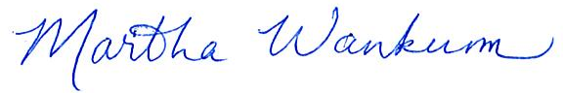

Martha Wankum
Regulatory Manager
Summit Natural Gas of Missouri, Inc.

