Exhibit No.:
Issue: Financial Aspects
Witness: John P. Cassidy
Sponsoring Party: MoPSC Staff
Type of Exhibit: Direct Testimony

Case No.: GT-2003-0117
Date Testimony Prepared: November 19, 2002

MISSOURI PUBLIC SERVICE COMMISSION

UTILITY SERVICES DIVISION

DIRECT TESTIMONY

OF

JOHN P. CASSIDY

LACLEDE GAS COMPANY

CASE NO. GT-2003-0117

Jefferson City, Missouri
November 2002
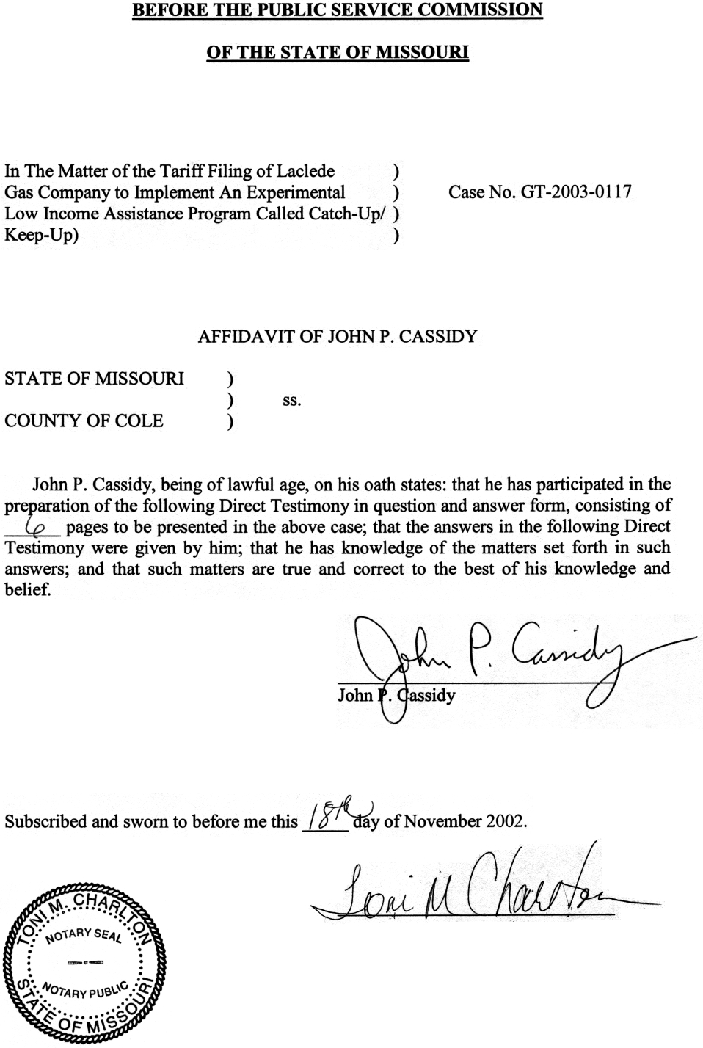
DIRECT TESTIMONY
OF

JOHN P. CASSIDY
LACLEDE GAS COMPANY
CASE NO. GT–2003–0117

Please state your name and business address.
John P. Cassidy, 815 Charter Commons, Suite 100B, Chesterfield, Missouri 63017.
By whom are you employed and in what capacity?
I am employed by the Missouri Public Service Commission (Commission) as a Regulatory Auditor.
Please describe your educational background.
I graduated from Southeast Missouri State University, receiving a Bachelor of Science degree in Business Administration, with a double major in Marketing and Accounting in 1989 and 1990, respectively.
What has been the nature of your duties while in the employ of this Commission?
Since joining the Commission Staff in 1990, I have assisted with and directed audits and examinations of the books and records of utility companies operating within the state of Missouri. I have also conducted numerous audits of small water and sewer companies in conjunction with the Commission’s informal rate proceedings.
Have you previously filed testimony before this Commission?
Yes, I have. Please refer to Schedule 1, which is attached to my direct testimony, for a list of cases in which I have previously filed testimony.
With reference to Case No. GT–2003–0117, what is the purpose of this direct testimony?
The purpose of this direct testimony is to address the level of annualized uncollectibles expense, included in Laclede Gas Company’s (Laclede or Company) last four rate cases (Case Nos. GR-98-374, GR-99-315, GR-2001-629 and GR-2002-356). This testimony will also include a discussion of the Staff’s methodology for determining these annualized uncollectibles expense levels. This testimony will show that methodologies used to incorporate bad debt expense in Laclede’s rates has been adequate to allow the Company to recover all of its bad debt write-offs. This fact will be shown by a comparison of actual net write-offs experienced by the Company to the level of uncollectible expense that has been built into the Company’s rates during the past four rate cases. My testimony will also show that with this new rate increase, Laclede is proposing to collect from its customers an amount for bad debt expense that it has never incurred.

UNCOLLECTIBLES
What level of uncollectible (bad debt) expense has the Staff included in Laclede’s past four rate cases?
The Staff included $8.0 million in its cost of service calculation for Case No. GR-2002-356. In this case, $7.25 million of this amount was related to ongoing uncollectible expense while the remaining $750,000 inclusion pertained to the provisions of the Emergency Cold Weather Rule (ECWR), which was in effect for the period covering November 18, 2001 through March 31, 2002. This $8.0 million level of uncollectibles is included in Laclede’s current rates, which took effect November 9, 2002.
In Case No. GR-2001-629, the Staff included $7.75 million in the cost of service calculation for uncollectibles expense. In this case, $7.0 million was related to ongoing uncollectible expense while the remaining $750,000 pertained to the ECWR. The $7.75 million level of uncollectibles was incorporated into Laclede’s rates that were in effect during the period covering December 1, 2001 through November 8, 2002.
In Case No. GR-99-315, the Staff included $6.352 million in the cost of service calculation for uncollectible expense. This level of uncollectibles expense was included in Laclede’s rates that were in effect during the period covering December 27, 1999 through November 30, 2001.
In Case No. GR-98-374, the Staff included $5.878 million in its cost of service calculation. This rate filing did not result in a change in the Company’s tariffed rates on which the Commission issued an order on November 15, 1998. However, this $5.878 million level of uncollectibles would be reflective of ongoing levels of uncollectible expense for the period covering November 15, 1998 through December 26, 1999. The chart shown below reflects the Staff’s filed and settled positions:
Settled Inclusion for Total Inclusion
Case Staff Direct Uncollectible Emergency In Rates For
Number Filed Position Position CWR Uncollectibles
GR-2002-356 $6,858,806 $7,250,000 $750,000 $8,000,000
GR-2001-629 $4,833,369 $7,000,000 $750,000 $7,750,000
GR-99-315 $6,351,500 $6,351,500 $0 $6,351,500
GR-98-374 $5,877,954 $5,877,954 $0 $5,877,954

How has the Staff annualized uncollectible expense in its direct filing for Laclede in these last four rate cases?
The Staff used multi-year averages of actual net write-offs to annualize uncollectible expense for the past four Laclede rate cases. Use of actual net write-offs to annualize uncollectible expense has been the standard practice of the Staff in previous electric and gas cases before this Commission.
How do the total actual net write-offs experienced by the Company compare with amounts actually included in rates during the time period rates were in effect for Case Nos. GR-98-374, GR-99-315 and GR-2001-629?
The Staff has prepared another chart, shown below, which compares actual net write-offs experienced by the Company with the various levels of uncollectible expense that has been included in rates during the past three rate cases.
Period Total Inclusion Company Over
Case Rates In Rates For Actual Net (Under)
Number Effective Uncollectibles Write-Offs Collection
GR-2001-629 12/1/01 – 9/30/02 $ 6,458,333 $ 6,271,033 $187,300
GR-99-315 12/27/99 – 11/30/01 $12,259,086 $13,038,378 $(779,299)
GR-98-374 11/15/98 – 12/26/99 $ 6,547,112 $ 5,542,831 $1,004,281
Total Overcollection $412,282
This chart shows that for the time period when rates have been in effect for the past three rate cases (November 15, 1998 through September 30, 2002), the Company has collected $412,282 more in rates than they actually incurred in net write-offs. This chart also indicates that the rate case process has provided Laclede with sufficient funds to meet the actual net write-offs that it has experienced since November 1998.
What level of actual net write-offs has Laclede experienced in the past?
The chart shown below summarizes ten years of actual net write-offs experienced by the Company on a fiscal year ending basis covering October 1, 1992 through September 30, 2002:
Actual
Year Ending Net Write-offs
September 1993 $3,475,778
September 1994 $5,527,491
September 1995 $5,766,154
September 1996 $4,246,546
September 1997 $8,236,705
September 1998 $7,584,521
September 1999 $5,377,844
September 2000 $4,583,253
September 2001 $5,379,383
September 2002 $11,294,193
Under the Company’s proposed Catch-Up Keep-Up plan, what level of funds is available for the recovery of uncollectible accounts?
As is more fully discussed in the direct testimony of Staff witness Thomas M. Imhoff, the Company’s proposed plan could allow a potential recovery of up to $6.0 million for uncollectibles through the Catch-Up Keep-Up plan. Given the fact that the Company currently has $8.0 million included in its rates to recover actual net write-offs of uncollectible accounts and also to address the ECWR, with the addition of the Catch-Up Keep-Up plan the Company would have funding available to recover $14.0 million for uncollectibles annually. In the last ten fiscal years ending September 30, the Company has never experienced a $14.0 million level of actual net write-offs. To institute the Company’s proposed Catch-Up Keep-Up plan would allow the Company to potentially recover approximately $2.7 million more than the Company has ever experienced in actual net write-offs during any of the last ten fiscal year ends.

Does this conclude your direct testimony?
Yes.
RATE CASE PROCEEDING PARTICIPATION

JOHN P. CASSIDY

COMPANY CASE NO.
Missouri Cities Water Company WR-91-172
Missouri Cities Water Company SR-91-174
St. Louis County Water Company WR-91-361
Southwestern Bell Telephone Company TC-93-224
Laclede Gas Company GR-94-220
Empire District Electric Company ER-95-279
Imperial Utility Corporation SC-96-247
St. Louis County Water Company WR-97-382
Laclede Gas Company GR-98-374
United Water Missouri, Inc. WR-99-326
Union Electric Company EC-2000-795
Union Electric Company GR-2000-512
Laclede Gas Company GR-2001-629
Union Electric Company, d/b/a AmerenUE EC-2002-01
Union Electric Company, d/b/a AmerenUE EC-2002-1025
Laclede Gas Company GR-2002-356

