www.FairPoint.com
908 W. Frontview
Dodge City KS 67801

December 22, 2015

Steven Reed
Governor Office Bldg
200 Madison Street
PO Box 360
Jefferson City MO 65102-0360

RE: Tariff Update – P.S.C. MO No. 1 – ExOp of Missouri, Inc. d/b/a FairPoint Communications

Dear Mr. Reed:

Enclosed for the Commission’s approval, ExOp of Missouri, Inc. d/b/a FairPoint Communications, hereby submits the following tariff pages with changes to be effective January 1, 2016:

Section 9, Ninth Revised Sheet No. 51
Section 9, Seventh Revised Sheet No. 51.01

The purpose of this filing is to offer a Business Customer Appreciation promotional offering for current Business customers who request a line disconnect but instead choose to retain the access line. These customers will be eligible to receive a monthly discount for 12 months. The promotion will run for 90 days from January 1, 2016 to March 30, 2016. Discounts for eligible customers are as follows:

Business Customers $ 2.50 per line per month
Centrex Customers $ 1.75 per line per month
ISDN PRI Customers $17.75 per interface per month

Please contact Beth Westman at 207.535.4249 or bwestman@fairpoint.com with any questions or concerns regarding this filing.

Sincerely,
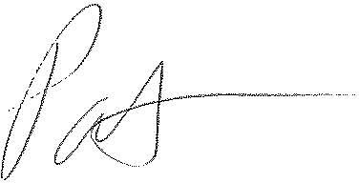
Patrick L. Morse
Senior VP Governmental Affairs
FairPoint Communications
P: 620-227-4409
F: 620-227-8576

