Exhibit No.:
Issues: Complaint
Witness: James L. Ketter
Sponsoring Party: MoPSC Staff
Type of Exhibit: Rebuttal Testimony
Case No.: EC-2002-112
Date Testimony Prepared: May 31, 2002

MISSOURI PUBLIC SERVICE COMMISSION

Utility Operations Division

Rebuttal TESTIMONY OF

James L. Ketter

Sterling Moody
VS
Union Electric Company d/b/a amerenUE

CASE NO. EC-2002-112

Jefferson City, Missouri
May, 2002
NP
REBUTTAL TESTIMONY
OF
JAMES L. KETTER
STERLING MOODY
vs
UNION ELECTRIC COMPANY d/b/a AMERENUE
CASE NO. EC-2002-112

Q. Please state your name and give your business address.
A. James L. Ketter, P.O. Box 360, Jefferson City, Missouri 65102.
Q. Mr. Ketter, by whom are you employed and in what capacity?
A. I am employed by the Missouri Public Service Commission (MPSC or Commission) as an engineer in the Engineering Analysis section of the Energy Department.
Q. Please summarize your educational background and professional experience.
A. I received a Bachelor of Science degree in Electrical Engineering from the University of Missouri-Columbia in 1970. I served for 4 1/2 years as an officer in the United States Navy and returned to the University of Missouri-Columbia campus to pursue an advanced degree. In December 1977 I received a Masters degree in Business Administration from the University of Missouri-Columbia.
I have been employed by the Commission since 1976. As an engineer on the Staff, I have testified before the Commission on certificates for service areas, electric transmission and power plant certification cases, and territorial agreements. I have also presented testimony on rate design in electric, steam, and gas rate cases. I am a registered Professional Engineer in the state of Missouri; my registration number is E-20056. I am a member of the National Society of Professional Engineers and I am a member of the Jefferson City Chapter of the Missouri Society of Professional Engineers.
Q. What is the purpose of your testimony in this case?
A. I will address the Direct Testimony of Sterling Moody.
Q. Mr. Moody addresses an issue that he refers to as a deposit on page 9, line 18 of his Direct Testimony, continuing through page 11. An amount of $45,000 was set by AmerenUE (UE) as an amount necessary to restore electric service. Do you agree with the term deposit when used in this context of payment necessary to restore service?
A. No, the $45,000 was not held as a deposit to secure the account, but as a minimum payment necessary to restore electric service. In fact, the $45,000 was applied to the “Common Area Meter” (meter number 70593313; account number 57300-01916).
Attached to my testimony, as Appendix A, is the Staff Report filed November 29, 2001 pursuant to a Commission Order directing the Staff to investigate the complaint and submit a report. The Staff Report was filed as highly confidential and is still being treated as highly confidential pursuant to 4 CSR 240-2.070(10). The Staff Report includes a copy of the May 18, 2001 letter agreement between UE, Sterling’s Marketplace I, Inc. and P. & B. Real Estate, L.L.C. as Attachment D. This letter agreement contains further explanation of the agreement and subsequent responsibilities of the parties receiving service at the premise. Mr. Moody refers to this letter in his Direct Testimony on page 11, line 2.
Q. Was a deposit held by UE on the Sterling Moody accounts?
A. Yes, the reference to a deposit of $9,493 was the amount of the deposit held by UE for the Sterling Moody accounts. It appears that this deposit was transferred to the account Mr. Moody was responsible for, pursuant to the May 18, 2001 letter agreement.
Q. What was the responsibility of Mr. Moody under the May 18, 2001 letter agreement?
A. Mr. Moody would be responsible for service through meter numbers 0159500 and 50688215 and the arrears on that account of $89,000 as stated on line 21, page 10 of Mr. Moody’s testimony. A monthly payment of $2,000, in addition to payment for the regular monthly usage, would be applied to the arrears.
Q. How were the other arrears for the building and the ongoing responsibility for monthly bills addressed in the May 18, 2001 letter agreement?
A. The “Common Area Meter” (meter number 70593313) was designated as the responsibility of P. & B. Real Estate, L.L.C. The past due amount on that account was settled with the checks totaling $45,000 applied to that account.
Attachment E of Appendix A to my testimony is the notification from P. & B. Real Estate L.L.C., in a letter dated June 1, 2001, that P. & B. Real Estate L.L.C. was not responsible for the current bill for the “Common Area Meter”. This refusal by the landlord to assume responsibility for electric service through this meter lead to the request by Mr. Moody’s attorney for termination of service, Attachment G of Appendix A to my testimony.
Q. Does this conclude your rebuttal testimony?
A. Yes, it does.
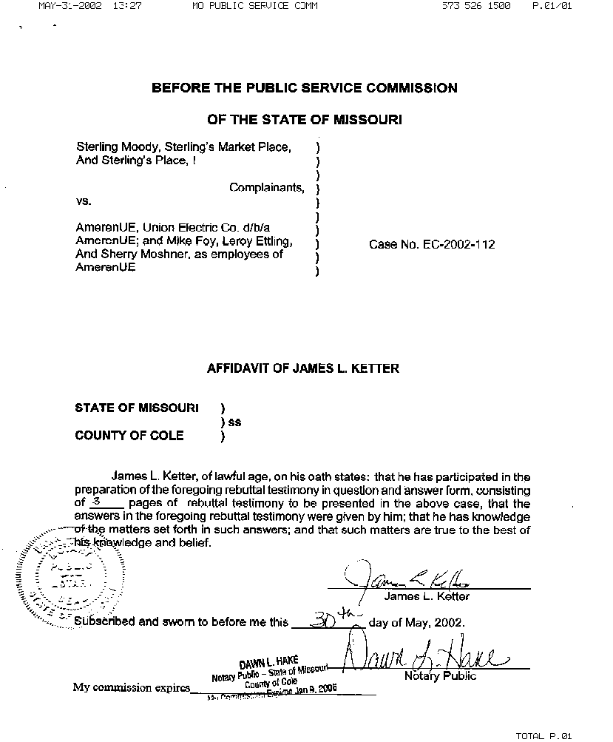

REBUTTAL TESTIMONY
JAMES L. KETTER

APPENDIX A

HAS BEEN DEEMED

HIGHLY CONFIDENTIAL

IN ITS ENTIRETY

