Exhibit No.:
Issues: Payroll Expense;
Employee Benefits;
Payroll Taxes
Witness: Dana E. Eaves
Sponsoring Party: MoPSC Staff
Type of Exhibit: Direct Testimony
Case No.: GR-2004-0072
Date Testimony Prepared: January 6, 2004

MISSOURI PUBLIC SERVICE COMMISSION

UTILITY SERVICES DIVISION

DIRECT TESTIMONY

OF

DANA E. EAVES

AQUILA, INC. D/B/A
AQUILA NETWORKS L&P AND
AQUILA NETWORKS MPS

CASE NO. GR-2004-0072

Jefferson City, Missouri
January 2004
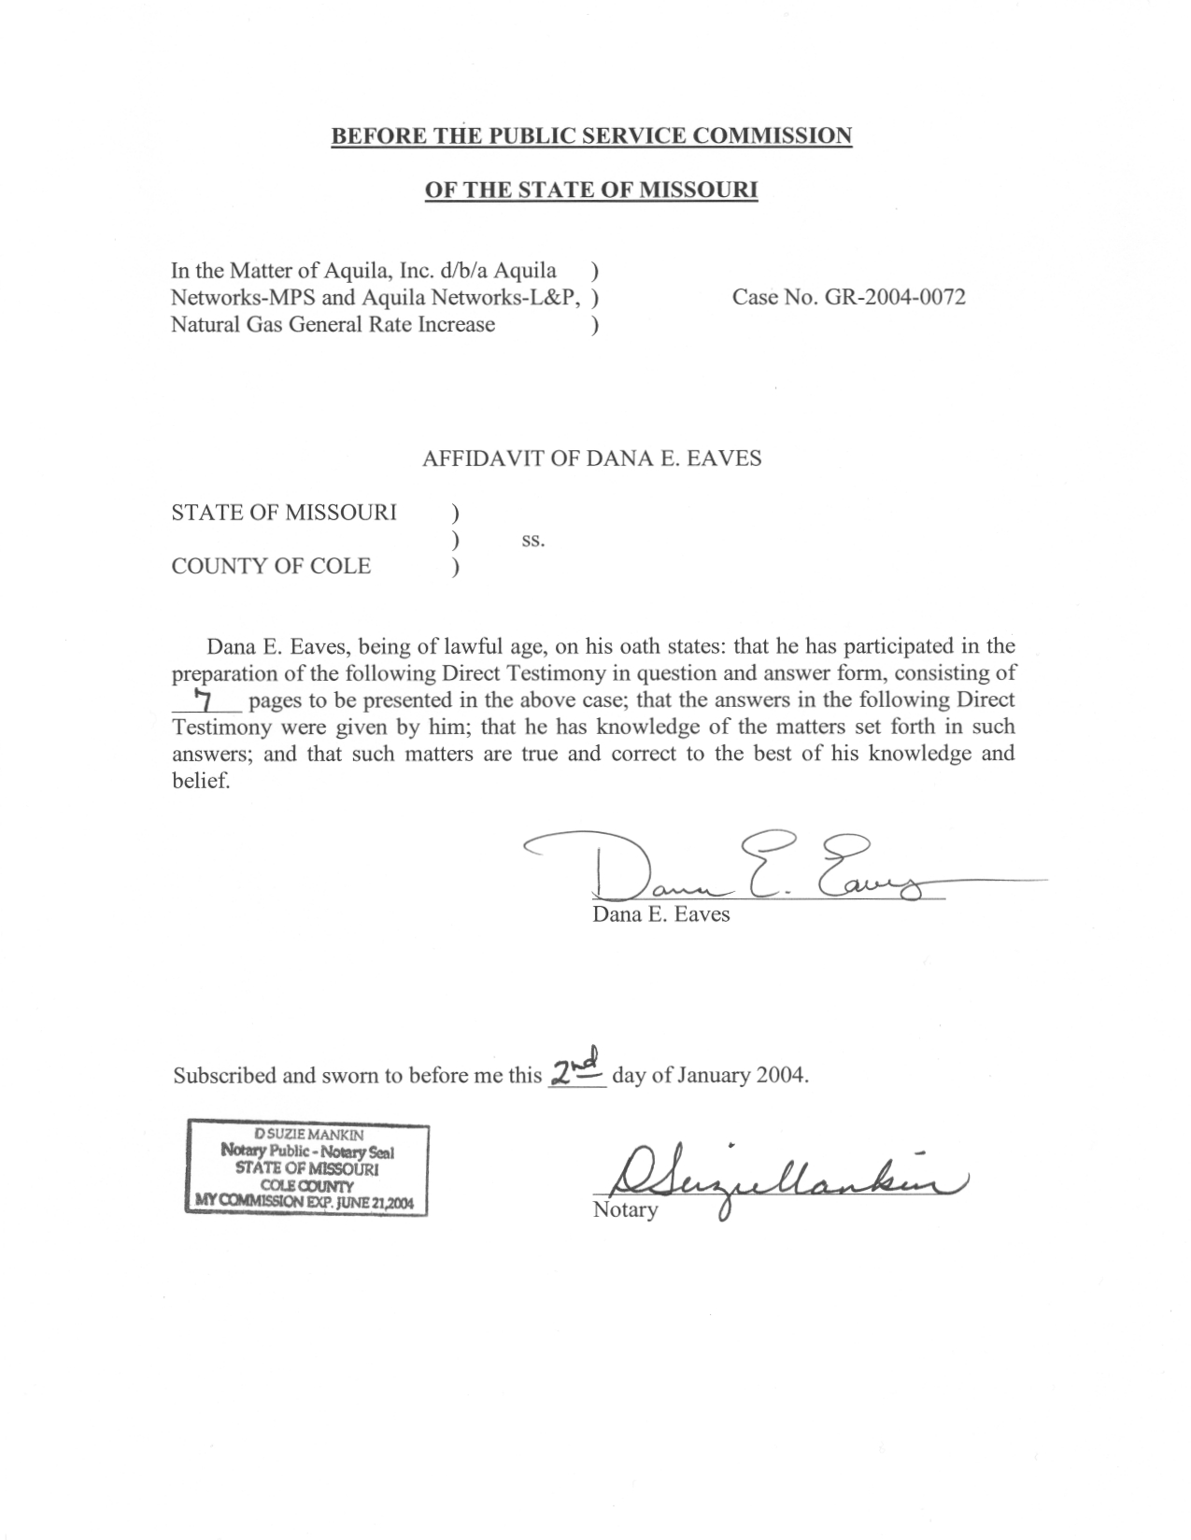
TABLE OF CONTENTS
DIRECT TESTIMONY OF
DANA E. EAVES
AQUILA, INC. d/b/a AQUILA NETWORKS-MPS - Natural Gas
AND AQUILA NETWORKS – L&P – Natural Gas
CASE NO. GR-2004-0072
ACCOUNTING ADJUSTMENTS 3
PAYROLL EXPENSE 3
PAYROLL TAXES 5
EMPLOYEE BENEFITS 6

DIRECT TESTIMONY
OF
DANA E. EAVES
AQUILA, INC.
d/b/a AQUILA NETWORKS-MPS AND
AQUILA NETWORKS – L&P – Natural Gas Operations
CASE NO. GR-2004-0072
Q. Please state your name and business address.
A. Dana E. Eaves, PO Box 360, Suite 440, Jefferson City, MO 65102.
Q. By whom are you employed and in what capacity?
A. I am a Regulatory Auditor for the Missouri Public Service Commission (Commission or PSC).
Q. Please describe your educational and employment background.
A. I graduated from Columbia College in May 1995 with a Bachelors of Science degree in Business Administration with an emphasis in Accounting. I commenced employment with the Commission Staff (Staff) in April 2001. Prior to employment with the Commission I held the position of Accountant with Midwest Block and Brick, Inc.; Vice President of Operations with Practice Management Plus, a healthcare consulting firm; and Director of Finance with Capital City Medical Associates.
Q. What has been the nature of your duties while employed by the Commission?
A. I am responsible for assisting in the audits and examinations of the books and records of utility companies operating within the state of Missouri.
Q. Please describe your areas of responsibility in Case No. GR-2004-0072.
A. I am responsible for the areas of payroll expense, payroll taxes and certain employee benefits: 401(k) benefits, health, vision and dental benefits, and Company’s Employee Stock Option (ESOP) contribution.
Q. What knowledge, skills, experience, training or education do you have in these areas of which you are testifying as an expert witness?
A. I have been assigned to and filed testimony as described in Schedule 1, which is attached to my testimony. I have also extensively reviewed other utility rate cases related to the issues I am sponsoring to ensure the consistency of the Staff’s method and procedures. My prior academic education helped prepare me to successfully sponsor the ratemaking areas I’ve been assigned in this case. I have received certificates of training from the National Association of Regulatory Utility Commissioners in seminars it has sponsored concerning water, gas and electric utility cost of service and regulation. Further, I have attended numerous in-house training seminars at the Commission specifically designed for continuing education and training in the areas of regulatory issues. I have also worked closely with Senior Staff members familiar with my areas of responsibility.
Q. Will your testimony be addressing the natural gas operations of both Missouri Public Service and Light & Power?
A. Yes. My testimony will address payroll and payroll related benefits for both business units and relate specifically to the gas operations of Aquila Networks, d/b/a Missouri Public Service (MPS), northern-southern systems and the eastern system. This testimony will also address the operations of Aquila’s natural gas operations in St. Joseph, Missouri, Aquila Networks Light & Power (L&P) (the former St. Joseph Light & Power Company). Light & Power was acquired and merged within Aquila in January 2001.
Q. Have you previously filed testimony before this Commission?
A. Yes. Please see Schedule 1 for a listing of specific cases and issues.

ACCOUNTING ADJUSTMENTS
Q. What adjustments are you sponsoring in this case?
A. I am sponsoring all of the Income Statement adjustments in the areas payroll expense, payroll taxes and certain employee benefits adjustments.

PAYROLL EXPENSE
Q. Please explain the payroll adjustments you are sponsoring.
A. As Staff Auditing witness Phillip K. Williams explains in his direct testimony, the Staff is filing a calendar year 2002 test year updated for known and measurable events through September 30, 2003. I have therefore developed the payroll expense by annualizing payroll costs at September 30, 2003, for all MPS, L&P/Enterprise Support Function (ESF) and Intra Business Units (IBU) departments. Please refer to the Staff Auditing witness Charles R. Hyneman's testimony for a description and explanation of ESF and IBU departments. I annualized payroll and payroll-related benefits for MPS and Light & Power gas operations. This approach takes into consideration actual employees at September 30, 2003, as well as authorized wage levels paid at the same point in time.
Q. Are there separate adjustments for both the MPS and L&P divisions of Aquila?
A. Yes. There are separate revenue requirement runs for the MPS
northern-southern systems and the MPS eastern system and the L&P gas system. The adjustment numbers will be the same for each revenue requirement run for the MPS northern-southern systems, and the MPS eastern system and the L&P gas system will have distinctive adjustment numbers as designated in testimony.
Q. Please list the adjustment numbers you are sponsoring to include the effect of the payroll annualization process discussed above.
A. I am sponsoring the following MPS northern-southern systems and MPS eastern system – natural gas adjustments: S-14.1, S-17.1, S-18.1, S-19.1, S-21.1, S-23.1,
S-24.1, S-26.1, S-27.1, S-28.1, S-29.1, S-30.1, S-31.1, S-32.1, S-34.1, S-36.1, S-38.1, S-39.1, S-40.1, S-41.1, S-42.1, S-43.1, S-45.1, S-46.1, S-47.1, S-50.1, S-52.1, S-53.1, S-54.1, S-55.1, S-56.1, S-57.1, S-58.1, S-60.1, S-61.1, S-70.1, and S-72.1.
I am sponsoring the following L&P- natural gas adjustments: S-14.1, S-19.1, S-21.1, S-24.1, S-26.1 S-27.1, S-28.1, S-29.1, S-30.1, S-34.1, S-36.1, S-37.1, S-38.1, S-39.1, S-40.1, S41.1, S-43.1, S-44.1, S-45.1, S-48.1, S-50.1, S-51.1, S-52.1, S-53.1, S-54.1, S-55.1, S-56.1, S-59.1, S-68.1, and S-70.1.
Q. How did the Staff develop payroll costs in this case?
A. The Staff requested payroll for each department and individual employed by Aquila and its operating divisions. This information was analyzed to track changes in the work force and to identify any areas that needed to be reviewed in further detail. Salary and wage rates were reviewed to determine the pay levels of the Aquila employees.
I determined the salary and wage rates as of September 30, 2003, and applied those rates to employees who were included in the payroll costs as of that date. The annualized amount was compared to the test year per book amount at December 31, 2002, to identify the related adjustment to the annualized level as of September 30, 2003. The annualized amount was distributed to the Federal Energy Regulatory Commission (FERC) Uniform System of Accounts by a payroll distribution percentage based on the payroll distribution percentage incurred for the test year.
Finally, I was provided changes to the costs, subject to allocation, for specific corporate departments by Staff witness Hyneman to incorporate into the payroll and payroll related costs. For a discussion on the corporate costs, please see Mr. Hyneman’s testimony.
Q. How did the Staff account for the payroll costs of Aquila’s corporate departments and other business units that provide service to MPS and L&P?
A. These costs have been allocated to the three natural gas systems of MPS and the L&P natural gas system using an appropriate allocation factor derived at by Mr. Hyneman.
Q. Please list the adjustment numbers you are sponsoring to reflect the payroll effects of the Staff’s changes to ESF/IBU departments costs subject to allocation to the MPS and L&P divisions.
A. I am sponsoring the following adjustments:
MPS northern-southern systems and MPS eastern system – Natural gas: S-14.2, S-17.2, S-18.2, S-19.2, S-21.2, S-23.2, S-24.2, S-26.2, S-27.2, S-28.2, S-29.2, S-30.2, S-31.2, S-32.2, S-34.2, S-36.2, S-38.2, S-39.2, S-40.2, S-41.2, S-42.2, S-43.2, S-45.2, S-46.2, S-47.2, S-50.2, S-52.2, S-53.2, S-54.2, S-55.2, S-56.2, S-57.2, S-58.2, S-60.2, S-61.2, S-70.2, and S-72.2.

L&P – Natural gas: S-19.2, S-21.2, S-24.2 S-26.2, S-27.2, S-28.2, S-29.2,
S-30.2, S-34.2, S-36.2, S-37.2, S-38.2, S-39.2, S-40.2, S-41.2, S-43.2, S-44.2, S-45.2, S-48.2, S-50.2, S-51.2, S-52.2, S-53.2, S-54.2, S-55.2, S-56.2, S-59.2, S-68.2, and S-70-2.

PAYROLL TAXES
Q. Please explain your MPS northern-southern and MPS eastern system– natural gas adjustments: S-77.1, S-77.3, S-77.4 and S-77.5; and L&P – natural gas adjustments:
S-75.2, S-75.3, S-75.4 and S-75.5, related to payroll taxes.
A. These adjustments serves to ensure the appropriate level of Social Security (FICA), Medicare, state unemployment (SUTA) and federal unemployment (FUTA) taxes associated with the Staff’s annualized payroll are included in rates.
Q. Please briefly explain how you computed the correct level of payroll taxes.
A. The current 2003 tax rates for the individual tax components were used for this calculation. Applying these rates to the current annualized level of payroll expense produces the best available level of payroll taxes on a going forward basis.

EMPLOYEE BENEFITS
Q. Please describe your adjustment MPS northern-southern systems and MPS eastern system – natural gas adjustment: S-65.9; L&P – natural gas adjustment: S-63.11 related to 401(k) benefits.
A. The 401(k) benefits matching expense incurred by MPS and L&P in the test year represent a certain percentage of payroll. I have maintained this same percentage, but multiplied it by the Staff’s annualized level of payroll to produce the Staff’s 401(k) benefit level. The difference between this and the test year level gives rise to my adjustment.
Q. Please describe your adjustment to MPS northern-southern systems and MPS eastern system – natural gas adjustment; S-65.1 and L&P – natural gas adjustment; S-63.1 related to the Company’s health, vision and dental benefits.
A. This adjustment reflects the historical over-accrual on the Company's books for the self-insured portion of health, dental and vision, which has been higher than actual cost based on claims paid.
Q. Please describe your adjustment to MPS northern-southern systems and MPS eastern system – natural gas adjustment; S-65.3 and L&P- natural gas adjustment;
S-63.12 related to the Company’s Employee Stock Option Plan (ESOP) contribution.
A. The ESOP contribution expense is incurred by MPS and L&P in the test year represents a certain percentage of payroll. I have maintained the same percentage the Company used, but multiplied it by the Staff’s annualized level of payroll to produce the Staff’s ESOP contribution expense level. The difference between this and the test year level gives rise to my adjustment.
Q. Does this conclude your direct testimony?
A. Yes, it does.
CASE PROCEEDING PARTICIPATION

DANA E. EAVES

PARTICIPATION |  | TESTIMONY
COMPANY | CASE NO. | ISSUES
Aquila Networks MPS Electric | ER-2004-0034 | Direct - Payroll Expense, Employee Benefits, Payroll Taxes
Aquila Networks-L&P Electric & Steam | HR-2004-0034 | Direct - Payroll Expense, Employee Benefits, Payroll Taxes
Osage Water Company | ST-2003-0562  WT-2003-0563 | Direct - Plant Adjustment, Operating & Maintenance Expense Adjustments
Empire District Electric | ER-2002-0424 | Direct - Cash Working Capital, Property Tax, Tree Trimming, Injuries and Damages, Outside Services, Misc. Adjustments
Citizens Electric Company | ER-2002-0297 | Direct - Depreciation Expense, Accumulated Depreciation, Customer Deposits, Material & Supplies, Prepayments, Property Tax, Plant in Service, Customer Advances in Aid of Construction
UtiliCorp Missouri Public Service Division | ER-2001-672 | Direct - Advertising, Customer Advances, Customer Deposits, Customer Deposit Interest Expense, Dues and Donations, Material and Supply, Prepayments, PSC Assessment, Rate Case Expense

