BEFORE THE PUBLIC SERVICE COMMISSION
OF THE STATE OF MISSOURI

In the Matter of Laclede Gas Company’s )
Request to Increase its Revenues for ) Case No. GR-2017-0215
Gas Service )

In the Matter of Laclede Gas Company )
d/b/a Missouri Gas Energy’s )
Request to Increase its Revenues for ) Case No. GR-2017-0216
Gas Service

Office of the Public Counsel, )
)
Complainant v. )
)
Laclede Gas Company and Missouri Gas ) Case No. GC-2016-0297
Energy, )
Respondents ) (Consolidated)

CONFIDENTIALITY CERTIFICATION

I, David Wooley, am Of Counsel at the Law Firm Keyes & Fox LLP. I certify that I have reviewed the Missouri Public Service Commission’s rule prescribing the procedure for handling highly confidential and proprietary information (4 CSR 240-2.135) and that I will comply with the requirements of the rule. I am representing the Environmental Defense Fund in this proceeding.

Dated: September 5, 2017

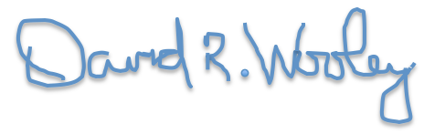

_________________________________

David Wooley
Of Counsel, Keyes & Fox LLP
436 14th Street Suite 1305
Oakland, CA 94612
(510) 314-8207
dwooley@kfwlaw.com

