February 3, 2012

VIA ELECTRONIC FILING

Mr. Steven C. Reed, Secretary/General Counsel
Missouri Public Service Commission - attention Data Center
PO Box 360
Jefferson City, MO 65102

RE: Missouri Gas Utility, Inc./ Summit Natural Gas of Missouri, Inc.

Dear Mr. Reed:

Missouri Gas Utility, Inc., a natural gas utility regulated by the Missouri Public Service Commission, has changed its name to Summit Natural Gas of Missouri, Inc.

Please accept for filing, in accordance with Commission Rule 4 CSR 240-2.060(5), the following fourth revised tariff cover page and adoption notice:

These tariff sheets contain an issue date of February 3, 2012, and a proposed effective date of March 5, 2012 (30 days).

Enclosed for reference is the Company’s Certificate of Good Standing issued by the Colorado Secretary of State (Appendix A), and its Certificate of Good Standing issued by the Missouri Secretary of State (Appendix B).

Please bring this to the attention of the appropriate Commission personnel. If there are questions or if additional information is needed, please contact me.

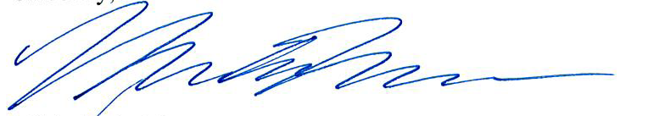

Michelle Moorman
Regulatory Manager
Summit Utilities, Inc.
7810 Shaffer Pkwy, Ste 120
Littleton, CO 80127
P: 720-981-2127 C: 303-478-0329
mmoorman@SummitUtilitiesInc.com

