Exhibit No.:

Issues: Purchase Power

Witness: Leon C. Bender
Sponsoring Party: MO PSC Staff
Type of Exhibit: Rebuttal Testimony
Case Nos.: ER-2004-0034
& HR-2004-024
Date Testimony Prepared: January 26, 2004

MISSOURI PUBLIC SERVICE COMMISSION

Utility Operations DIVISION

REBUTTAL TESTIMONY

OF

Leon C. Bender

Aquila, Inc.
d/b/a Aquila Networks -- mps
and Aquila Networks -- l&p

CASE NOS. ER-2004-0034 & HR-2004-024
(CONSOLIDATED)

Jefferson City, Missouri
January 2004

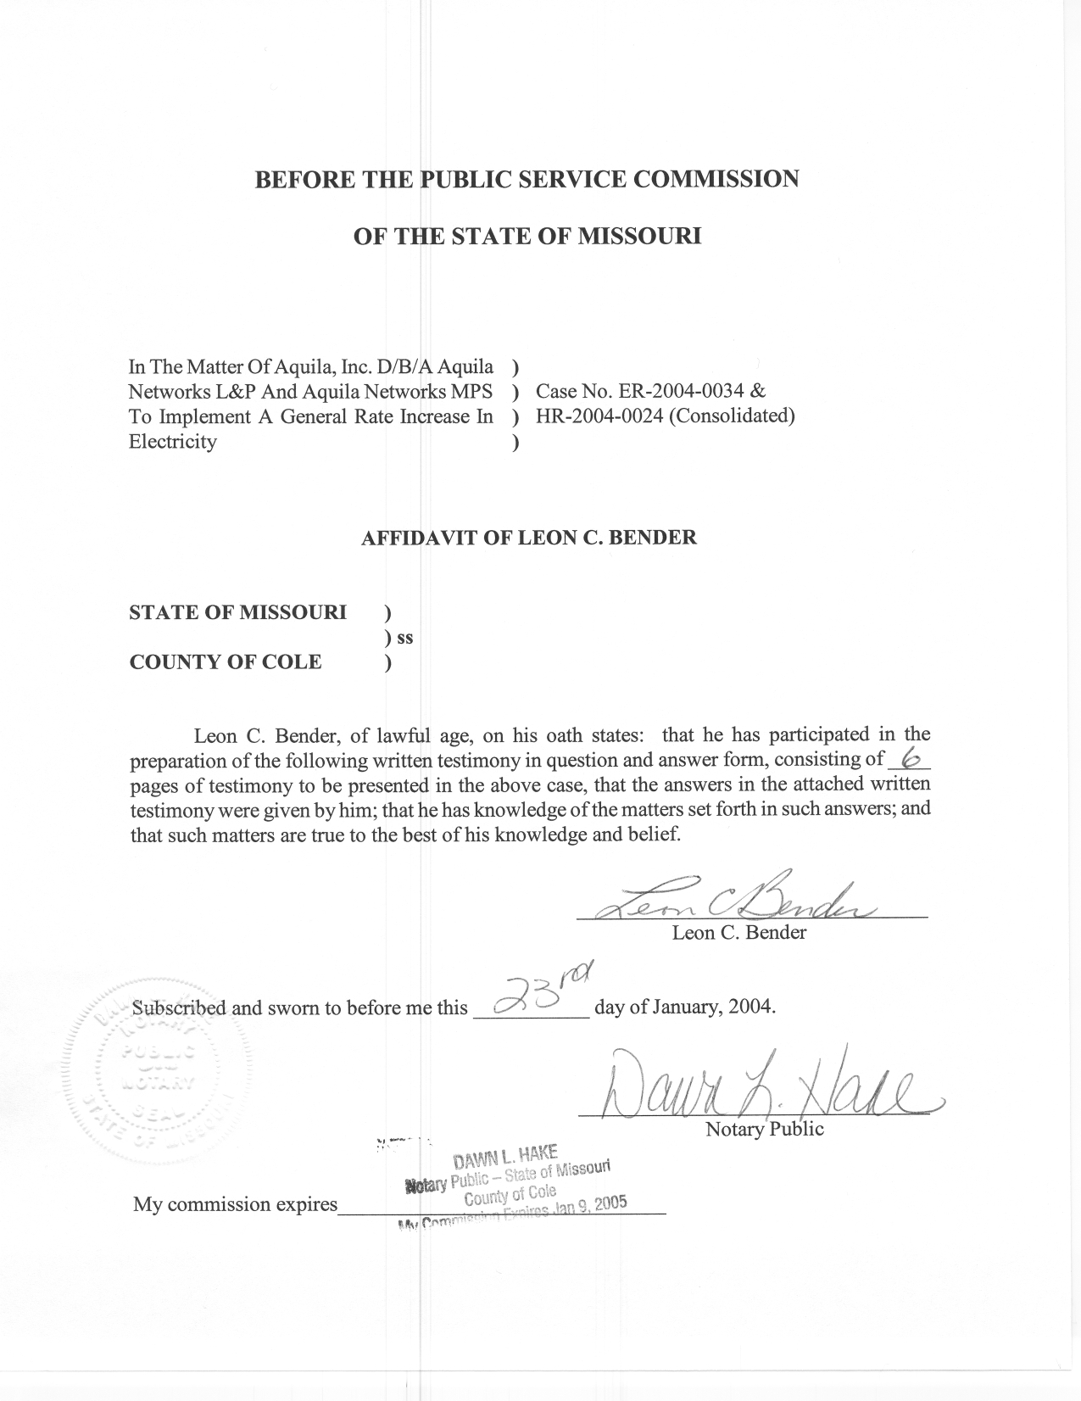
REBUTTAL TESTIMONY

OF

LEON C. BENDER
AQUILA NETWORKS, INC.
D/B/A AQUILA NETWORKS – MPS
AND AQUILA NETWORKS – L&P
CASE NOS. ER-2004-0034 AND HR-2004-0024
(CONSOLIDATED)

Q. Please state your name and business address.
A. Leon C. Bender, P.O. Box 360, Jefferson City, Missouri, 65102.
Q. Are you the same Leon C. Bender who filed direct testimony in this case?
A. Yes, I am.
Q. What is the purpose of your rebuttal testimony in this case, Aquila, Inc. (Aquila) D/B/A Aquila Networks-MPS (MPS) and Aquila Networks-L&P (L&P)
Case No. ER-2004-0034?
A. The purpose of my rebuttal testimony is to respond to purchased power inputs described in the direct testimony of Jerry G. Boehm, of Aquila. These purchased power inputs were used by Aquila in its electric production cost model simulation to estimate fuel and purchased power cost for Aquila for the test year.
Q. Did you review the purchased power inputs of Aquila’s production cost model and compare these with the Missouri Public Service Commission Staff’s (Staff) inputs of Staff’s production cost model?
A. Yes, I did.
Q. Did you find differences between these inputs?
A. Yes, I found differences in the spot purchased power prices used and the amount of purchased power energy available.
Q. Why were the prices different?
A. The prices differed because the methods used to determine those prices were different.
Q. Please describe the method used by Aquila to determine spot purchased power prices.
A. The method used by Aquila is described in Mr. Boehm’s direct testimony starting on page 10, line 3 of his testimony and particularly on page 13 line 3.
Q. Please summarize this method in your own words.
A. Aquila used the purchased power estimates from simulations of the MIDAS analysis software from M.S. Gerber and Associates. These estimates are based upon inputs which include existing generation, forecasts of new proposed generation, load profiles with forecasted load growth, and current and forecasted fuel prices of Aquila and other electric utilities in the regions surrounding Aquila (Jerry G. Boehm’s direct testimony, page 10, lines 11 through 16). In other words, the spot purchased power prices used by Aquila are forecasted prices based upon forecasted events and forecasted gas prices affecting Aquila and the surrounding utilities that are not known and measurable.
Q. Did Staff attempt to verify the inputs to the MIDAS analysis software used by Aquila to determine spot purchased prices?
A. Yes. However, Aquila stated, in response to Staff Data Request
No. MPSC-32, that the data was available only to a licensed user with a licensing agreement. Staff does not have a licensing agreement to view the data.
Q. Could this method be used to determine spot purchased power prices for a rate case? Please explain.
A. It may be that this method could be used for a rate case but Staff did not have access to all the input data or to the MIDAS model. Therefore, Staff is unable to determine whether it is appropriate. If Aquila used actual test year inputs to model the spot purchased power market, it may be appropriate to use this method. However, Aquila used forecasted future events to determine prices for an updated test year in which spot purchased prices were known. Using forecasted future events would be appropriate in determining the forecasted fuel budget for future years, but it is not appropriate for determining input spot purchased power prices in a rate case. The Commission has ordered the test year to be the 12 months ending December 31, 2002, updated for known and measurable changes to
September 30, 2003. Aquila used results from a model that utilized forecasted, not historical, inputs. Therefore, the spot purchased power prices used by Aquila to estimate average annual fuel and purchased power are not appropriate for this rate case.
Q. What data did Staff use as input to its method of determining spot purchased power prices?
A. As described in my direct testimony on page 5, line 9, Staff used actual non-contract data submitted by Aquila for the time period ordered by the Commission. Staff has traditionally used historical data submitted by the companies for input to its production cost model.
Q. Did Aquila’s use of forecasted spot purchased power affect the results of Aquila’s production cost model? Please explain.
A. Yes. Aquila’s final computed yearly average spot purchased power price for joint dispatch was $37.23 per mega-watt-hour (MWH). This number is computed by dividing the dollar amount for spot purchases, as submitted in Schedule 1 of Jerry G. Boehm’s direct testimony, by the number of MWH purchased. This result is much higher than the actual historical computed yearly average for any year since the merger and is higher than any previous historical yearly average for the former Missouri Public Service Company. Use of Aquila’s computed yearly average spot purchased power price results in a considerable overstatement of the fuel and purchased power expense for the updated test year.
Q. What is the actual historical yearly average price of spot purchased power in the last three years?
A. For the year 2000, it was $ 32.00/MWH, for 2001, it was $30.44/MWH and for 2002, it was $23.62/MWH. Aquila’s estimated annual average purchased power in this case is $5.23 greater than the highest of these prices.
Q. How does the Staff’s estimated spot purchased power yearly average price compare to historical values?
A. In this case, Staff’s production cost model computed a spot purchased power yearly average price of $30.10 per MWH. This is much closer to the historical averages shown above. Staff’s use of historical data inputs, instead of unknown future events, results in costs that are more representative of historical actual results.
Q. Are there any other checks for reasonableness that raise doubt as to the validity of Aquila’s spot purchased power inputs?
A. Yes. In its production cost model, Aquila made an excessive amount of spot purchased energy available, and also used an unreasonable outage rate for spot purchased power. Aquila made a total 1800 megawatts (MW’s) of spot energy available in every hour of the year. This is greater than the peak for the combined MPS and SJLP systems and greater than any amount actually purchased in any hour since the merger. Also, due to the forced outage rates for each spot purchased level included in the model, the spot purchased energy available in some hours is zero. It is unrealistic to assume that Aquila could import enough energy in all hours to supply its entire demand. It is also unrealistic that there were approximately 600 hours in the test year in which no energy could be imported by Aquila.
Q. Do Aquila’s excessive and unrealistic assumptions regarding spot purchased energy available and its forced outages have a significant effect on production cost?
A. Initially, Staff ran its production cost model using Aquila’s spot purchased energy available for every hour and found the difference between the results of using Staff’s energy available and Aquila’s energy available to be insignificant. However, when the Staff included Aquila’s spot purchased power outage rate with Aquila’s energy available in the Staff’s production cost model, as was the case in Aquila’s model run, the model found hours for which no spot energy was available due to the outages. This resulted in the model making more expensive generation from gas fired combustion turbines. Consequently, the cost of production increased significantly.
Q. Have you made any changes to Staff’s purchased power inputs that you filed direct testimony on as a result of discussions with the other parties in prehearing?
A. No, I have not.
Q. Does this conclude your rebuttal testimony?
A. Yes, it does.

