Exhibit No.:

Issues: Least-Cost Analysis for

Metro East Transfer
Witness: Alan J. Bax
Sponsoring Party: MoPSC Staff
Type of Exhibit: Rebuttal Testimony
Case No.: EO-2004-0108
Date Testimony Prepared: January 30, 2004

MISSOURI PUBLIC SERVICE COMMISSION

Utility Operations Division

Rebuttal TESTIMONY

OF

ALAN J. BAX

UNION ELECTRIC COMPANY
d/b/a AmerenUE

CASE NO. EO-2004-0108

Jefferson City, Missouri
January, 2004
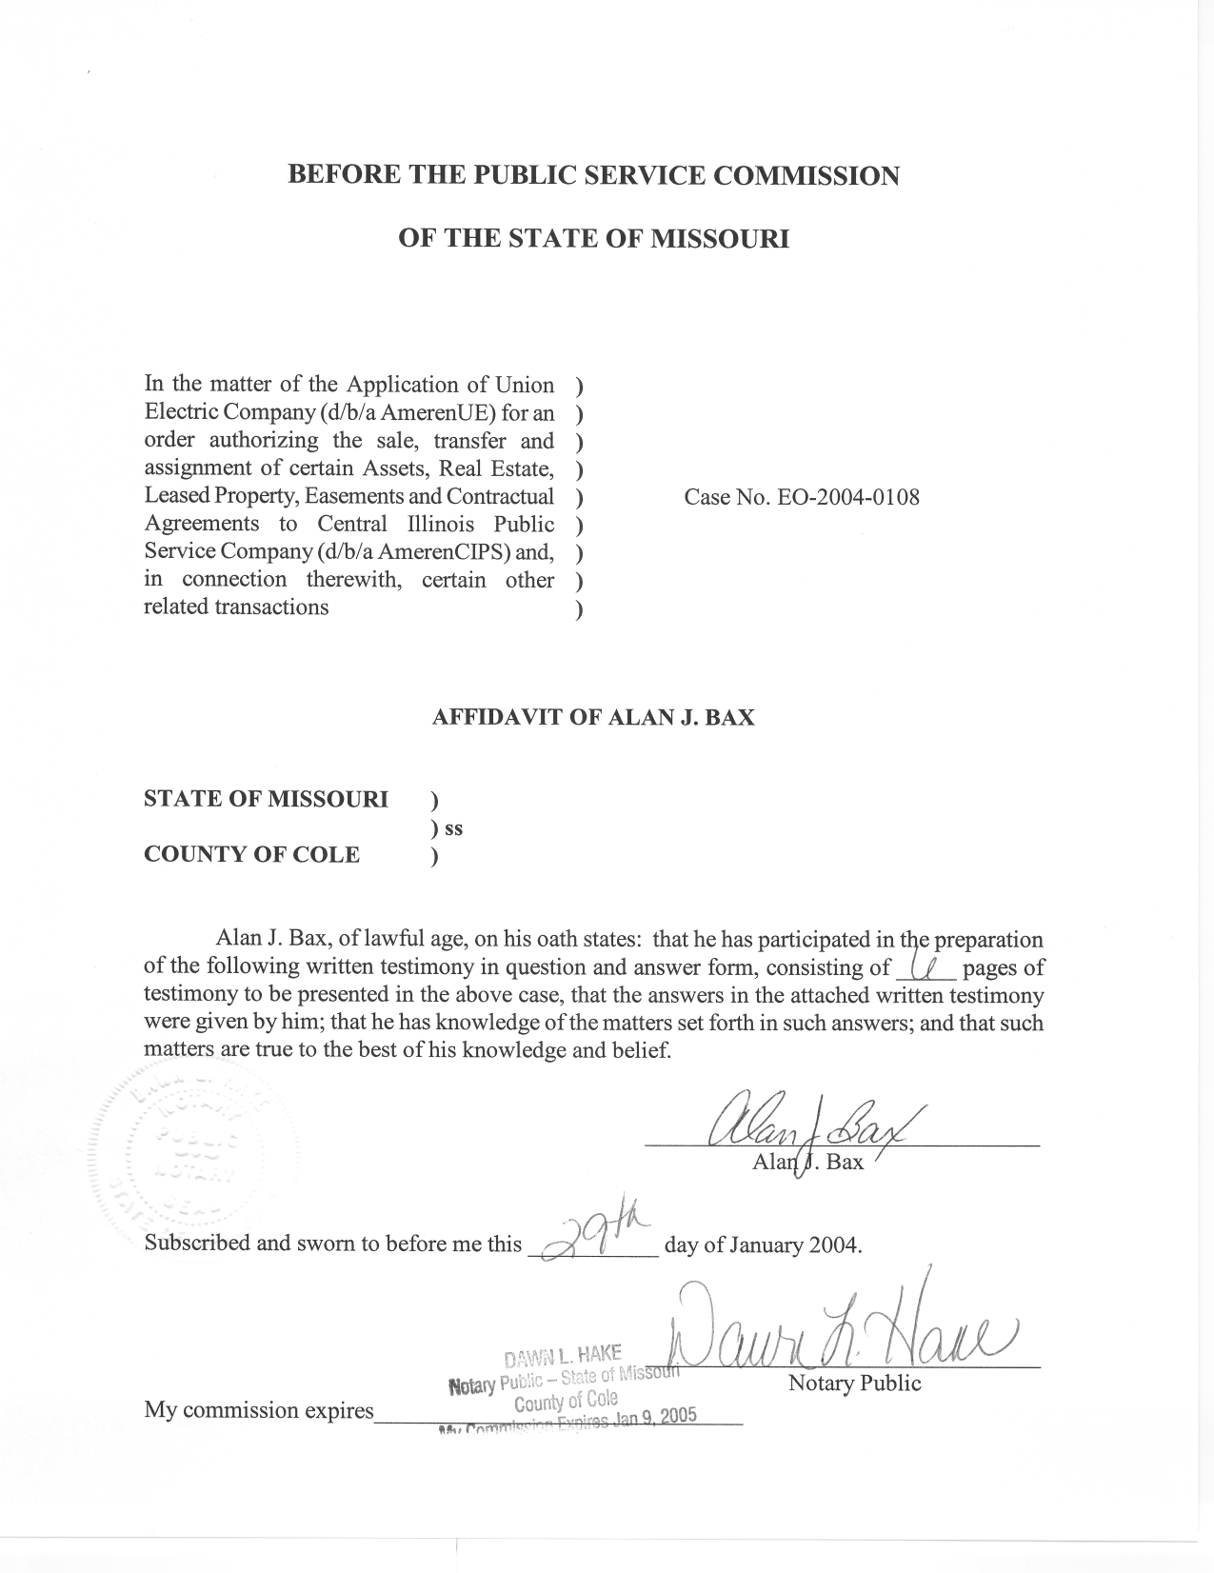
REBUTTAL TESTIMONY
OF
ALAN J. BAX
UNION ELECTRIC COMPANY d/b/a AMERENUE
CASE NO. EO-2004-0108

Q. Please state your name and business address?
A. Alan J. Bax, P.O. Box 360, Jefferson City, Missouri, 65102.
Q. By whom are you employed and in what capacity?
A. I am employed by the Missouri Public Service Commission (Commission) as a Utility Engineering Specialist III in the Energy Department of the Utility Operations Division.
Q. Please describe your educational and work background.
A. I graduated from the University of Missouri - Columbia with a Bachelor of Science degree in Electrical Engineering in December 1995. Concurrent with my studies, I was employed as an Engineering Assistant in the Energy Management Department of the University of Missouri – Columbia from the Fall of 1992 through the Fall of 1995. Prior to this, I completed a tour of duty in the United States Navy, completing a course of study at the Navy Nuclear Power School and a Navy Nuclear Propulsion Plant. Following my graduation from the University of Missouri - Columbia, I was employed by The Empire District Electric Company (Empire) as a Staff Engineer until August 1999, at which time I began my employment with the Staff of the Public Service Commission (Staff).
Q. Are you a member of any professional organizations?
A. Yes, I am a member of the Institute of Electrical and Electronic Engineers (IEEE).
Q. Have you previously filed testimony before the Commission?
A. Yes, I filed testimony on jurisdictional allocations and system energy losses in electric rate cases involving Empire (ER-2002-424) and Missouri Public Service, a division of Utilicorp United, Inc. (Case No. ER-2001-672) and, more recently, Aquila Networks - MPS. (ER-2004-0034). In addition, I filed testimony on losses and jurisdictional allocations in a complaint case involving Union Electric Company d/b/a AmerenUE (AmerenUE) (Case No. EC-2002-1) and filed true-up testimony concerning jurisdictional allocations in an electric rate case involving Empire (Case No.
ER-2001-299).
Q. What is the purpose of your testimony?
A. The purpose of this testimony is to provide a description of certain electric transmission, distribution, and generation assets presently owned and operated by AmerenUE within the state of Illinois and to discuss possible outcomes to Missouri electric customers should ownership of these assets be transferred to Central Illinois Power Service Company (AmerenCIPS) as requested in this case.
Q. Has AmerenUE provided a list of the assets to be included in the proposed transfer?
A. Yes. In the response to Staff Data Requests Nos. 1 and 3 in this case, Staff received a list of assets to be transferred upon Commission approval. The list appears to include essentially all of the electric distribution assets currently utilized to provide service to AmerenUE’s existing customers in Illinois as well as most of the AmerenUE transmission assets, which are used by both its Missouri and Illinois electric customers.
As indicated in the response to Staff Data Request No. 7 and on Page 7 and Schedule 1 of the Direct Testimony of Ameren Service Company (Ameren Services) Vice President Craig D. Nelson, (filing on behalf of AmerenUE), AmerenUE would transfer all of its distribution plant and customers in Illinois to AmerenCIPS. In addition, as a result of the transfer, AmerenUE would no longer own transmission assets in Illinois, including the transmission assets used to deliver energy to Missouri customers, with the exception that AmerenUE would retain ownership of all river crossings up to and including the first connection point in Illinois. Items intended to be transferred include the associated switchyard for AmerenUE’s generation located at Venice, Illinois and the transmission assets currently owned by AmerenUE that provide a direct connection from the generation facilities located at Pinckneyville, Illinois to Missouri.
Q. Are the Pinckneyville generation facilities presently owned by AmerenUE?
A. No. Ameren Energy Generating (AEG) currently owns the generating facilities at Pinckneyville, Illinois. AmerenUE has made it clear that it intends to purchase those facilities from AEG along with the AEG’s generation facilities at Kinmundy, Illinois in order to meet AmerenUE’s capacity requirements.
Q. Explain further who would own the facilities at Venice, Illinois should this transfer take place as proposed?
A. According to the supplemental response to Staff Data Request No. 42, received January 26, 2004, AmerenUE would retain ownership of the Venice generating facilities, both current and the planned additions, as well as the generator lead lines and the associated 13.8 kV switchgear building. AmerenUE would transfer to AmerenCIPS the adjoining switchyard it currently owns, containing the 69kV and 138kV substations, to AmerenCIPS. Illinois Power would retain its current ownership of five bus ties at the Venice site.
- Is there a concern about the operation of the transmission system should
this transfer of assets be approved?
A. Yes. Potentially, the transfer of certain transmission assets, specifically those associated with the generation facilities at the Venice and Pinckneyville plants, could cause AmerenUE to be subject to additional transmission charges when securing capacity or acquiring energy from available generation at these aforementioned facilities and/or any future generation located in Illinois. The Staff has been informed that, due to the joint dispatch of generation units, the transmission system would be operated as one control area, as it has been during the past several years, since the merger of the Union Electric Company and Central Illinois Power Service Company. Presuming that the system will be operated as a single control area, a main concern lies with assuring transmission capability to transport available power generated at AmerenUE’s Illinois facilities to Missouri. Little or no assurance has been provided thus far that Missouri customers would retain (or be guaranteed) priority status with respect to the power generated at AmerenUE owned facilities in Illinois. Without such an assurance, if the transfer of assets is allowed, AmerenUE could be forced to install additional transmission facilities to ensure the availability of its generation, as Ameren Services may not value transmission availability and/or energy transfers to Missouri customers as highly as AmerenUE does. This scenario seems plausible based on an initial review of the current interconnection agreement for the generation facilities at Pinckneyville.
As part of the supplemental response to Staff Data Request No. 42, received January 22, 2004, Ameren Services provided a copy of a draft document containing details of an interconnection agreement concerning any future generation facilities at the Venice site in Illinois. The agreement between AmerenUE and Ameren Services, identified as the generation owner and the transmission owner respectively, suggests that AmerenUE would only have access to the transmission system subject to constraints.
Q. Isn’t there a similar concern with respect to ownership of the transmission assets that connect to the generation facilities at Kinmundy, Illinois?
A. Yes. However, because AmerenCIPS already owns these transmission assets, it is not a subject of this case.
Q. Do you have any recommendations regarding the transfer of the distribution and transmission assets?
A. Yes. If the Commission approves the transfer of assets, the Commission should only grant approval of the specific distribution assets identified on Page 7 and Schedule 1 in the testimony of Mr. Nelson, filed on behalf of AmerenUE. The Commission should not approve the transfer of the transmission assets without a written assurance from Ameren Services that AmerenUE would be held harmless as described in the testimony of Staff witness Dr. Michael S. Proctor.
Q. Would you like to make any additional comments should this transfer of assets be consummated?
A. Yes. In its application in this case, Ameren Services asked that the Commission approve the use of the latest available 12-month coincident peak (12 CP) demand allocation factor, adjusted for the elimination of the Illinois demands, for the reallocation of the AmerenUE’s generation capacity and the Callaway Nuclear Power Plant decommissioning cost. Staff wholeheartedly agrees with utilizing a 12 CP methodology in determining allocations.
Q. Does this conclude your prepared rebuttal testimony?
A. Yes, it does.

