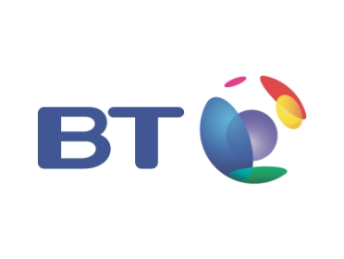

Writer’s Direct Dial: 703.755.6733
Facsimile Number: 703.755-6740
Linda.Cicco@bt.com

Date: April 14, 2011

To: Missouri Public Service Commission

From: Linda Cicco, Regulatory Compliance Manager
BT Communications Sales, LLC

Re: BT Communications Sales, LLC
2010 Annual Report - CPNI Compliance Certificate

Please be advised that BT Communications Sales, LLC (“BTCSLLC”) is currently not providing services on either a federal or state level. Since it has no activities, personnel, sales or marketing campaigns, it is unable to provide documentation regarding safeguards in place for the protection of customer CPNI. Once services do commence, BTCSLLC will comply fully with the Missouri Public Service Commission’s CPNI rules of 4 CSR 240-33,160(7). In addition, on a federal level, BTCSLLC’s parent, BT Americas Inc. provides telecommunications services requiring compliance with the FCC’s CPNI rules and has implemented policies and procedures in place for compliance with same.

