Exhibit No.:
Issues: Fuel Expenses;
Purchased Power

Witness: Leon C. Bender
Sponsoring Party: MO PSC Staff
Type of Exhibit: Direct Testimony
Case No.: ER-2004-0570
Date Testimony Prepared: September 20, 2004

MISSOURI PUBLIC SERVICE COMMISSION

UTILITY OPERATIONS DIVISION

DIRECT TESTIMONY

OF

LEON C. BENDER

THE EMPIRE DISTRICT ELECTRIC COMPANY

CASE NO. ER-2004-0570

Jefferson City, Missouri
September 2004

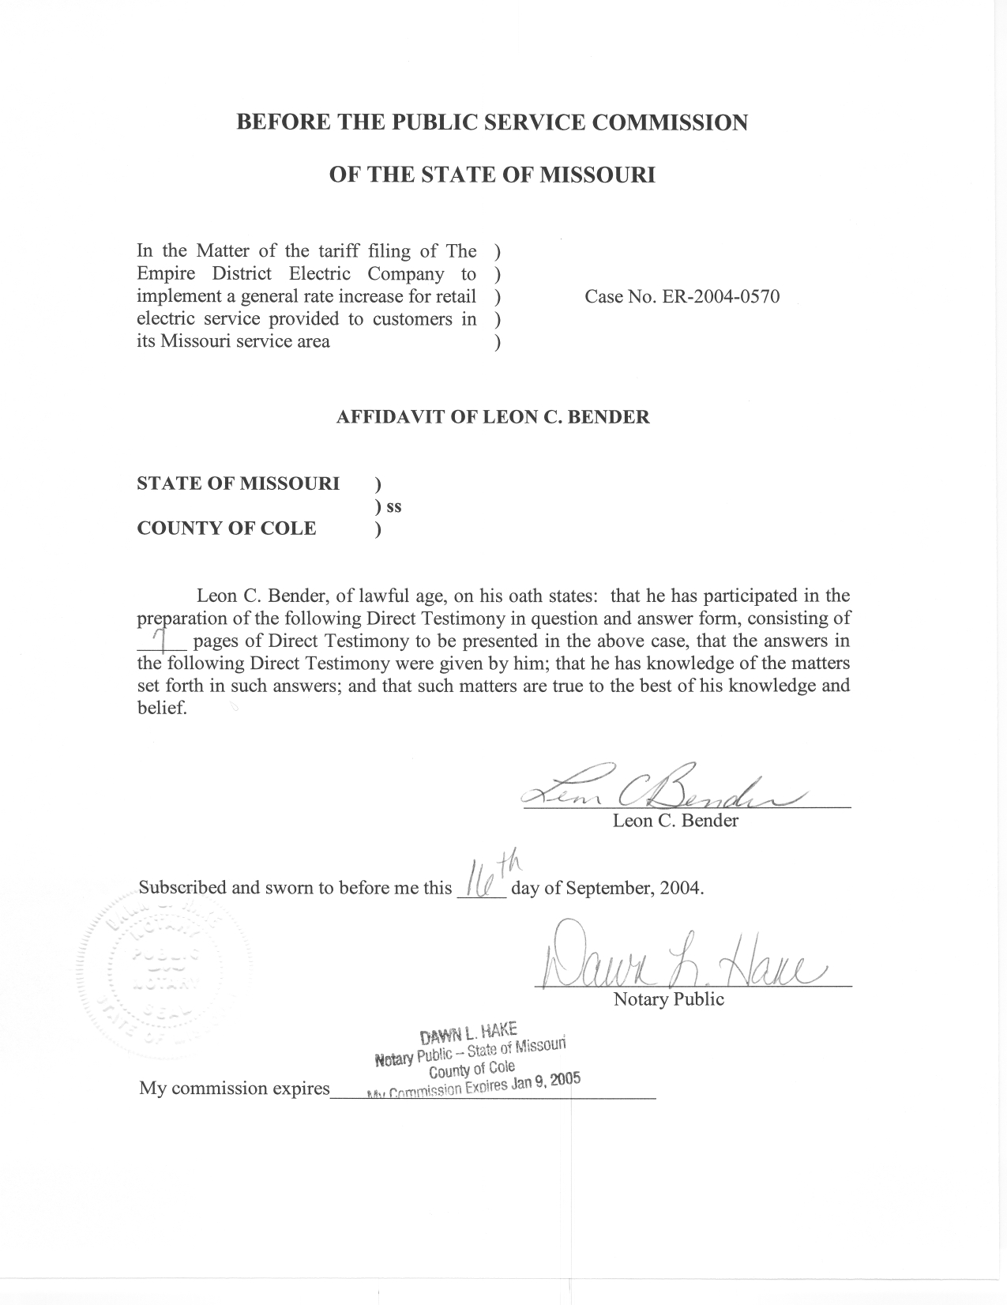

DIRECT TESTIMONY

OF

LEON C. BENDER

THE EMPIRE DISTRICT ELECTRIC COMPANY

CASE NO. ER-2004-0570

Q. Please state your name and business address.
A. Leon C. Bender, P.O. Box 360, Jefferson City, Missouri, 65102.
Q. By whom are you employed and in what capacity?
A. I am employed by the Missouri Public Service Commission Staff (Staff) as a Regulatory Engineer in the Energy Department of the Utility Operations Division.
Q. Please describe your educational and work background.
A. I received a Bachelor of Science degree in Mechanical Engineering in August 1978 from Texas Tech University. I became employed by Southwestern Public Service Company (SPS) as a power generation plant design engineer in September 1978. While employed by SPS, I was lead engineer on many projects involving design and construction of new power generating stations and the upgrading of their older plants. In 1983, I became a registered Professional Engineer in the state of Texas. In 1986, I transferred to SPS’s newly formed subsidiary company, Utility Engineering Corporation, and was responsible for various projects at various other clients’ power generation plants. In June 1990, I accepted employment as a systems engineer with Entergy Operations, Inc. at the nuclear powered generating station, Arkansas Nuclear One. In December 1995, I joined the Missouri Public Service Commission (Commission).
Q. Have you filed testimony in previous cases before this Commission?
A. Yes I have. Please refer to Schedule 1, which is attached to my direct testimony, for a list of cases in which I have previously filed testimony.
Q. What is the purpose of your testimony in this case?
A. The purpose of my testimony is to present the results of the Staff’s electric production cost model simulations that were run in this case to establish a base and ceiling amount of normalized fuel and purchased power cost for the Empire District Electric Company (EDE) for the test year ending December 2003 and updated through June 2004.
Q. Briefly summarize the results of the production cost model simulation.
A. The results of the production cost model simulations, as shown in Schedule 2, show that the estimated base amount of annual variable cost of fuel and net purchased power is $86,319,146. The results show that the estimated ceiling amount of annual variable cost of fuel and net purchased power is $109,770,670.
Q. Why did you estimate two levels of variable fuel and net purchased power costs?
A. A base amount of fuel and purchased power was needed by Staff in establishing its proposed permanent rates. The ceiling amount was necessary for establishing the amount of money to be collected, subject to refund, by the Staff’s proposed Interim Energy Charge (IEC). For a more in depth discussion of how fuel and purchase power are used to establish an IEC, please refer to Staff witness John Cassidy’s testimony.
Q. What were the differences between the base production cost simulation run and the ceiling production cost simulation run?
A. The only difference between the two simulation runs was the gas price input. All other inputs remained the same.
Q. What is a production cost model?
A. A production cost model is a computer program used to perform an hour-by-hour chronological simulation of a utility’s generation and power purchases. The model determines energy costs and fuel consumption necessary to economically meet a utility’s load within the operating constraints of the utility’s resources used to meet that load.
Q. What is meant by an “hour-by-hour” chronological simulation of a utility’s generation and net power purchases?
A. The production cost model operates in a chronological fashion, meeting each hour’s energy demand before moving to the next hour. It will schedule generating units to dispatch in a least cost manner based upon fuel cost and the cost of purchased power. This model closely simulates the way the company should dispatch its generating units and purchase power to meet the net system load in a least cost manner.
Q. What production cost model did the Staff use in this case?
A. The RealTime ® production cost model was used.
Q. What were the sources for data used in the model?
A. The sources for data used in the model are listed in Schedule 3.
Q. What is purchased power?
A. Purchased power is the hourly energy which is purchased in the market place from another electric supplier and which is used to help meet the load of the electric utility company. Purchased power is also commonly referred to as wholesale power.
Q. Does EDE use purchased power to serve native load?
A. Yes. EDE purchases power from other sources during times of plant forced or planned outages and during times when it is more economical to purchase power rather than generate power.
Q. What were the sources of data used to calculate purchased power prices and to determine the amount of purchased power energy available?
A. The data used to calculate purchased power prices and to determine the amount of energy available was determined from data submitted to Staff by EDE, as required by Commission Rule 4 CSR 240-3.190 (3.190 data) formerly Rule 4 CSR 240-20.080.
Q. What different kinds of purchased power were used in the production cost model?
A. Two kinds of purchased power were used in the production cost model; capacity and spot purchased power.
Q. Please explain what is meant by capacity purchases.
A. Capacity purchases are made through capacity contracts for the purchase of power where the purchaser pays a fixed cost for the ability to receive a maximum number of megawatts (MW) per hour and also pays a variable cost for MW hours of the energy associated with the generating capacity that is being purchased. The purchasing company can obtain a quantity of hourly energy up to the maximum amount shown in the capacity contract. The fixed costs are not included in the model results.
Q. What capacity purchase contracts were used in the production cost model?
A. The Western Resources Inc. Jeffries Unit Participation Contract was modeled in the production cost model. It is the only capacity contract in EDE has in effect at this time.
Q. How did you calculate the hourly prices for this capacity contract?
A. I used actual prices paid in the test year as obtained from EDE from DR No. 0262. The prices were fixed for each hour of every month regardless of the amount of energy purchased up to the contract maximum. Prices varied monthly.
Q. What are spot market purchases?
A. Spot energy is energy purchased on an hourly basis rather than through a longer-term contract. The purchasing company decides to buy spot energy from one or more suppliers based on the economics and availability of its generating units and capacity purchases. Purchases of spot energy are made in order to lower costs when the spot market price is below both the marginal cost of providing that energy from the company’s generating units and the cost of capacity purchases. Since the spot market depends on energy supply and demand, the prices tend to be much more volatile than capacity purchases.
Q. What methodology did you use to determine the spot market purchased energy prices?
A. I used a procedure developed by the Commission’s Energy Department- Engineering Section described in the document entitled A Methodology to Calculate Representative Prices for Purchased Energy in the Spot Market (March 18, 1996). The method uses a statistical calculation based on the truncated normal distribution curve to represent the hourly purchased power prices in the spot market. EDE’s actual hourly non-contract transaction prices in the period of twelve months ending June 30, 2004, obtained from EDE’s 3.190 data, are used as price inputs in the calculation. The calculation yields a spot energy price for each hour of the year.
Q. Explain why you chose the twelve months ending June 30, 2004 to obtain the hourly non-contract transaction prices.
A. In periods previous to July 2003, EDE was buying some of its purchased energy with short-term contracts from American Electric Power (AEP). However, after July 2003, EDE was unable to purchase this energy. After January 2004 AEP stopped offering this energy on a short-term contract basis. Since the update period for this case is through June 2004, and because the purchase prices are more representative of EDE’s market purchases in the absence of the short-term contracts with AEP, I decided to use the period of July 2003 thru June 2004.
Q. How did you determine spot purchased energy available?
A. I limited the spot purchased energy available in any hour of the month to the maximum amount that was actually purchased in the same hour of the month as shown by the 3.190 data. After the amount of spot purchased energy available was determined, the amount was input into Staff’s production cost model to calculate the amount of spot energy purchased to meet load in a least cost manner.
Q. What fuel prices were used in the production cost model?
A. I used the fuel prices provided by Staff witness John Cassidy. Because of the proposed IEC, separate simulations of the model were made for the base gas price and the ceiling gas price.
Q. What is the test year cost, of fuel and net purchased power, as determined by the Staff’s production model for EDE?
A. As noted earlier, the results of the production cost model simulation, as shown in Schedule 2, show that the base amount of annual variable cost of fuel and net purchased power is $86,319,146. The results show that the ceiling amount of annual variable cost of fuel and net purchased power is $109,770,670. These amounts were supplied to Staff witness John Cassidy, who used this input in the annualization of fuel expense. For further discussion of how Staff annualized the overall fuel expense in this case, please see Staff witness John Cassidy’s direct testimony.
Q. Does this conclude your direct testimony?
A. Yes, it does.

