Exhibit No.:
Issues: Fuel Run and Production Cost Model
Witness: Leon C. Bender
Sponsoring Party: MO PSC Staff
Type of Exhibit: Surrebuttal Testimony
Case No.: EC-2002-1
Date Testimony Prepared: June 24, 2002

MISSOURI PUBLIC SERVICE COMMISSION

Utility Operations DIVISION

SURREBUTTAL TESTIMONY

OF

Leon C. Bender

UNION ELECTRIC COMPANY d/b/a

AMERENUE

CASE NO. EC-2002-1

Jefferson City, Missouri
June 24, 2002

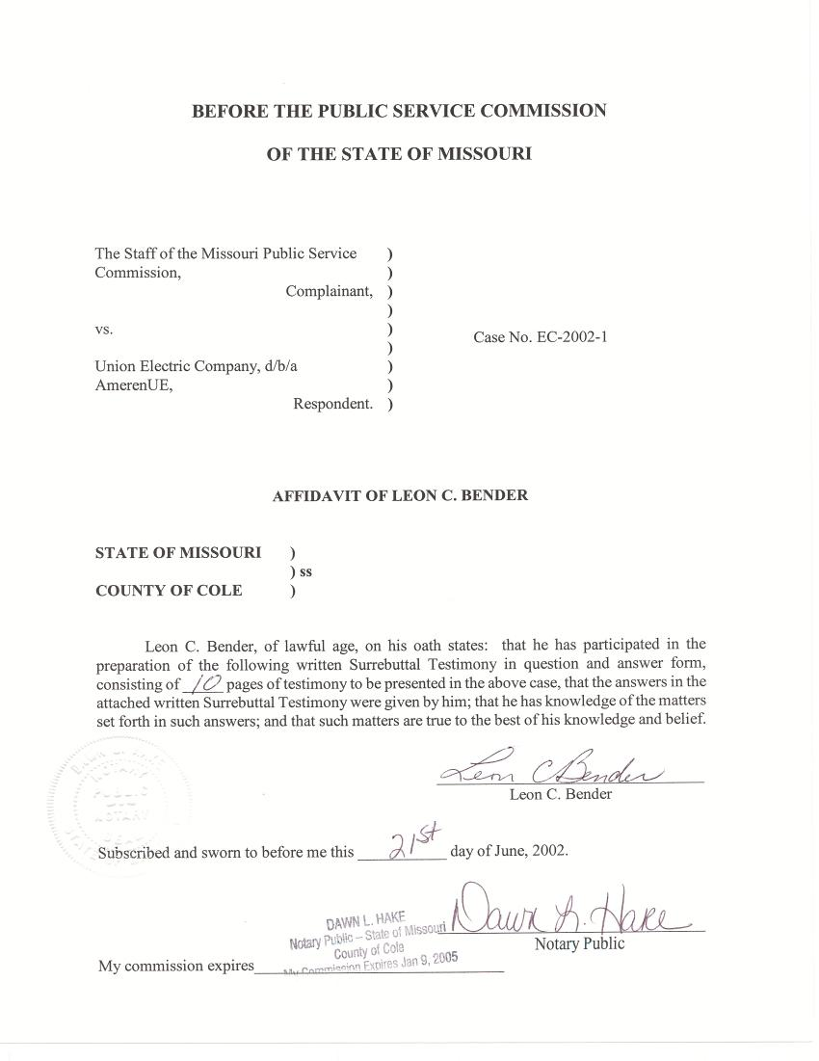

SURREBUTTAL TESTIMONY
OF

LEON C. BENDER
UNION ELECTRIC COMPANY
d/b/a AMERENUE
CASE NO. EC-2002-1
Q. Please state your name and business address.
A. Leon C. Bender, P.O. Box 360, Jefferson City, Missouri, 65102.
Q. Are you the same Leon C. Bender who filed direct testimony in this case?
A. Yes, I am.
Q. What is the purpose of your surrebuttal testimony in this case?
A. The purpose of my surrebuttal testimony is to respond to the rebuttal testimony of UE witness Timothy D. Finnell regarding the results of Staff’s production cost model simulation that is used to determine fuel and purchased power cost for UE for the test year.
Q. Do you have any recommendations for the Commission?
A. Yes. I recommend that the Commission adopt the Staff’s normalized fuel and purchase power costs of $338,803,609. I also recommend that the Commission order UE to comply with the Commission rule 4 CSR 240-20.080 by submitting actual capacity contract prices, not estimated prices, to the Commission’s Energy department on a going forward basis.

Q. Did you review the testimony of Mr. Finnell?
A. Yes, I did.
Q. What differences between Staff’s production cost model and UE’s production cost model did Mr. Finnell address in his rebuttal testimony?
A. In addition to expressing a concern that Staff failed to calibrate its production cost model to actual test year results, Mr. Finnell addressed differences associated with: a) the generating units used; b) the prices of capacity contracts included; c) the number of hours used for outages in the model; d) plant heat rates; e) capacity reductions due to fuel quality and equipment problems; f) the use of supplemental fuel by the Meramec Plant; and g) the number of starts on units dispatched by the model. I will address each of these concerns in my testimony.
Q. Have you made an update to the Staff’s production cost model to reflect changes pointed out by UE?
A. Yes, I have. The changes to the production cost model are listed in Schedule 1.
Q. What is the test year allocated cost of fuel and net purchased power, based upon the results of the updated production cost model?
A. The test year allocated cost for fuel and net purchased power in the test year (twelve months ending June 2001, updated to September 2001) is $338,803,609. This amount was supplied to Staff witness John Cassidy to use in the annualization of fuel expense.
Q. Should Staff’s production cost model results be calibrated to match actual test year results as alleged in Mr. Finnell’s rebuttal testimony?
A. No. Staff seeks to represent a normalized year and not necessarily to duplicate any one set of unique circumstances that may have arisen in a particular test year. Actual events during the test year are not necessarily representative of any other particular year. Each year is unique in the set of problems that arise because of weather, unit outages, fuel prices, market conditions, and management decisions. Therefore, Staff normalizes as many of these factors as possible. It is not reasonable to assume that the normalized result would match the actual result of any particular test year. This does not mean however, that checks for reasonableness are not done. All of the inputs into Staff’s production cost model are compared to UE’s inputs into its production cost model used for budgeting. Staff also carefully examines the outputs of the model for reasonableness. One such examination is the comparison of Staff’s results with five-year average generation levels for UE’s major plants, which is shown on Schedule 2, attached hereto.
Q. What were the major differences between the generating units included in the Staff’s and UE’s production cost models?
A. As stated in my direct testimony, I included thirteen combustion turbine units that do not presently exist. These would supply a total of 500 megawatts. UE did not include these units in its production cost model. Instead, UE modeled a short-term capacity and energy contract, which has expired. For a discussion of why these units were included in the Staff’s model and not the short-term capacity and energy contract, see the direct testimony of Staff witness Dr. Michael S. Proctor.
Q. What is Mr. Finnel’s concern regarding the prices for capacity contracts that you used in the model?
A. Mr. Finnell stated, on page 4 of his rebuttal testimony, that the capacity contract prices I used were incorrect because they were estimates rather than actual prices.
Q. What prices did you use for capacity contracts in the production cost model?
A. As stated in my direct testimony, I used the prices supplied to the Staff by UE, as required by Commission Rule 4 CSR 240-20.080 (20.080 data). This rule states, in pertinent part, as follows:
(1) “every electrical corporation, as defined in section 386.020, RSMO, subject to the jurisdiction of the Public Service Commission (PSC) shall accumulate the following information and transmit it in writing to the manager of the energy department of the PSC, or his/her designee, no later than the last business day of the month following the month to be reported and after that on a monthly basis: . . .

(D) Hourly purchases and sales of electricity from or to other utility companies, independent power producers or cogenerators, including the parties to purchases and sales, and terms of purchases and sales;”

Q. Does Commission Rule 4 CSR 240-20.080 state that the Company will supply estimated prices?
A. No, it does not. The rule requires that Missouri regulated electric utilities furnish actual prices. Until I read Mr. Finnell’s rebuttal testimony, I understood the prices submitted to be actual prices, not estimates. In a telephone conversation with Mr. Finnell after his rebuttal was filed, I asked if there was a problem with supplying actual prices in time for the monthly report, and he replied there was not. Staff requests that the Commission order UE to comply with the rule and submit actual prices, not estimated prices, on a going forward basis.
Q. Have you replaced the estimated prices with the actual prices in Staff’s update of the production cost model?
A. Yes, I have. I used the actual prices paid, which were listed in Mr. Finnell's work papers.
Q. Please state Mr. Finnell’s concern regarding the hours you used for both planned maintenance and forced outages.
A. Mr. Finnell stated on page 12 of his rebuttal testimony that some of the data I used for unit outages did not include maintenance outages in the production cost model.
Q. Where did you obtain the data for these unit outages?
A. Originally, I used the planned and forced outage hours submitted by UE in response to Staff data requests 4146 and 4114. However, I learned during a discussion with Mr. Finnell in March, after Staff had already filed direct testimony, that the planned outage hours supplied by UE did not include so-called “maintenance outages.” Maintenance outages are short-term outages that are scheduled to make repairs or improvements to the plant.
Q. Have you included the maintenance outage hours in an update to the model?
A. Yes, I have. I included maintenance outage hours in the averages used for planned outages. For the update, I have used the 20.080 data submitted monthly by UE as a source of the data to ensure that all outages were included.
Q. Please state Mr. Finnell’s concerns regarding the unit heat rates used in the Staff’s production cost model.
A. Mr. Finnell stated that the heat rates for generating units were not current because Staff did not use the most current Efficiency Deviation Factors (EDFs) to calculate heat rates for input into the Staff’s production cost model. In his testimony on page 13 and 14, Mr. Finnell explains EDFs and how UE uses EDFs to determine heat rates.
Q. Please explain why you did not use the most current EDFs to determine heat rates used in the production cost model in your March 2002 testimony.
A. I used the EDFs submitted by UE in response to Staff data request 2918. This data request asked for information updated thru September 30, 2001, which is the update period for the test year. It was not until Staff asked that the information be updated through December 31, 2001, which is outside the update period for the test year ordered by the Commission, that UE supplied the updated EDFs. However, in subsequent discussions, UE explained that the data used to develop the EDFs was acquired during the test year. Therefore, Staff has used the most current EDFs to calculate heat rates of units, and used the updated heat rates in its updated production cost model.
Q. Mr. Finnell asserts in his rebuttal testimony that the Staff’s production cost model does not take into account equipment-related capacity reductions, which he refers to as load reductions. Is he correct?
A. Yes, he is. Since equipment problems are random events, these resultant capacity reductions, or load reductions, occur randomly. Staff’s production cost model is not capable of modeling random capacity reductions. This is a limitation of Staff’s model. Staff has not done an analysis of the impact of random capacity reductions at this time. To do so would require that the capacity reductions be normalized, which is something the company has not done in its own production cost model. The vendor for the Staff’s model plans to add this feature at some future date. The difference in the result of Staff’s model versus the result that would be observed if the capacity reductions were modeled is anticipated to be small.
Q. Did Staff include any planned capacity reductions to individual units, as defined in Tim Finnell’s rebuttal testimony, in its March, 2002 production cost model?
A. Yes, it did. The reduction in generation capability of the Callaway Nuclear Plant before and after a planned outage is an example. Schedule 3 is a graph that shows the comparison of the modeled capacity reduction with the actual capacity reduction for the Callaway Nuclear Plant. The graph shows that the capacity shapes are almost identical.
Q. Did Staff include fuel quality capacity reductions, as defined in Tim Finnell’s rebuttal testimony, for the Meramec plant in its March, 2002 production cost model?
A. The fuel quality capacity reductions for the Meramec Plant, due to use of a different fuel, were not modeled in Staff’s March, 2002 production cost model, but are modeled in the update.
Q. Mr. Finnell also alleged that gas is used as a supplementary fuel and flame stabilization at the Meramec Plant, and that Staff’s model run supporting its direct testimony does not recognize this. Please comment.
A. Mr. Finnell is correct. The Staff model included gas only as a startup fuel for the Meramec Plant. If Staff input gas as a supplementary fuel, the model would choose not to use it since the price of gas is higher than the coal price, the normal source of fuel. However, in the Staff’s update of the model, gas has been input as a blend with coal so that the model will burn more gas, as actually occurs in that unit. Gas is burned with coal in this plant for operational reasons.
Q. In his rebuttal testimony, Mr. Finnell also alleges that the fact that the number of starts on several units is considerably different from actual indicates that the model needs to be calibrated. Do you agree?
A. No, I do not. Staff seeks to determine the amount of fuel expense necessary to meet a normalized year’s load that UE is obligated to serve, not an actual year’s load that also contains sales on the interchange market. The model will meet the normalized load with the resources available. If a unit is not needed to meet the load, and is reduced below its minimum capacity, the model will shut the unit down and start it up again when it is needed to meet load. Every time this occurs for a particular unit, the model will report a start for that resource. However, in an actual year UE has the opportunity to sell energy in excess of load and often does. Consequently, UE does not shut that unit down as frequently as the model would indicate. The actual number of starts, therefore, may be very low because the load on the unit is never reduced below its minimum. As a result, the actual number of starts will not compare to Staff’s model reports.
Q. Do you recommend that the Commission use the results from UE's production cost model?
A. No, I do not.
Q. Please explain why UE’s production cost model results should not be used for establishing normalized cost of fuel and net purchased power.
A. UE’s production cost model results should not be used for the following reasons: a) UE used the wrong time period; b) UE used actual outages instead of normalized outages; and c) UE included capacity contracts that expired during the test year and were not renewed. These shortcomings are discussed below.
Q. Did UE use the test year in its estimation of fuel and purchase power costs?
A. No. According to Tim Finnell’s rebuttal testimony on page 19, the Company modeled the period October 1, 2000 through September 30, 2001. Thus, UE did not model the test period ordered by the Commission. In his surrebuttal testimony, Staff witness Greg Meyer discusses the implications of estimating fuel and purchase power prices in a year different from the test year.
Q. Did UE normalize the outages of its generating units?
A. No. According to a statement made by Tim Finnell at the prehearing, UE used actual outages in its model. This is not appropriate because, as stated in my direct testimony, actual outages will tend to skew the results of the model toward a more expensive or less expensive unit. In order to avoid this problem, the Staff believes a five-year average of outages is more appropriate.
Q. Did UE include in its production cost model any capacity contracts that were expired?
A. Yes. UE included the Mid-America Energy Contract, which expired on May 30, 2001. UE also included a short term, “must take” contract, from American Electric Power. Neither of these contracts should be included in a normalized production cost model for a rate case because they have expired, which is why Staff did not model either contract. The model should only include those contracts that are in effect through the update period of September 30, 2001.
Q. What are Staff’s recommendations regarding fuel and net purchased power?
A. The results of the UE production cost model are seriously deficient for reasons just discussed. By contrast, the Staff’s model, which does not suffer from those deficiencies, now incorporates almost all of the suggestions made by UE witness Tim Finnell. Therefore, the Commission should reject UE’s results and instead adopt Staff’s recommended cost of fuel and purchased power, as amended and submitted in conjunction with Staff’s surrebuttal testimony.
Q. Does this conclude your surrebuttal testimony?
A. Yes, it does.

Changes Made To Production Cost Model Inputs Since April 19, 2002

1. New planned outage and forced outages are used based an analysis of 20.080 data More planned outage hours are used because addition of maintenance and scheduled extensions. Outages are normalized based upon data from October 1996 to October 2001.

2. Actual prices are used for the capacity purchase contract prices, as presented in Tim Fennel’s work papers, rather than the “estimated prices” UE supplied in the 20.080 data.

3. Heat rates updated to December 1, 2001 are used with the understanding these are more representative of the test year than the heat rates presented in an earlier DR response.

4. Gas is used as a blended fuel with coal at the Meramec plant.

5. Meramec 3 and 4 maximum capacities were reduced in months that the plants used Powder River Basin coal.

6. New loads were used as supplied by Staff witness Lena Mantle.

7. Spot purchase prices and capacities were rerun to match the new loads stated in item 6.

Comparison of Normalized Model Generation Results
With Five-Year Average Actual Generation
 | 5 year Average Actual MWH Generation | Model MWH Generated | 5YR AVE DIFF | %of 5yr over or under
Callaway | 8,936,388 | 8,825,346 | -111,042 | -1.24%
Labadie 1 | 3,498,037 | 3,516,087 | 18,050 | 0.52%
Labadie 2 | 3,528,838 | 3,576,452 | 47,614 | 1.35%
Labadie 3 | 3,711,853 | 3,672,691 | -39,162 | -1.06%
Labadie 4 | 3,565,842 | 3,427,081 | -138,761 | -3.89%
MERAMEC | 2,535,448 | 2,563,020 | 27,572 | 1.09%
Rush Island 1 | 3,563,703 | 3,564,962 | 1,259 | 0.04%
Rush Island 2 | 3,733,555 | 3,600,014 | -133,541 | -3.58%
Sioux 1 | 2,559,362 | 2,437,665 | -121,697 | -4.75%
Sioux 2 | 2,528,973 | 2,345,117 | -183,856 | -7.27%
Total | 38,161,999 | 37,528,435 | -633,564 | -1.66%

