Exhibit No.:
Issues: Purchased Power

Witness: Leon C. Bender
Sponsoring Party: MO PSC Staff
Type of Exhibit: Surrebuttal Testimony
Case Nos.: ER-2004-0034
& HR-2004-0024
Date Testimony Prepared: February 13, 2004

MISSOURI PUBLIC SERVICE COMMISSION

Utility Operations DIVISION

SURREBUTTAL TESTIMONY

OF

Leon C. Bender

Aquila, Inc. d/b/a Aquila Networks--MPS
and Aquila Networks--L&P

CASE NOS. ER-2004-0034
& HR-2004-0024

Jefferson City, Missouri
February 2004

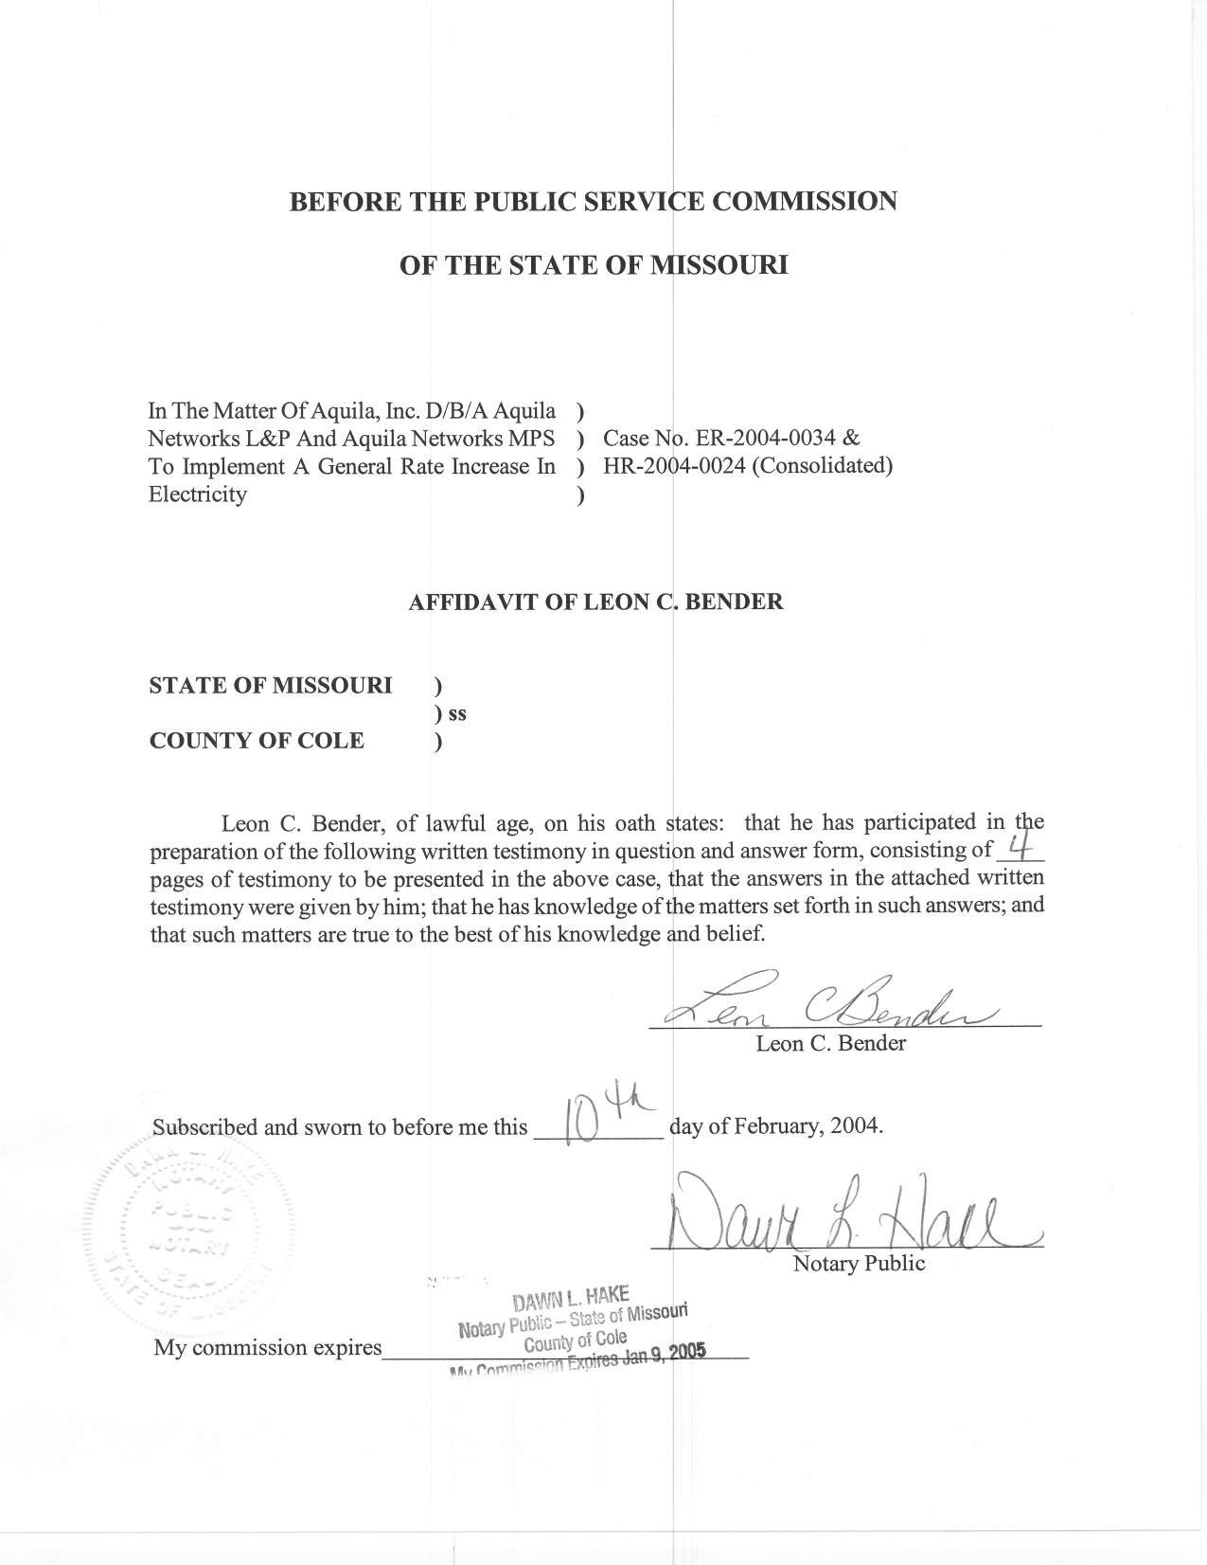
SURREBUTTAL TESTIMONY
OF
LEON C. BENDER
AQUILA, INC.
D/B/A AQUILA NETWORKS-MPS AND

AQUILA NETWORKS-L&P

CASE NOS. ER-2004-0034 AND HR-2004-0024
(CONSOLIDATED)
Q. Please state your name and business address.
A. Leon C. Bender, P.O. Box 360, Jefferson City, Missouri, 65102.
Q. Are you the same Leon C. Bender who filed direct and rebuttal testimony in this case?
A. Yes, I am.
Q. What is the purpose of your surrebuttal testimony in this case, Aquila, Inc. (Aquila) d/b/a Aquila Networks-MPS (MPS) and Aquila Networks-L&P (L&P) Case No. ER-2004-0034?
A. The purpose of my surrebuttal testimony is to respond to statements in the rebuttal testimony of James W. Okenfuss, of Aquila concerning Staff’s determination of purchased power prices. In particular, I wish to respond to Mr. Okenfuss’ suggestion that purchased power prices in the production cost model should be correlated with the predicted natural gas prices (page 6) as well as his statement that Staff has confused costs with prices (page 4).
Q. Do you agree that the Staff should change its purchased power prices based on natural gas prices?
A. No. Purchased power prices are influenced by many factors.
Q. What are some of the factors that could have an influence on purchased power prices in general?
A. Schedule 1 lists some of the factors that influence purchased power prices such as plant specific characteristics, the economy, electrical system congestion and a sellers intent.
Q. With all these variables affecting purchased power can one assume only one variable controls the outcome?
A. No. A change in any one of these variables can influence the final choices a supplier makes to minimize its costs. Some factors have a greater influence than others but all the variables influence the outcome in some way. For example, a suppliers low cost unit being forced out during peak periods probably would cause a rise in local market prices. As another example, load could decrease due to a sudden reduction in demand from a large industrial customer’s closing. The supplier would have excess generation available thus lowering the price at which energy could be purchased. Or, for instance, a marketer may be anticipating an increase in demand and may be holding back his unit to save on maintenance cost as he expects prices to go even higher in the near future. In the last example, marginal cost at the hub has little to do with his decision but the effect might be increased prices.
Q. Please discuss how Staff’s method satisfactorily addresses the interdependence of the various inputs.
A. Since Staff is using actual prices, this by definition accounts for all the variables that affected the market price curve during the test year. Thus, Staff’s method avoids the need to speculate as to the effect of any one variable or combination of variables upon the purchase power price.
Q. Has Staff confused cost with prices as Mr. Okenfuss states at the bottom of page 4 of his rebuttal testimony?
A. No. Mr. Okenfuss’s testimony is confusing when he refers to Staff’s use of cost and prices. Staff develops prices for input into the production cost model. To do so, Staff uses Aquila’s actual purchased power cost in dollars ($) divided by the amount purchased in mega-watts (MW) to determine the actual price paid ($/MW) in each hour of the test year.
Q. Does the Staff’s method used to develop purchased power prices determine a cost curve or a market price curve?
A. In effect, it develops a market price curve, based on the market conditions in the test year as represented by Aquila’s expenditures for power and the amount received. This so-called market price curve is then input into the production cost model.
Q. Please briefly discuss the Staff’s method.
A. The Staff’s method is described in my direct testimony in this case. The method employs actual data submitted by Aquila during the test year through August 2003. The data includes actual cost and amounts for energy sales and energy purchases for every hour. As stated earlier, the total cost ($) for each hour is divided by the total amount (MW) for each hour to obtain the price ($/MW) for each hour. This price represents the power market price ($/MW) for Aquila during that hour. In hours for which no energy was purchased, a statistical calculation is used to estimate a price for that hour. The calculation is based upon actual prices in other hours around it and is not a forecasted price. The prices are then aligned with the weather-normalized load to ensure that the highest price is paid during the period of highest demand and vice versa. This forms a market price curve for use in the estimation of fuel and purchased power expense that is consistent with the prices from the time period ordered by the Commission.
Q. Why doesn’t Staff use a forecasted market price curve in its production cost model, as does Aquila?
A. Staff has traditionally used inputs to its production cost model that are from the same period for which revenues are calculated in a rate case. Staff witness, Dana E. Eaves, discusses why it is appropriate to use matching revenue and cost data to set rates in his rebuttal testimony on page 8, starting at line 9 of his testimony.
Q. Have you made any changes to Staff’s purchased power inputs that you filed direct testimony on as a result of discussions with the other parties in prehearing?
A. No, I have not.
Q. Does this conclude your surrebuttal testimony?
A. Yes, it does.

