Exhibit No.:

Issues: Transportation Service-Internal; Deferred Carrying Cost Balances; Other

Witness: Annell G. Bailey
Sponsoring Party: MoPSC Staff
Type of Exhibit: Direct Testimony
Case Nos.: GR-2001-39 and GR-2001-388 (Consolidated)
Date Testimony Prepared: January 9, 2003

MISSOURI PUBLIC SERVICE COMMISSION

UTILITY SERVICES DIVISION

DIRECT TESTIMONY

OF

ANNELL G. BAILEY

SOUTHERN MISSOURI GAS COMPANY

CASE NOS. GR-2001-39 AND GR-2001-388
(CONSOLIDATED)

Jefferson City, Missouri

January 2003
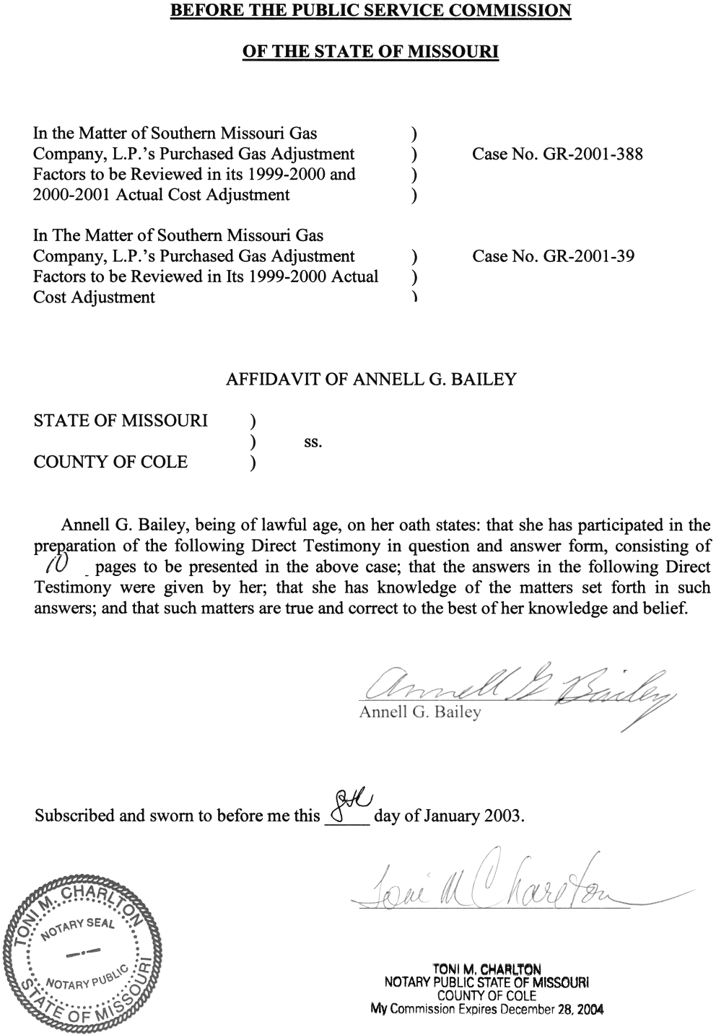

TABLE OF CONTENTS
ANNELL G. BAILEY
SOUTHERN MISSOURI GAS COMPANY, L.P.
CASE NOS. GR-2001-39 AND GR-2001-388

CONSOLIDATED
TRANSPORTATION SERVICE – INTERNAL 3
DEFERRED CARRYING COST BALANCE 5
OTHER ISSUES 8
SUMMARY 9

DIRECT TESTIMONY

OF
ANNELL G. BAILEY
SOUTHERN MISSOURI GAS COMPANY, L.P.
CASE NOS. GR-2001-39 AND GR-2001-388

CONSOLIDATED
Q. Please state your name and business address.
A. Annell G. Bailey, P.O. Box 360, Jefferson City, Missouri 65102.
Q. By whom are you employed and in what capacity?
A. I am a Regulatory Auditor in the Procurement Analysis Department of the Missouri Public Service Commission (Commission).
Q. Please describe your educational background.
A. I graduated from Missouri Valley College in Marshall, Missouri, from which I received a Bachelor of Arts degree in French in June 1966. I did graduate study at the University of Missouri – Kansas City, from which I received a Master’s degree in Business Administration in May 1978. I have been a Certified Public Accountant (CPA) since 1980, holding certificates from Missouri, Kansas and Minnesota. I hold a currently active license to practice as a CPA in Missouri. I also have been a Certified Internal Auditor since 1989.
Q. Please describe your work background.
A. I was a Writer and Senior Editor for Hallmark Cards, Inc. from August 1967 to June 1975. I was a Staff Accountant and Auditor with Wolkow and Calys CPAs in Shawnee, Kansas from November 1977 to July 1979. I was a Supervising Senior Auditor with C.H. McBride CPA in Kansas City, Missouri from July 1979 to December 1980. I was a Staff Accountant/Auditor with A.E. Richardson CPA in Kansas City, Missouri from December 1980 to September 1982. I was an Accounting Manager with Jefferson Company in Joplin, Missouri and Minneapolis, Minnesota from October 1982 to January 1985. I was a Financial Accounting Manager with Standard Aero, Inc. in Edina, Minnesota from March 1985 to November 1985. I was the founding Accounting Manager at the startup of Aspen Medical Group in St. Paul, Minnesota from December 1985 to July 1987. I was an Audit Specialist and Internal Audit Manager with the Soo Line Railroad and its parent company, Canadian Pacific Limited in Minneapolis, Minnesota and Toronto, Canada from August 1987 to August 1997. I was a Contract Senior Auditor with Land O’Lakes, Inc. in Arden Hills, Minnesota from December 1997 to April 1999. I was an Accounting Management Consultant with RHI Management Resources in Minneapolis, Minnesota from July 1999 to February 2002.
Q. Please describe your duties while employed by the Commission.
A. I audit natural gas companies’ annual filings for Purchased Gas Adjustment (PGA) and Actual Cost Adjustment (ACA) rate changes, and the financial records that support the computations in those filings.
Q. Did you make an examination and analysis of the books and records of Southern Missouri Gas Company, L.P. (Company or SMGC) in regards to matters raised in Case No. GR-2001-388?
A. Yes. I reviewed the Company’s calculation of its ACA balance as of August 31, 2001 and the books and records supporting the related revenues, gas procurement plans, gas costs, imbalances, refunds and the deferred carrying cost balance for the year then ended.
Q. What matters will you address in your testimony?
A. I will address the “Transportation Service – Internal” revenue and the deferred carrying cost balance.
Q. What knowledge, skill, experience, training or education do you have in these matters?
A. As a CPA since 1980 I have performed financial audits of various companies and nonprofit organizations. I also have performed compliance audits of governmental recipients of U.S. government grants. As a Certified Internal Auditor since 1989 I have performed and supervised financial and operational audits of internal control, efficiency, effectiveness and compliance with various standards. Since being on the PSC Staff since March 2002, I have conducted ACA reviews of regulated gas utilities on a full-time basis. I also have acquired knowledge of the matters contested within this case through seminars, meetings and gas publications.
Q. What is the purpose of your direct testimony?
A. The purpose of my direct testimony is to explain the Staff’s recommendations in the two areas with which the Company expressed disagreement in SMGC’s Response To Staff Recommendation, which the Company filed with the Commission on November 25, 2002.

TRANSPORTATION SERVICE – INTERNAL
Q. Please explain “Transportation Service – Internal.”
A. “Transportation Service – Internal” is an unauthorized service that SMGC began providing to one industrial customer in April 2001, and to a second industrial customer in July 2001. SMGC sells these customers gas at the Williams pipeline interconnect at a contractually agreed-upon rate. From that point SMGC provides transportation service. Each month SMGC sends these customers two bills: one bill for transportation service at tariff-authorized rates and a separate bill for the gas commodity at the contractually agreed-upon rate.
Q. During the audit period was there a tariff in place authorizing “Transportation Service – Internal?”
A. No. I found no relevant tariff or authorizing rate schedule. Please refer to the direct testimony of Staff witness James M. Russo for details on tariff authorization issues.
Q. Did SMGC have an authorized tariff PGA schedule for gas sales that was applicable to these two customers during the audit period of September 2000 through August 2001?
A. Yes. The Southern Missouri Gas Company, L.C. Schedule of Rates for Natural Gas Service, 9th revised Sheet No. 27, effective February 2001 until cancelled October 1, 2002.
Q. Did you compute a Staff adjustment to the ACA balance for the difference between the contractually agreed-upon rate and the authorized PGA rate?
A. Yes. Please refer to Schedule 1.
Q. Please explain Schedule 1.
A. The purpose of Schedule 1 is to compute the effect of disallowing the unauthorized PGA revenues, costs and net income for “Internal Transport” per the Company’s filing dated November 8, 2001, and adjusting the ACA balance to reflect the theoretical PGA/ACA revenues and costs if those volumes of gas had been sold at a rate that complied with the SMGC tariff 9th revised Sheet No. 27, effective February 2001. The result is the Staff’s recommended adjustment to decrease the ACA balance by $105,809. The columns of Schedule 1 show the computation for each month’s reported “Transportation Service – Internal” sales from April 2001 through the last month of the audit period (August 2001), followed by a five-month total column. The far right column shows the computation of the Staff adjustment to the ACA balance. That column shows the $235,157 that the Company reported as PGA revenue from this service. Next is the Staff computation. If those volumes of gas had been sold at a rate that included the authorized $0.8434 PGA rate plus the $0.0634 ACA rate, they would have produced $317,127 PGA revenue and $23,839 ACA revenue. Subtracting the total of these two numbers from the reported $235,157 produces the $105,809 revenue that should have been collected and reported.

DEFERRED CARRYING COST BALANCE
Q. Did SMGC’s PGA filing include a deferred carrying cost balance in the computation of the Company’s ACA balance for August 31, 2001?
A. No, it did not.
Q. Did you compute an adjustment for the deferred carrying cost balance?
A. Yes. The Staff adjustment is for $2,024 of imputed interest due to the Company. The computation is included in this direct testimony as Schedule 2.
Q. What tariff section authorizes SMGC to include a deferred carrying cost balance in their ACA balance?
A. Authorization for the deferred carrying cost balance is in Section IV. “Deferred Purchased Gas Cost – Actual Cost Adjustment Accounts,” on Sheet Nos. 26 and 26.1 of the Southern Missouri Gas Company, L.C. Schedule of Rates for Natural Gas Service. That section states, in part:
(a) No carrying costs shall be applied in connection with any PGA-related item, until such time as the net ‘Deferred Carrying Cost Balance’ exceeds an amount equal to ten percent (10%) of the SMGC’s average annual level of gas costs for the then most three recent ACA periods….

The Deferred Carrying Cost Balance shall include the cumulative under or over recoveries of gas costs at the end of each month for each annual ACA period. The under or over recoveries of gas costs at the end of each month to include in the DCCB will be defined and computed as the product of: (a) the difference between SMGC’s actual annualized unit cost of gas … and the estimated annualized unit cost of gas factor included in SMGC’s then most recent PGA filing, times (b) the total volumes of gas sold during such month.

(b) In the event the DCCB exceeds ten percent of the LDC’s Annual Gas Cost Level, a carrying cost equal to simple interest at the prime rate minus one percentage point shall be applied to such portion of the balance amounts as exceeds five percent…

Q. Does the SMGC tariff contain an inconsistency in the percentages in paragraph “(b),” stating both 10% and 5% as the point at which carrying costs apply?
A. Yes. Please refer to the direct testimony of Staff witness Russo for details regarding this tariff issue.
Q. How did you interpret these percentages in computing the DCCB?
A. I interpreted the 5% to be an error. I could find no way of using both 10% and 5% to comply with the tariff, so I used 10% in my computation.
Q. Please explain Schedule 2.
A. Schedule 2 is the Staff’s computation of the DCCB for the period September 2000 through August 2001. There are two separate computations, one for large customers and one for general/residential customers because the Company applies PGA rate changes to large customers a month earlier than to general/residential customers. Totals from the two computations are added together in a third computation, where the cumulative DCCB is computed, the 10% threshold is tested, and interest is computed where applicable, resulting in the $2,024 computed total interest due the Company. At the bottom of Schedule 2 is the computation of the 10% threshold, which the tariff defines as “ten percent (10%) of the SMGC’s average annual level of gas costs for the then most three recent ACA periods…” The columns in Schedule 2 are explained below, in the order they are mentioned in the tariff Section IV. “Deferred Purchased Gas Cost – Actual Cost Adjustment Accounts:”
Column “H,” named “Cumulative DCCB,” is the Deferred Carrying Cost Balance, which includes the cumulative under or over recoveries of gas costs at the end of each month. It is the total of the individual month amounts in Column “G.”
Column “G,” named “Monthly DCCB Subject to Interest,” is the under- or over-recoveries of gas costs at the end of each individual month. This column is the product of the price variance (Column “E”) times the total volumes of gas sold (Column “F”).
Column “E,” named “Price Variance,” is the difference between SMGC’s actual annualized unit cost of gas (Column “C”) and the estimated annualized unit cost of gas factor included in SMGC’s then most recent PGA filing (Column “D”).
Column “F,” named “Billed Sales Volumes,” is the total volumes of gas sold each month, per customer bills.
Column “I,” named “10% Threshold,” is the 10% threshold, which is taken from the computation at the very bottom of Schedule 2. This is computed to comply with the tariff section “(a)” which states, “No carrying costs shall be applied in connection with any PGA-related item, until such time as the net ‘Deferred Carrying Cost Balance’ exceeds an amount equal to ten percent (10% of the SMGC’s average annual level of gas costs for the then most three recent ACA periods….”
Column “J,” named “Amount subject to interest,” is the difference between the cumulative DCCB (Column “H”) and the 10% threshold. There is a number in this column only if the difference is over 10% as defined above, requiring interest to be computed to comply with the tariff as stated above.
Column “K,” named “Interest rate: prime less 1%,” is the interest rate computed as described in the tariff section “(b)” which states “a carrying cost equal to simple interest at the prime rate minus one percentage point.”
Column “L,” named “Interest Due to Company of (Customers),” is the interest computed for the months when the DCCB exceeded the 10% (Column “J”), at the tariff-authorized rate (Column “K”). The total of that column is the $2,024 Staff adjustment to the ACA balance.
Q. Do the billed sales volumes in column “F” include the gas sold to “Transportation Service – Internal” customers.
A. No, they do not. These are volumes taken from bills to regular customers, to which the Company charged the authorized PGA and ACA adjustments.

OTHER ISSUES
Q. Do you have any other issues?
A. Yes. The Staff Recommendation in the consolidated cases, Case Nos. GR-2001-39 and GR-2001-388 that was filed on October 31, 2002 contained four other recommendations besides the two with which the Company disagreed. The Commission, in its Order Directing Filing dated December 5, 2002, ordered that SMGC must comply with two of the recommendations -- the provisions of paragraph 5 and paragraph 6 requiring SMGC by March 3, 2003, to submit information regarding the Company’s purchasing practices and reliability analysis. However, two additional issues remain:
1. Approve the 1999-2000 ACA under-recovery balance of $1,670,180.
2. Dismiss the “Bidding Process” issue that was in dispute in the 1999-2000 ACA Case No. GR-2001-39. In the 1999-2000 ACA recommendation (filed July 2, 2001) Staff proposed that the Company establish a formal Request For Proposal (RFP) process. In the Company’s Response to Staff Recommendation (filed August 1,2001 for Case No. GR-2001-39) the Company indicated that due to its size and the volatility of the market, it does not issue RFP’s. After further review, the Staff concurs with the Company that a formal RFP is not required in this instance. Staff no longer proposes that the Company issue RFP’s in its gas planning process for the 1999-2000 ACA period. The Staff proposes that Case No. GR-2001-39 be closed.

In the Company’s Response To Staff Recommendation for Case Nos. GR-2001-39 and GR-2001-388 consolidated (filed November 25, 2002), the Company stated that “most” of Staff’s “recommendations are acceptable to the Company.” SMGC did not clearly set out what it found acceptable, but it did not object to the recommendations set out above. Therefore, these issues appear to be resolved.

SUMMARY
Q. Please summarize the Staff ‘s recommendations.
A. The Staff recommends that the Commission issue an order requiring Southern Missouri Gas to:
1. Approve the 1999-2000 ACA under-recovery balance of $1,670,180.
2. Dismiss the “Bidding Process” issue that was in dispute in the 1999-2000 ACA. Case No. GR-2001-39. Staff no longer proposes that the Company issue RFP’s in its gas planning process for the 1999-2000 ACA period. The Staff proposes that Case No. GR-2001-39 be closed.

3. Decrease the firm sales ACA balance by $105,809 to include revenues for Transportation Service – Internal at the amount the revenues would have been if the gas had been sold at the authorized PGA-adjusted rate.

4. Increase the firm sales ACA balance by $2,024 to include the carrying cost of the DCCB for the 2000/2001 ACA period.

Q. Does this conclude your direct testimony?
A. Yes, it does.

