M E M O R A N D U M

TO: Missouri Public Service Commission Official Case File
Case No. EO-2004-0352, Joe D. Carter for a Change of Electric Supplier

FROM: Jim Ketter, Energy Department

/s/Warren Wood 4/15/04____ /s/ Steven Dottheim 04/16/04
Energy Department/Date General Counsel’s Office/Date

SUBJECT: Staff Recommendation to Reject Application

DATE: April 15, 2004

On February 5, 2004, Joe D. Carter (Applicant) filed an Application of Change of Electric Service Provider from White River Valley Electric Cooperative (White River) to the City of Nixa, Missouri. On February 9, 2004, the Commission issued an ORDER AND NOTICE AND ORDER DIRECTING FILING, requiring the staff to file a memorandum advising either approval or rejection responses by February 24, 2004. On March 22, 2004, Applicant filed a letter requesting that the Commission delay taking action on this case until his property is annexed in the City of Nixa. On March 24, 2004, Staff filed a motion for extension of time, until April 16, 2004, to file its memorandum that was granted.

Applicant states that his electric service is presently provided by White River. Applicant requests authority to change his electric service provider to the City of Nixa. Applicant states that but for the remaining one acre of property that he owns, property that he sold to a developer has been annexed by the City of Nixa and that the City of Nixa will provide electric, gas, water and sewer service to the new homes under construction.

Discussion with the developer of the subdivision reveals that the developer is responsible to convert the overhead electric service of the Applicant to underground service because it is the developer’s desire to remove the overhead electric lines in the new subdivision. Conversion of the White River overhead facilities that cross through the subdivision to serve the Applicant will require boring under a new street and across two lots to install underground conduit. Underground service to Mr. Carter from the City of Nixa is available without crossing under the street. The developer is responsible for this conversion, not the Applicant. Photographs attached as Appendix A show the Applicant’s property and the electric facilities serving his home. The new subdivision has underground facilities serving the homes under construction.

Staff conducted an inspection of the Applicant’s property and the surrounding area. Applicant is at the end of the White River electric line that serves other cooperative customers along South Harrison Street. White River has a retail electric meter serving the residence and may continue to provide electric service to the Applicant regardless of the outcome of annexation. Other city utility service would be available if Applicant’s property is annexed. In its response filed March 2, 2004, White River opposes the application for change of supplier.

Applicant states that a request for annexation of the Carter property into the City of Nixa has been initiated. Notification from the City of Nixa is expected within sixty (60) days as indicated in Applicant’s letter of March 18, 2004. In the present situation outside the city limits, the City of Nixa does not have authority to provide new utility service to the Applicant’s property. Consequently, White River is the only lawful provider of electric service.

After review of the application, discussion with the parties and an inspection of the area, Staff recommends that the application be denied. Applicant has not shown that the change of electric supplier is in the public interest. White River has electric facilities in place and has provided reliable service as stated by the Applicant. It may be convenient for the developer and the Applicant for White River to abandon the service, but White River can continue to provide electric service even if the property is annexed. In addition, after the developer has installed underground conduit, White River can provide underground electric service to Applicant.
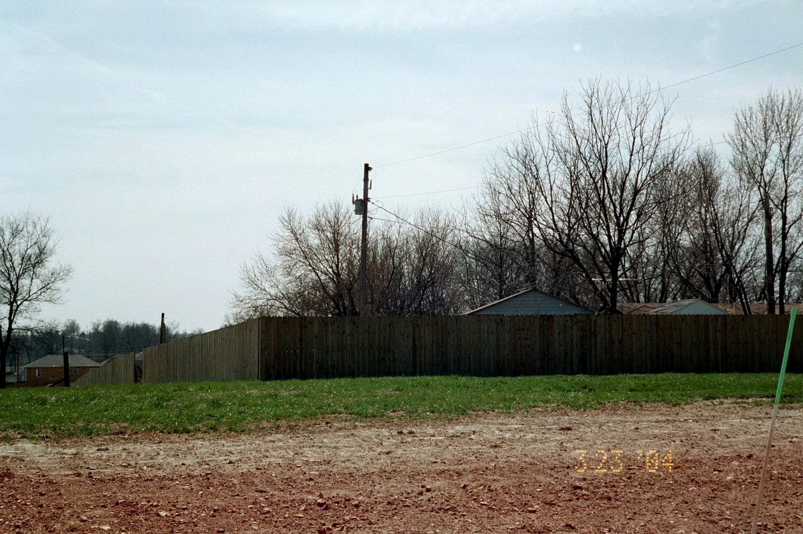

Looking southwest at rear of Mr. Carter’s property, fence divides properties
White River overhead electric facilities shown serving the home

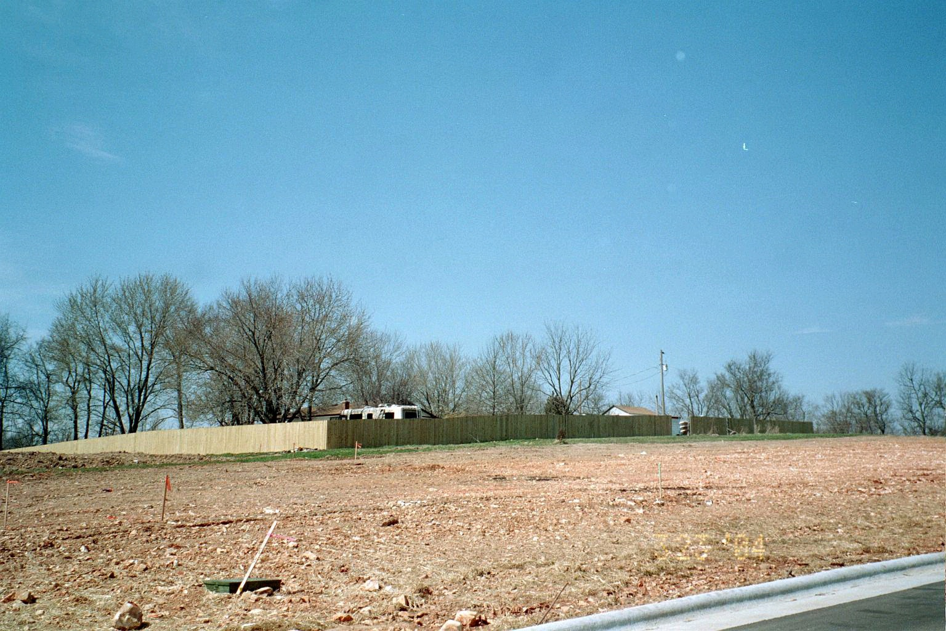

Looking northwest at rear of Mr. Carter’s property, subdivision lots in foreground
Page 1 of 3
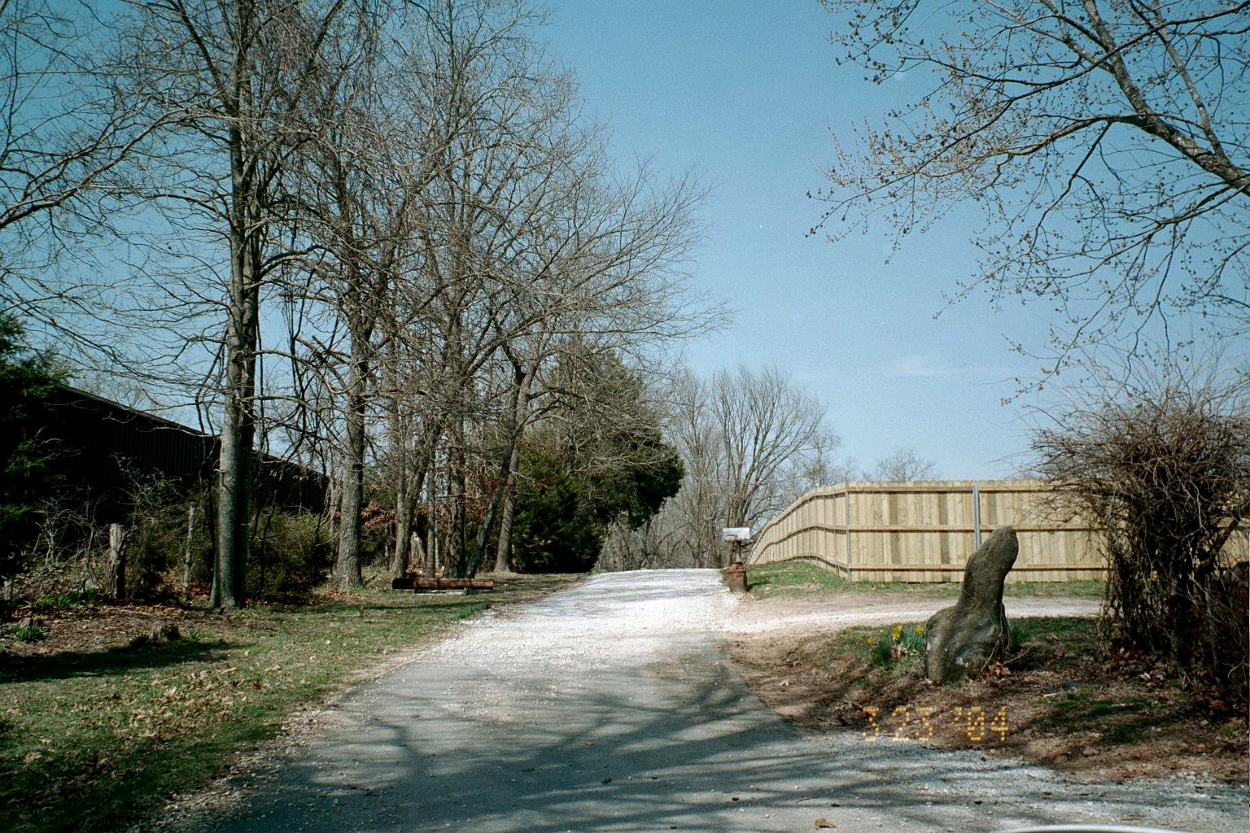

Looking north on South Harrison Street, Mr. Carter’s property on the right

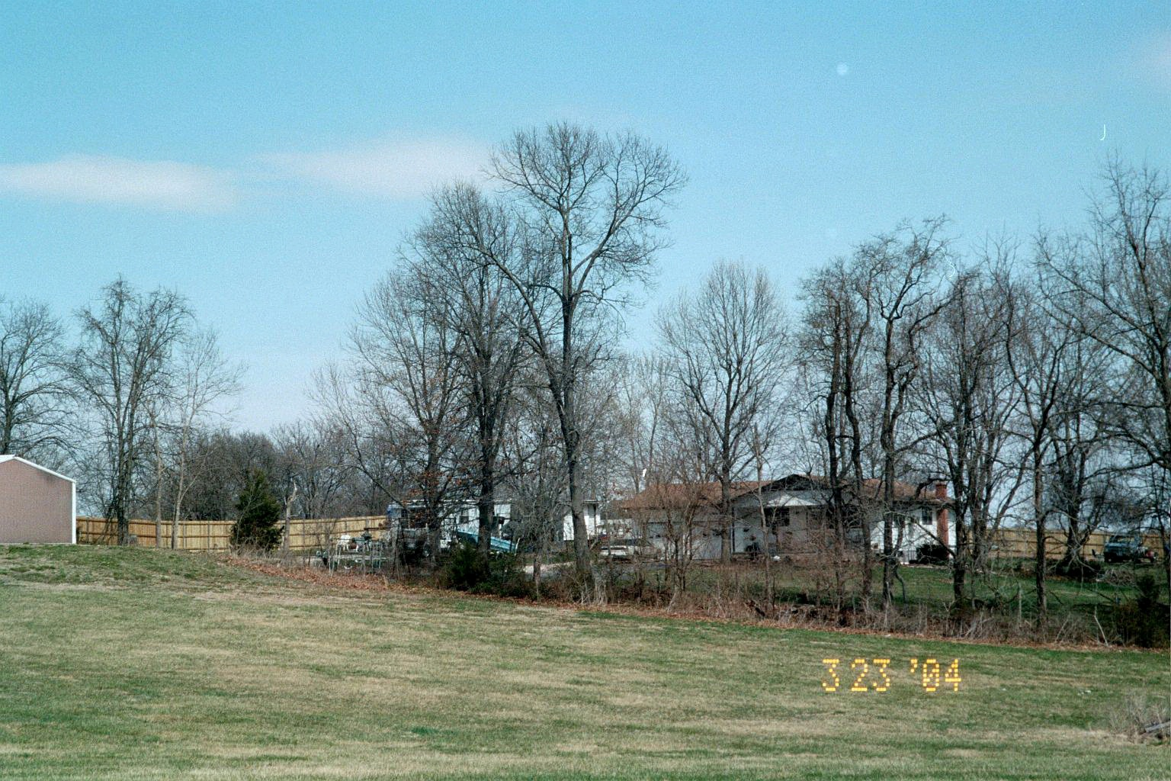

Looking east at Mr. Carter’s property, new subdivision is on three sides of the house

Page 2 of 3

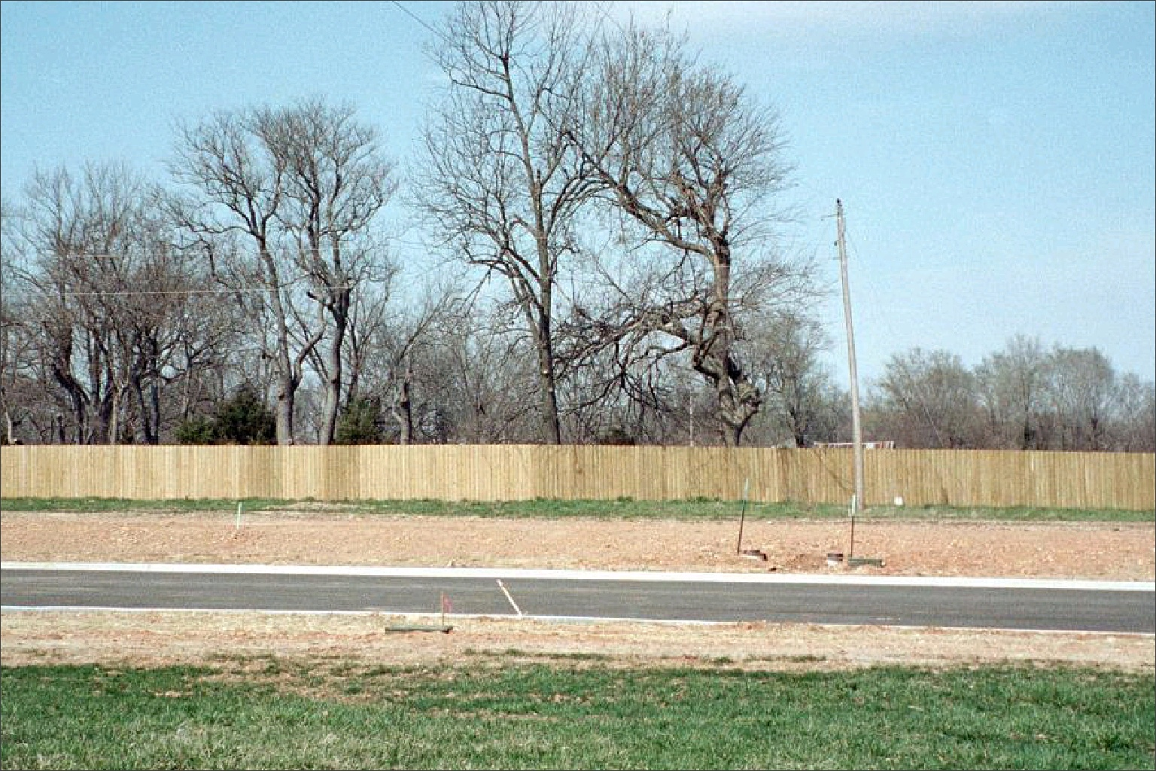

White River overhead electric facilities from the north, behind fence.
These overhead facilities will be converted to underground on a route from the pole,
across the lot to the street, under the street, across the lot to Mr. Carter’s property. The Nixa underground electric facilities are available from the grassy lot in foreground.

Page 3 of 3

