BEFORE THE PUBLIC SERVICE COMMISSION

OF THE STATE OF MISSOURI

In the Matter of a New Proposed )
Rule 4 CSR 240-33.045 ) Case No. TX-2005-

NOTICE OF NEW CASE

The Commission is considering the possibility of a new rule 4 CSR 240-33.045. This notice is being issued to create a case number in the Commission’s electronic filing system.
BY THE COMMISSION
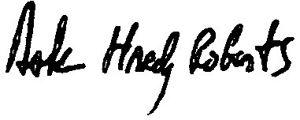

Dale Hardy Roberts
Secretary/Chief Regulatory Law Judge

( S E A L )

Dated at Jefferson City, Missouri,
on this 2nd day of February, 2005.

Mills, Deputy Chief Regulatory Law Judge

